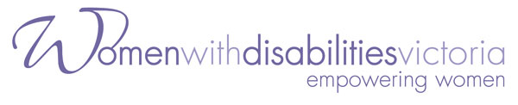

Co-Facilitator for the Enabling Women Program

Women with Disabilities Victoria is a small and vibrant organisation of women with disabilities working for women with disabilities in Victoria.

We are looking for a woman who identifies as having a disability, with some experience of supporting other people with a disability, to assist with the delivery of the

Enabling Women Program –
a Leadership Program for Women with Disabilities in Shepparton.

Women from the Goulburn Valley Region are encouraged to apply.

Further inquiries can be made to Jane Oldfield, Partnership and Leadership Development Officer by phoning 9286 7807 or Sharon Granek 9286 7802.

The position description and program information can be downloaded from http://www.wdv.org.au.

Applications close 5pm on Monday 16.3.15

Applications addressing the selection criteria should be addressed to
Jane Oldfield,
Partnership and Leadership Development Officer,
Women with Disabilities Victoria,
GPO Box 1160, Melbourne 3001, or email Jane.oldfield@wdv.org.au

