Enabling Women Leadership Program

A leadership program for women with disabilities
In Melbourne’s North East

Information Session
Women with Disabilities Victoria (WDV) is offering a 5 day leadership program to women who wish to step up in their own communities.
The leadership program is offered in plain English.
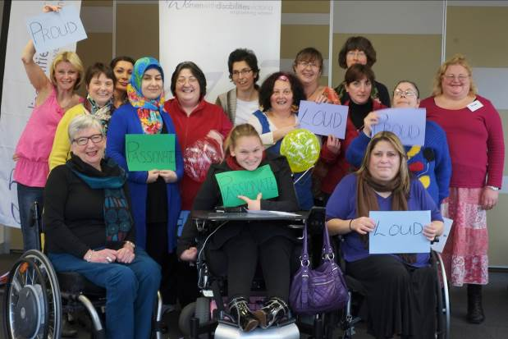
Topics covered include

- Getting to know you
- The Social Model of Disability
- Self-Identity
- Human Rights
- Communication
- Advocacy (speaking up for your rights)
- Leadership Graduates 2013

The program provides an opportunity for women from diverse backgrounds with disabilities to come together. Woman will share their stories and find solutions to common problems together.
Learn more at the Information Session
Where: Civic Centre (Fountain View Rear Room),
25 Ferres Boulevard, South Morang 3752 (Melway 183 A10)

Transport assistance to the venue is available.

Time: 1.00pm – 2.30pm
When: Friday 21st August 2015
The program will run over 5 Fridays: 23rd and 30th October, 6th, 13th and 20th November (10.30am – 3.30 pm).
Enquiries & RSVPs Jane Oldfield | Ph. 9286 7807 | Email jane.oldfield@wdv.org.au
Partnerships and Leadership Development Officer, WDV

More information can be found on our website www.wdv.org.au

