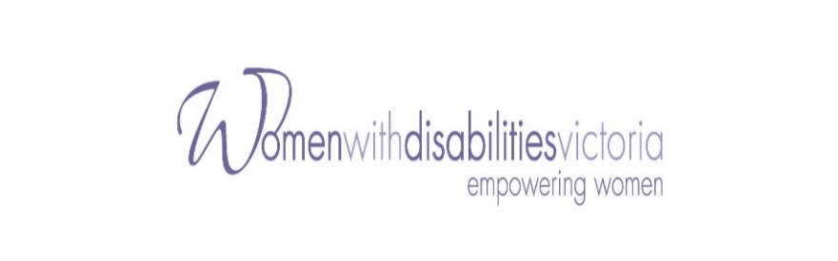
Enabling Women Leadership Program
A leadership program for women with disabilities
living in the Moira Shire and beyond.

‘Women with Disabilities Victoria’ is offering a leadership program to women who wish to speak up in their own communities.
The program will be delivered every Thursday for 6 weeks from 29th June 2017
until 3rd August 2017. A graduation event will be held on the 10th August 2017
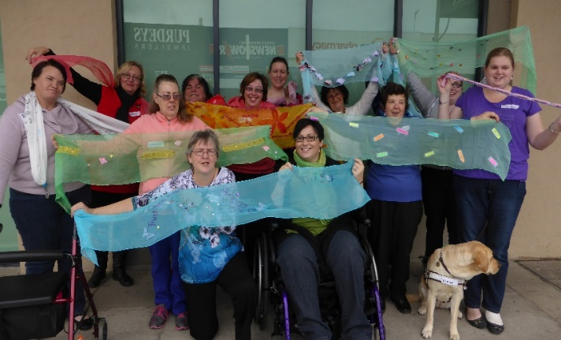
This course will give you:
- Confidence and new skills
- Connections with other women
- Information about your rights
- Learning with fun
- Self esteem
- Leadership skills
Goulburn Valley Graduates 2015

This FREE program will provide an opportunity for local women with disabilities from diverse backgrounds to come together to share their experiences and support one another to achieve their goals.

Information sessions to find out more:
Session One: Wednesday 7th June, 2.00pm – 3.30pm
Cobram Community House, 43 Punt Road, Cobram

Session Two: Thursday 8th June, 9.00am – 10.00am
Yarrawonga Neighbourhood House, 1 Hargrave Crt, Yarrawonga

Session Three: Thursday 8th 11.30am – 1.00 pm
Nathalia Community House, 17 Harcourt St, Nathalia

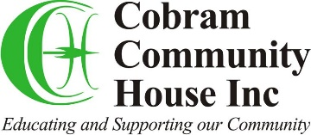
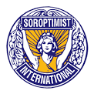
To register for information session, for more information, assistance to apply, or help with transport, please contact Jane Oldfield at
Women with Disabilities Victoria on 9286 7807
or email jane.oldfield@wdv.org.au

