“Women with Disabilities: Our Right to Respect!” Women’s Peer Education Program
Do you want to talk about your rights as a woman with disabilities?
Do you want to find out about services in your area that support women’s health and wellbeing?
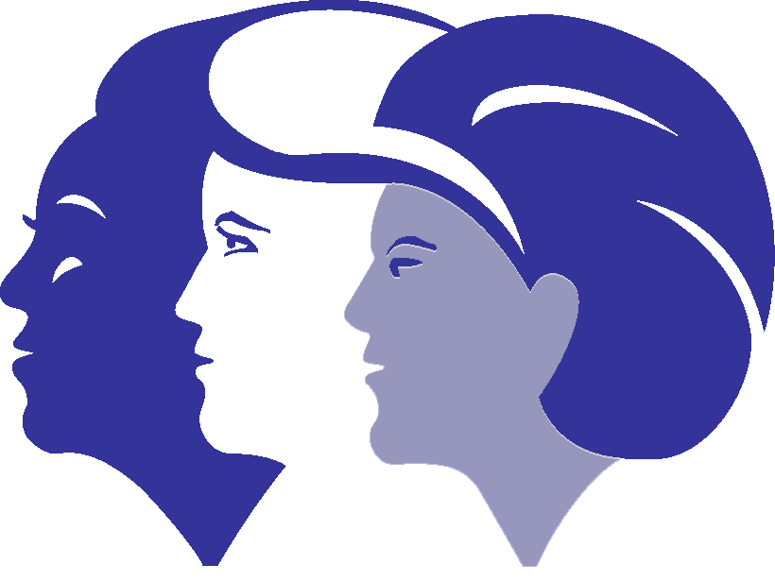
“Our Right to Respect” is a free Peer Education Program for women with disabilities who want to talk about their rights, safety and having respectful relationships.
This program is run by Women with Disabilities Victoria in partnership with Glen Eira City Council for and with women with disabilities!
You will be able to talk about:
- Being a Woman – with Disabilities
- Having Rights and Speaking Up about Safety
- Getting Support to Feel Safe
- Being the Woman You Want to Be

The program will run over 4 weeks from 12:30pm to 4:00pm on Tuesdays and includes a light lunch.

When: February 28th – March 21st 2017
Where: Duncan Mackinnon Reserve Pavilion Meeting Room
Corner North and Murrumbeena Roads, Murrumbeena 3162

Expressions of Interest Encouraged
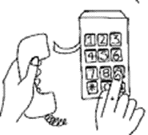
If you are interested and would like more information, please call or email Bianca Evans at:
Women with Disabilities Victoria
T: (03) 9286 7809 or E: bianca.evans@wdv.org.au

What is this all about?

We want women with disabilities to have a space to talk about respect, feeling empowered and in control of their lives, and knowing what services are available to help if they are being discriminated against or hurt. Women with disabilities experience more discrimination than most other groups – this must end!
In each session we listen and watch stories from real women, and then talk about their stories together.
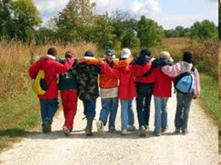
Session One - Being a Woman with a Disability
In this session we talk about being a woman, the way people can treat you differently and discriminate against women, and why this discrimination happens. We also talk about early signs of disrespect and abuse – and what you can do to get help.

Session Two - Having Rights & Speaking Up about Safety
We talk about respect and what it means to you, and how it looks in your life. We listen to women’s stories, and talk about how they got help and support when they were not being treated with respect.

Session Three - Getting support to feel safe
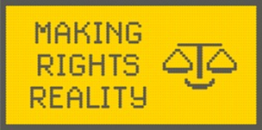
We talk about how many women with disabilities have experienced sexual assault, that this is not OK and is illegal, and that there is help available.

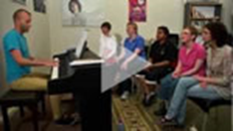
Session Four - Being the Woman you want to be
In the final session we talk about the rights of women with disabilities to live the way they want to live. We watch 4 amazing videos of women using their rights to live the lives they want.

Learning partners – Someone to come with you
You can bring a trusted female friend or worker to the program if you want. You don’t have to, some people do, and some people don’t.
This is a person who can join in the conversation at the program, and you can talk with them about the program and what you think. They could also help you if you want to talk with any of the services we talk about.

“Women with Disabilities: Our Right to Respect!”
Women’s Peer Education Program

Expressions of Interest Form

Name: _______________________________________
Address: _______________________________________
Phone: _______________________________________
Email: _______________________________________

Support/contact person (if appropriate): ___________________________
Email:_____________________________ Phone: ___________________

Why do you want to be a part of the program?
___________________________________________________________
___________________________________________________________

What do you hope to learn from participating in the program?
___________________________________________________________
___________________________________________________________
Access: What do you need in order to participate in the program?
(For example: attendant care/support worker, learning partner, Auslan or other language interpreters, large print, hearing loop, dietary or other requirements)

Please email your completed enrolment form to Bianca Evans from WDV at bianca.evans@wdv.org.au or you can call Bianca and she can fill it out.
Bianca will contact you by email or phone to confirm your place in the program.

