“Women with Disabilities: Our Right to Respect!” Women’s Peer Education Program
Do you want to talk about your rights as a woman with disabilities?
Do you want to find out about services in your area that support women’s health and wellbeing?
“Our Right to Respect” is a free Peer Education Program for women with disabilities who want to talk about having respectful relationships.
This program is run by Women with Disabilities Victoria for and with women with disabilities!
You will be able to talk about:
- Being a Woman – with Disabilities
- Having Rights and Speaking Up about Safety
- Getting Support to Feel Safe
- Being the Woman You Want to Be

The program will run over 4 weeks from 9:30am to 1:00pm on Thursday’s and includes a light lunch.
When: March 9th – March 30th 2017
Where: Ringwood Library - also called Realm,
179 Maroondah Hwy, Ringwood.
(Fully Accessible, changing places on site)

Expression of Interest/Enrolments Encouraged
If you are interested and would like more information, please call or email Bianca Evans at
Women with Disabilities Victoria
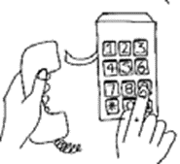
T: (03) 9286 7809
E: bianca.evans@wdv.org.au

What is this all about?

We want women with disabilities to have a space to talk about respect, feeling empowered and in control of their lives, and knowing what services are available to help if they are being discriminated against or hurt. Women with disabilities experience more discrimination than most other groups – this must end!
In each session we listen and watch stories from real women, and then talk about their stories together.

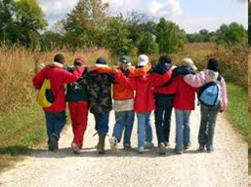
Session One - Being a Woman with a Disability
In this session we talk about being a woman, the way people can treat you differently and discriminate against women, and why this discrimination happens. We also talk about early signs of disrespect and abuse – and what you can do to get help.

Session Two - Having Rights & Speaking Up about Safety
We talk about respect and what it means to you, and how it looks in your life. We listen to women’s stories, and talk about how they got help and support when they were not being treated with respect.

Session Three - Getting Support to Feel Safe
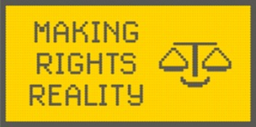
We talk about how many women with disabilities have experienced sexual assault, that this is not OK and is illegal, and that there is help available.

Session Four - Being the Woman You Want to Be
In the final session we talk about the rights of women with disabilities to live the way they want to live. We watch 4 amazing videos of women using their rights to live the lives they want.

Learning partners
Learning Partners are someone that you can talk to about the program. A trusted female friend or worker that you can bring to the first day of the program if you want. You don’t have to, some people do, and some people don’t.
This is a person who can join in the conversation at the program, and you can talk with them about the program and what you think. They could also help you if you want to talk with any of the services we talk about.

“Women with Disabilities: Our Right to Respect!”
Women’s Peer Education Program

Enrolment Form

Name: _______________________________________
Address: _______________________________________
Phone: _______________________________________
Email: _______________________________________

Will a learning partner or support worker come with you? Yes No
Support/contact person (if appropriate): ___________________________
Email:_____________________________ Phone: ___________________

Why do you want to do the program?
___________________________________________________________
___________________________________________________________

What do you hope to learn from participating in the program?
___________________________________________________________
___________________________________________________________
Access: What do you need in order to participate in the program?
(For example: attendant care/support worker, learning partner, Auslan or other language interpreters, large print, hearing loop, dietary or other requirements)
___________________________________________________________
Please email your completed enrolment form to Bianca Evans from WDV at bianca.evans@wdv.org.au or you can call Bianca (9286 7809) and she can fill it out.
Bianca will contact you by email or phone to confirm your place in the program.

