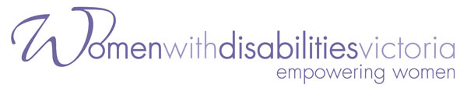

**Women with Disabilities Victoria (WDV)**

**Advocacy and Linkage Forum**

Are you a woman with a disability living in the Winchelsea region in Surf Coast Shire?

Do you want to learn more about advocacy opportunities in your region?

Do you want to meet with local advocacy organisations and services?

Do you want to add your voice to WDV’s advocacy work?

Women with Disabilities Victoria, in partnership with Rights Information and Advocacy Centre, is organising an advocacy and linkage event in Winchelsea.

**Details:**

Wednesday 22nd August 2018

10:00am – 2:00pm

Eastern Reserve Community Centre

70 Hopkins Street, Winchelsea, 3241

Lunch and refreshments will be provided

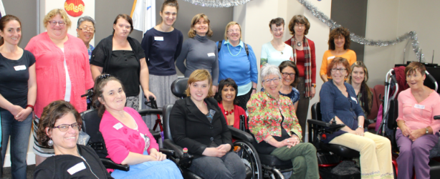There will be opportunities to meet and receive information from the following organisations:

* Women with Disabilities Victoria
* Rights Information and Advocacy Centre

(NDIS Appeals)

* Surf Coast Shire Rural Access
* Women’s Health and Wellbeing Barwon

South West Women with disabilities attending a WDV event

* And more!

**To Register**

Please register for this event on Eventbrite by **11:59pm Monday 20th August 2018.**

If you would like assistance to register for this event, please contact Elyse Cox at [elyse.cox@wdv.org.au](mailto:elyse.cox@wdv.org.au) or (03) 9286 7800.

<https://wdv-advocayandlinkageforum-winchelsea.eventbrite.com.au>

Please register as early as possible to help us organise any access requests.

Proudly supported by the Victorian Government, Rights Information and Advocacy Centre and RuralAccess Surf Coast Shire Council.