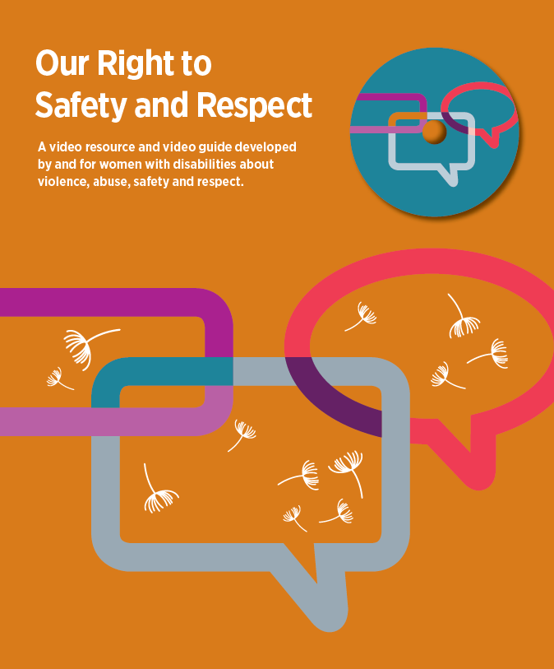
Image: The cover has an orange background with different coloured thought bubbles intertwined and floating white dandelions with the title Our Right to Safety and Respect. A video resource and video guide developed by and for women with disabilities about violence, abuse, safety and respect.

Image: Women with Disabilities Victoria logo. The logo font is purple against a white background. In large font, it says Women with Disabilities Victoria and below it in a smaller font it says empowering women.
Contents

Foreword................................................................................................................................................. 1
Acknowledgements................................................................................................................................. 2
The Video Guide and Video.................................................................................................................... 3
Watching the Video and Using the Guide................................................................................................4
Women with Disabilities - Rights, Power and Control..............................................................................6
Trusting Yourself and Others...................................................................................................................8
Finding Someone to Trust........................................................................................................................9
What is Violence and Abuse?............................................................................................................... 10
What Can You Do to Get Help?.............................................................................................................12
Places Where You Can Get Help...........................................................................................................13
How Can We Recover from Violence and Abuse?.................................................................................15
Glossary – Words and Meanings...........................................................................................................17

Image: Victorian State Government black and white logo, against a white background.
The development of this resource was supported by the Victorian Government.
The Victorian Government’s funding is gratefully acknowledged.
The video was produced by Fertile Films for Women with Disabilities Victoria.
This video guide was prepared by Women with Disabilities Victoria.
Published by Women with Disabilities Victoria: Level 9/255 Bourke Street, Melbourne, Victoria 3000
© Women with Disabilities Victoria 2018

Foreword

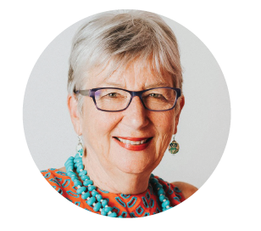
Image: Keran has short silvery coloured hair and is wearing glasses and smiling. Keran is wearing an orange printed top with a blue beaded necklace and colourful long earrings. Keran is seated in a wheelchair.

The Our Right to Safety and Respect video is a celebration of the strength of women with disabilities. It shows three women’s stories of getting safe from violence and abuse.

It shows the different ways we, can be connected in our communities and find people we can trust.

It is empowering to find ways to speak up and be heard. It is important to find people to believe you.

As women with disabilities we, challenge abuse of power and violence in our lives. We are strong and we are not alone.

Keran Howe
Executive Director,
Women with Disabilities Victoria

Image: 2 purple coloured dandelion spores floating against a white background. Please note, this image appears throughout the guide but only appears once in this document.

Acknowledgements

Women with Disabilities Victoria (WDV) thanks Fertile Films – Sarah Barton and her team – for developing the video as part of the WDV Safeguards Project.

WDV also acknowledges Lightside Consulting for the initial research and consultation that informed the development of the video and video guide.

Many thanks to the women with disabilities who gave their valuable time to participate in individual and group, consultations that helped shape the contents and form of the resource.

We also thank our partners in informing the consultation and supporting the consultations to take place smoothly in their local areas – Women's Health West, City of Latrobe, Scope, Self Advocacy Resource Unit.

Our particular thanks to the nine women with disabilities who contributed expert advice that informed the on-going development of the video and the guide.

Project consultations highlighted the importance of hearing directly from women with disabilities – learning from their experience, wisdom and strength. WDV acknowledges the invaluable contribution of the women who shared their stories in the video – Jane, Sam and Tess. Thank you also to the women who provided their expertise and knowledge in the video:
Keran Howe, Executive Director, WDV
Jenny Godwin, Leadership Hub Liaison Officer, WDV
Maree Ireland, Disability Advocate
Megan Dobbs, Acting Inspector, Victoria Police.

A cross-sector Stage 2 Project Advisory Group provided significant expertise and guidance to the development of the resource. Membership comprised:
• Fofi Christou, (Chair) WDV
• Jen Hargrave, WDV
• Karleen Plunkett, WDV member
• Lisa Brumtis, WDV member
• Stacey Christie, WDV member and Youth Disability Advocacy Service
• Amanda Leitch and Anusha Rodrigo, Department of Health and Human Services
• Claire Varley and Amy Webster, Women’s Health Victoria
• Elizabeth Weston, Scope
• Marianna Codognotto, Office of the Disability Services Commissioner
• Sophia Spada-Rinaldis, Office of the Public Advocate.

Members’ enthusiasm, commitment and valuable insights through all stages of the development of the resource are, much appreciated.

Thank you to Lydia Phillips for her management of the resource development in the early stages.
Thanks to WDV staff for their on-going support of the Safeguards project. Thanks to Cath McNamara and Kelly Parry for project and advisory group support.

The Video Guide and Video

This video guide helps us understand the video better. The guide helps us to think and talk about violence and abuse so as women with disabilities we know more about our rights to safety and respect.

Purpose of the video guide
The guide helps us:
• understand and learn more about the information and stories in the video
• ask questions and talk about violence and abuse of women with disabilities
• learn more information that is helpful.

We strongly suggest you read the guide before watching the video.

You can also use the guide, while watching the video:
• on your own
• with a friend or support person
• in a group.

The guide gives phone numbers and links to services and organisations that can support us and help us feel safer.

The video guide is available in Easy English.

Aim of the video
This video aims to give women with disabilities information to, better understand how to identify violence and abuse and how to get help to feel safe.

In the video, women with disabilities speak about their personal experiences of violence and abuse. Women with a disability talk about empowerment, respect and ways to feel safe.

Other women who work in different services talk about violence, and abuse and how they can help. All women with disabilities have the right to feel safe, and be, respected.

This video was, made for and with women with disabilities.

About the video
The video runs for 20 minutes and is, divided into sections. The sections are:
• Introduction
• What is violence and abuse?
• What helps keep us safe and respected?
• What can we do to get help if we feel unsafe?
• How can we recover from violence and abuse?
• The video has open captions in English and features an Auslan interpreter on screen. There is also:
- an audio-only file for people with vision impairments
- a transcript of the video.

Viewer information
This video is about how to be safer from violence and abuse.
Violence and abuse are never OK.
Some of the things talked about in this video may be upsetting for some people.
You may prefer to watch the video with a trusted friend or support person.
Watching the Video and Using the Guide

In the guide, there are questions and ideas for each section to help with discussion and conversation.
It can be, watched alone, or with a friend or support person.
It can also be used by, community groups and organisations.
The information and women’s stories can be useful for self-advocates, friends, advocates, family, support workers, and other people who support and work with women with disabilities.

Watching the video and using the guide in a group setting
We know women with disabilities are more likely to have experienced violence and abuse, than, women without disabilities. If you are sharing this video with a group, there are some safety issues you need to think about to prepare for it.

1. What do you need to do to prepare before the day of viewing of the video
a) Create a safe space for women to view the video and put in place some things to support women to feel safe. This is very important both before and on the day of viewing with a group.

b) It is important that you view the video in a small group that is for women only and without disability support workers present. This is because sometimes women won't speak up when their support workers or men are present.

c) Women may become distressed while watching the video and may need to be, referred to a professional counselling service. You can contact a specialist family violence service, or counselling service in your local area. You may be able to organise a counsellor to be available in person or by phone on the day of the viewing to support women who become distressed.

d) Preparing and providing the group with a list of referral contact numbers for services is important. Women may become distressed or upset after the session and need someone to contact and talk to when they leave. You can use the list of supports and services in this guide on page 13.

e) The place where you are viewing the video should have privacy from being, overheard or being, seen by other people if possible. Make sure you and everyone else will feel safe and comfortable in the room you are using to watch the video.

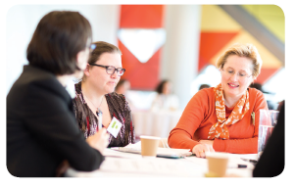
Image: 3 women sitting around a table talking. One of the women has her back to the camera she, is wearing a black long sleeve top, has short brown bobbed hair, and wearing glasses. Another woman, who is sitting in the middle, is wearing glasses, and has her hair pulled back and is wearing a printed colour top in brown and red. The third woman has blond hair tied back off her face wearing an orange long-sleeve top with orange multi-colour scarf around her neck.

Watching the Video and Using the Guide continued

2. On the day you are viewing the video
a) On the day of the viewing with the group and before showing the video, it is important to let the group know that the video is about women’s stories of violence and abuse. Some may find it upsetting or sad. It could trigger or remind them of something that has happened to them in the past or is happening now either, to them, or someone they know. Let women know what you have put in place to make sure they can get the help they need if this happens.

b) It can be useful to talk about group safety beforehand. You might choose a word or signal to let people know if you, or anyone else, want the video to stop.

c) Make sure, that anyone watching can stop the video at any time. It could be because they feel sad or upset or just need a break. They may choose not to watch the video and that’s OK.

d) Anyone can take time out if they need to or talk about what they are feeling or ask to talk with someone who knows more about violence and abuse and can give them support.

e) It’s good to check in with ourselves and each other to make sure we are feeling OK. This is important during the session, after the session and a day or two later.

3. Privacy and sharing stories
a) Privacy is important in the group and you have the right to your personal information being, kept private. It means, that anything said or done, or, any stories shared by women in the group, need to be, respected and, not shared outside of the group.

b) It’s important to check with everyone in the group to make sure they understand about privacy.

c) Privacy outside of the group setting is also important. Letting people know what can and can’t be shared to people outside of the group is important. This means that if someone speaks about their personal experience that this should not, be shared without their permission.

4. Sharing stories and looking after each other
a) It can be upsetting to hear about violence and abuse, so it's a good idea to check in before the start of the video to make sure everyone feels OK to hear the stories of other group members.

b) Sometimes stories can be shared that make you worry about someone’s safety or upset other people in the group. If you are feeling worried or concerned about another person’s safety you can contact one of the support services for advice and support.

Women with Disabilities – Rights, Power and Control

Who are women with disabilities?
One of the best things about women with disabilities is how different and diverse we are.
• We come from different cultures and countries
• We may speak or sign different languages
• We may live in a city or a country town
• We may be attracted to, women, or, men or both
• We could be rich or poor
• We could be younger or older
• Or we could be any combination of these.

We all have different things that make us feel safe, and happy and good about ourselves. We are resilient we, know ways to keep ourselves safe, we are capable and strong.

Some important things to think about
• We have a right to feel and be safe
• It is important to recognise when we are not feeling safe and trust ourselves, and our feelings
• It’s good to learn more about:
- knowing our rights
- speaking up so we can have a voice and be heard
- making decisions for ourselves
- feeling powerful as women with disabilities
• It’s good to become involved in:
- women’s peer support or leadership groups
- self-advocacy groups
- community activities that you like participating in with others. You can find activities at your local council, arts centre, sports club and women’s health service
• It can be helpful to build your friendship circle of women, as they are often good listeners
• Find a person or people you can trust and talk to them. If they are not helpful, keep trying to find people who understand, believe you, and respect your rights.

All of these things can help to build our confidence and give us more control over our lives. Unfortunately, it may not always stop people trying to control or abuse us. But it will help us to feel stronger, not feel so alone and have more ways of getting support if and when we need it.

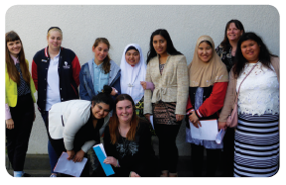

Image: A group of women from different cultural backgrounds from the Enabling Young Women's Group standing with course facilitators. Some of these women are wearing hijabs and scarves on their heads, all of the women are smiling and are standing in front of a white wall.

Some questions to help us think about safety, respect and being in control

Q Did you know that it is a human right for us to feel safe and respected?
Q How important is it for us to know we have control in our own lives?
Q What does being treated with respect feel like, look like, sound like?
Q What do happy and respectful relationships look like, feel like, sound like?

“Enabling Women program – it’s a program to empower, to enable the women to learn to gain confidence as well as to make friends, to be involved with their communities, to learn to make change and to lobby for change.”

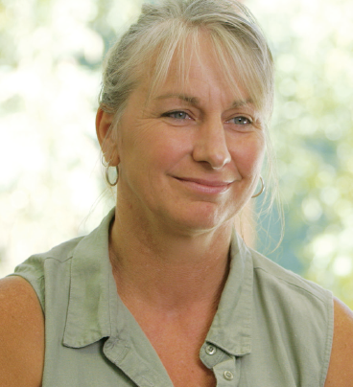

Image: Jenny has blond hair, which is, tied back. Jenny is wearing a short sleeve green top, and, is sitting in a wheelchair in front of a brightly light window. She is quoted from the video, with the words attached to the image “Enabling Women program – it’s a program to empower, to enable the women to learn to gain confidence as well as to make friends, to be involved with their communities, to learn to make change and to lobby for change”

Trusting Yourself and Others

Trusting yourself
First of all it’s especially important to trust ourselves.

This can mean trusting ‘our gut feeling’ to know when something is OK or not OK. Some people call this a ‘gut instinct.’

We can get feelings in other parts of our body as well. Some women say they feel it in their head, heart, neck, back, hands or feet.

It’s good to notice how our gut instinct feels in different situations and with different people.

Q How does your gut instinct feel when you’re scared or upset?
Q How does your gut instinct feel when you’re happy or excited?

If something doesn’t feel right or we feel frightened then it’s not right for us.

Trusting someone else
Q How do we know when we can trust someone?
Q Is there a person that you trust and helps you to feel safe and happy?
Q If you or someone you know felt unsafe, is there someone safe for you to tell?
Q What are some other ideas for safely telling someone you trust?

An example in the video was to have a secret code word to let them know you don’t feel safe. Would that be something that would work for you?

Image: Maree has short blond hair, wearing glasses and a short sleeve floral top in blue and brown is, seated in a wheelchair with backdrop of a hallway, quoted from the video as saying “It’s important to listen to women with disabilities. We have good ideas about our right to be safe – not just rights in relation to their disability but also women’s rights.”

Finding Someone to Trust

We can find people to trust in our friends, family and in our community. Here are some ideas about finding people to trust in the community.

Health services and Women’s Health Services
• Your local doctor and counsellors may work in health services and we might see them on a regular basis
• Some health services run groups where we can meet other women and support each other
• Staff who work in these services are likely to know about violence and abuse and can listen and help.
They also know may know about other services that can support us with our safety and rights.

We can find out about our local women’s health service from Women’s Health Victoria www.whv.org.au/publications-resources/healthinformation-links

Or we can visit GEN VIC website to find out about what’s going on at our local women’s health services www.actionpvaw.org.au/taking-action/servicesregional-action

If you would like to find a support group that brings women together to talk about violence and abuse contact the Domestic Violence Resource Centre of Victoria (DVRCV) and they will give you details of your nearest support group.
Phone: 03 9486 9866 or find out more on the DVRCV website www.dvrcv.org.au/talk-someone/support-groups

Community or neighbourhood houses
• They run fun and interesting activities
• They are great places to meet new friends
• They know about other services that may be useful for us.
We can find out about our local neighbourhood or community house here: www.nhvic.org.au/searchdirectory or Phone: 03 9602 1228

Our local council
• They have access workers or inclusion officers who understand about disability and access in your local community
• They work with organisations in local communities to run programs and activities
• They have information about what’s going on in your local area.
We can find our local council here: www.knowyourcouncil.vic.gov.au/councils

Disability advocacy organisations
• They can give us information and support.
We can find out about our local disability advocacy organisation from

• Disability Advocacy Resource Unit
Phone: 03 9639 5807 or Email: admin@daru.org.au Website: www.daru.org.au/find-an-advocate

• Self Advocacy Resource Unit
Phone: 03 9639 6856 Email: saru@rosshouse.org.au Website: www.saru.net.au/saru-links

Women with Disabilities Victoria (WDV) Enabling Women programs and regional leadership hubs
WDV runs 6 day, leadership programs for women who wish to lead in their own communities. The program sessions are, held one day a week over 6 weeks. WDV supports leadership hubs in some country areas.
Find out more on the WDV website: www.wdv.org.au Or Phone: 03 9286 7800
What is Violence and Abuse?

Violence and abuse affects many women with and without disabilities.

Violence and abuse can be anything that takes away our right to safety and respect.

This is never OK.
This is never our fault.

Sometimes there are people in our lives who don’t treat us as well as we deserve, who ignore our rights to feel and be safe.

Violence and abuse can happen in different ways.

It can be:

Control
Some examples might be someone controlling:
• what we do
• where we go
• who our friends are
• who we can see or speak to.

Financial
Some examples might be someone:
• using our money when we don’t want them to
• not letting us have our own money
• telling us how to use our money.

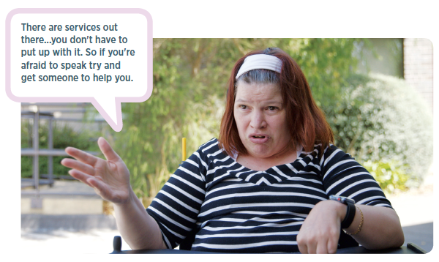

Image: Sam has shoulder length brown hair, wearing a white headband and a long sleeve black and white striped top is seated in a wheelchair with backdrop of a garden, quoted from the video as saying ”There are services out there...you don't have to put up with it. So if you're afraid to speak try and get someone to help you.”

What is Violence and Abuse? continued

Emotional
Some examples might be when someone:
• teases us or puts us down
• swears or shouts at us
• ignores us
• makes us feel bad about ourselves
• makes us feel like we can’t trust ourselves
• makes us feel that we are alone and that nobody likes us
• treats us like a child

Physical
• This is when someone tries to hurt, or hurts our bodies in any way.
It could be pinching, slapping, pulling hair, pushing around, or serious life threatening assault involving a weapon.

Sexual
This is when someone tries to:
• Make us, or makes us do sexual things we don’t want to do
• Touches us or makes us touch them in ways that make us feel uncomfortable.

Violence and abuse can also be using our disability to control us or treat us badly.

Some examples might be when someone:
• won’t assist us with our daily care
• does not give us medication we need or gives us too much medication
• takes the wheels off our wheelchair or doesn’t recharge the battery on a motorised wheelchair
• takes away or destroys our communication aids or other equipment
• locks or closes the door so we are trapped
• doesn’t allow us to eat or drink when we want to
• makes us have sex in return for care and support.

Q Are there other ways that someone might use our disability and the fact that we are a woman to abuse our rights and disrespect us?

You don’t have to put up with other people’s abusive or violent behaviour.

Sometimes you might have to tell a few different people to get the help you need.

Sometimes you might have to go to a few different services to get the help you need.

Don’t give up because eventually you will find the right person or service.

Keep trying because you have a right to safety and respect.
What Can You Do to Get Help?

Q What are some ideas you have after watching the video?

You could:
- Tell someone you trust
- Talk to your doctor
- Contact a Women’s Health Service
- Contact a specialist family violence service
- Contact the Disability Services Commissioner
- Contact the Office of the Public Advocate
- Contact the Police

You could also:
- Think about the ways you are able to communicate how you are feeling, what is happening or what has happened. It could be face to face, TTY, with an interpreter, communication device, texting, email, or with a support person beside you.
- Sometimes talking about violence and abuse can be hard so you could write down what you want to tell someone you trust. Only write things down if it is safe to do so.
- You could work out your own safety plan or contact a specialist family violence service like safe steps Family Violence Response Centre to help you make a plan for your safety.

What is a safety plan?
A safety plan means you plan ahead for your safety. Every plan is different as every person has different needs. Things that a safety plan may include are:
- Contacts in an emergency
- Contacts for support
- A safe place to go
- Transport – how will you get to your safe place
- Money – if you don’t have access to money there are other services that can help you with financial support
- You could plan for any extra support or care you or your children might need.
- For crisis payments to assist with support needs you could contact:

Disability and Family Violence Crisis Response Initiative (DFVCRI)
Phone the Disability Family Violence Liaison Officer – 0437 741 920 or 03 843 6304

- You could tell your trusted person what you plan to do and how they could help you
- You could put important things such as medicine, scripts, aids and equipment somewhere easy to access. This way you can take them with you if you have to leave your home suddenly because you feel unsafe and in danger
- You could keep important documents in a safe place. For example, Centrelink and Medicare cards, birth certificate/s, passport, drivers licence, or legal papers or things you might need in one place.
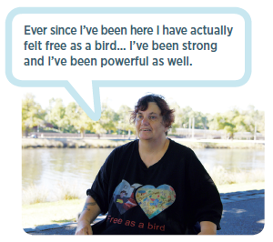
There’s a lot to think about and depending on your situation you may need other things included in your safety plan. It’s good to contact a family violence service to help develop a safety plan that suits your needs and the needs of your children if you have them.

Image: Jane has short brown hair and is wearing a short sleeve black t-shirt which has a colourful print on it with the saying “Free as a Bird”. Jane is, seated on the bank of a river, quoted from the video as saying, “Ever since I’ve been here I have actually felt free as a bird... I’ve been strong and I’ve been powerful as well.”

Places Where You Can Get Help
If you need help to leave a violent or abusive situation or are feeling unsafe, the following places may be able to help you.

Victoria Police on 000 in an emergency.
An emergency, is, when something bad is happening now or just happened.
For more information about how Police can help with family violence and abuse or sexual assault www.police.vic.gov.au/content.asp?Document_ID=48090

safe steps Family Violence Response Centre –
Phone 1800 015 188 or www.safesteps.org.au
safe steps is Victoria’s family violence support service and is open 24 hours a day seven days a week.

Centre Against Sexual Assault (CASA House) –
Phone 1800 806 292 or www.casahouse.com.au
CASA can provide counselling and crisis support if you have been sexually assaulted recently or in the past.
For information about violence, abuse and sexual assault in Easy English
www.secasa.com.au/pages/making-rights-reality/

1800RESPECT –
Phone 1800 737 732 or www.1800respect.org.au
1800 respect is the national counselling, referral and information service and is open 24 hours a day/7 days a week.
1800 respect wants everyone to be able to access their services no matter what their support needs www.1800respect.org.au/accessibility

WIRE –
Phone 1300 134 130 or email support@wire.org.au or www.wire.org.au
Wire offers a free information and referral service for all Victorian women. They are open Monday-Friday 9-5pm (except public holidays).
You can also visit WIRE at the Women’s Information Centre Monday-Friday 9.30-4.30pm

Disability and Family Violence Crisis Response Initiative (DFVCRI)
Phone the Disability Family Violence Liaison Officer - Phone 0437 741 920 or Phone 03 9843 6304
The DFVCRI can provide funds to women and their children who may require immediate disability support. Money can be provided for up to 12 weeks.

Disability Services Commissioner (DSC) –
Phone 1800 677 342 or TTY 1300 726 563 or www.odsc.vic.gov.au
If you would like to make a complaint, or talk about violence, abuse or neglect you can contact the DSC for advice or information. People with disability, families, carers, friends or disability service providers are encouraged to call.

Office of the Public Advocate –
Phone 1300 309 337 or www.publicadvocate.vic.gov.au
Office of the Public Advocate provide guardianship and advocacy services for people with disabilities. They provide advice and support.

Communication Rights Australia –
Phone 1300 666 604 or www.caus.com.au
Provides information and advocates for people with disabilities whose human rights have been abused. It gives priority to people with little or no speech.
Places Where You Can Get Help continued

Victims of Crime -
Phone 1800 819 817 or www.victimsofcrime.vic.gov.au
Open every day 8am-11pm
Provides free information and support to help you manage the effects of crime and guide you through the legal process.

Djirra –
Phone 1800 105 303 or Phone 03 9244 3333
Djirra provides information, referral, support, legal service, and workshops for Aboriginal women who are experiencing family violence.

InTouch – Multicultural Centre Against Family Violence –
Phone 1800 755 988
InTouch supports women and children from migrant and refugee communities who are experiencing violence. You can contact for free and confidential advice.

Women’s Legal Service –
Phone 03 8622 0600 or Toll Free: 1800 133 302
Women’s Legal provides free legal services to women.

Legal Aid –
Phone 1300 792 387 or www.legalaid.vic.gov.au/contact-us
Contact on Monday to Friday from 8.45 am to 5.15 pm, for free information over the phone about the law and how they can help you.

Lifeline –
Phone 13 11 14 or www.lifeline.org.au/get-help/get-help-home
Anyone experiencing a personal crisis or thinking about suicide can contact Lifeline 24 hours a day/7days a week for confidential support.

beyondblue –
Phone 1300 22 4636 or www.beyondblue.org.au/
Provide information and support about anxiety and depression 24 hours/7 days a week.

Mental Health Complaints Commissioner Victoria (MHCC) –
Phone 1800 246 054 or www.mhcc.vic.gov.au
If you would like to make a complaint about a mental health service or treatment and care, the MHCC would like to hear from you.

Switchboard (Telephone counselling, information and referrals for LGBTIQ
community members and supporters)
Phone 1800 184 527 3pm – midnight, 7 days a week or www.switchboard.org.au
Switchboard provides free, confidential and anonymous telephone and web-based counselling, referral and information services. It is for the Victorian and Tasmanian lesbian, gay, bisexual, transgender, intersex, and queer (LGBTI) community and its supporters. All switchboard volunteers identify as part of the LGBTIQA community.

iHeal Family Violence Recovery Support –
Phone 9663 6733 or www.ds.org.au/our-services/ihealfamily-violence-recovery-support/
Drummond Street Services – iHeal provides counselling, casework, advocacy, support groups, recovery education with specialist recovery support for women with disabilities.

How Can We Recover from Violence and Abuse?

Recovery can take time and different things will work for different people at different times. It is important to learn to take care of, ourselves, when we feel sad, or upset, or when hard things happen in our lives.

Some ideas that women find useful are:
- speak to a counsellor
- talk to a trusted friend
- go to the park or to the beach
- listen to music
- paint and draw
- dance
- be quiet in a place that is safe for you

Q What are some other ideas that might work for you?

Q What are some ideas you have to recover when hard things happen?

Q What are some things that help you to feel happier and more powerful in your own life?

One example in the video was setting up a Facebook page so that they could share stories and information.

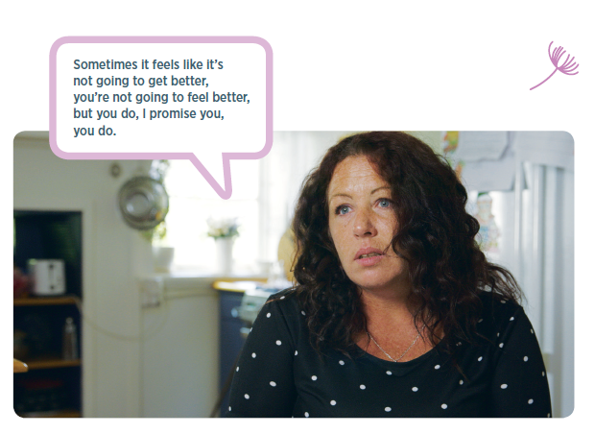

Image: Tess has long brown curly hair, she is wearing a short sleeve blue and white polka-dot shirt, Tess is sitting down with a backdrop of a kitchen behind her. Tess is quoted from the video as, saying, “Sometimes it feels like it’s not going to get better, you’re not going to feel better, but you do, I promise you, you do.”

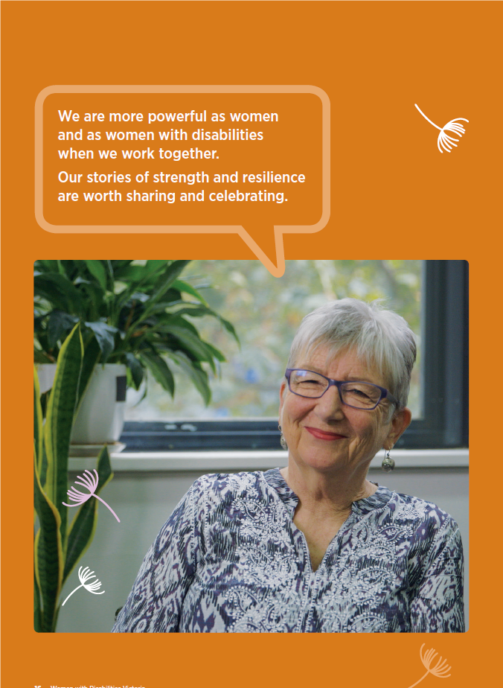

Image: Keran has short silvery coloured hair she is wearing glasses, and has a blue and white long sleeved pattern shirt on. Keran is seated in a wheelchair in front of a window, to the right of her there are 2 pot plants. There are also 4 white dandelion spores floating as an overlay to the image. Keran is, quoted, from the video as, saying, “We are more powerful as women and as women with disabilities when we work together. Our stories of strength and resilience are worth sharing and celebrating.”

Glossary – Words and Meanings

Captions
Words that are written on the screen while you are watching the video that are the same as the words spoken in the video.

Communication device
Equipment that helps a person with a voice, speech, language or hearing impairment to express themselves or say what they want to say. Communication devices can be something simple like a picture board or something like a computer program that makes written words into spoken words.

Empowerment
Means becoming stronger and more confident, especially in controlling our lives and claiming our rights.

Gender
Gender is about how society expect women and men to behave in certain ways and have different roles and responsibilities. Gender can mean different things for different people.

Human rights
The rights everyone is entitled to no matter who they are or where they live. The rights all people have simply because they are alive. These rights are in a document called the Universal Declaration of Human Rights, which tells us about the thirty rights all people have. The Convention on the Rights of Persons with Disabilities (CRPD) describes the rights of people with disabilities.

Intervention order
A family violence intervention order protects a person from a family member or family-like member who is using family violence. Family violence is behaviour between family or family-like members that causes fear. It includes emotional and financial abuse, as well as physical violence and sexual abuse.

AVO
Apprehended Violence Order – This is what they call an Intervention order in New South Wales.

Medication
Medicine we need to take to stay well.

Perpetrator
A person who hurts or is violent or abusive to someone else.

Resilience
Means being able to recover when hard things happen or when things go wrong and being able to cope with changes.

Specialist family violence services
(sometimes called outreach services) provide support for women and children experiencing family violence. The, people who work in specialist family violence services, understand what women and children experiencing family violence are going through and know how to help them keep safe.

Sexual assault services
Provide counselling and support for women and children who have recently, or in the past, experienced sexual assault.

Transcript
A written or printed version of what is said in the video.

Woman with disabilities
A person who identifies as a woman who has a disability or multiple disabilities.

Women with Disabilities Victoria
Level 9, 255 Bourke Street, Melbourne VIC 3000
Postal: GPO Box 1160, Melbourne VIC 3001
Phone: 03 9286 7800
Fax: 03 9663 7955
Email: wdv@wdv.org.au
www.wdv.org.au

