The Enabling Women
Leadership Program – South East 2018

Are you a woman who sees their disability as a strength?
Are you a woman who takes on life’s challenges?
The Enabling Women Leadership Program is an exciting free opportunity for women with disabilities from all cultures to come together, share their lived experiences and support each other to develop a strong sense of leadership within their community.
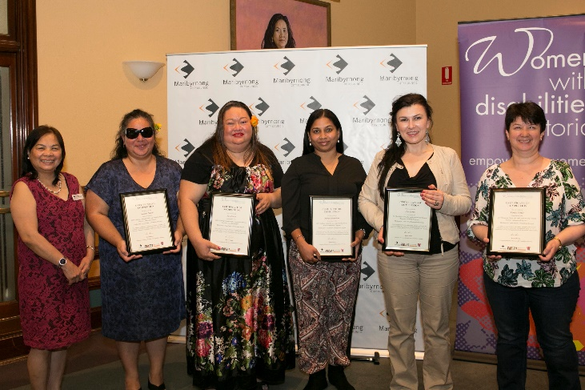
Enabling Women Graduates, Maribyrnong, 2017
This program is a safe environment that respects and welcomes women of all cultures and abilities. The program will be run at the Noble Park Aquatic Centre, 9 Memorial Drive, Noble Park. This is an accessible venue. The program runs every Tuesday for 6 weeks starting in October 2018.

This program will give you:

- Leadership skills
For more information please contact Sharon Granek from Women with Disabilities Victoria on 9286 7816 sharon.granek@wdv.org.au

We would love to meet you!

- Confidence
- Connections with other women
- Information about your rights
- Community Connections
- Self esteem
- Build upon employment skills

