Enabling Women Leadership Program
Empowering women with disabilities through access, choice, and respect

EXPRESSION OF INTEREST NOW OPEN
Women with Disabilities Victoria in partnership with Chisholm Institute of TAFE, Kingston City Council, Frankston City Council, Mornington Peninsula Shire, Women’s Health In the South East and Peninsula Health are offering an exciting opportunity for women in Frankston and its surrounds to become empowered in the community with a six-day leadership program.
This no cost program provides an opportunity for women with disabilities from diverse backgrounds to come together, gain knowledge, new community connections, tools and skills to speak up in the community.
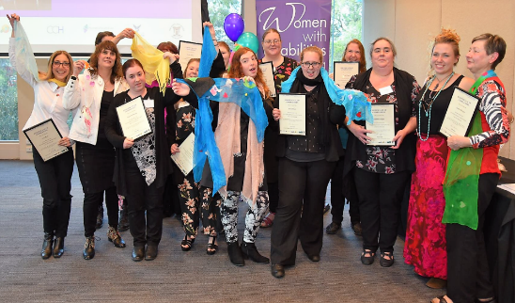

This course will give you:
✓ Confidence and new skills
✓ Connections with other women
✓ Information about your rights
✓ Learning with fun
✓ Self-esteem
✓ Leadership skills
INFORMATION SESSION
When: 10:30am – midday
Thursday 11th October 2018
Where: RM FR-W114 Chisholm Institute of TAFE Fletcher Rd, Frankston VIC 3199
Please note: Lift access available
PROGRAM DETAILS
When: Every Thursday for six weeks from 25th October to 29th November.
Where: RM FR-W114 Chisholm Institute of TAFE Fletcher Rd, Frankston VIC 3199
Please note: Lift access available
Graduation: 6th December Venue to be advised.TO FIND OUT MORE
Contact Ph: (03) 9286 7800 or E: jane.oldfield@wdv.org.au

