ENABLING YOUNG WOMEN
A LEADERSHIP PROGRAM FOR YOUNG WOMEN WITH DISABILITIES

Do you identify as a young woman aged
15 - 25 years.

Would you like to increase your confidence and learn more about leadership?

Women with Disabilities Victoria will be running a free six day leadership program for young women with disabilities in 2018.

The program will run during the day on Wednesdays in Montrose from 31st October to 5th December, Plus a graduation ceremony on Friday 14th December in the afternoon.

To find out more, or answer any questions you have about the program, please contact:
Bridget Jolley
Women with Disabilities Victoria.
bridget.jolley@wdv.org.au
03 9286 7813

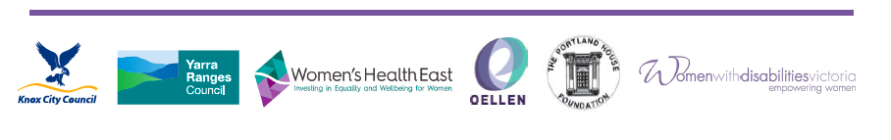
The program is supported by Knox City Council, Yarra Ranges Council, Women’s Heath East, OELLEN, The Portland House Foundation and Women with Disabilities Victoria.

