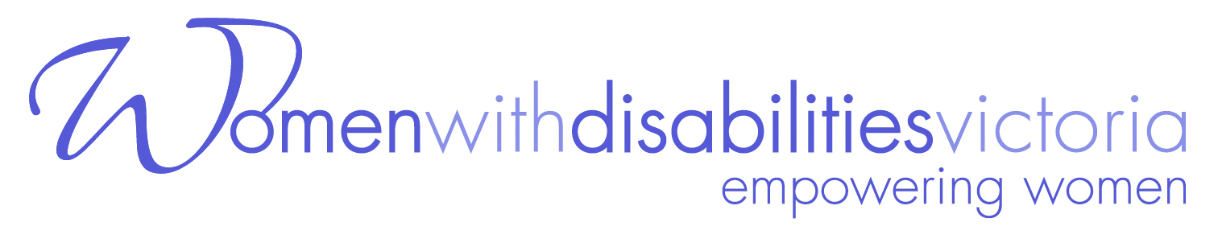

POSITION DESCRIPTION
Co-Facilitator, Enabling Women Leadership Program - Wyndham

Women with Disabilities Victoria (WDV) is a member led, dynamic and vibrant organisation of and for women with disabilities in Victoria. Our mission is to advance real social and economic inclusion for women with disabilities in Victoria.
WDV is recruiting for the potions of Co-Facilitator to assist in the recruitment, delivery, and evaluation of the Enabling Women Leadership Program – Wyndham, in 2019, with a main focus on delivery of the Program.

The Enabling Women Leadership Program (EW) is led by Women with Disabilities Victoria, in partnership with Wyndham City Council (WCC).
The Enabling Women Leadership Program is a strengths based community leadership program, empowering a group of 8-12 women who identify as having a disability. The program aims to build upon the participants’ leadership skills, and self-confidence, to enable them to voice issues that are important to them, and other women with disabilities within their community.
The program provides the opportunity for women with disabilities, aged 18+, from all backgrounds, to come together to share their lived experiences of disability, build on confidence/self-esteem, expand community networks, gain knowledge on rights, increase communications skills, find solutions to address issues of social and cultural challenges, so they can rise to their true leadership and advocacy potential.
We are looking for a woman who has connections to the area of Wyndham, and who identifies as having a disability, with facilitation experience and / or skills, to fulfill the position of Co-facilitator.
Some experience of supporting people with disabilities to become more empowered is desirable.

EW CO-FACILITATOR POSITION TIME COMMITMENTS
Panel member for Enabling Women Participant interviews - upto 2 days (max 6 hrs/day) | Upto 12 hours
Information sessions and participant recruitment | 3 hours
Preparation time for each Enabling Women session – 1.5 hours per session x 6 | 9 hours
Enabling Women sessions - 5 hours per session x 6 | 30 hours
Staff induction, program set up / pack up, debriefing / providing feedback and input for evaluation | 12 hours
Graduation event - 1 x 5hours | 5 hours
TOTAL NUMBER OF HOURS | 59 + (up to 12 hours for participant interviews)  = 71 hours

EMPLOYMENT CONDITIONS
Classification: Women’s Health Victoria Enterprise Agreement (2007)
Level 2, Year 1 (+ 25% casual staff loading) = $32.99 per hour
Hours of work: Up to 71 hours spread over 4 months

This is a fixed term contract for four months ending April 30th 2019

KEY RESPONSIBILITIES
Reporting to the lead facilitator, Bridget Jolley, you will be responsible for assisting with the following:

- Early Jan: attend a staff induction day
- Early Jan: assist with recruitment of Leadership Program participants
- Late Jan: present at information sessions for potential participants
- Early Feb: assist in conducting interviews for potential Program participants
- Feb – April: prepare and deliver Program content for the 6 Program days (held from Feb 21st to Mar 28th), and assist with preparations for the Graduation Ceremony (April 4th)
- April 4th: attend and support the Enabling Women Graduation Ceremony
- Feb – April: facilitate the group’s learning experience
- Feb – April: support the women participating in the Program
- Feb – April: provide feedback and evaluation input
- Jan – April: undertake other duties and responsibilities as required

SELECTION CRITERIA
- Personal lived experience as a woman with disability
- An understanding of and commitment to working from a feminist, and a social model of disability, perspective
- Good communication skills, both written and verbal
- The ability to support people with disabilities to become more empowered
- Knowledge, and experience - or the potential to acquire the skills, to facilitate group learning
- An understanding of how to support people to make informed choices
- Experience in developing and delivering information in simple English
- Connection to the Wyndham area

To apply for this role, please provide your:
- cover letter (with your name and address)
- CV/resume
- response to each of the 8 selection criteria
- two referee names & contacts

Please email or post applications to:
Bridget Jolley
Women with Disabilities Victoria
GPO Box 1160, Melbourne 3001
Email: recruitment@wdv.org.au

Women with disabilities from diverse backgrounds, including Aboriginal and/or Torres Strait Islander, CALD, and migrant / refugee backgrounds, are encouraged to apply!

Please contact Bridget Jolley on 9286 7813 for more information, if you require any support to complete the application, or would like to discuss accessibility around Key Responsibilities

Applications close at 5pm on Wednesday
12th December 2018
Applicant interviews for this role are planned for the week starting Dec 17th 2018

The Enabling Women Program is supported by:
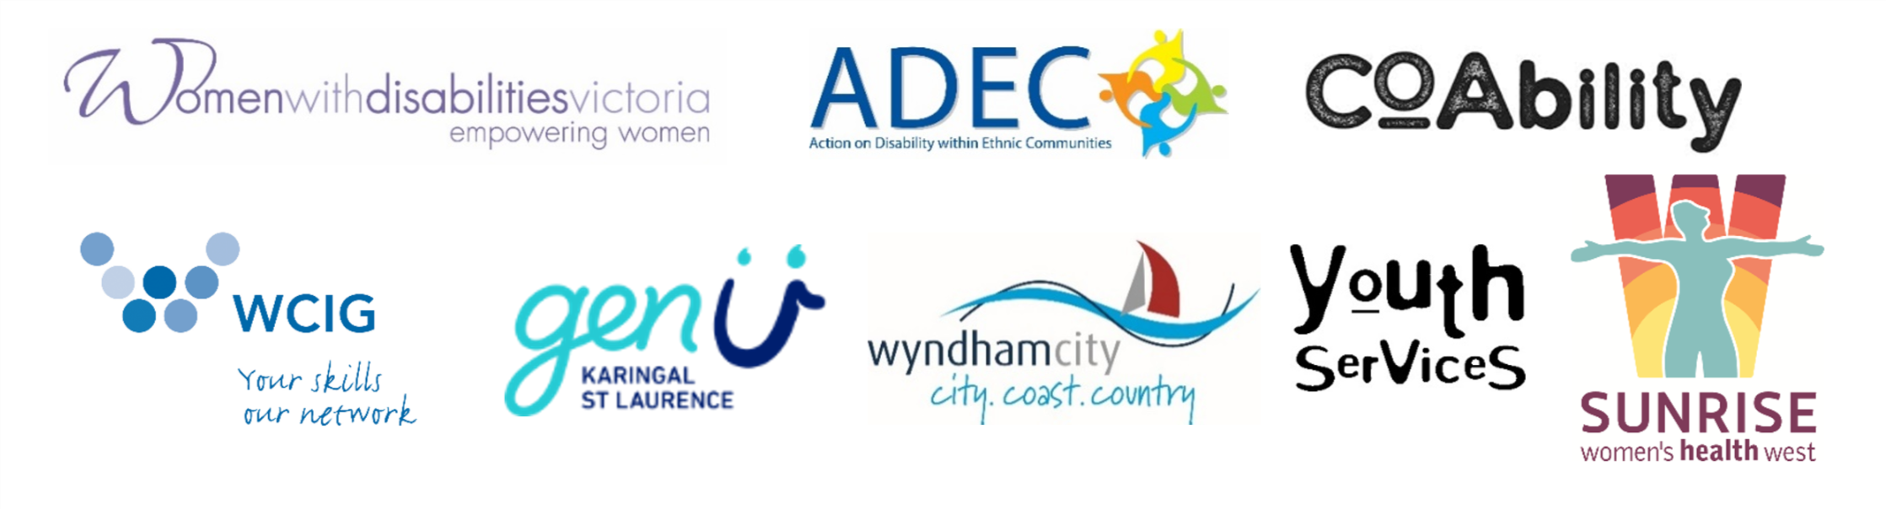Action on Disability within Ethnic Communities (ADEC), CoAbility, GenU, Westgate Community Initiatives Group (WHIG), Women with Disabilities Victoria (WDV), Women’s Health West (WHW), Wyndham City Council (WCC), and Wyndham City Council Youth Services.

