POSITION DESCRIPTION
Mentor Co-ordinator, Enabling Women Mentor Program - Wyndham

Women with Disabilities Victoria (WDV) is a member led, dynamic and vibrant organisation of and for women with disabilities in Victoria. Our mission is to advance real social and economic inclusion for women with disabilities in Victoria.
WDV is recruiting for the position of Mentor Co-ordinator to assist with recruiting and supporting mentors as part of the Enabling Women Mentor Program. The Mentor Program will run to complement the Enabling Women Leadership Program – Wyndham, in 2019.

The Enabling Women Leadership Program is a strengths based community leadership program, empowering a group of 8-12 women who identify as having a disability. The program aims to build upon the participants’ leadership skills, and self-confidence, to enable them to voice issues that are important to them, and other women with disabilities within their community.
During the Leadership Program, participants will be matched with a mentor who they will work with for a total of 6 sessions that will be held during the Program and for a short time after its’ conclusion. The mentoring relationship will focus on working towards and achieving a leadership goal defined by the participant
The Enabling Women Mentor Co-ordinator will drive recruitment of mentors for the Program, assist in matching participants with mentors, and support the mentors as they work with participants of the Leadership Program
WDV is looking for a woman who identifies as having a disability, who has strong connections to and networks within the Wyndham area, and who has excellent networking skills, to fulfill this position.

EMPLOYMENT CONDITIONS:
Classification: Women’s Health Victoria Enterprise Agreement (2007)
Level 3, Year 1 (+ 25% casual staff loading) = $36.40 per hour

Hours of work: Up to 92 hours spread over 5 months, ending May 31st 2019

KEY RESPONSIBILITIES
Reporting to the lead Enabling Women Program facilitator, the mentor co-ordinator will have the following responsibilities
- Mid Jan: attend a staff induction day
- Mid Jan – Late Feb: facilitate and participate in the recruitment process for mentors
- Jan 30th: present at the information session for potential mentors
- Early Feb: attend interviews for Leadership Program applicants
- Mid Feb: assist in conducting interviews for potential mentors in person or via phone
- Mid Feb: match potential mentors with program participants
- Mid Feb: co-ordinate criminal history/police checks for all successful mentors
- Late Feb – May 31st: support the mentor/participant relationship as required
- Feb 28th: attend the second day of the Enabling Women Leadership Program
- April 4th: attend and support the Enabling Women Graduation Ceremony
- April – May: organise evaluations of mentors, and provide evaluation input
- Jan – May: undertake other duties and responsibilities as required

SELECTION CRITERIA
- Personal lived experience as a woman with disability
- Good communication skills, including the ability to communicate with women of all abilities and diversities
- High level organisation, prioritisation and time management skills
- Have strong local networks, and/or ability to use strong networking skills
- Experience with supporting people with disabilities to become more empowered
- Experience in or ability to, support people in difficult situations
- An understanding of and commitment to working from a feminist, and a social model of disability, perspective, is also desirable
- Connection to the Wyndham area

To apply for this role, please provide your:
- cover letter (with your name and address)
- CV/resume
- response to each of the 8 selection criteria
- two referee names & contacts

Please email or post applications to:
Bridget Jolley
Women with Disabilities Victoria
GPO Box 1160, Melbourne 3001
Email: recruitment@wdv.org.au

Women with disabilities from diverse backgrounds, including Aboriginal and/or Torres Strait Islander, CALD, and migrant and refugee backgrounds, are encouraged to apply!

Please call WDV on 9286 7800 and ask for Bridget Jolley for more information, if you require any support to complete the application, or would like to discuss accessibility around Key Responsibilities

Application Period Extended
Applications now close:
9am, on Monday 14th January 2019

Applicant interviews for this role are planned for the week of 14th – 18th Jan 2019

The Enabling Women Program is supported by:
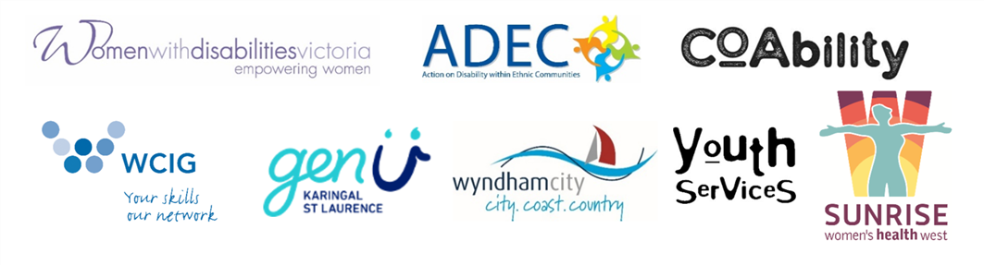
Action on Disability within Ethnic Communities (ADEC), CoAbility, GenU, Westgate Community Initiatives Group (WHIG), Women with Disabilities Victoria (WDV), Women’s Health West (WHW), Wyndham City Council (WCC), and Wyndham City Council Youth Services.

