Women with Disabilities Victoria – Where to find us
MAP
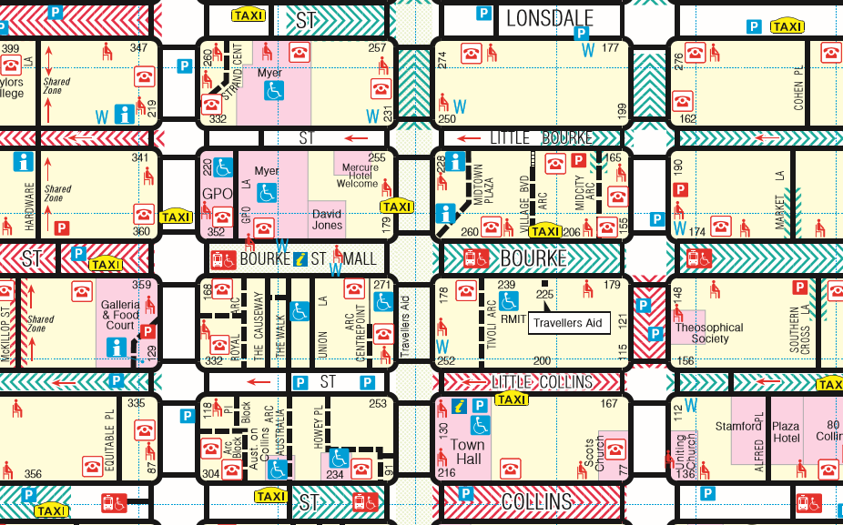
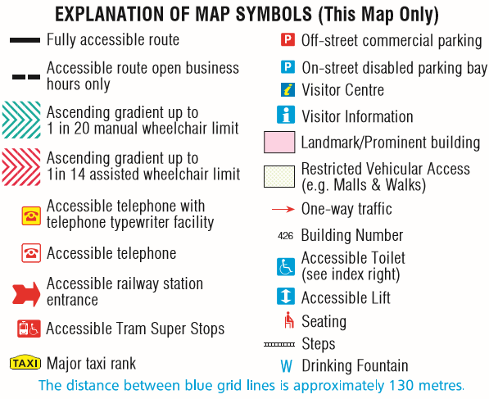
Excerpt of CBD Mobility Map, published by the City of Melbourne
The full map can be viewed at:
http://www.melbourne.vic.gov.au/sitecollectiondocuments/cbd-mobility-map-2011.pdf

CONTACT INFORMATION

Street Address: Level 9, 255 Bourke Street Melbourne 3000

Postal Address: GPO Box 1160, Melbourne, VIC, 3001

Phone: (03) 9286 7800

Office Hours: 10:00am to 4:00pm, Monday – Thursday

Email: wdv@wdv.org.au

Web: www.wdv.org.au

PUBLIC TRANSPORT
Women with Disabilities Victoria is located near the South-East corner of Bourke and Swanston Street, on the Collins and Russel Street sides.
Trains (nearest stations)
Flinders Street Station – Corner of Flinders and Swanston Street (0.5 Km)
Melbourne Central Station – Swanston Street (0.6km)
Parliament Station – Bourke Street (0.7Km) or wheelchair access via Lonsdale Street (0.9km)
Trams
The two nearest tram stops are both accessible by wheelchair (However, not all trams are guaranteed to be low floor trams).
Stop No 6 – Swanston Street / Bourke Street, is situated directly in front of our office building on Bourke Street, (tram routes 86 and 96).
If travelling by tram along Swanston Street, Stop no. 10 - Bourke Street Mall / Swanston St, stops in Swanston Street, just north of Bourke Street, (tram routes 1, 6, 16, 3/3a, 67, 64, and 5)
For all other information concerning public transport travel, including information in other languages, please contact Public Transport Victoria (PTV)
Website: https://www.ptv.vic.gov.au/
Phone: 1800 800 007 or TTY: 03 9619 2727 (6am – midnight daily, and all night Fridays and Saturdays)

INFORMATION FOR PEOPLE WITH VISION IMPAIRMENT
We are located on the south side of Bourke St, to the east of Swanston St. If walking along Bourke Street toward Russel Street, we are on the right hand side. Classical music can usually be heard from the building’s speakers. There is a moderately sized sign for ‘Lifeworks’ above the footpath. Our building is between a small mobile phone accessory shop (Dr Boom Communications) and a telecommunications / phone shop (Optus).
There are two steps and a wheelchair accessible ramp (on the left side of the stairs) which lead to the building entrance. TGSIs are located at the top of each. When coming up the steps, automatic doors to the building are directly in front of you. After walking through the doors, continue straight ahead for about 8 metres to the lifts. There are two lifts with a panel in between them, containing the lift call buttons. The lifts have Braille and raised tactile buttons. If facing the back of the lift, button panels are on the door side to the right, and on the left side towards the back wall. The lifts provide audible announcements.
Proceed to level 9. When exiting the lift, turn right by 90 degrees and walk 2-5 metres (dependent on which lift you exited from), there is a corridor to the right. Walk down the corridor, which is approximately 10 metres in length. At the end of the corridor is a locked glass door. Press the doorbell to the right of the door approximately 1 metre high, or knock on the glass door, and a staff member will attend you.

