Victoria Against Violence – 16 Days of Activism campaign in partnership with Women with Disabilities Victoria invite you to the film screening and panel discussion of
OUR RIGHT TO SAFETY & RESPECT
This event is a celebration of the strength of women with disabilities advocating for their right to safety and respect.

The event includes:
- Film screening of “Our Right to Safety and Respect: A video resource, developed by, and for, women with disabilities about violence, abuse, safety and respect”
- Followed by, panel discussion featuring women from the film as well as key people working in disability and violence prevention and response sectors.
- Showcase of resources developed by WDV to prevent violence and empower women with disabilities

When: Wednesday 28th November 2018 at 1:00pm for a 1:30pm start (event concludes at 4:30pm)
Where: Foy’s Arcade, Level 6, 246 Bourke Street Melbourne
Register: Thursday 22nd November 2018
through EventBrite https://ourrighttosafetyandrespect.eventbrite.com.au
or by phoning 9286 7800

#OurRightToSafetyandRespect #HearMeToo

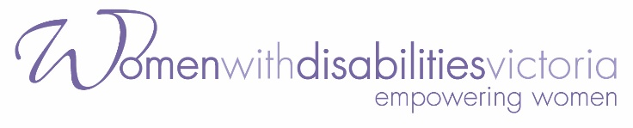
Image description: Women with Disabilities Victoria logo font is purple against a white background. In large font, it says Women with Disabilities Victoria and below it in a smaller font it says empowering women.

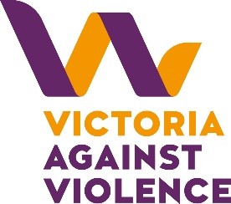
Image description: Victoria Against Violence logo. Two intertwined purple and yellow V's with the word Victoria sitting underneath in yellow followed by the words Against Violence underneath in purple.

