Page 1
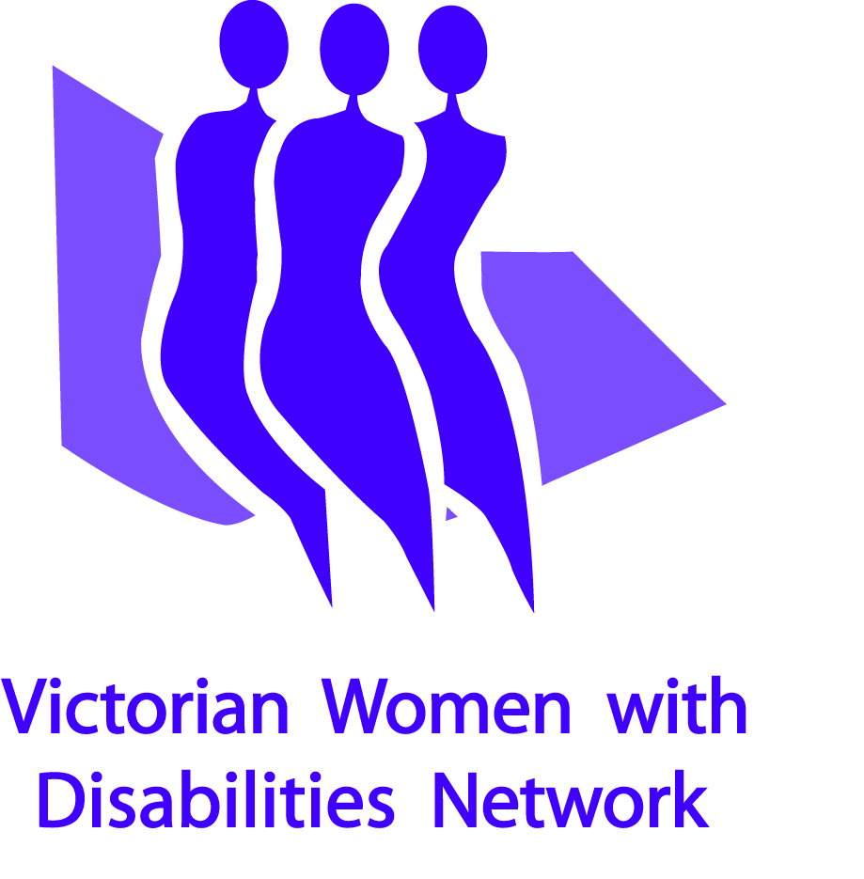
Victorian Women with Disabilities Network
Annual Report 2008 – 2009
Page 2
Our Vision
A world where all women are respected and can fully experience life

Our Mission
Leading the way for Victorian women with disabilities and improving women’s choices by building partnerships and providing support, information and community education.
Our Values
VWDN works within a value base that upholds:
- Equality of opportunity
- Accessibility for all
- Respect for all
- Working together collaboratively
- Effectiveness
- Creativity
- Different opinions and perspectives
- Human Rights
- Social justice
- Valuing diverse abilities

Our Goals for 2009 -2011

- Provide advocacy, information and community education to improve the choices of women with disabilities particularly in relation to our priority issues.
- Continue to develop policies and processes for effective governance and development of the organisation as a whole.

- Further strengthen and resource member’s involvement in advocacy and leadership on behalf of the Network.

- Continue to build collaborative partnerships with other women’s and disability related organisations to advance our goals.

- Secure a financial base that affords sustainability for the organisation’s future growth.
Page 3
The Chairs’ Report (Photos)
Women with disabilities hold the same expectations and aspirations to lead fulfilling and enjoyable lives as everyone else. We face the same challenges but in addition we grapple with the daily obstacles that living with a disability presents.
Victorian Women with Disabilities works to empower women to overcome the social and environmental hurdles that stand in our way. We celebrate the wonderful lives and contribution that women with disabilities make.
In a short space of time the VWDN has achieved recognition as a credible voice for women with disability in Victoria. As a small organisation we can achieve so much more when we collaborate with organisations with common values and purposes. We are very grateful to our inaugural partnership with Women’s Health Victoria which enabled VWDN to grow and establish the VWDN Information and Advocacy Service. Our partnerships with The University of Melbourne, Domestic Violence Victoria (DVVic) and Domestic Violence Resource Centre (DVRC) enable us to contribute to research, evaluation and policy development that relates to women with disability.
VWDN has been able to greatly increase its impact because of the energy and commitment of our Board, members and staff. We would like to acknowledge the excellent contribution of our Board members: Margaret Bayly, Catherine Brooks, Delia Portlock and Margaret Stevenson, our retiring members, Sharon Granek and Effie Meehan. Our heartfelt thanks goes to the contribution of Deb Humphris who resigned in April 2009. We have greatly benefitted from the pro-bono legal advice of our Board legal adviser, Dominique Saunders and to Catherine Brooks, Holding Redlich.
Advocacy and communication are critical to our success and we extend our thanks to all of the members who have represented VWDN’s priority concerns on committees, advisory groups and forums and contributed to our government submissions. The website and newsletter are vital to getting the message out and staying in touch and we are enormously indebted to Margaret Bayly and Margaret Stevens for being our volunteer editors.
Finally we would like to express our appreciation to Keran Howe, Executive Officer, for her outstanding leadership, vision and guidance and the staff of the VWDN Advocacy Information Service for their committed and professional work on behalf of women with disabilities.

Wendy Brooks Tricia Malowney
Co Chair (Governance) Co Chair (Representation)

The Executive Officer’s Report

In 2008 – 2009 Victorian Women with Disabilities Network (VWDN) built on our previous year’s achievements in governance and organisational development as well as continuing our work advocating on behalf of women with disabilities. The improvements we have undertaken have strengthened the Network and increased our capacity to influence others to ensure women with disabilities feature in government policy development and planning.
This year we oversaw an evaluation of the VWDN Advocacy Information Service and utilised the learnings of this evaluation to look at how we move forward. In November 2008 the VWDN Board and VWDN AIS staff undertook Strategic Planning for the next two years in light of the planned transfer of fund holding from Women’s Health Victoria to VWDN by July 1st 2009. The Strategic Plan seeks to balance our advocacy and community education work with the continued development of the organisation and our engagement with our members. We continue to focus on our three priority areas: violence against women with disabilities, access to health services and recognition of the rights of women with disabilities as parents. The year held many highlights, summarised on page 5.
In the coming year we plan to undertake two new projects: firstly, to document the history of VWDN and secondly, a member mentoring and skills support project to build on our current work in representing issues for women with disabilities, as well as to increase women with disabilities’ opportunities to find work.
I would like to acknowledge all of our funders and our donors for their generous support: Disability Services Division and the Office of Housing at Department of Human Services; the Victorian Women’s Trust; Portland House; and Department of Families, Housing, Community Services and Indigenous Affairs (FaHCSIA). We are grateful to both the University of Melbourne and Domestic Violence Resource Centre for their generous contribution to the Building the Evidence research and to Victorian Health Promotion Foundation for their sponsorship of the Launch of the Report and the Online Resource Collection.
Thank you to all who have volunteered their time: Dominique Saunders and Amy Moore for their legal expertise; Amanda D’monte and Rod Brook, for their assistance with the VWDN website. Consultants this year contributed significantly to our capacity: Lucy Healey provided insightful research for the Building the Evidence Project, Justine Dalla Riva and Margaret Krajnc provided excellent graphic designs, Alison Amos and the ECHO team undertook our evaluation and Strategic Planning and Nicole Maruff wrote our Policies. Finally, my thanks to our staff, Melanie Thomson, Kate Hood and Sarah Boyd, for all of their fabulous work.
Keran Howe

Executive Officer
Our Board
Chairs
Wendy Brooks (Co Chair, Governance)
Tricia Malowney (Co-Chair, Representation)
Treasurers
Margaret Stevenson (Sept 2007 to June 2009)
Simone Rutherford (from June 2009)
Directors
Margaret Bayly Sharon Granek
Effie Meehan Delia Portlock
Catherine Brooks (Co-opted Feb 2009) Deb Humphris (Resigned April 2009)
Board Advisor: Dominique Saunders (legal)

Our staff

Keran Howe, Executive Officer

Melanie Thomson, Information and Administration Officer (until April 2009)

Sarah Boyd, Information and Administration Officer (from April 2009)

Kate Hood, Policy Officer, Violence Against Women with Disabilities (from Nov 08)

The Years Highlights (with photos)

Building the Evidence: a Report on the policy and practice responding to violence against women with disabilities in Victoria was launched at the 5th International Conference n Mental Health and Mental Behaviour Disorders in Melbourne.

In September 2008 The Family Violence Protection Act passed through Parliament. After substantial work by VWDN, carer violence against women with disabilities was given some recognition in the Act.

VWDN hosted a members’ forum where US disability advocate, Amber Smock, presented on the work of FRIDA, a women’s disability activism group and Fe Fe, a young women’s empowerment group in Chicago, USA.

Kate Hood was welcomed to the team as the first Policy Officer, Violence Against Women With Disabilities.

Tricia Malowney attended the Fulbright Symposium on health policy with international guest, Sir Michael Marmot, renowned for his work on the Social Determinants of Health and spoke about health issues for women with disabilities.

At the VWDN Annual General Meeting the new VWDN website was launched by Leah Hobson, Blind Citizens Australia, who spoke of the importance of accessible information for women with vision impairment.

The VWDN Board endorsed the first VWDN Strategic Plan 2009-2011 and the first completed set of VWDN operational policies and procedures to guide the work of the organisation.

By 30th of June VWDN had established policies and systems to manage all financial and employment issues. On July 1st 2009, VWDN assumed responsibility for funding and staff of the Advocacy Information Services after a 6 year partnership with Women’s Health Victoria working to achieve this goal.

A Snapshot of Our Activities

Representation

Representation of the issues concerning women with disabilities at committees, forums, government advisory groups and through meeting with key service providers is at the core of the approach taken by VWDN. Here are some examples of representation in 2008-2009:

Representation on Health Issues
The Executive Officer attended a meeting with the University of Melbourne Faculty of Medicine, Dentistry and Health Sciences to discuss ways to involve women with disabilities in health research. The outcome of this was to work with the Director of the Key Centre for Women’s Health, Anne Kavanagh, to seek funding for research into the social and economic status of women with disabilities. This resulted in a meeting with the Chief Executive Officer of Vichealth, Todd Harper, to discuss ways funding might be achieved.

Representation on Parenting Issues
VWDN AIS gave a presentation at a Yooralla Society of Victoria forum on support for women with disabilities as parents. A key issue raised was the importance of parents being able to utilize their funded individual support to assist them in the care of their children. The Executive Officer raised this issue at a later meeting with the Minister for Community Services and the Executive Director, Disability Services Division and gained their assurance that the policy on individual support should allow for personal care to be available for the recipients in caring for their children.

Representation on violence against women with disabilities
VWDN sees clearly that while women with disabilities live in diverse domestic settings, this domestic diversity was not addressed in the family violence act. VWDN submitted to the review of the Family Violence Protection Act, attended community consultations and raised the matter with many relevant reference groups, senior government officers and Ministers. The Family Violence Protection Act introduced in September 2008 did take account of violence perpetrated by carers where the nature of the relationship is perceived as ‘family like’. We were pleased to see too that a further ‘review of the non-family violence intervention order system’ contained terms of reference which called for consideration of protection of persons vulnerable to non-family violence such as persons with disabilities.

Representation of gender in disability services
Margaret Stevens represented VWDN on the DHS Disability Services Industry Workforce Group and its Consumer Advisory Group and drew attention to specific issues concerning women with disabilities.

Conference Attendance Presentations and Submissions
Part of our representation involves ensuring a presence and active participation of our members and staff at relevant conferences and through written submissions.

Margaret Bayly and Margaret Stevens represented VWDN at the Premier Women’s Summit and highlighted some of the major areas of interest to women with disabilities in relation to government policy.

Tricia Malowney attended the National Quality and Safety Council Conference in Adelaide and presented on behalf of women with disabilities.

Keran Howe presented a paper, The Politics of Denial: discrimination against people with disabilities, at the 5th International Mental Health Conference.
Submissions were made to the Non-Family Violence Intervention Order System Review and VWDN contributed to Domestic Violence Victoria’s submission to the Federal Government’s Green Paper On Homelessness: Which Way Home?

Developing our knowledge base

Building the evidence
In 2007 the VWDN AIS received funding from Reichstein Foundation and an anonymous donor to provide evidence as to what is needed to better support women with disabilities who experience violence in Victoria. A partnership was developed with Professor Cathy Humphreys, Alfred Felton Chair of Child and Family Welfare, University of Melbourne and Chris Jennings at Domestic Violence Resource Centre. A research team was co-ordinated by Dr Lucy Healey.

The research analysed the extent to which current Victorian family violence policy and practice recognises and provides for women with disabilities who experience violence. The report found that: Family violence sector standards and codes and guidelines say little about how to support women with disabilities; most services do not routinely collect data on disability and family violence; most family violence workers consulted had minimal or no training in supporting women with disabilities; little is known about the help-seeking experiences of women with disabilities experiencing violence; and a sustained collaboration is needed between disability and family violence services to redress the significant service gaps.

Following the launch of the Report, Lucy Healey and Keran Howe met with representatives of the Department of Planning and the Community Development to discuss how the findings might be integrated with the Victorian Family Violence Reform Strategy. The Report was distributed to key Victorian and Federal ministers and presented to all key government departments and organisations: Department of Justice, Department of Human Services (Disability Services Division), the Interdepartmental Committee on Violence Against Women, the Family Violence Statewide Advisory Committee, the Local Government Disability Planners Network and Domestic Violence Victoria. A positive response was received with follow up meetings to discuss the report’s recommendations. At the Federal level, the Sex Discrimination Commissioner, Elizabeth Broderick and Graeme Innes, the Human Rights Commissioner and was submitted to the Consultation on the National Action Plan to Reduce Violence Against Women And Children.

Developing and Distributing Information

The VWDN AIS Online Resource Collection collects and distributes information about violence, health and parenting especially with regard to women with disabilities. There is no other searchable Clearinghouse of information resources addressing these issues in Victoria, or Australia. The Clearinghouse contains information resources in a variety of forms, many of which are available online. In 2008 the number of information resources in the VWDN Clearinghouse increased from 388 (July 2008) to 497 (June 2009), with over half available online. A promotional bookmark was produced and widely promoted.

VWDN Website
At the 2008 Annual General Meeting, VWDN launched its independent website.
The web pages were designed to maximise accessibility for all women with disabilities and have achieved w3c, the highest level of website accessibility. The website can be found at www.vwdn.org.au.

Resource development and Promotions
VWDN contributed to the development of a training DVD on assessing risk to women experiencing violence. VWDN provided advice on the content of the video regarding ways of supporting women with disabilities experiencing violence and identified women to be interviewed for the DVD. The DVD was made by DVRC, Swinburne University and No To Violence, and included a component on violence against women with disabilities.

Getting published
The Building the Evidence Report was featured in the Summer Edition, Newsletter 35, of the Australian Domestic and Family Violence Clearinghouse. It was summarised over two pages and its recommendations discussed. The report was also featured in the Domestic Violence Resource Centre Newsletter.

Keeping our members informed
The VWDN newsletter was first instigated in the early 1990s and has been keeping members informed for more than a decade. The newsletter goes out to most members electronically and is mailed to some members in both large print and 12 point font. A new format for the newsletter was developed and trialled in 2008 and moved to a bi-monthly distribution. A themed approach to each edition has also been instigated this year. Members responded very positively to the changes to the newsletter:

“As a member of VWDN, I look forward to receiving this fantastic newsletter.It is SO readable - it is in a great format but in relation to print size and layout of paragraphs - fantastic.

For me it is like a link to the real world as I have mobility issues which currently make accessing "the world" difficult and am also the full time carer for my husband who is disabled and chronically ill. To be treated as an intelligent human being and kept up to date with real issues of concern is a godsend - and to be able to find so much information about such a wide variety of topics all in the one newsletter is brilliant.

Hearing of the invaluable research that is happening and is proposed gives me great hope for the future, and in my darker moments reassures me that the world does care.Reading about the wonderfully talented members of VWDN inspires me to cling on to the belief that one day I too will be out there ensuring that the world is a place where all women are treated with respect.

Thank you all so much and CONGRATULATIONS on a job well done.
Norma”

Hello!
I just wanted to say congratulations on the new-look newsletter. It’s very swish! And, importantly, it contains a wealth of interesting information providing opportunities for people to access information and, importantly, to PARTICIPATE on a wide range of levels.
Well done! Sarah

In addition to the newsletter a fortnightly e-bulletin is distributed electronically and provides regular updates on news, events and the latest publications relevant to our areas of interest: health, preventing violence, parenting support, human rights, leadership and gender

Growing and strengthening our organisation
Strategic planning and Evaluation
The Phase 2 evaluation report was completed following interviews with external stakeholders, VWDN AIS partners and staff.
The report noted “the capacity of VWDN AIS has been strengthened through…
- Organisational development activities – improved governance, tax exemption charitable organisation status and Equal Opportunity Exemption
- Launch of the VWDN AIS Clearinghouse and website
- Securing recurrent funding for a family violence project officer and one-off funding for a range of other project initiatives
- Further developing a solid reputation for effective engagement and advocacy”.

The report presented a very positive view of the work of the Advocacy and Information Service over the last year and emphasised the importance of continuing to engage with members in the issues as well as ensuring the work does not become overwhelming. One external interviewee commented of VWDN

“They are breathtakingly effective. They see the opportunities and make the most of them…they’re effective at bringing people along.”

The report provided a basis for the strategic planning workshops held to develop a 2 year Strategic Plan. Initially the VWDN Board and staff of VWDN AIS met to discuss key issues in progressing VWDN. Twelve representatives of partner organisations and government departments were then invited to a strategic planning workshop with the Board and staff to further develop the strategies. Along with Women’s Health Victoria, the partners included University of Melbourne School of Social Work, Domestic Violence Victoria, Domestic Violence Resource Centre, Key Centre for Women’s Health, Women’s Health in the North, Women’s Health in the South East, as well as the Office of Housing and Disability Services Division.

Policy development
With the assumption of responsibility for funding and employment of staff the importance of clear policies and procedures for the organisation was prioritised as part of the Strategic Plan. With funding from Disability Services Division the Policies developed drew on the policies of established organisations, in particular Women’s Health Victoria. By 30th of June VWDN had established policies and systems in place to manage all financial and employment issues independent of WHV.

Funding
In addition to two recurrent grants from Department of Human Services the following funds were received in 2008-2009:
Portland House provided funding of $30,000 to develop the membership and volunteer support proposed within the draft Strategic Plan. It was agreed this grant will not be expended until 2009-2010.

Victorian Women’s Trust approved a $20,000 toward a project documenting and publishing the history of the VWDN. This project was also deferred until 2009-2010.

A grant of $4,790 from DHS was provided to assist with development of operational policies and procedures.

VWDN received a grant of $2,500 from FACHSIA for petrol expenses for volunteers.

Financial Report for the year end 30 June 2009
Income

Cheque Account
Opening Balance $ 3 990.37
Subscriptions $ 260.00
Donations $ 20.00
Book Sales $ -
DHS Grant $ 2 500.00
Philanthropic Grant $ 30 000.00
DHS Policies Grant $ 4 788.00
DHS Project Grant $ 9 926.42
$ 47 494.42

Term Deposit
Investment $ 34 000.00
Interest (3 months) $ 397.94
$ 34 397.94

Petty Cash
Balance $ 44.40

Total Income $ 81 936.76

Expenditure

Cheque Account
Transfer to Cash Management Account $ 2 000.00
ISBN (Publishing) Fee $ 86.50
Board Expense $ 43.00
Transfer to Term Deposit $ 34 000.00
Operational Policies - Consultant $ 2 000.00
Accountant Fees $ 544.50
Bank Fees and Charges $ 65.15

Total Expenditure $ 38 739.15

Cheque Account (balance) $ 12 745.64
Term Deposit $ 34 397.94
Petty Cash $ 44.40

Balance As at 30 June 2009 $ 47 187.98

Notes
The Financial Report 2007-2008: VWDN Profit and Loss details printed in the VWDN Annual Report 2007-2008 contained a typing error. The Cheque Account was incorrectly listed as having a balance of $1,760.20 as at 30 June 2008. This figure should have been $3990.37. Accordingly, the combined Current Balance of the Cheque Account, Cash Management Account and Petty Cash was $10,857.82 as at 30 June 2008, not $8,627.65 as listed.

“Women with Disabilities Working
for Women with Disabilities”

Become a VWDN Member contact us at VWDN

Victorian Women with
Disabilities Network
1st Floor, 123 Lonsdale Street
Melbourne Victoria 3000
GPO Box 1160
Melbourne Victoria 3001
Phone: (03) 9662 3755
Fax: (03) 9663 7955
Email: vwdn@vwdn.org.au
Web: www.vwdn.org.au

Please note - This report is available in alternative formats

