ENABLING WOMEN LEADERSHIP PROGRAM
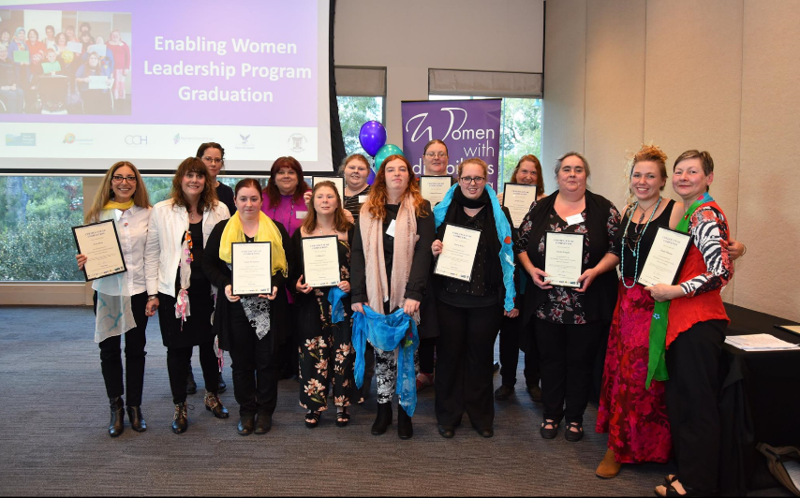
- Do you identify as a woman with disability?
- Would you like to know more about your rights, and speaking up?
- Do you want to take the next step in your leadership journey?
- Do you live, work, study or play in Wyndham?
If yes, this FREE Program is for you!!
Enabling Women focuses on confidence, speaking up, working with a mentor, creating connections, understanding the NDIS, leadership, and fun.
Where: Plaza Library, Pacific Werribee Shopping Centre, Derrimut Rd, Werribee
When: Every Thursday for 6 weeks, Feb 21st - March 28th 2019. 10am - 3pm.
Information Sessions - Registration required
When: Mon 21st Jan, 1:30pm-3pm  Where: Iramoo Community Centre,  84 Honour Avenue, Wyndham Vale | When: Fri 25th Jan, 1:30pm-3pm  Where: Plaza Library, Pacific Werribee Shopping Centre, Derrimut Road, Werribee
For assistance or further information, please contact Bridget Jolley on
03 9286 7813, or at bridget.jolley@wdv.org.au
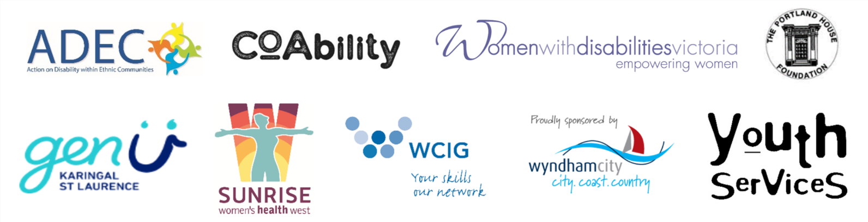
Applications close: 5pm, Tuesday 29th January 2019

