ENABLING WOMEN MENTORING PROGRAM
Wyndham 2019

MENTOR APPLICATION FORM

Want to know more about the Program, or need assistance in completing this form? Please contact Helen Guest – 0432 167 041 / helen.g@outlook.com.au

Name:

Address:

Phone:

Mobile:

Email address:

- What is your interest in mentoring a woman with disability? (Disabilities may be physical, sensory, psycho-social, autism spectrum conditions, intellectual, cognitive, etc)

- Please share your experience of being a mentor and/or mentee. Please share what you believe your role will be as a mentor.

- Please circle or underline the age group/s you would prefer to work with
18 – 25

25 – 35

35 – 55

55+

- Please circle or underline the days and times you are mostly available
- Monday - Morning Afternoon Evening
- Tuesday - Morning Afternoon Evening
- Wednesday - Morning Afternoon Evening
- Thursday - Morning Afternoon Evening
- Friday - Morning Afternoon Evening
- Saturday - Morning Afternoon Evening
- Sunday - Morning Afternoon Evening

- To be a mentor with this program, you are required to have a police check. We will support you to complete this check, with WDV to cover the costs of the Police Check.

Do you have any concerns about getting a Police Check?

- Please circle or underline the way/s you prefer to be contacted
Phone

Phone (text only)

Email

For more information please contact:
Helen Guest – 0432 167 041 helen.g@outlook.com.au
Or, Bridget Jolley – 03 9286 7813 / Bridget.Jolley@wdv.org.au

Applications can be emailed to helen.g@outlook.com.au, or posted to:
Helen Guest, C/O Bridget Jolley
Women with Disabilities Victoria
GPO Box 1160, Melbourne, 3001

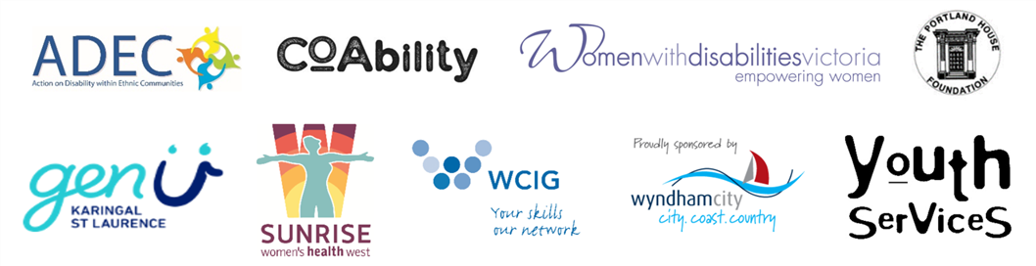
The Enabling Women Leadership Program is supported by:

