Mentoring Opportunity
Expressions of Interest are now open to be a mentor with the 2019 Enabling Women Mentoring Program - Wyndham

Women with Disabilities Victoria (WDV) are offering an exciting opportunity for women from or close to the Wyndham area, to mentor local women with disabilities for six individual sessions from February to May 2019.

The Enabling Women Mentoring Program runs alongside the Enabling Women Leadership Program – a free six week leadership program for women with disabilities.

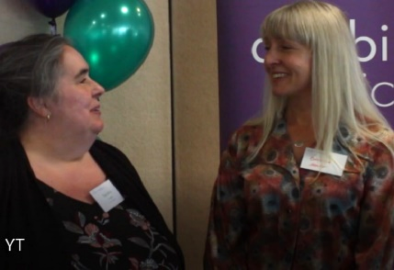
- Improve your skills in listening and providing support
- Widen your professional and personal networks
- Increase your knowledge, and understanding of barriers experienced by women with disabilities
- Achieve satisfaction from giving back to your community, and receive a certificate of appreciation
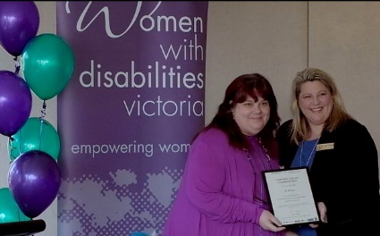

Come to the Information Session to find out more:
Where: Youth Resource Centre, 86 Derrimut Rd,
Hoppers Crossing
When: Monday 11th Feb, 12:00 – 1:30pm
RSVP: With access/dietary requirements by Mon 11th Feb
(A light snack will be provided)

To contact us for further information, or to RSVP:
Helen Guest – WDV Mentor Co-ordinator: helen.g@outlook.com.au / 0432 167 041
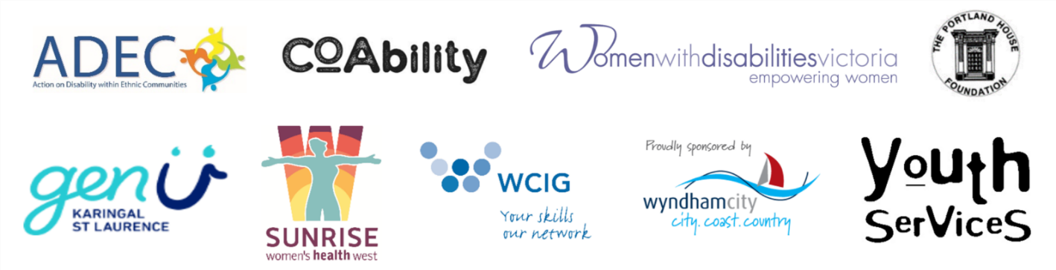
Bridget Jolley – Program Lead facilitator: bridget.jolley@wdv.org.au / 03 9286 7813

