VWDN Annual report 2006 as reprinted in December newsletter

From the Convenor:

This month’s newsletter contains the information provided at the Annual General Meeting held on 22 November 2006. Thank you to all those who attended.
The new Collective are
Margaret Bayly Khadiga Hamed
Deb Humphries Val Johnstone
Tricia Malowney Jody Saxton
Norma Seip Margaret Stevens
Sarah Waters
All office bearer positions fall vacant in December when the Collective votes for the Convenor and Treasurer positions.
The Collective and other VWDN members have been extremely supportive and have contributed strongly to the development of both VWDN and the VWDN AIS.
Here are our achievements:
- Our new logo is well developed and recognisable
- We have new brochures and business cards
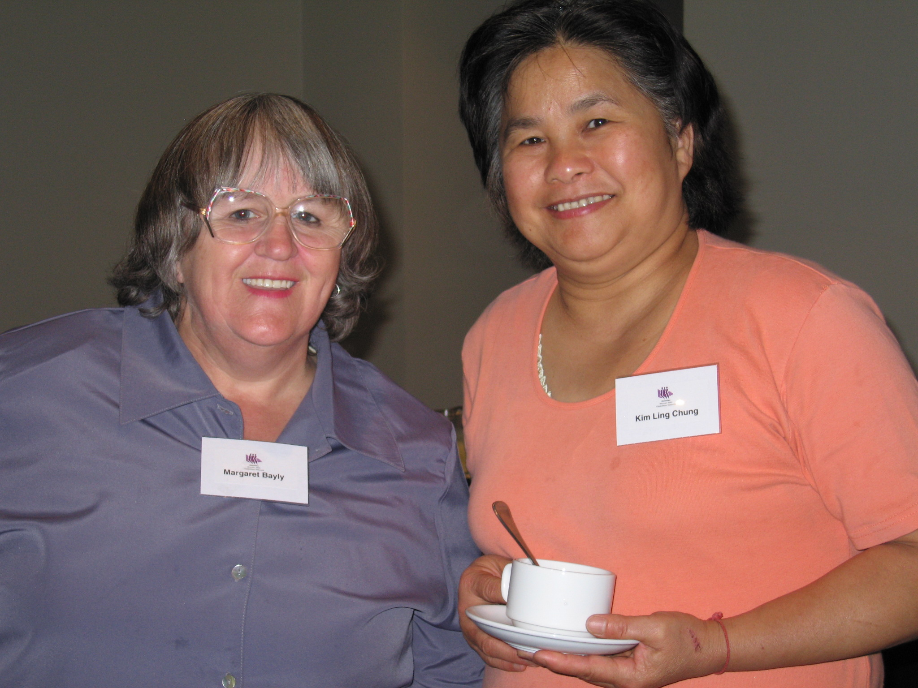
- Our newsletter is now a major method we use to keep members connected to the Network. We use it as a way of letting members and others know what we are doing, such as how we do systemic advocacy, who we are meeting with, who we are influencing, and the results of the advocacy. We also use it to let members know of events of interest, such as conferences and forums which they may wish to attend. We now send out 150+ copies – this includes email and hard copy versions as required.
- We send opportunities to members to apply for positions on mainstream boards and committees. This enables individuals to bring a gender and disability filter to mainstream work. We also send opportunities for other events at which the voices of women with disabilities should be heard. The development of our member data base will enable us to match representation opportunities to members of VWDN.
Here are the key elements which have helped us to continue to be a viable and dynamic organisation:
- Our general membership - the Victorian Women with Disabilities Network has a robust membership which includes women from across Victoria, with a range of abilities and capacities, all working towards a common aim, women with disabilities working for women with disabilities.
- We have individual and corporate associate members, who share our ideals and who support us in reaching our goals.
- Our Collective members have guided the work we do – ensuring a collaborative approach, helping us to target which pieces of work we prioritise.
- Our key partnership with Women's Health Victoria has assisted our ability to undertake systemic advocacy and manage the Advocacy Information Service.
In September 2005 we received an exemption from the Equal Opportunity Act to advertise and employ women with disabilities to undertake the work of VWDN.
    - We have participated in training – both as presenters and trainees
    - We have made a number of presentations to highlight the issues of concern to women with disabilities.
    - We have also participated in a number of working parties to ensure the inclusion of women with disabilities.
  - We have supported the funding of projects which will assist women with disabilities. These have included:
    - The Sexual Offences Project
    - Chris Jennings work at DVIRC
  - VWDN has contributed to, supported and authorised the use of the VWDN logo to endorse:
    - The 10 Point Plan for Women's Health
    - The Domestic Violence Code of Practice
  - We have presented papers to:
    - The Statewide Steering Committee to Reduce Family Violence.
    - Best Practice in Disability Conference held at the University of New England in New South Wales.
  - We have attended a number of consultation sessions and Forums to make sure our issues are considered. These included:
    - Department of Justice Victim’s Charter
    - Department of Justice Children’s Bill
    - Just Say No Campaign
    - Melbourne City Council Family Violence Report
    - Commonwealth Games access forum
    - Office of Women’s Policy Financial literacy forum
    - Bureau of Statistics Census development forum
    - Metropolitan Fire Brigade emergency procedures forum
    - DVIRC women with disabilities and violence forum
  - We provided a visible presence at a number of mainstream policy launches to ensure that our voices are heard. These have included:
    - Legal Reform Commission Family Violence Report
    - DHS Active Participation Launch

We have networked with key players in Government and non Government organisations and have them in our mailing lists so there are clear pathways for the exchange of information.

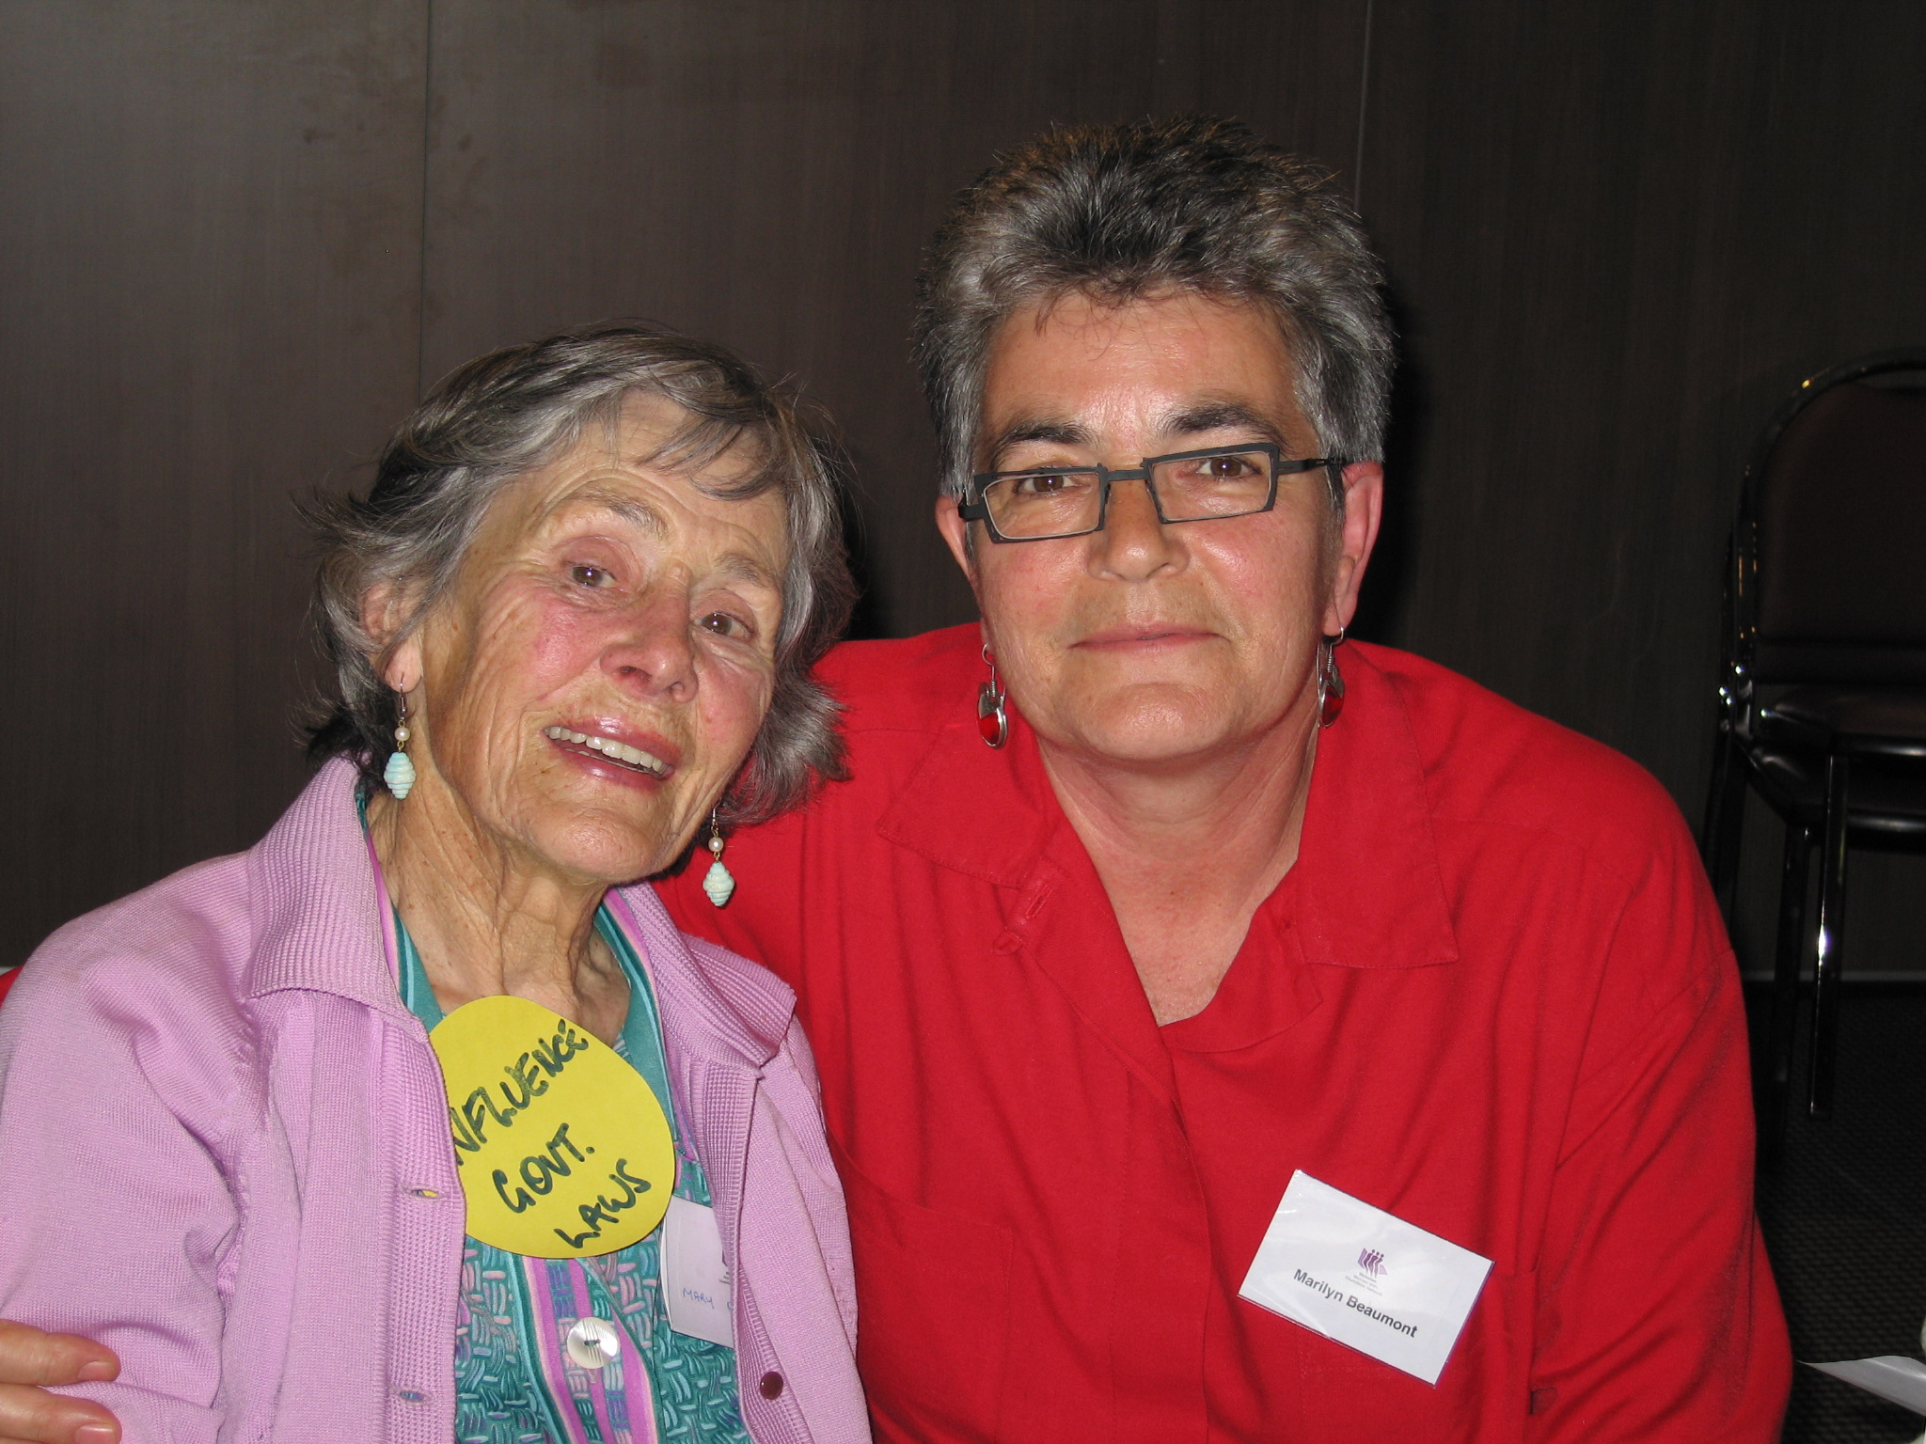
Thanks for your support Tricia Malowne

