NDIS and women with disabilities forum
- Are you a woman with disability living in Moreland, Hume or nearby?
- Would you like to hear from other women sharing their experiences of the NDIS?
- Do you have questions about your plan that you would like answers for?
- Are services that understand the needs of women with disabilities important to you?
Time 10:00AM – 2:00PM
Day Wednesday 29th May
Location Concert Hall East - Moreland City Council
90 Bell Street, Coburg
Lunch Provided
This is an event for women with disabilities only
Register for this event by C.O.B Thurs 23rd May using the EventBrite link on the WDV website:
https://www.wdv.org.au/InnerNorthForum
If you would like to discuss access or dietary requirements, need more information or assistance to register, please contact Jane Oldfield at
jane.oldfield@wdv.org.au or on 9286 7800
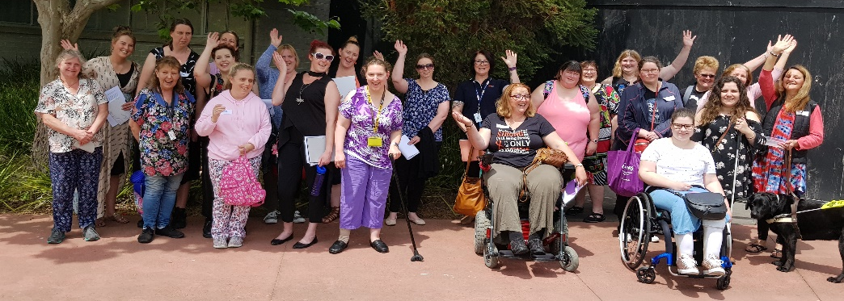
If needing an interpreter please register as soon as possible

