Mentoring Opportunity
Expressions of Interest are now open to be a mentor with the
2019 Enabling Women Mentoring Program - Bendigo

Women with Disabilities Victoria (WDV) are offering an exciting opportunity for women from or nearby to Bendigo, to mentor local women with disabilities as part of the Enabling Women Mentor Program, running from October to December 2019.

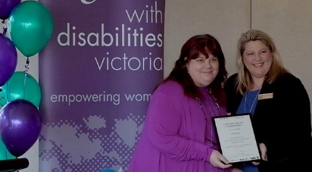
The Enabling Women Mentor Program runs alongside the Enabling Women Leadership Program – a free six week leadership program for women with disabilities.
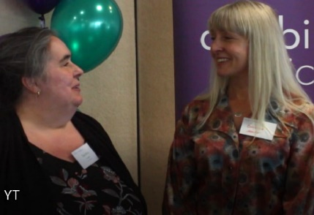
Why be a Mentor?
- Improve your skills in listening and providing support
- Widen your professional and personal networks
- Increase your knowledge, and understanding of barriers experienced by women with disabilities
- Achieve satisfaction from giving back to your community, and receive a certificate of appreciation
Come to the info Session to find out more!
When: Thurs 19th Sep, 1:15 – 2:15pm
Where: YO Bendigo – The Green Room, 45 Mundy Street, Bendigo
RSVP: With access / dietary requirements by C.O.B Tues 17th Sep
(A light snack will be provided)

To apply as a mentor, RSVP to the info Session, or for further information:
Please contact Juanita Miller – WDV Mentor Co-ordinator, via email or phone: EW.Mentor.Coordinator@gmail.com / 0438 605 361

Applications close: COB Monday 30th September, 2019
