Women with
Disabilities Australia

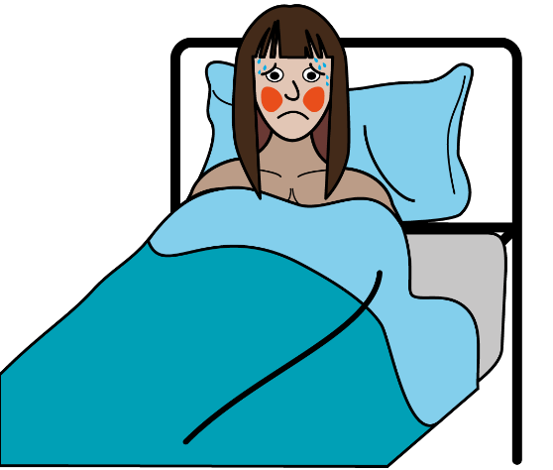

About Coronavirus.
Also called COVID – 19.

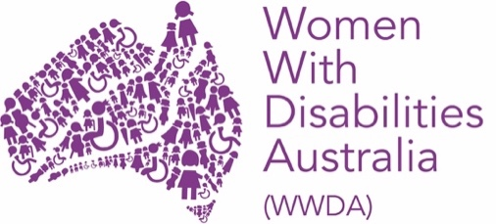

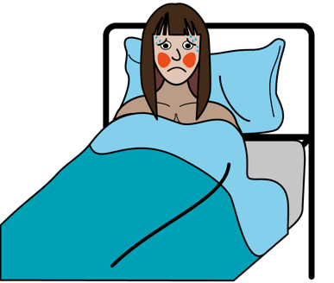
This book is about coronavirus.

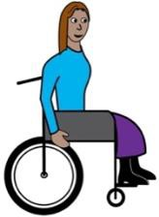

We wrote this book for women and girls with disability.

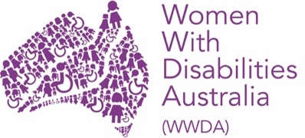
We are Women With Disabilities Australia.

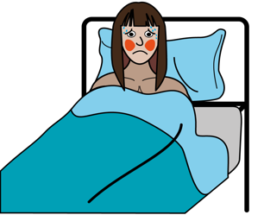
What is coronavirus?

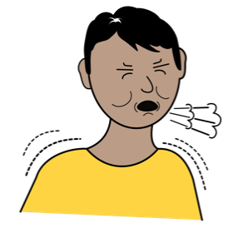
Coronavirus is like a bad flu or cold.

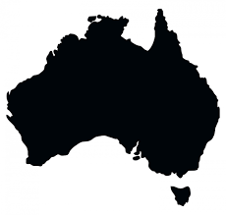

It is a new virus in Australia.

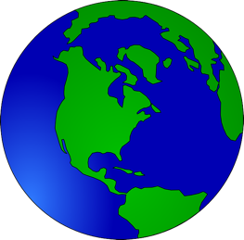
The coronavirus has been called a pandemic.
A pandemic is a new virus that has spread across different countries.

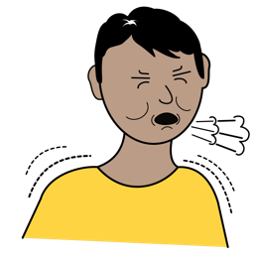
How do I get coronavirus?
You can get coronavirus through contact with another person that has coronavirus.

Like when someone with the virus

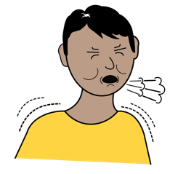
- coughs or sneezes around you

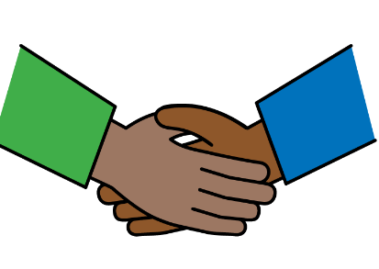
- shakes your hand
- touches something that you touch

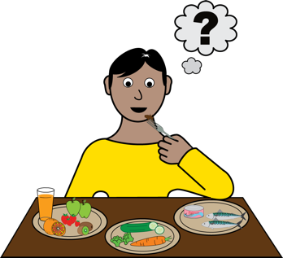

- shares drink or food with you.

How can I stay healthy?
There are things you can do to protect yourself and others from getting coronavirus.

You can
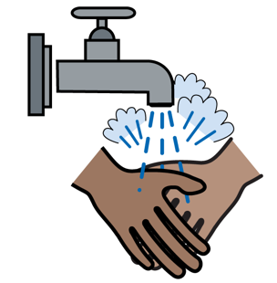
- wash your hands with soap and warm water
- try not to touch your face

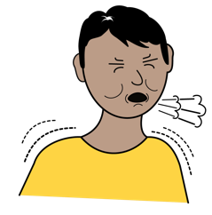
- stay away from people who are sick
- avoid places with lots of people

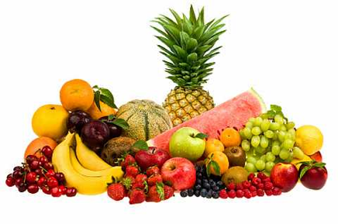
- eat fruit and vegetables
- get enough sleep.

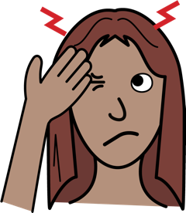
How do I know if I have
coronavirus?
If you have coronavirus you might

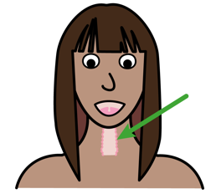
- have a cough
- have a sore throat

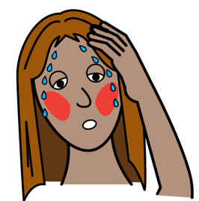
- feel very hot
- have a headache

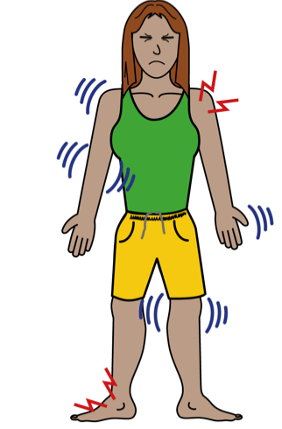
- have body pains
- feel tired.

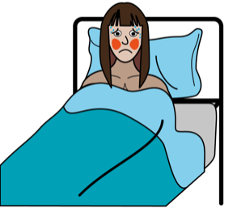
What do I do if I get sick?
If you feel unwell or have symptoms of coronavirus you should

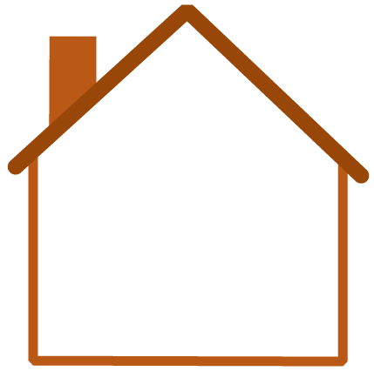
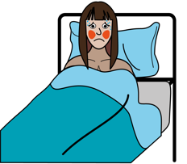
- stay home if you can
- try not to see other people

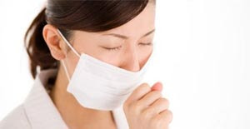
This Photo by Unknown Author is licensed under CC BY-NC-ND
- cover your mouth when you cough
- wear a mask when around other people.

- call your doctor and book an appointment
- tell them you might have coronavirus
- they can do a test to see if you have the virus.

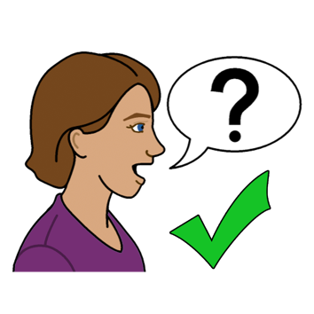
Where to get help
To get help or more information about corona virus you can contact

Coronavirus Health Information Line
call ………….. 1800 020 080
any time of day or night.

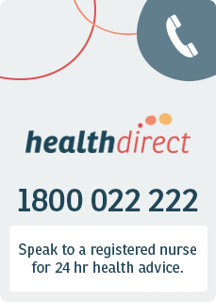
Health Direct
call ………….. 1800 022 222
any time of day or night.
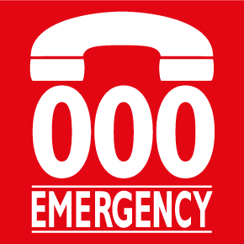
Ambulance
If you are very sick or cannot breathe
call ………….. 000

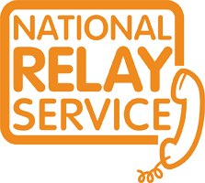
National Relay service
If you are deaf or have a speech impairment
call ………….. 1800 555 677
TTY …………. 133 677

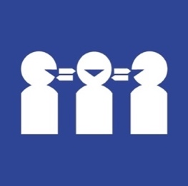
Translation and Interpreting Service
If you need a translator
call ………….. 131 450

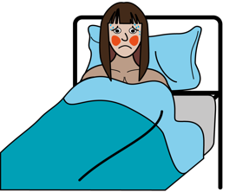
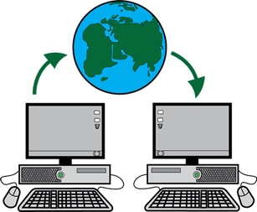
More information
You can get more information and updates on the coronavirus from

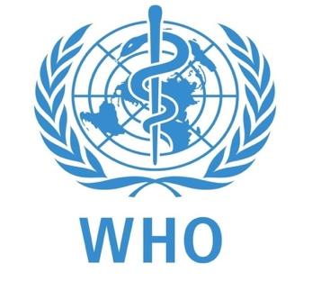
World Health Organisation
- www.who.int/emergencies/diseases/novel-coronavirus-2019

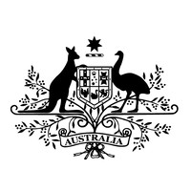
Australian Government
- www.health.gov.au/news/health-alerts/novel-coronavirus-2019-ncov-health-alert

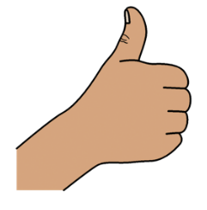
Thank you
Who wrote this book?
Women with Disabilities Australia wrote this book in 2020.
This book is for general education and information only.

Copyright
© Copyright
Women with Disabilities Australia (WWDA) Inc. 2020.

All intellectual property rights, including copyright and patents, in this book is owned and licensed by Women with Disabilities Australia Inc.

The images used in this fact sheet
Easy on the I Images © 2019 Leeds and York Partnership NHS Foundation Trust. Used with permission. www.easyonthei.nhs.uk
The Picture Communication Symbols © 2019 by Mayer Johnson LLC a Tobii Dynavox company. Used with permission. www.tobiidynavox.com

