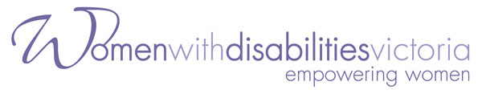
Local Leadership Hub Coordinator
Part-time (0.8 FTE)

Would you like to join a dynamic and fast-growing organisation and enjoy a variety of duties supporting a diverse range of programs?
Do you have a passion for feminist principles and the rights of women with disabilities?
Are you looking to utilise your excellent all-round administrative and organisational skills within a small friendly team?
Women with Disabilities Victoria is a vibrant organisation of women with disabilities working for women with disabilities in Victoria.
We are seeking an enthusiastic Local Leadership Hub Coordinator to join our friendly team. The Local Leadership Hub Coordinator is a position within the Community Inclusion & Women’s Empowerment team.
Salary range is between $70,386 - $ 75,349 per annum pro-rata plus 9.5% superannuation depending on experience. Salary packaging is available.
Hours are 60.80 hours per fortnight (0.8 FTE) to be worked over Monday to Thursday.
The position is from March 2020 or from date of appointment, until February 2023 and is subject to a three-month probationary period. A police check will be required to undertake the duties in this position.

We particularly encourage applications from women with disabilities.

Please note: only applications which address the Key Selection

Criteria will be considered.
Initial enquiries can be made by phoning Vikki Cummings on 9286 7800.
Please refer to the Position Description for further details. The Position Description can be downloaded from: http://www.wdv.org.au/get-involved/current-vacancies/

Applications close at COB on Monday 13 April 2020
Applications marked ‘Confidential’ are to be email to recruitment@wdv.org.au
or posted to: Vikki Cummings, Women with Disabilities Victoria, GPO Box 1160, Melbourne VIC 3001.

