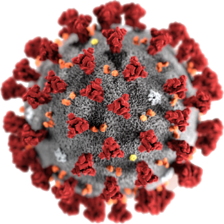

COVID - 19

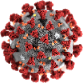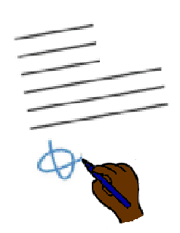

**New rules.**

**No groups**

30 March 2020

**Rules to use all the time**

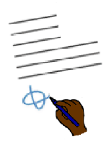

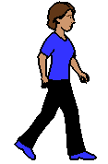

Keep space between us

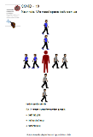Read the posters

**We need space between us**

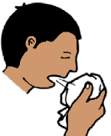

Sneeze into a tissue.

Put the dirty tissue in the bin.

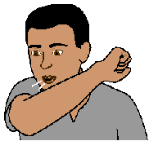Cough into your elbow.

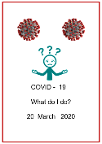Read the fact sheet

**Look after your self**

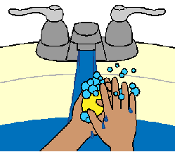

Wash your hands.

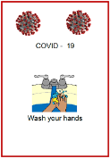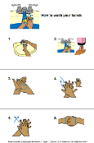Read the fact sheet **How to wash your hands**

Put up a poster where you wash your hands.

**New rules in Australia.**

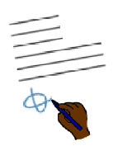

March 2020

**After 30 March 2020**

There are **more** new rules in Australia.

It is to slow down COVID - 19.

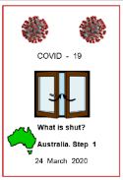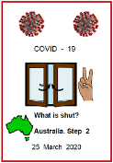These rules are as well as the rules in

* What is shut? Step 1. Australia
* What is shut? Step 2. Australia
* 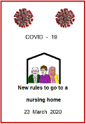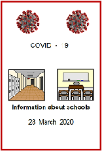Information for schools
* Nursing home rules.

**You must stay at home**

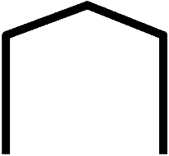Only the people who live in your house

****come in your house. Like

* your family



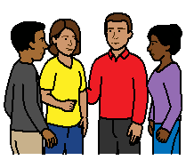

* housemates.

Do **not** do things with other people at home. Like

* 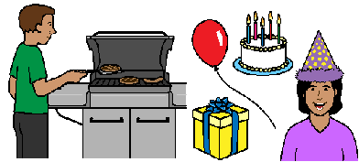do **not** have a BBQ with all your family
* do **not** have a birthday party
* do **not** have a house party.

**Only** go out to

* buy food
* to pick up take away

**or**



* go to the doctor

**or**

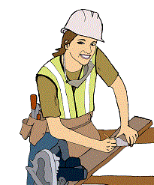

* go to work. But only when you can **not** work from home

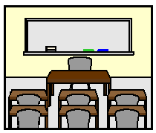

* go to school.

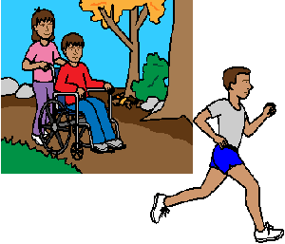You can go for a walk or run. It must be

* in your local area
* by your self

**or**

* with only 1 more person.

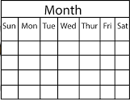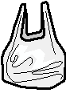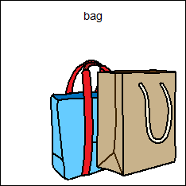

Do **not** go to the shops every day.

**No groups**



There must be **no** groups of people together.



You go to the shops.

You can be with all your family

**But**



Keep a space between you

**or**

You can be with **only** 1 other person to

* buy food
* go to the doctor
* go for a walk or run.

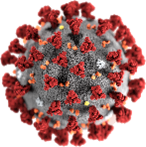**COVID19 may be very dangerous for some people**



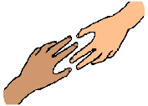The government says these people must try to stay at home. There will be more help to get the things they need. Like Someone to

* pick up your medicine
* pick up your shopping.

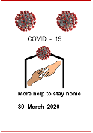Read the fact sheet

**More help to stay home.**

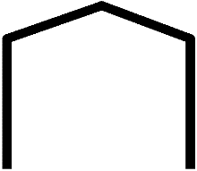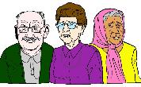For people over 70 years old

* try to stay home most of the time
* ask for help to get things at the shop.

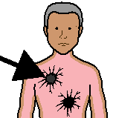For people over 60 years old

**and**

you also have an illness. Like

* cancer
* asthma

**Then**

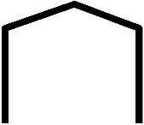

* 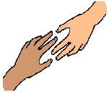try to stay home most of the time
* ask for help to get things at the shop.

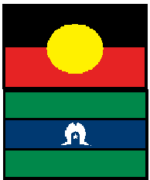For Aboriginal and Torres Strait Islander people over 50 years old



* 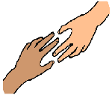try to stay home most of the time
* ask for help to get things at the shop.

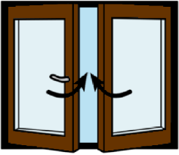**All these places are closed too.**

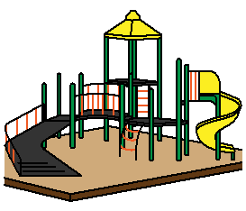

Outdoor childrens palygrounds.

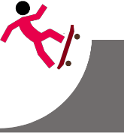

Skate parks.

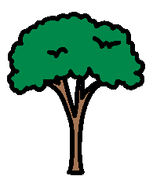

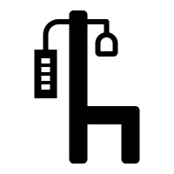

Outside gyms.

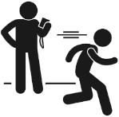Boot camps.

It must be only you and the trainer now.

This is like personal training

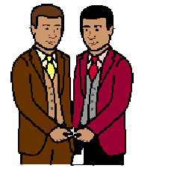**Weddings stay the same**

Only the 2 people

**and**

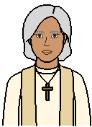The person who marries them.

2 people to witness.



**No** party after the wedding.

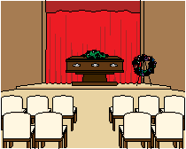**Funerals stay the same**



It must be less than 10 people.



Remember to have space for everyone.



Do **not** meet in a group after the funeral.

There will be **more** new rules.



Each state may also have more rules.

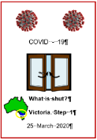

Read fact sheets for your state.

**More information**

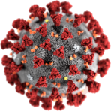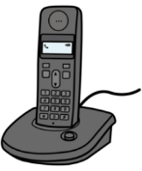

COVID - 19 information. Call 1800 020 080.

You can call at



* any time
* any day.

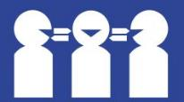Translations

Call 131 450

**Images**

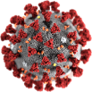We have used images from

* Freepikpsd
* ****Mayer-Johnson
* Picto-Selector
* TheNounProject.

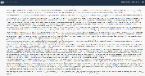This fact sheet is based on The Prime Ministers statement 29 March 2020 evening. <https://www.pm.gov.au/media/press-conference-australian-parliament-house-act-13>

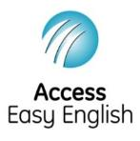Access Easy English wrote the Easy English.

25 and 26 March 2020.