Preventing and Responding to Family Violence
Women with Disabilities Victoria has collaborated with National Disability Services to develop a series of four short films for disability workers about family violence and disability.
The purpose of the film series is to help disability workers identify and respond to family violence.
Research shows that people with disabilities experience higher rates of violence than people without disabilities (Australian Institute of Health and Welfare, 2019).
Women with disabilities experience very high rates of family violence and violence against women (Women With Disabilities Australia & University of New South Wales and People with Disabilities Australia, 2013).
The disability workforce has a vital role to play in preventing, identifying, and responding to family violence.
There are two versions of each film to help model best practice in accessibility. One has an Auslan interpreter and subtitles. The other is audio described.
Each film has an accompanying handout with supporting information. This is the handout for Film 1: Preventing and responding to family violence.

About the Films

Film 1: Preventing and Responding to Family Violence
This film introduces the short film series. It explains what family violence is. It also explains some of the support services available for victim survivors, perpetrators, and practitioners. It is approximately 4 minutes long.

Film 2: Prevention
This film focuses on primary prevention of violence against women with disabilities. It explains the drivers – or causes – of violence against women with disabilities. It also identifies some of the actions people can take to challenge the attitudes and practices that allow violence to occur in the first place. It is approximately 10 minutes long.

Film 3: Early Intervention
This film focuses on early intervention of violence against women with disabilities. It covers how to recognise some of the early warning signs that someone might be at risk of family violence and take action to address these. It is approximately 10 minutes long.

Film 4: Response
This film focuses on responding to violence against women with disabilities. It covers how to safely support someone who is experiencing family violence. It also explains who to contact for advice and to provide ongoing support. It is approximately 10 minutes long.
All four films are connected and support one another. It is recommended you watch all four films and read through each of the handouts.
All four films are connected and support one another. It is recommended you watch all four films and read through each of the handouts.

What is Family Violence?
Family violence is:
- a violation of human rights and can include physical, emotional, financial, sexual or social abuse
- behaviour that reflects a pattern of coercion and control, where one person uses fear and abuse to control another person
- prevalent in Australian society across all cultures, communities and socio-economic statuses
- deeply gendered – while both women and men experience family violence, the evidence shows that most victim survivors are women and their children and most people who perpetrate violence are men (Australian Institute of Health and Welfare, 2018). It can be perpetrated by a current or former spouse or domestic partner, child, parent, or any other relative or family member. This includes anyone with a family or kinship relationship who is considered as being like a family member, such as a carer/support worker (Victorian Family Violence Protection Act, 2008).

Violence against women
Violence against women refers to “any act of gender-based violence that results in, or is likely to result in, physical, sexual or psychological harm or suffering to women, including threats of such acts, coercion or arbitrary deprivation of liberty, whether occurring in public or in private life” UN General Assembly, 1993).

This includes (but is not limited to):
- Intimate partner violence
- Family violence
- Sexual assault and harassment
- Disability based violence
- Forced sex work and trafficking
- Dowry related violence
- Female genital mutilation

Impacts of family violence
All forms of violence can have lasting impacts on victim survivors, including physical, psychological and financial impacts.
For Australian women aged 15-44 years, intimate partner violence is identified as a leading contributor to death, disability, and illness, outstripping other known risk factors like alcohol harm, illicit substances use, high blood pressure, obesity, and smoking. Impacts may include poor mental health, problems during pregnancy and birth, drug and alcohol use, suicide, injuries and homicide (Webster, 2016).
It can also have serious impacts on children, including low self-esteem, withdrawal, aggression or disobedient behaviour, impaired development and learning difficulties (State of Victoria, Department of Human Services, 2013).
Women with disabilities are twice as likely to experience family violence compared to women without disabilities (Women With Disabilities Australia & University of New South Wales and People with Disabilities Australia, 2013).

Family violence and other forms of violence against women are preventable
Each of the films looks at a different part of the spectrum of approaches to prevent family violence. This table describes each of these areas of prevention: primary, secondary, and tertiary.
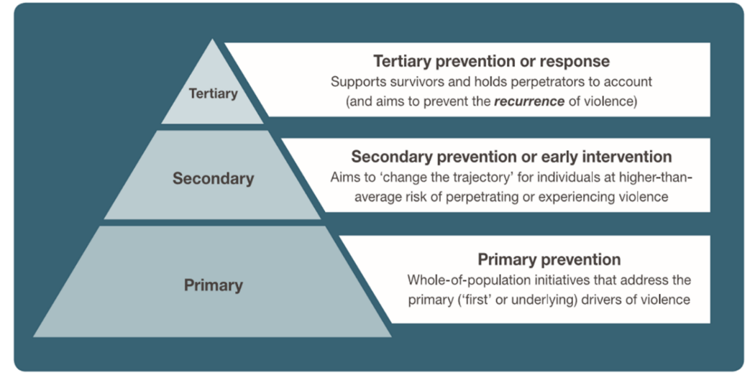

Source of pyramid graphic: Our Watch, ANROWS and VicHealth (2015) Change the story: A shared framework for the primary prevention of violence against women and their children in Australia, Our Watch, Melbourne, Australia, p.15.
Description of graphic:Above graphic is a pyramid divided into three sections. The bottom section is labelled Primary. The description reads: “Primary prevention: Whole-of-population initiatives that address the primary (‘first’ or underlying) drivers of violence.”
The middle section is labelled Secondary. The description reads: “Secondary prevention or early intervention: Aims to ‘change the trajectory’ for individuals at higher-than-average risk of perpetrating or experiencing violence.”
The top section is labelled Tertiary. The description reads: “Tertiary prevention or response: Supports survivors and holds perpetrators to account (and aims to prevent the recurrence of violence).”

By working across all three levels together, we can not only provide support to people who have experienced violence and keep them safe, but we can also seek to prevent violence from happening in the first place.
The three films show different scenarios featuring women with disabilities who are experiencing, or are at risk of experiencing, family violence.
Each film also features a range of experts who:
- provide information and help to unpack what is happening in each scenario
- talk through options for what disability support workers can do in each scenario to support a client to prevent and respond to the family violence.

Where to go for additional information and support

Support for someone experiencing family violence
In an emergency, always call Victoria Police on 000.

1800RESPECT is the national family violence counselling, referral and information service and is open 24 hours a day, 7 days a week. Phone 1800 7377 328 or www.1800respect.org.au

Safe Steps Family Violence Response Centre is Victoria’s family violence support service and is open 24 hours, 7 days a week. Phone 1800 015 188 or www.safesteps.org.au

Centre Against Sexual Assault (CASA House) provides sexual assault counselling and crisis support. Phone 1800 806 292 or www.casahouse.com.au

Djirra provides information, referral, support, legal service, and workshops for Aboriginal and Torres Strait Islander women in Victoria who are experiencing family violence. Phone 1800 105 303 or (03) 9244 3333 or https://djirra.org.au/

InTouch – Multicultural Centre Against Family Violence supports women and children from migrant and refugee communities who are experiencing violence. Phone 1800 755 988 or https://intouch.org.au/

With Respect provides specialist LGBTIQ family violence support and counselling. Phone 1800 LGBTIQ (1800 542 847) or https://www.withrespect.org.au/

WIRE offers a free information and referral service for all Victorian women. Phone (03) 8346 5200 or email support@wire.org.au or www.wire.org.au

Additional information and resources
Our Watch is a national leader in the primary prevention of violence against women and their children in Australia. www.ourwatch.org.au

Australia’s National Research Organisation for Women’s Safety (ANROWS) is the national research organisation on addressing violence against women and their children. www.anrows.org.au

Domestic Violence Resource Centre Victoria (DVRCV) is a state-wide Victorian organisation working to build the capability of professionals, organisations and systems to prevent and respond to violence against women. www.dvrcv.org.au

Women with Disabilities Victoria information and resources
A range of additional fact sheets and resources can be found at www.wdv.org.au
You can also find out more about Women with Disabilities Victoria’s Workforce Development Program on Gender and Disability. The program is a primary prevention strategy which aims to:
- prevent violence against women with disabilities
- improve gender and disability responsive service practice, and
- improve the status and opportunities of women with disabilities.
The Program works with women with disabilities, social service and government organisations and workforces to increase awareness and capacity to prevent violence against women with disabilities. It does this by implementing cultural change strategies and delivering gender and disability equitable, responsive and inclusive services.
The program is supported by the Victorian Government through the Office for Women as an initiative under the Family Violence Industry Plan.

For more information about the program or to engage Women with Disabilities Victoria to provide training to your organisation please contact (03) 9286 7800 or email your inquiry to wdv@wdv.org.au

References
Australian Institute of Health and Welfare (2019). People with disability in Australia. Cat. no. DIS 72. Canberra: AIHW.
Women With Disabilities Australia & University of New South Wales and People with Disabilities Australia, (2013) Stop the Violence: Improving Service Delivery for Women and Girls with disabilities, Sydney.
Australian Institute of Health and Welfare (2018). Family, domestic and sexual violence in Australia 2018. Cat. no. FDV 2. Canberra: AIHW.
Victorian Family Violence Protection Act (2008) ss 1, 12, 15, 16
UN General Assembly (1993), Declaration on the Elimination of Violence against Women, A/RES/48/104
Webster K (2016) A preventable burden: measuring and addressing the prevalence and health impacts of intimate partner violence in Australian women. ANROWS, Sydney. (Compass, 07/2016).
State of Victoria, Department of Human Services (2013), Assessing children and young people experiencing family violence, A practice guide for family violence practitioners.
Women With Disabilities Australia & University of New South Wales and People with Disabilities Australia, (2013) Stop the Violence: Improving Service Delivery for Women and Girls with disabilities, Sydney.

