Respect, Inclusion and Equality: Building Workforce Capacity to Prevent Violence Against Women with Disabilities

Women with Disabilities Victoria are hosting an event to mark 16 Days of Activism against Gender-Based Violence and celebrate International Day of People with Disabilities.

We would like workforces working with women with disabilities to join us
We will be showcasing our new workforce development resources along with a panel discussion on prevention of violence against women with disabilities.
- Presentation from CEO launching new resources
- Presentation on prevention of violence against women with disabilities
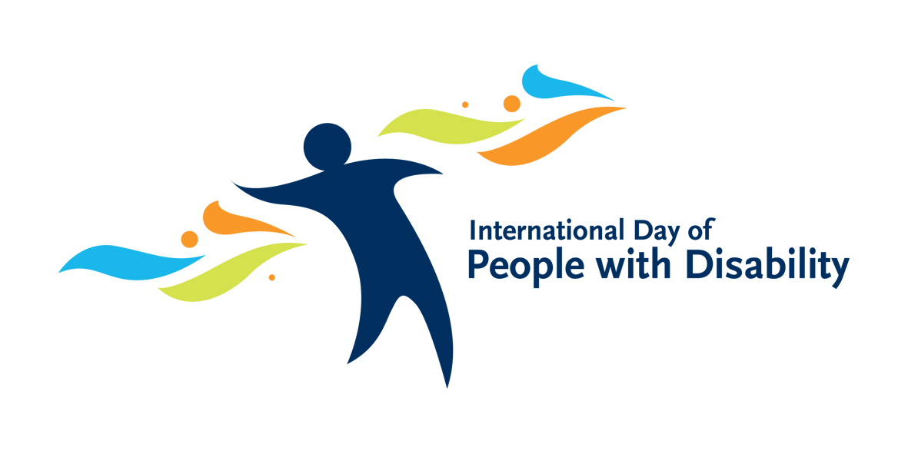
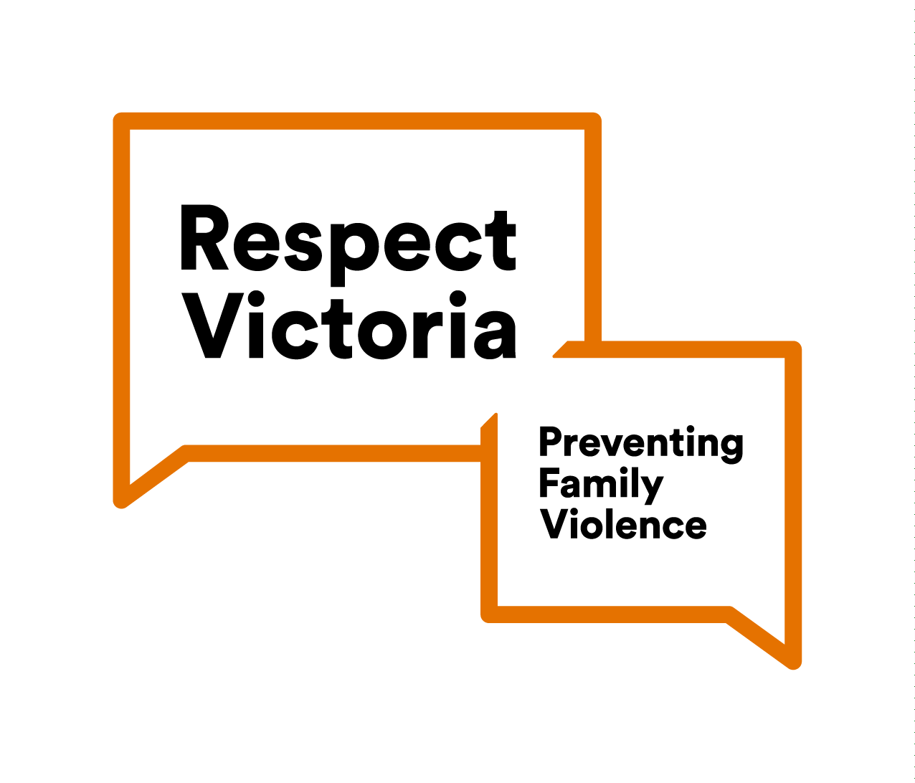
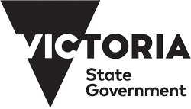
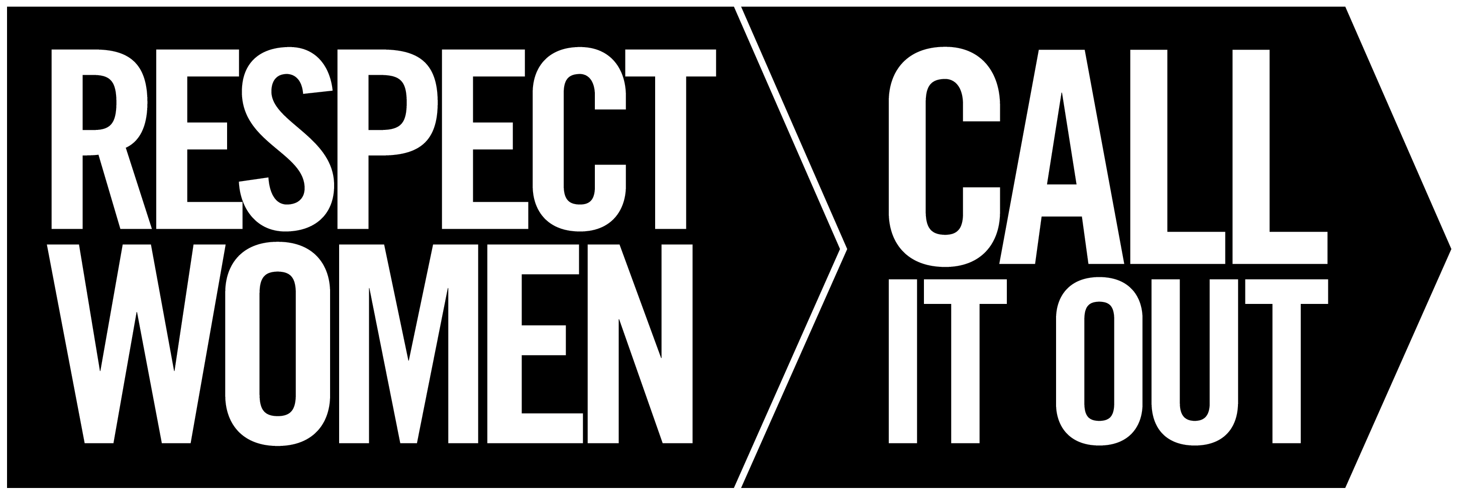
- Panel presentation and audience Q&A on respect for women with disabilities

Details
Date: Thursday 3 December 2020
Time: 10am–12pm
Location: via Zoom
Cost: Free
Register: by 26 November via Eventbrite via https://respectinclusionandequality.eventbrite.com.au
For more information contact Nicole Smith on nicole.smith@wdv.org.au

