RESPECT IS…

Gender and disability equality is key to preventing violence. Here is what women with disabilities say:

- Respect is supporting our decision-making.
- Respect is bodily autonomy.
- Respect is consulting with us about things that impact our lives.
- Respect is challenging sexist and able-ist stereotypes.
- Respect is letting me set my own boundaries and take my own risks.
- Respect is listening to us, learning from us and following our lead.
- Respect is not assuming you know better than I do.
- Respect is acknowledging our sexual and reproductive health rights.
- Respect is paying us for our labour.
- Respect is letting me speak for myself.
- Respect is believing me.
- Respect is recognising our skills, talent and contribution.
- Respect is making your space accessible.
- Respect is giving me the time I need to communicate.
- Respect is acknowledging my parenting abilities.
- Respect is disability pride.

#WDVtweets
#16dayscampaign
#respectis
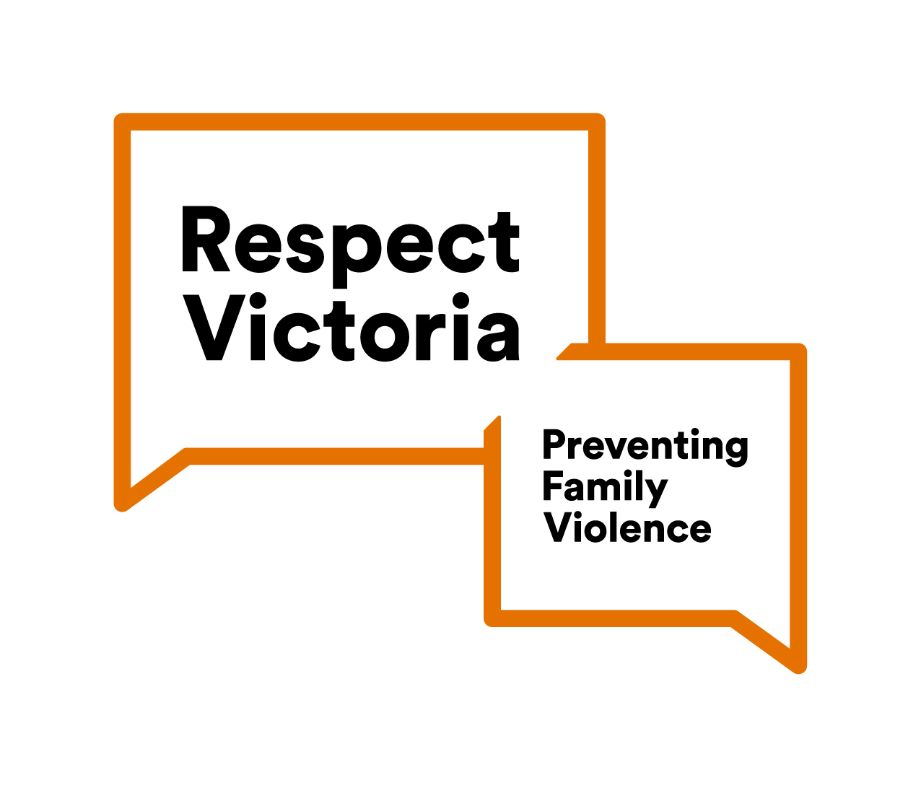
#callitout
