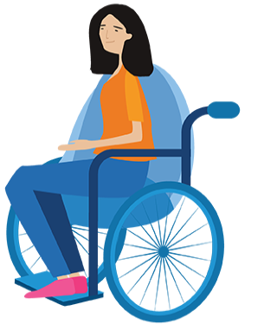

2021 Brenda Gabe
Leadership Award

Nomination Guidelines

- Nominees are those who have made a positive impact on the lives of other women with disability in Victoria.

- Individuals (or groups) nominated for this award must identify as female (cis or transgender) or a non-binary person with disability and reside in Victoria.

- You can nominate yourself or your group (self-nomination) or any individual who identifies as a girl/woman (cis or trans), non-binary, or gender diverse person.

- Nominations must be completed on the nomination form found at www.wdv.org.au/BrendaGabeAward.

- Nominations may be submitted via the WDV webpage, emailed to bgla@wdv.org.au or posted to GPO Box 1160, Melbourne. VIC 3001. Please retain proof of postage if posted on or around closing date.

- Nominations close at 5pm on Monday 2nd August 2021. Late nominations will not be accepted.

- Nominations will be acknowledged in writing within 14 days of the closing date.

- All nominations must be accompanied by two letters of support from referees.

- All nominations require a photograph and a 50-word profile summary which has been approved by the nominee for publicity and research purposes prior to submission.

- All nominations will be assessed by a panel who will select a winner they feel best exemplifies the award eligibility and criteria.

- The selection panel will be made up of representatives from the Women with Disabilities Victoria Board, the CEO and a community leader.

- The decision of the selection panel is final.

