State Disability Plan submission 2021 -
actions for a better Victoria for women with disabilities

Please accept Women with Disabilities Victoria’s (WDV’s) submission to the State Disability Plan (SDP) consultation.
The case for distinct approaches to planning for women with disabilities is clear. Women with disabilities experience all the inequalities of people with disabilities in combination with all the inequalities experienced by women and girls. These inequalities compound to mean that we are more likely to experience, for example:
- Unemployment and low pay
- Reduced access to education
- Reduced access to the NDIS
- Removal of our children through child protection
- Homelessness and housing stress (especially that caused by family violence)
- Gender based violence in mental health serivces
- Reproductive coercion
- Sexual assault, stalking and family violence.
While we could focus on every social issue, here we focus on the topics most aligned with WDV’s strategic plan. For data sources please see key references listed at the end of this document.

Contact Jen.Hargrave@wdv.org.au.

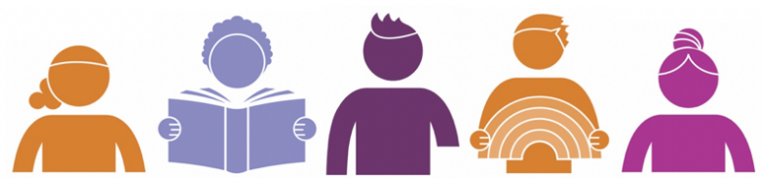

Making the SDP stronger would benefit all Victorians. Unfortunately, over time, for many reasons, we have seen the Office for Disability (OfD) who create and implement the plan shrink in staffing and resourcing. This undermines the plan’s potential as a primary structure to promote interdepartmental efforts towards disability access (for example encouraging improvements with Office for Women, Family Safety Victoria, Respect Victoria, Court Services Victoria, Police, Justice, Education, and so on). It is saddening to find that most government departments are unware of information access guidelines, the Disability Discrimination Act’s relationship to employment, and many other important obligations they hold to Victorians with disabilities.
WDV believe the plan’s impact could be improved through strengthening the resourcing and the inter-departmental leadership role of the OfD.
The plan itself does not receive any multi-year budget funding. Progressing disability access and inclusion requires not just planning but also multi-year funding.
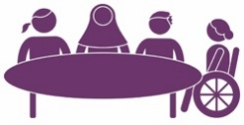 | Disability Action Plans (DAPs) support organisations and government departments to review, monitor and develop their disability access. DAPs can be an effective method to engage workforces and make improvements. Unfortunately, the funding that OfD received to run training and support organisations to develop DAPs has been lost. Other bodies such as VEOHRC have not truly filled this role, and there is a gap.  WDV has informed DAP development in Women’s Health Services, the Royal Women’s Hospital, Family Violence Specialist Services and government departments (such as Police and Justice). However, WDV can only do this as capacity and resourcing allow.  WDV see a government led support system for DAP development would be beneficial for creating leadership, coordination and currency. It would allow for a central, statewide collection of resources and contacts to support actions including capital works audits, policy audits, HR processes, IT, approaches to accessible consultation and information access.  Diversity Plans are an acceptable alternative to DAPs but they need to measure real progress and connect to concrete accountabilities like the Act, the SDP and the DDA, and they need to resource involvement of people with disabilities in all stages.

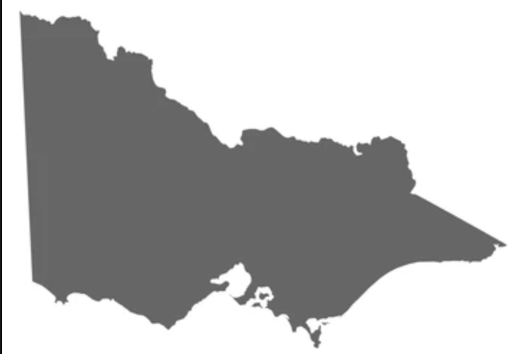 | Statewide infrastructure for community development sits alongside advocacy and safeguarding as a critical component of protecting our rights and preventing their infringement. Examples of community development programs include WDV’s Enabling Women Program and Local Leadership Hubs. Victoria also used to have Rural and Metro Access Officers in each local government area who could provide a statewide infrastructure for community development and promoting local inclusion.  These programs can connect communities. That connection allows knowledge to be shared and collective action when the rights of people with disabilities are breached. They allow contact points for regional work. Further, having a base in local government promotes council services, events and other activities to be accessible which makes us all feel safer and included in our communities.  Lastly, everything we read about pandemic and disaster tells us that connected communities are more resilient. ILC funding has not replaced the functions of our former network of Rural / Metro Access Officers leaving a gap for Victorians with disabilities. While Victorians with disabilities require access to state services like health, family violence, housing, education, local government, and so on, the Victorian Government still has a role here. We are interested to explore state capacities to influence the national government and achieve funding alignment funding to cover service gaps for people with disabilities.
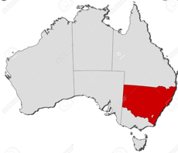 | The interface between Victorian and National frameworks is challenging to build. For example, it is not straightforward to create links between the National Disability Strategy and the SDP, between state services like Health and Family Violence with national services like the NDIS, between the Victorian Disability Advisory Council and the NDIS Independent Advisory Council, and between safeguarding frameworks.  WDV is interested to support efforts to build these inter-jurisdictional links due to the benefits that would have on our members who raise concerns about the ways the disconnection negatively impacts their day to day lives. We recognise that much the decision making lies in the hands of the national government but would be interested to explore state capacities (such as reporting and advocacy) to highlight the situation and encourage accountability.

State oversight bodies such as Office of the PulOPA, the Disability Worker Commission and the Disability Services Commission serve an important role in Victorian monitoring and Parliamentary reporting. While they cannot serve the safeguarding function of community development, they complement it. They also are also more accessible to Victorians than national bodies - they are closer to community they are tasked to serve.We note that each body usually has a specific scope and that for generalist statutory authorities the prioritisation of disability can be fleeting.
WDV recommends that the state to maintain a focus on state-based safeguarding. Most Australians with disabilities are not covered by NDIS safeguards. WDV note with concern that Victoria is set to lose the Disability Services Commissioner, and with it, we will lose some if its functions such as investigation of preventable deaths in disability services. WDV would like to see replacements investigated. This points to the need for an analysis of state level safeguarding gaps with solutions enshrined in law.
Advocacy in all its forms is a crucial part of protecting the rights of Victorians with disabilities. Self Advocacy, led by SARU, has changed the face of disability advocacy in Victoria for the better sparking self advocacy groups of the highest standard and exceptionally valuable resources through Voice At the Table. Victorian individual and systemic advocacy are nationally leading, and are focus on particular population groups. Victorian systemic advocacy has led to outcomes including impact on the Family Violence Royal Commission, high quality research outputs, and essential funding streams. Maintaining these distinct forms of advocacy must be a central aspect to Victoria’s future disability state planning.
Consultation with women with disabilities is an essential part of any community consultation on disability or critical issues impacting women. When planning any community consultation,, the Victorian Government should consider whether women with disabilities should be consulted as a specific cohort. There are some topics which we know many women will not raise in groups with men present.
Increasing the Victorian Government to runs specific consultations for LGBTIQA+ Victorians with disabilities, which is terrific. We must not forget that women also require the same level of consideration.
WDV has supported government and its authorities to run consultations for the Gender Equity, child protection, safeguarding, and much more, resulting in positive outcomes. WDV expect all future government planning will consider if consultation subject matter requires safe spaces for women and non binary people. These should be created with community partners, resourcing for appropriate counselling supports and resourcing for disability access requirements.

The Digital divide for women with disabilities can be invisible to many, and this has been particularly highlighted during COVID-19. While many of us benefited from the disability access options opened up by a world based more online, others have been left behind. So this is a worthy area of interest for State disability planning.
Internet use is obviously expensive patchy in regional areas, and beyond the budget of many on Newstart, DSP or other fixed incomes. Safe, private internet access can be absolutely compromised through experiences of family violence, and when women’s impairments restrict independent use of devices.
One of the most positive initiatives undertaken during the pandemic was the way SARU used grant money to provide people with devices and support to use them. WDV ran a similar project with SARU back in 2011 where WIRE Women’s Information Referral was engaged to support women to learn about how to use the internet and eSafety.
More recently, during lockdown, members of WDV’s Cobram Leadership Hub unable to meet and members became generally more isolated. Members identified that they would like to be able to continue to connect as a group. Many had very little knowledge of online communication, so the Hub Liaison Officer contacted Cobram Community House which hosts the Hub. The Community house was able to use an existing funding source to offer free internet training sessions to Hub members. Cobram Community House also made some computers available to women who needed them. At the end of the training, Hub members felt confident enough to join their local group online, and some joined a statewide WDV forum.
As more services are based online, WDV would encourage resourcing ongoing initiatives which provide equipment, data and training to people with disabilities. This helps us stay connected, access employment, manage finances and have social connections.
Prevention of violence against women has been an area where WDV has been at the cutting edge of tailored programs for women with disabilities and the most relevant workforces. This is priority work and should hold a place in the SDP
Victoria’s mainstream prevention work should represent women with disabilities in campaigns and more could be done to address ableist attitudes while addressing sexist attitudes through the Respectful Relationships program in schools.

Family violence was represented in the SDP for the first time in its most recent edition through the listing of funded projects which address family violence experienced by women with disabilities, and through mention of State Family Violence policy. This was such a positive.
To build on this policy link, WDV would like to see how the SDP may be resourced to do more than list funded projects. Alternatively the plan could support promising programs to expand either in terms of their accessibility to people with disabilities, their funding timeframe, their scale or their geographic reach. For example, Making Rights Reality is an evaluated program running in the Metro South East to Respond to disabled survivors of sexual assault – the SDP could support this program to roll out statewide. Or there are programs like Respectful Relationships (RR) - the SDP could support further tailoring and evaluation of RR for students with disabilities.
Despite the impact WDV made on the Victoria’s Family Violence Royal Commission, resulting in over 16 recommendations with specific mention of disability and mental health, we have some problems. Five years into implementation, there is no measure that indicates women with disabilities have better access to the family violence system. Disability has no dedicated portfolio in Family Safety Victoria. Capacity building projects have been short term.
Justice and child protection are areas where women with disabilities face discrimination. The VEOHRC report Beyond Doubt from 2014 still has recommendations which have not been implemented, despite departments agreeing to all. Further, those that have been implemented are often under-utilised and deserve promotion.
The absolutely gendered issue of child protection is one receiving attention from many advocates and researchers including STAR, OPA and WDV. WDV support any positive action the SDP can deliver in this area and we would be happy to discuss further.
Parenting supports and carer supports are areas the State provides services in. They should be kept in view during SDP development as people with disabilities fulfil parenting and caring roles, especially women with disabilities. Such programs are viewed as a primary strategy for preventing negative contact with child protection services which is of course an area where women with disabilities are over-represented. Programmatic access to these services must be promoted.

Housing and accommodation not only are areas that truly highlight disability access barriers but also highlight gender inequity. For example, family violence is the biggest cause of homelessness, women’s lower incomes and caring responsibilities make accommodation more unaffordable, and many types of temporary accommodation are places where gender based violence is a real risk.
There are a multitude of approaches that the SDP could take to addressing housing and accommodation. For example,
- mount and sustain pressure on the Commonwealth for a national building code which will accommodate future Australians with disabilities,
- monitor how positive rental law reforms impact women with disabilities
- improve safety in Supported Residential Services (during the next year WDV will publish findings form our project, which interviewed women living in SRSs, and OPA have certainly reported many critical recommendations to Parliament over the years)
- improve safety in Supported Residential Services (during this year WDV will publish findings from the ‘Spotlight on ‘Invisible’ Women’ project which interviewed advocacy organisations and women living in SRSs)
- report on the level of accessibility to the state’s housing and accommodation stock setting targets for improvement, and
ensure builds (of public and social housing, family violence refuge and crisis accommodation) provide optimum reasonable accessibility in each dwelling.
Health and reproductive health are areas of major concern for WDV members and therefor areas where we run programs. WDV is absolutely available to talk about our training and resources, and how the SDP can fill some of the huge structural issues which address service and practice gaps.
Other priorities for WDV and our members include:
- Representation in policy
- COVID-19 vaccination of people with disabilities
- Options to access Telehealth and options to access face to face services due to Telehealth safety and access barriers (see the digital divide section of this document)
- Better transport options to access health services
- Health information in accessible formats delivered in a timely manner (this links to earlier sections of this submission about strengthening promotion of and accountability to Government Information Access Standards)
Steps towards more disability inclusive, gender sensitive, trauma informed service design and delivery).
 | Mental Health reform is afoot in Victoria. The Mental Health Royal Commission report has little to say about women’s safety and less to say about disability access to services. Therefore, improved quality and safety of mental health services for women with disabilities will rely on implementation guided by mechanisms and representatives external to the Commission’s report, such as the SDP and the work of representative organisations including the Women’s Mental Health Alliance, Women’s Health Services, VIMIAC and WDV.
 | Government employment targets set in the last SDP are impressive. From information we have seen, we believe that government is still striving to reach the targets. WDV encourage these targets to represent women and a diversity of people with disabilities. This is important to WDV because we are acutely mindful of the employment and income inequities between men with disabilities and women with disabilities.
 | Evaluation of government programs often overlooks women with disabilities. For example, an evaluation of an actuarial family violence risk assessment system pilot cannot tell us much if it does not examine how the scheme succeeded regarding higher risk population groups. It is important to correct this evaluation practice so that we can be monitoring and improving outcomes for Victorian women with disabilities.
 | Procurement is a powerful way for government to show what counts. Government could demonstrate the importance of disability access by, for example, purchasing software that is accessible, and contracting consultants and architects who demonstrate accessible design skills. Contract management that is attentive to accessibility would strengthen this approach and prevent problems like we have with Victorian refuge developments which have steps into brand new accommodation built on clear. How accessibility of other government developments and redevelopments (such as The Orange Doors) is not apparent and anecdotally is unreliable.
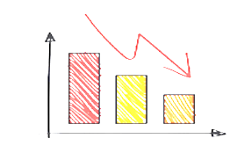 | Data collection being disability and gender disaggregated as much as practicable is recommended by WDV. This increases Victoria’s ability to monitor programmatic and system disability access and gender equity.
 | Please progress disability planning recognising the rights of Victorian women and girls with disabilities to be free from gender based violence, and to have equal access to services, opportunities, and resources.

Key references
- The DPOs shadow report to the UN (2019)
- Current data on measures of gender equity including unpaid care, income and leadership roles organised by local government area in the Victorian Women’s Health Atlas
- Statements from the Victorian Women’s Mental Health Alliance
- Analysis of what the NDIS means for women and girls in Power to Persuade (2020)
- Violence data analysis by the Centre for Excellence in Disability Health (2020-2021)
- WDV’s fully referenced submissions on our priority issues (including the recent submission on violence at home which captures much of the recent research)
- SARU and WDV’s Exploration of the digital divide for women with disabilities in Your Say, Your Rights (2011)
- WDV’s Strategic Plan (2021-2024)
- Information on WDV’s programs in women’s empowerment, workforce development and policy.
- Victoria’s Gender Equality Act sets out to improve equality for women in Victoria’s public sector and beyond (2020)
- The Convention on the Elimination of All Forms of Discrimination against Women (CEDAW) by the UN sets out the rights of women and girls around the world, including, and with specific mention of, women and girls with disabilities.

