2021 Brenda Gabe

Leadership Award

  - Celebrating Women
  - with Disabilities

Find out more here:

www.wdv.org.au/BrendaGabeAward

About the Award
The Brenda Gabe Leadership Award is a biennial award which recognises and rewards outstanding leadership from women with disability in Victoria.

Women with Disabilities Victoria (WDV) invites nominations of individuals or groups who have made a contribution which has either:
- Directly benefited women with disability, or
- Ensured a more inclusive community for women with disability in Victoria.
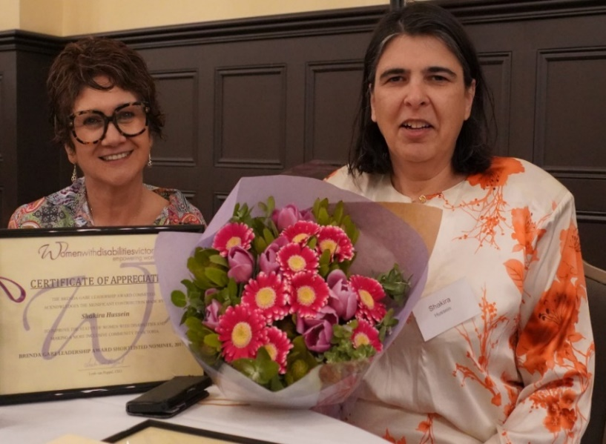

Winner of the 2019 Annual Brenda Gabe Leadership Award Shakira Hussein.

Eligibility
Individuals (or groups) nominated for this award must identify as female (cis or transgender) or non-binary person with disability and reside in Victoria.

You can nominate yourself or your group (self-nomination) or any individual who identifies as a girl/woman (cis or trans), non-binary, or gender diverse person.

We encourage the nomination of women with diverse backgrounds and/or life experiences.

Nomination Period
Nominations open: 9:00am Tuesday 1 June 2021
Nominations close: 5:00pm Monday 2 August 2021

The 2021 Brenda Gabe Leadership Award announcement
The recipient of the award will be announced at WDV’s Annual General Meeting on 27th October 2021 and will receive a $2,000 prize towards professional development or a capacity-building project.

The recipient will be required to provide:
- A proposal for use of the award money
- A demonstration of the use of the award money, including a report, by October 2022.

To nominate or find out more:
To find out more about the award, including how to nominate and details about previous nominees and recipients, please visit:
W www.wdv.org.au/BrendaGabeAward
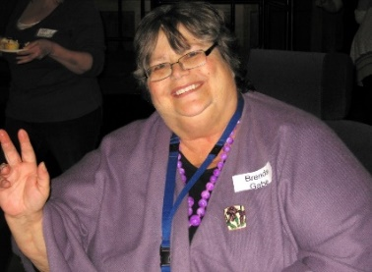
If you would like more information about nominating for this year’s award, please contact Phillipa Wray at WDV:
P (03) 9286 7800
E bgla@wdv.org.au

About Brenda Gabe
Brenda Gabe became a devoted disability advocate after being diagnosed with multiple sclerosis in 1994. The dedicated mother, psychologist and former champion swimmer was a much-loved member of WDV who represented the organisation on multiple committees and forums. Brenda worked tirelessly on many advocacy campaigns including accessible housing and transport, as well as gender and disability related campaigns, including preventing violence against women with disability.

Acknowledgement
WDV gratefully acknowledges the significant contribution and support provided by Dr. Helen Sykes AM, Director of Future Leaders, in making this award possible.

