Enabling Women Leadership Program Colac

Participants Application Form
To do the Enabling Women Leadership Program you will need to fill out this Application Form.

You can fill out the information on your computer, phone or tablet.
If you are using a computer to fill out this form, select the boxes by clicking the mouse or by using the spacebar.
Or you can print out the form and write your answers in by hand and send it to us.
Or ask Brigitte at WDV for help.​
Call Brigitte on (03) 9286 7805 or email brigitte.stone@wdv.org.au
Women with Disabilities Victoria is an organisation that focuses on the needs of women and gender diverse people with disability.
The Enabling Women Leadership Program is for:
Women and gender diverse people with disability.

Disability can be:
- physical, sensory, intellectual and cognitive, etc.
- Deaf / deaf / hard of hearing,
- Chronic illness, and/or pain,
- Neurodiversity, e.g. autistic; or
- Mental health challenges

Who live, work, study or play in the Colac Otway Region.

Your Details
 | First Name:
 | Family Name:
Pronouns: For example: if someone is talking about you, would you like them to say “she is or they are doing the Program”? |  | ☐ She/Her  ☐ They/them  ☐ He/Him  ☐ Ze/Hir  ☐ Choose not to say  ☐ Other:
Do you identify as Aboriginal or Torres Strait Islander? |  | ☐ Yes – Torres Strait Islander  ☐ Yes – Aboriginal  ☐ Both  ☐ No  ☐ Prefer not to say

Postal Address:

Postcode:
Suburb:
Email Address:

Phone Number:

Questions about you
Put your answer in the column next to the question.
Question | Your Answer
- What do you do for fun?

Examples: playing music, sport or watching TV
- Why do you want to do the Enabling Women Program?

Examples: to be more empowered or to meet new people
- a. Has anything stopped you from joining in the activities you want?  Example: feeling like you are not welcome | ☐ Yes  ☐ No
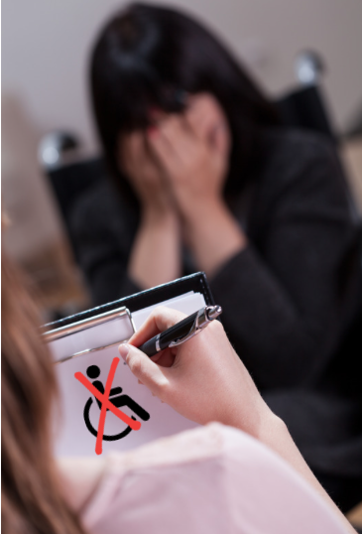  b. If you answered yes, do you think this was worse because of your disability? | ☐ Yes  ☐ No
c. Did you get past the problem? | ☐ Yes  ☐ No
d. If yes, what did you do?

Example: Telling someone no.
4. What links do you have with Colac?

Examples: you live, work, study or have friends here.
- a. Are you a member of any groups?
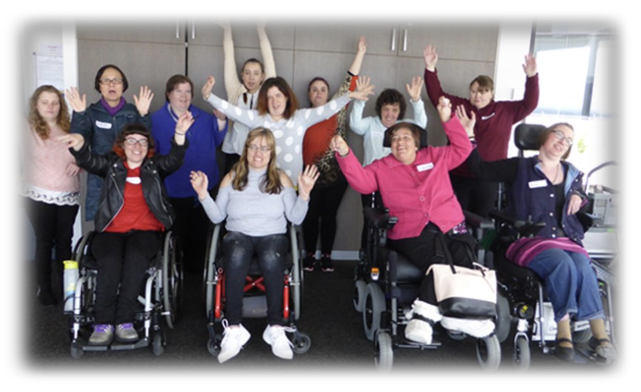
Example: Self-Advocacy Group
b. What did you do as a member of these groups?

Example: Writing letters to the local council or art projects
6. How did you hear about the Enabling Women Program?

Example: Social Media or the WDV Newsletter

To participate in the Program online:
Requirement | Please tick
Do you have a computer with the internet at home? | ☐ Yes  ☐ No
Does the internet work well? | ☐ Yes  ☐ No  ☐ Sometimes
If you do not have a computer with the internet, would you like to borrow one? | ☐ Yes  ☐ No
Does your computer have: | ☐ Microphone  ☐ Headphones  ☐ Speaker  ☐ Webcam
Have you done an online video meeting before? | ☐ Yes - Zoom  ☐ Yes - Teams  ☐ Other -please tell us:  ☐ No
If no, would you like help to use Zoom? | ☐ Yes  ☐ No
At times we may talk about hard topics, like violence and safety.  a. Do you feel comfortable doing the Program from your home? | ☐ Yes  ☐ No
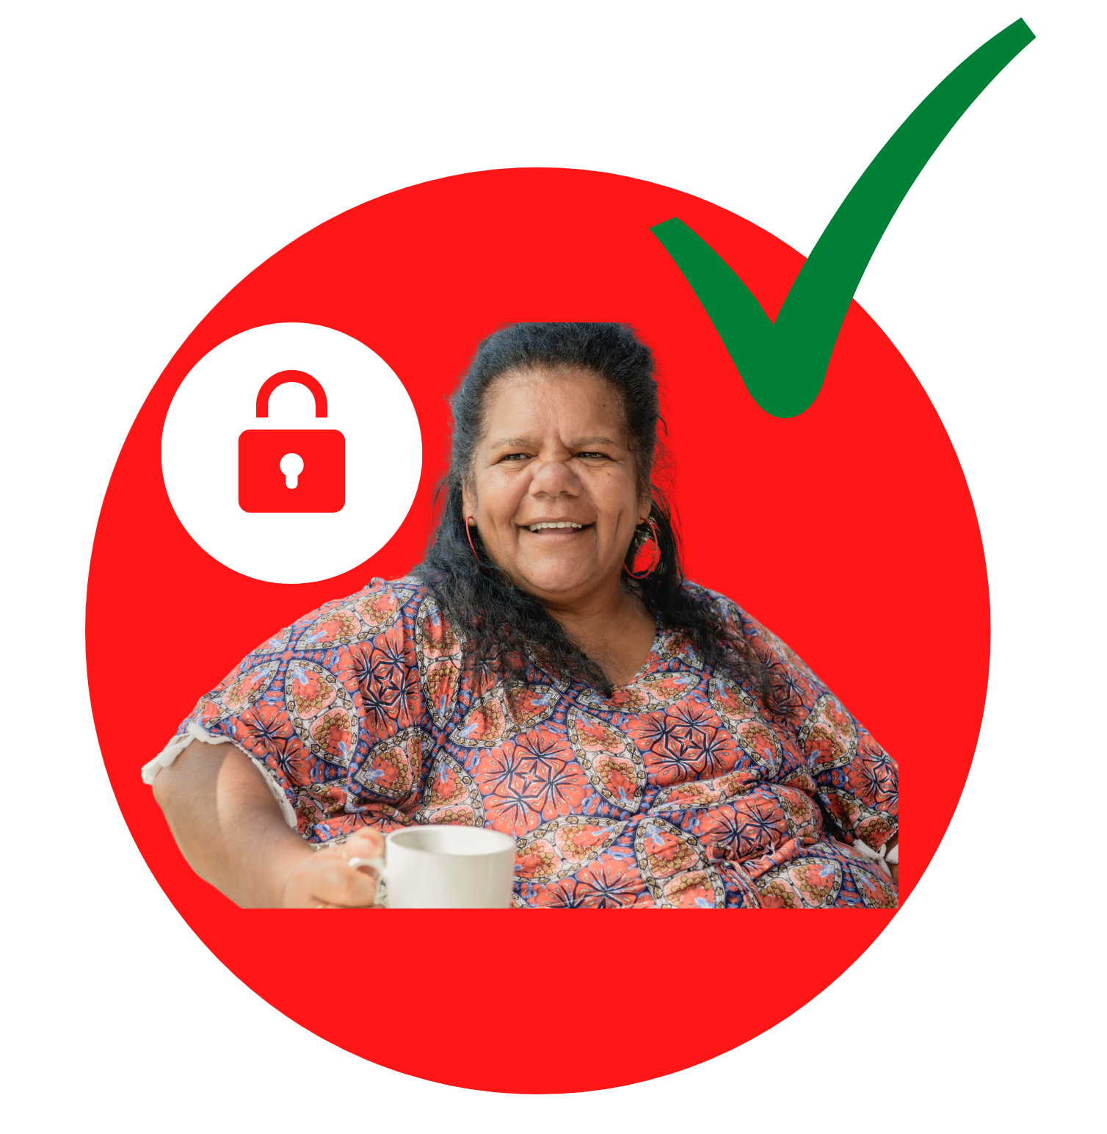  b. Do you have a place at home to be alone to do the Program? | ☐ Yes  ☐ No

Are there any access needs you have to support you to do the Program from home?
Requirement | Please tick
Attendant care | ☐
Note-taker  Someone to help write down your thoughts and information you may want to remember from the Program. | ☐
Interpreter | ☐
Information in alternative formats  Which formats:  Example: Easy Read | ☐
Dietary requirements  Example: Gluten Free, Vegan, Soft Food or Halal | ☐
Transport (if we can meet safely in person) | ☐
Other: | ☐

Keeping everyone safe and healthy is very important to us. To do this with Covid-19 we must follow rules from the Government.
During the Enabling Women Program you may be asked to do some of the things listed below.

Some people with disability have conditions that mean they cannot do all these things and that’s ok. This is called an exemption and you can tick the exemption box if you need.
The answers to these next questions are to help us keep you and everybody else safe. We will not use them to decide if you will be able to be a part of the Program.

Restrictions | Please tick
Wear a mask | ☐ Yes  ☐ Yes -with support  ☐ No – I have an exemption
Register in person via QR code | ☐ Yes  ☐ Yes -with support  ☐ No – I do not have a mobile phone or device compatible with QR codes
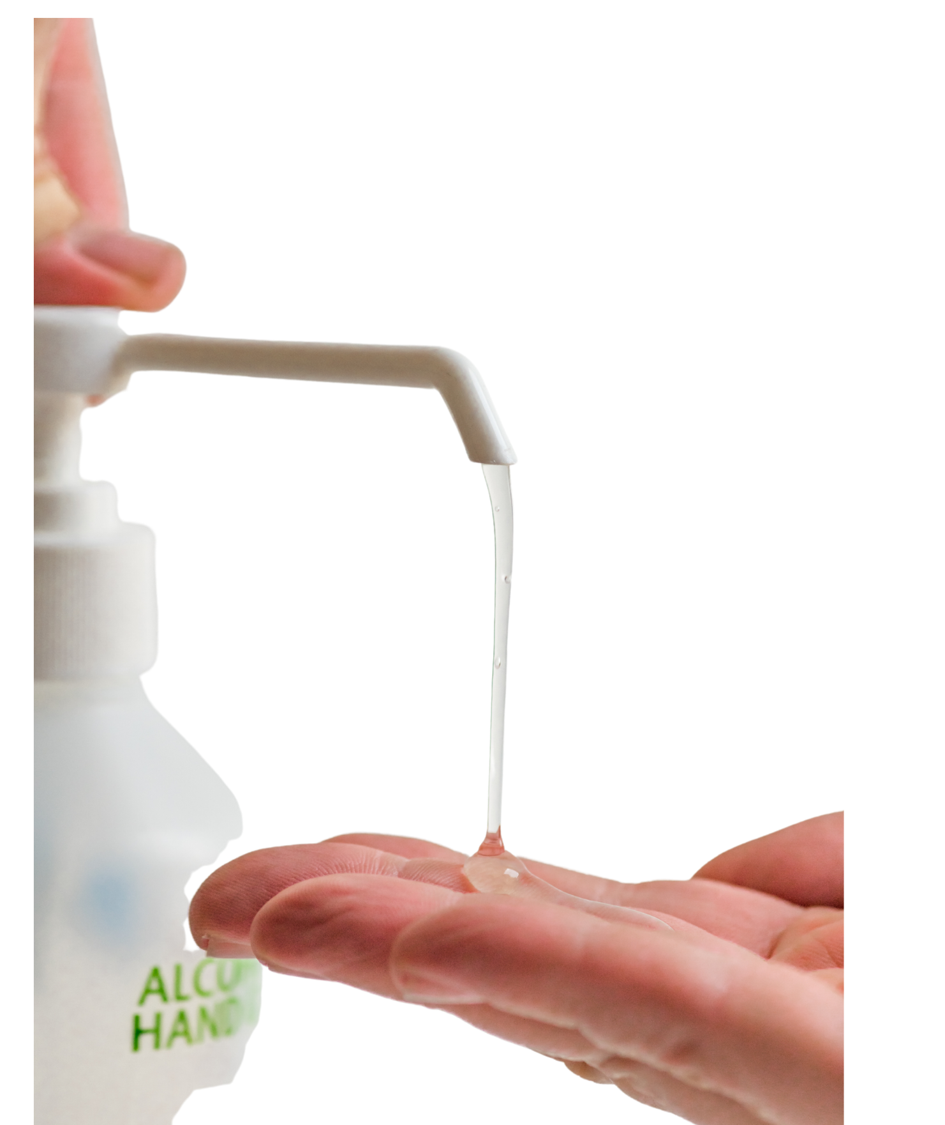  Use hand sanitiser | ☐ Yes  ☐ Yes -with support  ☐ No – I have an exemption
Sanitise working space and tools | ☐ Yes  ☐ Yes -with support  ☐ No – I have an exemption
Socially distance | ☐ Yes  ☐ Yes -with support  ☐ No – I have an exemption
Follow additional Covid safe guidelines as they arise | ☐ Yes  ☐ No

Dates
The Program, including the Graduation, will take place over 9 weeks.

Each session will run from 10am – 2pm. With lots of breaks and time for lunch.

Covid-19 has made things very hard to plan things too far into the future so we are asking you to let us know what days you might have free.

We know plans may change and that is ok.
Looking at your calendar right now, what days do you have free to do the Program?
Dates | Please tick if you are available
Thursday September 23  Thursday September 30  Thursday October 7  Thursday October 14  Thursday October 21  Thursday October 28  Thursday November 04  Thursday November 11  Thursday November 18  Thursday December 02 | ☐  ☐  ☐  ☐  ☐  ☐  ☐  ☐  ☐  ☐

We hope to make the Program a culturally safe and supportive space for participants with diverse backgrounds.

Including people from LGBTQIA+, CALD, and Aboriginal/Torres Strait Islander communities.

We know that some women and gender diverse people with disability will experience violence through their life and we want to make sure they feel safe and supported in the Program.

We do this by;
- being aware of what some participant’s may have been through.
- Creating a warm and comfortable place for everybody.
- being kind and thoughtful.
- Making things called Access Keys that give you lots of information about the Program and
- making Content Warnings that will let you know if we are going to talk about hard things like violence.
For more information on how we can support your participation please let us know.

Funded by the Australian Government Department of Social Services

