Lens on, hands on.
An Intersectional Guide to Financial Capability Program Development

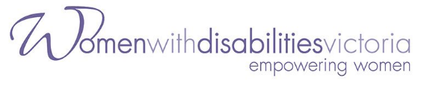
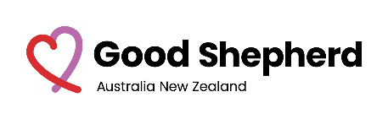
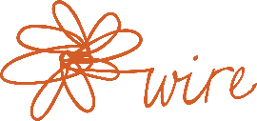

ACKNOWLEDGEMENT OF COUNTRY 2
INTRODUCTION 3
About the resource 3
FINANCIAL CAPABILITY PROGRAMS FOR WOMEN 4
What are financial capability programs? 4
The value of financial capability programs 4
Approaches to women’s financial capability building 6
What did women tell us? 7
LENS ON: INTERSECTIONALITY AS A THINKING TOOL 10
What is intersectionality? 10
What do we mean by power? 12
Why intersectionality is important 12
What is different about an intersectional power analysis? 14
How can intersectionality be used as a thinking tool? 16
Tips for intersectional practice 17
HANDS ON: INTERSECTIONAL PRACTICE PRINCIPLES & TOOLS 18
Principles for an intersectional approach 18
Who created these principles? 20
How to use the principles: 20
PRINCIPLE: Commit to equity & justice 21
PRINCIPLE: Respect and work with a person’s experience and expertise 22
PRINCIPLE: Ask about access from the start 23
PRINCIPLE: Value different ways of knowing, being & doing 24
PRINCIPLE: Prioritise trust building and relationships 25
PRINCIPLE: Promote autonomy and choice 26
PRINCIPLE: Challenge fixed mindsets – listen, learn and grow 28
PRINCIPLE: Put intersectionality into practice 29
PRINCIPLE: Advocate for financial inclusion and economic security for all women 30
Pathways and opportunities:Working with women with disabilities 32
Three Practice Tools – Reflection, Accessibility & Inclusion, and Power 34
Reflection tool: How is your intersectional practice? 36
Ten ways to think about accessibility and inclusion 37
Paying attention to power 40
TERMS WE USE 43
RESOURCES FOR PRACTITIONERS 46
ABOUT THE PROJECT AND PARTNERS 48
About the Project 48
People behind the guide 49
About the organisations 51
REFERENCES 53

ACKNOWLEDGEMENT OF COUNTRY

We acknowledge that Aboriginal and Torres Strait Islander peoples are the traditional – and only – custodians of country across Australia. Aboriginal and Torres Strait Islander peoples continue to maintain their wisdom and rich culture—the oldest continuous culture on the planet—despite having experienced genocide, dispossession and colonisation.
We recognise their continued connection to land, waters and culture and pay our respects to their Elders past and present. Sovereignty has never been ceded. This always was and always will be Aboriginal land.

INTRODUCTION

About the resource
‘Lens on, hands on’, is a practical guide for people who develop and deliver women’s financial capability and wellbeing programs to apply intersectionality in their thinking and practice.

In this guide, Intersectionality is described as a thinking tool to examine how power dynamics and structural barriers impact on women’s experiences with money. Practice principles and tools are provided to demonstrate a hands–on approach to shifting power when we design, adapt and deliver programs.
This resource is an output of the Women’s Financial Capabilities Project (WFCP), which aims to improve the financial capabilities and economic security of women across Victoria, with a particular focus on First Nations women, women from migrant, refugee, and asylum–seeker backgrounds and women with disabilities. Read about the project.

The contents of this guide were led by a co-design process with women from these specific communities who, collectively, brought a range of experiences and expertise in financial capability and Intersectionality. This guide is possible thanks to their generous contributions. Read about the people involved in creating the guide.

Note on gender identities and women focus of this project:
WFCP focuses on the financial capability of women and acknowledges that some people who identify as women are oppressed by heterosexism and that gender nonbinary and gender diverse people also experience economic marginalisation. While this project did not explicitly consider these experiences, we see this as an important gap and welcome further work in this area that speaks to the particularities, strengths and challenges for gender identities.

FINANCIAL CAPABILITY PROGRAMS FOR WOMEN

What are financial capability programs?

Financial capability can be defined as the “combination of knowledge, skills, attitudes and behaviours needed to make sound money decisions, based on personal circumstances, to improve financial well being.”
It is not just an individual’s responsibility, as people also need access to adequate income, financial and social resources, and opportunities to learn and act on behaviours. For women who have experienced trauma, financial capability is also about “confidence and belief that you can act on your desire.”
Programs in this area support people to talk and learn about money in one–on–one or group settings. ‘Money conversations’ in these settings are usually about financial health, how to manage, save, plan for the future, and make informed choices. Some also have a financial coaching element.

The value of financial capability programs

Financial capability programs increase access to information, build confidence, and motivate people to work towards their money goals.
They can also play an important role in reducing stress levels and helping individuals gain control and take steps to better their financial wellbeing.

Financial capability workers and coaches complement other financial service providers in addressing financial hardship, exploitation and abuse, through mutual referral pathways and advocacy, and by educating people about risk factors.
See Terms we use for more financial capability-related definitions

Approaches to women’s financial capability building
Many community organisations are successful creators of women’s financial capability programs. These address gendered, structural, and specific factors that affect women's experiences with money and long–term economic security.
A ‘gendered approach’ in financial capability programs:
- Recognise gendered learning environments and communications styles
- Recognise women’s money priorities and values on their own terms
- Know that women are diverse and have varied life experiences, needs and aspirations
- Understand women may not have learnt about certain aspects of money management in the past
- Understand women may not have had control, choice, or decision– making power in the past, or present
- Know that financial products may not relate to their needs or experiences

‘Specialist approaches’ consider trauma, family violence, power differentials, and differences among women. These include:
- Trauma and violence informed approach
- Intersectional feminist empowerment model
- Social model of disability
- Culturally safe and community–led approaches
(Source: Fernando 2018 ‘key elements for success’)

See Resources for practitioners for organisation specific–approaches to women’s financial capability programs

What did women tell us?
Insights from speaking to women about what makes financial capability programs work.

There are a spectrum of experiences. Don’t force us into one narrative.

“Everybody’s different… recognise that [with] any women with disabilities…it’s a systemic issue and that it’s not their fault.”
– Cath, Expert by Experience, WDV
“Look at [migrant women] individually, it’s a spectrum, don’t group them in one category…”
– Eman, Let’s Talk Money Peer Educator, WHIN

Attitudes matter. Don’t make assumptions about us.
“If you can’t change your attitudes, we can’t communicate with you."
– Expert by Experience, WDV
“Just be prepared not to assume, and to listen.”
– Eman, Let’s Talk Money Peer Educator, WHIN
“Gain her trust first of all. Don't assume she doesn't know or understand what you are talking about.”
– First Nations Co-design Participant

Respect and listen with understanding and compassion.

“Treat us as adults, once that happens then respect flies, then you can have that conversation that you need.”
– Expert by Experience, WDV

“Be understanding, don't be judgmental, be yourself, be their friend... that's where you will gain respect when working with First Nations women.”
– First Nations Co-design Participant

“Have some compassion. Consider them human beings regardless of [ethnic groups] they belong to... Every individual has her own characteristics. Acknowledge those things.“
– Sadia, Let’s Talk Money Peer Educator, WHIN
Find out what we want. Learn and grow with us. Help us see possibilities.

“Sit and talk to our women and find out what they want, never stand over them while they are sitting, always let them talk...'
– First Nations Co-design Participant

“See our potential…[be] like gardeners, just planting the seeds”
– Veronika, Stepping Stones Program Participant, BSL

“I think it is important that we show women with disabilities what the possibilities are.”
– Eva, Expert by Experience, WDV
Make it relatable.
“When you make it relatable, you establish something on a human level. It’s not just education, it’s deeper than that.”
– Eman, Let’s Talk Money Peer Educator, WHIN

“It’s much more powerful when a woman with a disability presents to women with a disability. It’s not somebody who is not familiar with the functional barriers that we face. It’s somebody that we relate to.”
– Tricia, Disability Consultant

“Having a First Nations woman presenting the program. I believe [this] would make the ladies feel more comfortable and welcomed.”
– First Nations Co-design Participant

LENS ON: INTERSECTIONALITY AS A THINKING TOOL

What is intersectionality?

Intersectionality is a way to see a person or group’s experience of both privilege and marginalisation through hierarchies of power. As a feminist framework, it focuses on how power works through social and economic systems to maintain positions of power or powerlessness.
An intersectional lens is concerned with women who face more than one form of unequal treatment and discrimination in their lives. These people are often up against a combination of oppressive systems and power structures, all working together to exclude or keep a person down. In intersectional terms this is described as compounded disadvantages.

We see and experience privilege and oppression when we are forced into categories through socially constructed markers of difference. These can include– indigeneity, class, race, ethnicity, disability, gender identity, sexual orientation, geographical location, age, life stage, migration status, religious beliefs, family, marital status, work, neurodiversity, drug use.

See Terms we use for more Intersectionality–related definitions

Remember, our social locations and positions of power/powerlessness are fluid and relational. Our experiences of privilege and oppression shift according to power dynamics in that situation.
Watch or Listen to ‘What is Intersectionality’
by Newcastle University

“Intersectionality is the sweet spot between disability and culture, and that working together. Recognising that together…and that it makes the person. That one influences the other. It’s not serviced differently.”
– Janet, Self-Advocate and Disability Support Worker

“It’s kind of the need to not have to suppress one part of your identity to get the other part addressed.”
– Ashleigh, Disability Advocate and Consultant

“There’s things outside that people can see . . . but if you went deeper…what else can magnify my situation, what lies underneath is more important than what you can see, so take that extra step to understand me, to look at me differently, to put me on an equal platform with others.”
– Joy, Stepping Stones Program Participant, BSL

What do we mean by power?
There are many ways to understand power in the context of social change, and it is easiest to do so using different frameworks, such as the ‘powercube’.
A common association is power as a negative force– a type of control that is held over others. Power can also be thought of as a positive force. This sees power as transformative and enabling the ability to act.
It is hard to see power in its subtle forms. We can remind ourselves that ‘power is everywhere’. It is distributed, rather than concentrated, and embedded in social relations and processes. Another good way to notice how power ‘shows up’ is to look out for it’s different forms and expressions.
See Terms we use for more definitions on power

Why intersectionality is important
- Intersectionality sees multiple sources of discrimination and oppression
A gender lens advocates for gender equality. However, simply thinking about gender isn’t enough. Privilege and marginalisation is fluid and shaped by many systems of oppression. First Nations people still experience the effects of colonisation. Deep–seated racist, heteronormative, and ableist ideas persist in societal attitudes and structures. Many women are made to experience a higher proportion of poverty, discrimination, or life–threatening harm because of them.

“We are not inherently vulnerable. People, and structures and power and society are choosing to make us vulnerable.”
- Ashleigh, Disability Advocate and Consultant

- Intersectionality will benefit everyone, but we need each other to get there
The more creative and inclusive our solutions are, the more potential they have to reach people that need support the most. But we need the right mix of perspectives. Thinking about how we can create equal, safe, accessible, and supportive spaces and cultures is the first step to truly working with the rich and diverse experiences people bring.

Did you know? – “products and services designed with the needs of people experiencing poverty, disability or the effects of ageing in mind can reach four times the number of intended consumers and impact the bottom–line of organisations.”
– PwC Australia Centre for Inclusive Design (2019) ‘The benefits of designing for everyone’

- Power is the root cause of inequality
Intersectionality is important because power is at the heart of social justice efforts. Power is acting in every context of injustice and inequality. Intersectionality is a tool to think about power and start to understand how we can address power imbalances with care when we design programs.

“As activists, we are concerned about the injustice, inequality, marginalization, exclusion, discrimination, stigma, and violence that we see around us. But do we always recognize that power is at the heart of each of these, and at the heart of every social problem? Do we realize that injustice and inequality of every kind is actually an expression of power or a symptom of power structures?”
– Srilatha Batliwala (2019) ‘All About Power’

What is different about an intersectional power analysis?
An intersectional approach can enhance systems-based approaches like this one, which shows financial wellbeing systems in three levels (micro, meso and macro).
Intersectional thinking is different in that it examines how power acts, is organised, and grouped together, in a way that empowers and disempowers. When multiple power structures are keeping a person down, intersectional thinking also helps us focus on what is important to that person, in that space and time.
This is by no means a simple process. Power is dynamic and adds complexity. Still, we must increase the visibility of where power is acting and the possibilities of our own agency. We have a role in dismantling compounding barriers and interlocking power structures and what we do with our power makes a difference.
“Power imbalance affects one group more than the other… That's the reality… one of the reasons why we don't see real change in the sector is because no one is challenging what needs to be challenged. We all play it safe, a little bit too safe sometimes. Sometimes power needs to be challenged.“
– Nimo, Co-design Consultant and Disability Advocacy Coordinator
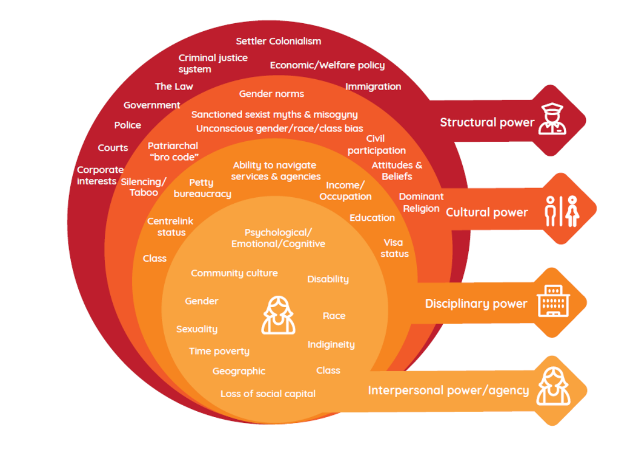
An Intersectional Power Analysis that shows power acting across four domains. All these impact the degree to which a person’s individual power and agency is obstructed or enabled.:
1) Interpersonal power/agency
2) Disciplinary power
3) Cultural power
4) Structural power

“Structural and disciplinary powers are tough to shift, but cultural and interpersonal powers are open to agency and change, particularly through collective efforts.”
– Dr Nilmini Fernando (2018) ‘When is the right time to talk about money?

How can intersectionality be used as a thinking tool?

In summary, Intersectionality as a thinking tool means we:
- Pay attention to power. How does it intersect and operate in the world?
- Think about your own positions of power and privilege.
- Look out for power dynamics. Call out power imbalances if it is safe for you to do so.
- Work more effectively with people whose intersecting experiences are marginalised or made invisible.
- Work towards removing compounding harms and dismantling barriers to access, inclusion, and participation at all levels of systems.
- Promote everyone’s human rights and ensure everyone can exercise their choices.

Tips for intersectional practice
Whether you have been ‘doing intersectionality’ for a while now, or are new to the idea, welcome.
Remember, it’s about power.
Our identities are an important part of who we are. It is the power that acts and intersects through identities and social locations that needs to be examined.

Reflect on your own positions.
Lean into the discomfort of your own privilege, or where you think you may be excluded or oppressed.

Practice self–care.
We are only human! This process involves some hard conversations. Take care of your wellbeing.
It’s okay not to have all the answers.
Power dynamics look different each time. It is not a ‘tick box approach’ and there is no ‘one–size fits all’ template. It’s more important to think about how you are harming or helping.
Meet people where they are.
No matter what, listen actively. Validate the act of sharing. Refrain from quick judgement.

You’re not in this alone!
Find trusted people you can talk to. Ask for training. Learning from each other is one of the best ways to practice intersectionality.

HANDS ON: INTERSECTIONAL PRACTICE PRINCIPLES & TOOLS

Principles for an intersectional approach
Intersectional practice is a journey. Use these principles to centre people who face multiple power structures. Look out for power imbalances. Practice reflection. Facilitate access and inclusion.
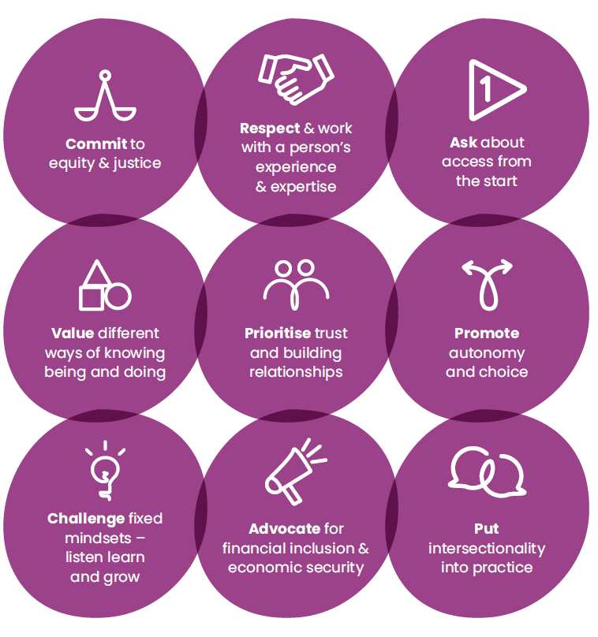

Commit to equity & justice
Think seriously about equity. How does our commitment to equity and justice translate into priorities, decision–making, and resource allocation?

Respect and work with a person's experience and expertise
Include the right mix of input and leadership when designing and delivering programs. Position women directly impacted as ‘experts’. Listen, take their lead.

Ask about access from the start
Be flexible and responsive. Ask about access from the start and at all stages, never assuming what a person’s needs are. Access is not just physical. Thinking about access, our attitudes and assumptions are the first point.

Value different ways of knowing being and doing
‘Normal’ is subject to our own position and perceptions. Value combining multiple ways of knowing, being and doing. Lift perspectives that may be undervalued or underrepresented by the mainstream.

Prioritise trust building and relationships
Recognise that for women who have experienced trauma, the need for trust, building relationships and safe spaces take precedence over other perceived good measures in a program.

Promote autonomy and choice
Be strength–based and locate people as “experts in their own life”. See women as being capable of making the decisions when given the right guidance, choices and support.

Challenge fixed mindsets – listen, learn and grow
Be aware that fixed assumptions can get in the way of working together. Be open to new ways of change: listen, learn and grow.

Put intersectionality into practice
See the ‘thinking and doing of intersectionality’ as one. Value authenticity over all else.

Advocate for financial inclusion and economic security
Working towards change within institutions, policies, and systems is our top priority. Find opportunities to advocate for change within these systems.

Who created these principles?
Intersectional practice starts with respecting experience and expertise. These principles were created from a process of listening to and working with women from various backgrounds. They represent what is important to the women who were part of the co-design process and what underpins intersectional practice.

How to use the principles:

These principles are useful for:
- People who create and deliver women’s financial capability programs.
- People who wish to account for power imbalances and different needs.
Use them together – they are equally important.
Think of them as opportunities – Think of these as overarching actions that will help shift power at all levels.
Ask questions and have conversations– Use the prompts and tools.
This guide doesn’t have all the answers– It is informed by multiple perspectives, but we recognise that some have also been left out.

Lay the groundwork before you begin, so that it helps, not harms:
Any intersectional endeavour must recognise the power dynamics inherent in this process, and the burden it can place on women that are expected to ‘represent’ this work and manage their own experiences of privilege and oppression. We can be eager to help, but the first priority should be to reflect on our own positions and perspectives. What do we need to support each other through this process and ‘do no harm’ to the people involved?

PRINCIPLE: Commit to equity & justice

Think seriously about equity. How does commitment to equity and justice translate into priorities, decision–making, and resource allocation?

Why? Programs are only fair if all women are at the same starting point. We know this is not the case. Many women are not treated as equals and do not have access to the same opportunities and resources as others.
Prompting questions:
- Who is routinely excluded from our programs and services?
- Who needs this program the most?
- How will we keep ourselves accountable?
Actions we can take when developing programs:
- Prioritise people who need this program the most
- Plan and allocate time and resources for outreach
- Empower people to be part of the decision–making process
- Work with them so we can understand what will make a difference to their lives

Actions we can take when delivering programs:
- Money education must be rights–based
- Support a person to advocate for their right

PRINCIPLE: Respect and work with a person’s experience and expertise

Include the right mix of input and leadership when designing and delivering programs. Position women directly impacted as ‘experts’. Listen and take their lead.

Why? If we are not our program’s target audience, we must seek out those who have experience firsthand as there will be perspectives or barriers we cannot see. No one speaks for everyone, but “speaking about us without us” is too common for marginalised women. What power imbalances might be at play here?
Prompting questions:
- What does a genuine partnership look like and mean?
- Whose perspectives tend to be valued? Whose tend to be sidelined?

Actions we can take when developing programs:
- Co–design. Share decision–making power
- Acknowledge and care for emotional labour
- Compensate anyone you work, consult or co–design with fairly for time and effort

Actions we can take when delivering programs:
- Let people share their money story
- Take a facilitator approach
People are the experts about their own life. Be wary of norms, biases or assumptions that tell us otherwise!

PRINCIPLE: Ask about access from the start
Be flexible and responsive. Ask about access from the start and at all stages, never assuming what a person’s needs are. Think about access in different ways. Our attitudes and assumptions are the first point.

Why? Asking about access early on will ensure programs set aside time and resources. Beyond that, programs must be open to seeking out needs that aren’t as obvious or may be distinct to a person, and be ready to welcome them.
Prompting questions:
- What assumptions and biases do we have about specific groups? How might these get in the way?
- How can we allocate time and resources to be flexible and responsive to access needs?

Actions we can take when developing programs:
- Embed access and inclusion planning
- Speak to a person directly about their access needs

Actions we can take when delivering programs:
- Ensure the person delivering is someone who can relate to your audience
- Always ask for feedback

See our Accessibility & Inclusion Tool for more tips

PRINCIPLE: Value different ways of knowing, being & doing

‘Normal’ is subject to our own position and perceptions. Value multiple ways of knowing, being and doing. Lift perspectives that may be undervalued or underrepresented by the mainstream.

Why? Inclusion and belonging must be cultivated. Even with a growing respect for different realities and cultures, many of our systems and structures are western, middle–class, heteronormative, patriarchal, and ableist.
Prompting questions:
- How might we lift emotional, local, indigenous, experiential, decolonising ways of knowing?
- How will we create culturally safe spaces and respond to discrimination?

Actions we can take when developing programs:
- Establish group rules that prioritise respect when people share their views
- Plan for inclusive and representative messaging - You can’t be what you can’t see

Actions we can take when delivering programs:
- Explore all learning methods and make it fun
- Build empathy not sympathy for people who are different to you

See the Accessibility & Inclusion Tool for more tips

Remember, financial well being means different things to different people. We all experience and cope with financial stress and financial difficulty differently.

PRINCIPLE: Prioritise trust building and relationships

Recognise that for women who have experienced trauma, the need for trust, building relationships and safe spaces take precedence over other perceived good measures in a program.

Why? Trust gaps can exist because people are let down by systems and services, and because communities are still mending and healing from the pain carried from trauma and violence in our histories. For many people, time, trust and safe spaces are needed to open up and talk about money.

Prompting questions:
- Why is trust or talking about money a barrier for this person or this community?
- How can leadership support their teams in this aspect of work and service delivery?

Actions we can take when developing programs
- Acknowledge we can both help and harm
- Agree to clear guidelines so people know what to expect and what support is available

Actions we can take when delivering programs:
- Work with trusted community organisations and groups

PRINCIPLE: Promote autonomy and choice
Be strength–based and locate people as “experts in their own life”. See women as being capable of making the decisions when given the right guidance, choices and support.

Why? Autonomy and choice are important motivators and catalyst for change. Many women also need self–belief and confidence in order to take financial action.
Prompting questions:
- How do we support people to realise their money goals on their own terms?
- What does it mean by ‘people are the experts in their own life’?

Actions we can take when developing programs:
- Challenge deficit–based thinking that sees individuals as the problem

Actions we can take when delivering programs:
- Coach, don’t tell
- Validate their values and priorities

“It’s about centering in all aspects of the program. It’s not just that you’re quite happy to deliver to women with disabilities. You want to co–design with them, you want them to deliver your programs, you want them to evaluate your programs and you want them to, you know, be happy with your programs. And there’s also the unavoidable fact that a lot of people will experience disability themselves. So, you’re future proofing yourself in a job potentially”
– Ashleigh, Disability Advocate and Consultant

“Understand the effects of trauma. You're not always going to be available, if you're having a stressful day or week, the trauma belts you and it's not easy to be present.”
- First Nations Co-design Participant
“Have the opportunities ready to employ all these talent, skills, no matter how big or small they are, no matter how old or young they are, there is a place for them in the employment sector [and] in society. Just play to everyone’s strengths, not everyone’s weaknesses.”
- Eman, Let’s Talk Money Peer Educator, WHIN.

PRINCIPLE: Challenge fixed mindsets – listen, learn and grow
Be aware that fixed assumptions can get in the way of working together. Be open to new ways of change: listen, learn and grow.

Why?
Getting the right mix of perspectives is the first step. Working together and finding ways to reach consensus is another. It can be hard to acknowledge our own blindspots. Always try to see it from different views and be mindful of our own assumptions and biases.
Prompting questions:
- How can we challenge our own assumptions and biases and refuse to pass on stereotypes to others?
- How can we lean into the discomfort of our own privilege?

Actions we can take when developing programs:
- Create ‘listen, learn, grow’ cultures in our teams, programs and organisations
- Apply these principles to yourself

Actions we can take when delivering programs
- Listen actively– maintain eye contact if appropriate, do not interrupt, avoid distraction, present positive body language and tone, give positive feedback

PRINCIPLE: Put intersectionality into practice
See the ‘thinking and doing of intersectionality’ as one. Value authenticity over all else.

Why? To undertake this work we need to rethink priorities and regular processes. One of the biggest barriers we face is time. But time and space is needed to interrogate power. Another barrier is checkbox approaches and tokenistic commitment. This can be more harmful.

Prompting questions:
- What challenges do we face with putting intersectionality into practice?
- What promotes tokenism? How can we be more authentic?

Actions we can take when developing programs:
- Consider intersectionality at the outset don’t add–on at the end
- Develop an organisational wide approach

Actions we can take when delivering programs:
- Look out for power imbalances
- Ask for time to reflect

PRINCIPLE: Advocate for financial inclusion and economic security for all women

Working towards change within institutions, policies, and systems is our top priority. Find opportunities to advocate for change within these systems.

Why? Money education, at the right time, can be crucial for women to make informed decisions. But what people also need is equitable access to money, resources, social capital, and relevant financial services.

Prompting questions:
- How can we ensure people directly impacted by our programs have a voice?
- Where in our organisations do we need to have more accessibility and inclusion conversations?

Actions we can take when developing programs:
- Work with grassroots organisations that are speaking directly to women

Actions we can take when delivering programs:
- Listen to clients and participants you work with and share their insights

“... You will need to build rapport. I think the use of visible materials such as cards, videos and getting them to participate by using cards to communicate what they are thinking or what they think it means to them and their family. We found that talking about money through their painting work.”
– First Nations Co-design Participant

“[In] our workshops, we try to teach some terminology in English. We write the translation next to it, but it is in English and we tell them please learn this term. You will face it many times in the coming days and living your life here.”
– Eman, Let’s Talk Money Peer Educator, WHIN
“Running powerpoint presentations on a slide, you are likely to lose the captive of the group, if you replace it with hands on programs, these work much better. “
– Jennifer, First Nations Co-design Participant

Pathways and opportunities
These insights are from a co-design process with a group of women with disabilities to develop this guide and show what is important in order for programs to work well for them.

Program design
Ask about access from the start
“We need the same information as everyone else, just in a different way.”

Commit to equity & justice
Prioritise those who are often excluded.

Respect and work with experience and expertise
Position women with disabilities as the experts. Co–design.

Advocate for financial inclusion and economic security
Women with disabilities may: Be excluded from employment; not have access to their bank account; have been traditionally silenced.

Challenge fixed mindsets
People automatically have low expectations.

Put intersectionality into practice
Centre women with disabilities.

Program delivery
Prioritise trust–building and relationships
It takes time to get to know your target audience.
Work with trusted organisations so there is a safe space to talk about money.
Value different ways of knowing, being and doing
“I want to relate to the person who is running the program.”
You can’t be what you can’t see.

Promote autonomy and choice
Are you working with women with disabilities?

Challenge fixed mindsets
If your attitudes are patronising, clients will be unable to communicate with you.
“Speak to me, not to the Support worker.”

Three Practice Tools – Reflection, Accessibility & Inclusion, and Power

#1 Reflection tool: How is your intersectional practice?
Reflection is an important activity that helps us take a pause at different stages of program development and delivery. Reflecting individually or together can uncover the relational and contextual aspects of power. Use this tool to reflect on the principles and our positions in relation to the work.
#2 Ten ways to think about accessibility and inclusion
Intersectional practice means working towards removing compounding harms and dismantling barriers to access, inclusion, and participation at all levels of systems. Accessibility is an ongoing conversation. In this tool we provide ten ways to think about access and inclusion.

#3 Paying attention to power
Power is dynamic and complex. Looking out for power imbalances is a collaborative process and takes practice. In this tool we provide three examples of power imbalances to be aware of during program design and delivery.

Reflection tool: How is your intersectional practice?
Use this tool to reflect on the impact of your positions and actions, and identify strengths and weaknesses in how you, your team, and your organisation practices intersectionality.

Reflection is a process | Find strengths
- Create space and time so we can reflect deeply  and share safely  - Practice active listening and respectful communication  - Look out for power imbalances at play in the process | - What are we already doing?  - What are our strengths?  - What do we do well in the way we work and in our programs?
Whose views are important? | Find weaknesses
- How will you centre the person in your program/service?  - What do these principles mean to them?  - Whose voice is missing here? | - What aren’t we doing? Why? What’s important?  - What stops us as individuals/ teams/ programs/ organisations?  - What do we need to do differently? Who might we need to work with?

Ten ways to think about accessibility and inclusion
This tool will help you think about different ways to facilitate access and inclusion when creating programs.

THREE GENERAL RULES:
- Everyone is different even if we share similarities. Get to know your target audience.
- Asking is better than assuming. People know best what they need.
- Removing barriers and understanding what a person needs is an ongoing conversation and starts with respect.

- ATTITUDES & ASSUMPTIONS
- What preconceptions and assumptions do you have to guard against?
- How will you reframe ableist narratives or myths about culture?

- COMMUNICATION ACCESSIBILITY
- Do you need Plain English or Easy English?
- Is there a glossary of key terms?
- Do you need audio or visual prompts or a translator?
- Do you know what accessible communication format is needed?
- PHYSICAL ACCESSIBILITY AND LOCATION
- Do your participants have physical accessibility needs?Are the bathrooms accessible and gender neutral?
- Is the lighting suitable for vision impaired people?
- Is there a break room or resting space?
- Is there clear information about transport and parking?

- DIGITAL ACCESS
- Do your participants need good internet connection?
- Are they comfortable with online technology?
- Who may be included or excluded if the program is digital only?
- Are you recording online sessions?
- Do you need a quick exit button for web pages?

- CULTURAL SAFETY AND SENSITIVITY
- Is the space safe for people to talk about money?
- How will you respect cultural norms that are not your own?
- Who is facilitating? How will you make the session relatable?
- Do you have strategies for discriminatory or disrespectful behaviour?
- LANGUAGE
- Do you know about person–first or inclusive language?
- Are you matching the spoken and body language of your participants?
- Are you able to explain financial jargon in everyday words?

- TIME
- Are you flexible when working with co–design participants or consultants?
- Are you giving time to read, time to speak, time to process, time to translate, time to trust and time for feedback?

- LEARNING STYLES AND TOPICS
- Are you using adult learning principles?
- Do you know what participants are interested in knowing more about?
- Have you explored all learning styles?
- How will you make it fun? Less scary? Or not boring?

- DIFFERENT LIFE STAGES AND CIRCUMSTANCES
- How will you value different money stories and experiences?
- What specialist approaches do you need?
- How will you safely respond to financial abuse or family violence disclosures?

(10) POWER IMBALANCES
- What power differentials in the room do you have to look out for?
- How can you take an “I am not the expert” approach?
- How will you respect and work with the experience people have?

Paying attention to power
Three examples of power imbalances that can come up in program design and delivery,
and what we can do about it.

Power imbalances to be aware of: | What can I do about it?
Dominant paradigms and structures  Powerful forces always act in parallel to systems of oppression, directly, or indirectly maintaining them. The paradigms and social structures currently dominant in Australia are white, patriarchal, and capitalist, and are built on historically accumulated power and stolen First Nations land. Power imbalances in this category run deep. They are entrenched in our realities and social norms and translate into rules and processes we follow. (See Fernando 2018 cultural and structural power domains) | - Remember, being insulated by our positions of privilege can mean it’s easier to brush off demands, or make it hard to notice imbalances.  - Be open to disturbance, going against the flow, or questioning norms.  - Find strength in numbers. Work with active change agents. Help keep each other in check.  - Look out for deficit-based framing and othering  - Keep speaking to and nurturing new paradigms and practices that promote equity and justice
Decision making power  Many of our organisational models are designed for top-down decision-making. People who are directly impacted by our programs may be consulted, but seldom lead the design and decision-making process. Power imbalances in this area can also show up relationally, when we “unknowingly take positions of power and assume that [a person’s] difference makes them less capable of making decisions. | - Ask: How can we redefine who the ‘right’ people are to make decisions?  - Apply co-design models that share power (See McKercher model as example)  - Cultivate power to, power with and power within (See principles: Promote autonomy and choice and Challenge fixed mindsets)  - Increase the visibility and legitimacy of grassroots issues, voice and demands.  What not do to:  - Token representation.  - Fail to compensate co-design participants for their time and efforts.
Power differentials in a group  Power imbalances in groups are different every time, as they depend on group dynamics, and factors like who’s in the room, what is being discussed, unspoken norms, who is leading the discussion. Power imbalances in groups can be internalised. Because they are highly contextual and relational,what can feel relatively harmless or normal to one person, can be highly uncomfortable, or at the expense of someone else. | - We need to work together to address racist, ableist, sexist, ageist, and heteronormative assumptions  - Establish group agreements and anti-discrimination strategies  - Be clear about decision-making processes  - Prioritise safety and doing no harm over the what might appear to be the perceived normal comforts of the group  What not do to:  - Minimise a person’s experience  - Single people out based stereotypes

TERMS WE USE

Financial capability and wellbeing
Financial capability is “a combination of knowledge, skills, attitudes and behaviours needed to make sound money decisions, based on personal circumstances, to improve financial wellbeing.” (Source: Muir et al. 2017). It is an individual and structural idea. For women who experience trauma, marginalisation, or have limited control over their finances, financial capability is also about access (opportunities to act) and self–efficacy (confidence and belief that you can act on your desire) (Source: WIRE Purse Project 2021).
Financial well being means different things to different people. It is a holistic way to understand a person’s financial position beyond income alone (Source: Brown & Noone 2021). It can be defined as, “when a person is able to meet expenses and has some money left over, is in control of their finances and feels financially secure, now and in the future.” (Source: Muir et al. 2017).
Financial inclusion “Focuses on the extent to which people can access and use appropriate financial products. In Australia, financial inclusion is commonly measured in terms of access to appropriate and affordable insurance, credit, and transaction accounts (Connolly, 2014). However, access is not sufficient to ensure wellbeing, and a purely product-based approach is too narrow to meet a population’s complex financial needs.” (Source: Good Shepherd Microfinance Advisory Services 2019)
Financial coaching is an “application of coaching techniques designed to develop a client’s capability to manage their own finances and sustain economic security in accordance with their self-defined goals.” (Source: Collins n.d.)

Power and Intersectionality
Intersectionality: A working definition - “Intersectionality investigates how intersecting power relations influence social relations across diverse societies as well as individual experiences in everyday life…” (Source: Collins & Bilge 2020). In this guide, it is described as a feminist framework that focuses on how power works through social and economic systems and acts in different contexts to create positions of power or powerlessness.
Feminist Framework: “Centers women’s lived experiences and critically addresses power differentials that create complex, intersecting entrenched gendered barriers that persistently and disproportionately economically disadvantage women in comparison to men.”(Source: Fernando 2018).
Power: There are many approaches to understand ‘power’. In this guide, we have described power as being everywhere, distributed, rather than concentrated, and embedded in social relations and processes, a definition put forth by Foucalt (Source: Powercube).
Privilege: “Rights or benefits available and unearned to a particular person or group in detriment of others. These benefits constitute forms of power … Privilege is closely linked to the concept of oppression as it constructs social relations and practices by putting certain individuals or groups at disadvantage.” (Source: Mendez de la Brena & Baracsi 2020).
Oppression: a “dynamic and contextual process by which a group in society acquires power and privilege through the systemic exploitation and control over other groups, which are pushed down into lower strata of the social order (Pincus, 2006, p. 145).” (Source: Mendez de la Brena & Baracsi 2020).
Systems of oppression: “are embedded in beliefs, attitudes, behaviors, socio-cultural structures, institutionalized policies and ideologies… systems of oppression such as classism, (hetero) sexism, ableism, racism and other oppressive “isms” are interconnected in ways that nurture, reinforce and validate each aspect of existence” (Source: Mendez de la Brena & Baracsi 2020).
Forms of power (Source: Powercube):
- Visible: observable decision-making mechanisms, winners and losers
- Hidden: setting the agenda behind the scene, biases which exclude
- Invisible: social conditioning, ideology, influencing people’s needs
Expressions of power: A helpful way to conceptualise power as it shows how power can be a positive and transformative force (Source: Powercube).
- Power over: domination or control of one over another
- Power to: individual ability to act
- Power with: collective action, working together
- Power within: self-worth, dignity
Fernando’s (2018) Intersectional Power Analysis: shows power acting across four domains. All these impact the degree to which a person’s individual power and agency is obstructed or enabled. (Source: Fernando 2018)
- Disciplinary power: how structural power is organised and managed through bureaucratic organisations, policies and protocols that dictate access and eligibility (e.g. Centrelink, schools, Legal Aid, Child Protection)
- Cultural power: dominant white Western cultural norms, gender, heteronormative, ableist, racist norms, values, beliefs and ideologies that make oppressions seem legitimate
- Structural power: overarching power structures like the Law, courts, immigration regimes, global economy, corporate interests which are slow to change, and in Australia, are rooted in white Western settler colonialism
Marginalisation: “The multilayered and dynamic process of being made peripheral or silenced in a social group, preventing individuals and groups from having access to and control over resources and power.” (Source: Mendez de la Brena & Baracsi 2020).
Social locations: “depend on the specific situations and settings in which we find ourselves: our political and historical contexts, as well as the forces that govern our behaviour and operate around us such as laws, policies, institutions and media. Our social locations [are not fixed] and arise from a constellation of many co-operating factors and interactions of power and discrimination.” (Source: Chen 2017).

Program approaches
Strength-based “responses locate women as ‘experts’ in their life who have survived and managed their safety throughout their family violence journeys, and who are able to make choices and decisions when provided with knowledge, information and support.” (Source: Fernando 2018)
Trauma-informed care and practice is “a strengths-based framework grounded in an understanding of and responsiveness to the impact of trauma, that emphasises physical, psychological, and emotional safety for everyone, and that creates opportunities for survivors to rebuild a sense of control and empowerment (Hopper et al., 2010).” (Source: Blue Knot Foundation)
Trauma and violence informed approach: “doesn’t ask, What’s wrong with you? but what happened to you?... is woman-centered, holds women’s individual needs at the central focus, and accounts for the intersecting impacts of systemic and interpersonal violence and structural inequities on a person’s life (Hegarty et al. 2017)…” (Source: Fernando 2018).
Social model of disability: “From the medical model, a person with disability is in need of being fixed or cured. The social model sees ‘disability’ as socially constructed and the result of the interaction between people living with impairments and an environment filled with physical, attitudinal, communication and social barriers…[and that these] must change to enable people living with impairments to participate in society on an equal basis with others.” (Source: People with Disability Australia 2018).
Cultural safety: “Cultural safety for Aboriginal people is an environment where there is no assault, challenge or denial of their identity, of who they are and what they need”(Source: Everybody Matters 2018).
Co-design: “An approach to designing with, not for, people. While co-design is helpful in many areas, it typically works best where people with lived experience, communities and professionals work together to improve something that they all care about. Overall, the primary role of co-design is elevating the voices and contributions of people with lived experience.” (McKercher 2020)

RESOURCES FOR PRACTITIONERS

Organisation Specific
WIRE
- Women’s Financial Capability Project
- Financial capability and wellbeing resources
- Training Intersectional Economics and ‘Purse Project’
- Videos MODEL for money conversations
Good Shepherd (GSANZ)
- Financial Capability and Wellbeing Programs
- Financial resources and publications
Brotherhood of St Laurence (BSL)
- Stepping Stones to Small Business Program
- BSL Financial Wellbeing Framework
First Nations Foundation
- Resources for Industry Partners
- Research publications
Women’s Health in the North (WHIN)
- Let's Talk Money Program

Intersectional, feminist, power
Sector publications
- Chen (2017) Intersectionality Matters
- Dawson, Kovac, Lewis (2020) Measure For Measure: Gender Equality in Australia
- Our Watch (2017) Equality and respect for all women: An intersectional approach
- WIRE (2021) Intersectional Economics Training Resource List
Books, articles, resources
- Ali (2020) I am not ‘hard to reach’
- Collins & Bilge (2020) Intersectionality
- D’Ignazio & Klein (2020) Seven intersectional feminist principles for equitable and actionable COVID-19 data
- Lorde (2007) Sister Outsider Essays and Speeches
- Powercube Handout on Power and Empowerment
- Stewart (2017) Diversity and Inclusion vs Equity and Justice
- Who, Drummond and Watego (2019) The Blackfulla Test: 11 reasons that Indigenous health research grant/publication should be rejected
- Zevallos (2017) White privilege in discussions of racism
- For discussions on equity, diversity, inclusion, social justice Dr Zuleyka Zevallos The Other Sociologist Blog
- For a diagram on systems of oppression see page 5 (Source: YWCA Australia 2020)
- For systems of oppression definitions see Mendez de la Brena & Baracsi 2020

For video and audio learners
- Newcastle University (2018) What is Intersectionality
- Crenshaw (2016) The urgency of intersectionality
- University of Maine (2019) Video on equity and equality
- Women with Disabilities Victoria (2021) Six Keystones for Understanding Disability

Co-design justice
- Design Justice Network (2016) Design Justice Network Principles
- McKercher (2020) Beyond Sticky Notes
- Jax Weschler (2021) Trauma-informed design research

Reflection
- DVRCV Reflective practice
- Kaplan & Davidoff (2014) A Delicate Activism: A Phenomenological Approach to Change
- Vikki Reynolds (2020) Resisting ‘Burnout’ &‘Vicarious Trauma’ Collective Care & Justice-Doing : The Zone of Fabulousness
- Wheatley (2002) Willing to be Disturbed

ABOUT THE PROJECT AND PARTNERS

About the Project
The Women’s Financial Capabilities Project (WFCP) aims to improve the financial capabilities and economic security of women across Victoria, with a particular focus on First Nations women, women from migrant, refugee, and asylum–seeker backgrounds and women with disabilities. The program identifies the intersecting barriers faced by women in achieving financial security and economic empowerment, and works to find best practice ways to address these on an individual, community and structural level.

Find out more about the project.

WFCP is a partnership between WIRE, Good Shepherd Australia and New Zealand, First Nations Foundation, Brotherhood of St Laurence and Women with Disabilities Victoria, and funded by the Office for Women, the Victorian Government.

Read more about the organisations and their work in financial capability building.

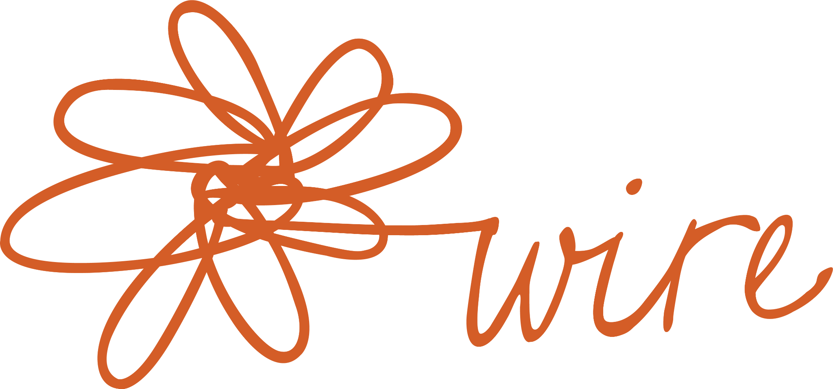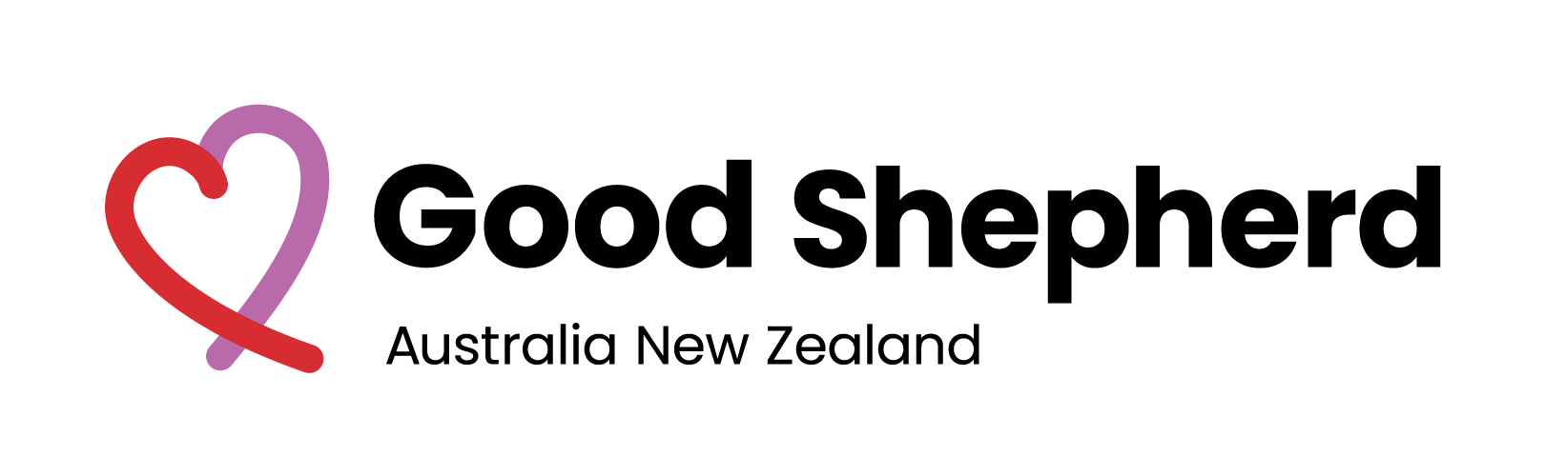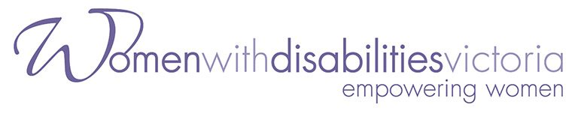

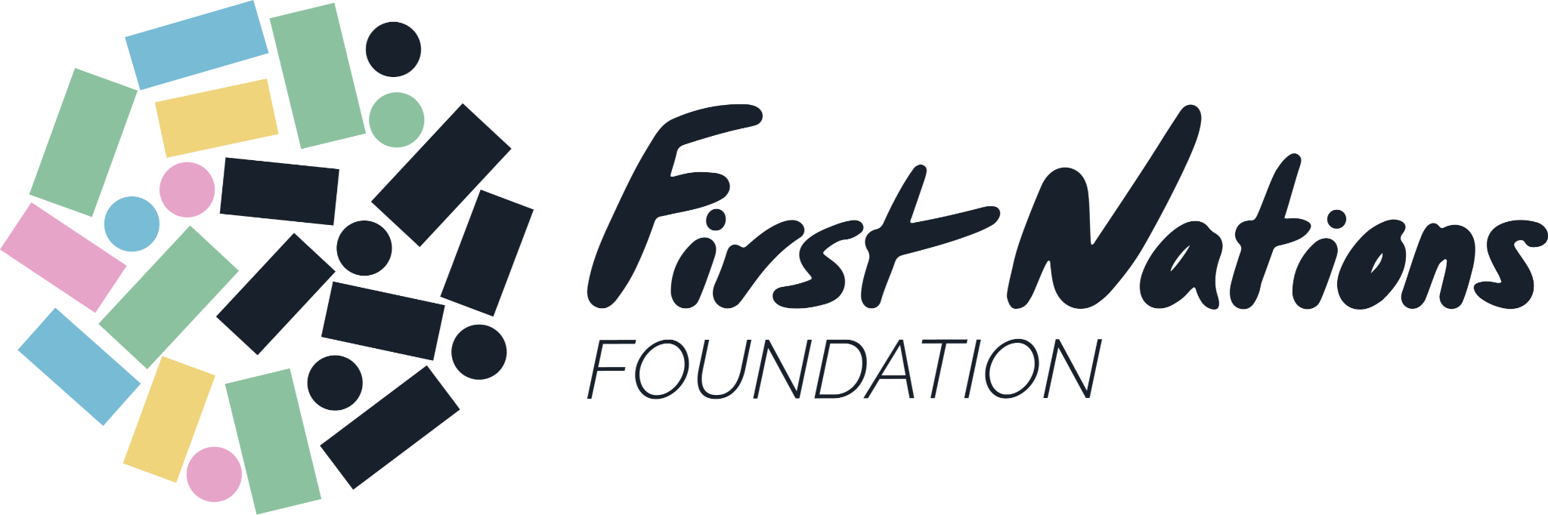

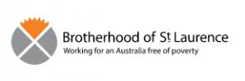

People behind the guide
The project co–design team included:
- Rachel Soh, GSANZ, Financial Capability Co–design Facilitator
- Catherine Connolly, WIRE, WFCP Project Manager
- Tricia Malowney, Disability Consultant
- Ashleigh Malone, Disability Advocate and Consultant
- Janet Curtain, Self-Advocate, Power in Ethnicity and Culture, and Disability Support Worker
- Nimo Hersi, Co–design Consultant and Disability Advocacy Coordinator for the Ethnic Communities Council of Victoria
- Wendy Brown, GSANZ, Financial Capability Program Manager

Partners and networks who supported the project through additional co–design, consultation and feedback:
- Women with Disabilities Victoria (WDV), Experts by Experience Group and team members: Carmela, Kerrie, Sam, Helen, Larissa, Cath, Ashleigh, Karleen, Eva, Rachael, Tess, Carly, Bianca
- Brotherhood of St Laurence (BSL) Stepping Stones Program Participants and team members: Tania, Sangita, Madina, Taghrid, Veronika, Joy, Abrar, Linet, Emma, Angie, Marta
- Women’s Health in the North (WHIN) Let’s Talk Money Program Peer Educators and team members: Manasi, Shazia, Eman, Sadia, Candice, and Farah
- Lynda Edwards, Coordinator Financial Capability, Financial Counselling Australia, and Larisha Jerome, Community Engagement and Project Officer, First Nation Foundations, their partners and colleagues across Australia: Carmen, Tania, Jennifer, Shardai, Patrice, Teisha
- WIRE: Julie Kun, CEO and WIRE staff
- Good Shepherd Australia New Zealand (GSANZ): Ramesh Kumar, Head of Program Delivery Financial Health & Wellbeing Services, the Financial Capability Team, Financial Coaches, Good Money Store workers, and people in service and program design/coordination
- Additional consultants, co-design contributors: Carol, Mim, Dr Nilmini Fernando, and Zuleika Arashiro
- WFCP governance group members

Design acknowledgements:
- Designed by studio kettle
- Title idea ‘hands-on’ credited to First Nations co-design contributions Jennifer and Tania
- Pathways and Opportunities idea credited to Jessica Pieris, GSANZ

About the organisations

WIRE is a leading service delivery organisation with more than 38 years’ experience supporting women, nonbinary and gender diverse people across Victoria. WIRE are the only state–wide free service that provides information, support and referrals on any issue, empowering service users to make informed decisions in their lives. WIRE’s projects, services & advocacy analyse economic contexts through an intersectional, feminist lens, recognising that current economic practice and policies do not impact people equally.

Good Shepherd Australia New Zealand (GSANZ) is a community service not for profit organisation that challenges the critical and ongoing issues facing women, girls and families. Good Shepherd provides support in the areas of family and domestic violence, financial insecurity and youth experiencing disadvantage. Their services ensure people do not fall through the cracks, helping them to feel safe and take control over their own lives. Good Shepherd’s vision is for all women, girls and families to be safe, well, strong and connected.
Women with Disabilities Victoria (WDV) is an organisation of women with disabilities for women with disabilities. WDV recognises that women with disabilities are among the most marginalised in our community and empowers women with disabilities to achieve their rights in Victoria. WDV focuses on those areas where gender inequity and/or disability have the biggest impact on the capacity of women with disabilities to be respected and to fully experience life.
Women’s Health in the North (WHIN) is the women’s health service in the northern metropolitan region of Melbourne. WHIN works to eliminate gender inequities and improve outcomes in women’s health, safety and wellbeing.

Brotherhood of St Laurence (BSL) addresses poverty through grassroots programs and policy development informed by research and the best available evidence. Their long experience tells that the best results are achieved when we join hands with others. BSL believes it is essential that the voices of the people we work with and their communities are heard and considered.

Financial Counselling Australia (FCA) is the national voice of the financial counselling profession in Australia. There are about 800 financial counsellors working in Australia. Through their efforts, thousands of Australians are able to overcome financial hardship.

First Nations Foundation is an Indigenous financial wellbeing foundation led by an Indigenous majority board since 2006. The Foundation has a strong trust reputation with both financial and Indigenous community sectors, a powerful track record of results, agility and innovation. They work with Indigenous communities and the finance industry to provide customer centric financial education, training and information.

REFERENCES

Arashiro, Z. (2021). Too visible, yet not fully seen: Insights from the COVID-19, Financial Capability, and Intersectionality Project. WIRE. https://www.wire.org.au/too-visible-yet-not-fully-seen/
Australia and New Zealand Banking Group (ANZ) (2018). Financial Wellbeing: A survey of adults in Australia. ANZ. https://www.financialcapability.gov.au/files/anz-financial-wellbeing-summary-report-australia.pdf
Batliwala, S. (2019). All about power: Understanding social power & power structures. https://namati.org/wp-content/uploads/2019/05/All-About-Power-Srilatha-Batliwala.pdf
Brown, J.T., Noone, J.,.2021. Amplify Insights: Financial Wellbeing. Centre for Social Impact, UNSW Sydney.
Brown, J., & Noone, J. (2021). Addressing financial wellbeing with a systems based approach. Power to Persuade. http://www.powertopersuade.org.au/blog/addressing-financial-wellbeing-with-a-systems-based-approach/22/7/2021
Chen, J. (2017). Intersectionality Matters: A guide to engaging immigrant and refugee communities to prevent violence against women. Multicultural Centre for Women’s Health. https://www.mcwh.com.au/wp-content/uploads/Intersectionality-Matters-Guide-2017.pdf
Collins, P. H., & Bilge, S. (2020). Intersectionality (2nd ed.). Polity Press. https://play.google.com/books/reader?id=fyrfDwAAQBAJ&hl=en_GB&pg=GBS.PT170
Crenshaw, K. (2016). The urgency of intersectionality. https://www.ted.com/talks/kimberle_crenshaw_the_urgency_of_intersectionality
Culture Amp. (2019). Workplace Diversity, Inclusion, and Intersectionality. https://www.cultureamp.com/resources/diversity-inclusion/workplace-diversity-inclusion-and-intersectionality-report-2019?submissionGuid=014e9bcb-1398-4d2f-adb1-f5b50321729a
Design Impact. (2017). Metathemes: Designing fro Equitable Social Change. https://d-impact.org/portfolio/metathemes/
Design Justice Network. (2018). Read the Principles. Design Justice Network. https://designjustice.org/read-the-principles
D’Ignazio, C., & F. Klein, L. (2020). Seven intersectional feminist principles for equitable and actionable COVID-19 data. Big Data & Society, 7(2), 205395172094254. https://doi.org/10.1177/2053951720942544
Diversity Council Australia/Jumbunna Institute (Brown, C., D’Almada-Remedios, R., Gilbert, J. O’Leary, J. and Young, N.) Gari Yala (Speak the Truth): Centreing the Work Experiences of Aboriginal and/or Torres Strait Islander Australians, Sydney, Diversity Council Australia/Jumbunna Institute, 2020.
Faulkner, N., Borg, K., Zhao, K., & Smith, L. (2020). THE INCLUSIVE AUSTRALIA SOCIAL INCLUSION INDEX: 2020 REPORT. 34.
Fernando, N. (2018). Financial ‘Teachable Moments’ for women affected by family violence (p. 106). https://www.wire.org.au/wp-content/uploads/2018/12/WhenIsTheRightTimeToTalkAboutMoney.pdf
Gender Equity Victoria (GENVIC). (2021). Facilitating inclusive discussion in digital feminist spaces. https://www.genvic.org.au/wp-content/uploads/2021/02/Feminist-Deliberation-Online-FINAL240221.pdf
Heath. (2019). How to really build financial capability.
Hopkins, P. (2018). What is intersectionality? https://www.youtube.com/watch?v=O1islM0ytkE
Kaplan, A., & Davidoff, S. (2014). A Delicate Activism: A Phenomenological Approach to Change. Proteus Initiative. http://www.proteusinitiative.org/books-and-other-publications
Kutin, D. J. (2019). Improving the financial capability and financial confidence of women in Victoria. 32.
Landvogt, K. (2008). Money, Dignity and Inclusion: The role of financial capability. Good Shepherd Youth & Family Service.
Landvogt, K. (2011). Effective financial education for vulnerable groups. Good Policy: Newsletter of Good Shepherd Youth & Family Service Social Policy Research Unit, 7(1). https://goodshep.org.au/wp-content/uploads/2020/12/good_policy_volume_7_no1_-autumn_2011.pdf
Lorde, A. (2007). Sister Outsider: Essays and Speeches. Ten Speed Press. http://images.xhbtr.com/v2/pdfs/1082/Sister_Outsider_Essays_and_Speeches_by_Audre_Lorde.pdf
McKercher, K. A. (2020). Beyond Sticky Notes. Inscope Books. https://www.beyondstickynotes.com
Muir, K., Hamilton, M., Noone, J.H., Marjolin, A, Salignac, F., & Saunders, P. (2017). Exploring Financial Wellbeing in the Australian Context. Centre for Social Impact & Social Policy Research Centre – University of New South Wales Sydney, for Financial Literacy Australia
Multicultural Centre for Women’s Health (MCWH). (2019). Six things you need to know about intersectionality – Multicultural Centre For Women’s Health. https://www.mcwh.com.au/six-things-you-need-to-know-about-intersectionality/
Multicultural Centre for Women’s Health (MCWH). (2020). Challenging myths about culture and violence in migrant and refugee communities. https://www.mcwh.com.au/wp-content/uploads/Challenging-Myths-210617-FINAL.pdf
Our Watch. (2017). Equality and respect for all women: An intersectional approach. https://media-cdn.ourwatch.org.au/wp-content/uploads/sites/2/2019/02/15002445/PG_Equality-and-respect-for-all-women_UpdatedFeb2019.pdf
Powercube. (n.d.). Foucault: Power is everywhere | Understanding power for social change | powercube.net | IDS at Sussex University. Powercube.Net. https://www.powercube.net/other-forms-of-power/foucault-power-is-everywhere/
PwC Australia. (2019). The Benefit of Designing for Everyone (p. 18). Centre for Inclusive Design. https://centreforinclusivedesign.org.au/wp-content/uploads/2021/05/inclusive-design-report-digital-160519.pdf
‘Reach everyone on the planet...’ Kimberlé Crenshaw and Intersectionality. (n.d.). Retrieved 17 August 2021, from https://www.boell.de/sites/default/files/crenshaw_-_reach_everyone_on_the_planet_en.pdf
Russell, R., Kutin, J., Stewart, M., & Rankin, G. (2017). MoneyMinded impact report 2017, with a focus on financial wellbeing in a disability services context. (p. 36).
The State of Victoria (Family Safety Victoria). (2018). Everybody Matters. 56.
Toolkit_on_intersectional_mainstreaming-komprimiert.pdf. (n.d.). Retrieved 17 August 2021, from https://www.esaa-eu.org/fileadmin/esaa/content/communication_kit/toolkit_on_intersectional_mainstreaming-komprimiert.pdf
Western, D. (n.d.). Learning through reflective practice. Domestic Violence Resource Centre Victoria. https://www.dvrcv.org.au/help-advice/service-providers/family-violence-practitioners/reflective-practice
WIRE. (2021a). Intersectionality Action Plan project. WIRE. https://www.wire.org.au/intersectionality-action-plan/
WIRE. (2021b). WIRE Purse Project: Training Manual and Slides.
WIRE. (n.d.). Better access for women, nonbinary & gender diverse people over 50. https://www.wire.org.au/better-access-for-older-people/
Zevallos, Z. (2020). Intersectionality, Equity, Diversity, Inclusion and Access. Other Sociologist. https://othersociologist.com/intersectionality-equity-diversity

Muir et al. (2017)
ANZ 2018
Fernando (2018)
Batliwala (2019)
Powercube (n.d.)
See p. 5 for diagram on systems of oppression by YWCA Australia (2020)
Power to Persuade (2021)
Design Impact (2017)
Fernando (2018)
Fernando (2018)
WIRE, Purse Project (2021)
Design Impact (2017)
Diversity Council Australia/Jumbunna Institute (2020)
Fernando (2018); Landvogt (2008)
Design Impact (2017)
MCWH (2017)

