The WDV 2021 AGM via Zoom:
Guide for Attendees
This year, the Women with Disabilities Victoria Annual General Meeting will again be held completely online, via the teleconferencing application Zoom.
You can join the Zoom meeting on either a computer, laptop, tablet, or mobile phone. You can even join on just a landline phone - though note that this will give you sound only, and you won’t be able to take part in voting (you will have to appoint a Proxy to vote for you instead).
This document will guide you through the process to register, access and participate in the AGM.
The following is a summary of the process:
- To access the AGM, first you need to register by filling in the Registration/RSVP Form. You can do this at any time prior to the start of the meeting, but we ask that you do this by Friday 22 October if possible, to avoid potential delays to the start of the meeting.
- Once you have done this you will be given the details on how to access the meeting. You will also be sent an email with these details as well.
- To join the meeting on the day you will simply need to click on the link in your confirmation email.
- Important: Before you attempt to register and access the meeting, you will need to have Zoom installed on your computer or device (unless you are joining by phone only – see more information in the following guide). You can download Zoom here. (Choose either “Zoom Client for Meetings” for a desktop device, or “Zoom Mobile Apps” for a mobile device.)
Zoom has a range of in-built accessibility features and in addition we will have both captioning and real-time Auslan interpreting at the meeting. We have also developed an Accessibility Guide if you wish to read more on accessing these features.
Please note that the AGM will be recorded. There is a chance that in the recording, some Members’ faces might be visible, so if you do not want to be photographed/filmed, please turn off your video.
If you are planning to share a device with another Member/s and you all want to vote, please read the special instructions for this. One or more of you will have to appoint a proxy to be able to vote.
Please note that the following guide contains screenshots of what you might see if you are viewing a device. Captions are provided underneath to describe the content of the screenshots.

Contact us
If you have any questions or require any assistance with accessing the meeting, WDV staff are available to help as best we can! You can contact us prior to the meeting on:
- Email: AGM@wdv.org.au
- Phone: (03) 9286 7800.
Technical support will also be available during the meeting, but we will be limited in how many requests we can answer so we recommend that you keep this guide close-by as well.
We look forward to seeing you at our virtual 2021 AGM!
Regards,
The Women with Disabilities Victoria AGM Team

Table of Contents
Contact us 2
Part 1 - Registering for the AGM 4
Part 2 – Joining the Meeting 7
Part 3 – Inside the Meeting 10
Turning off your video (if you don’t want to be seen) 10
Raising Your Hand 10
Moving and Seconding a Motion 12
Voting in the Board Elections 12
If Members Are Watching on the Same Device 12
Members Appointed as a Proxy 13
Speaking during the meeting 13
Asking a question during the meeting 13
Requesting technical support during the meeting 14
Accessibility Guide 15
Auslan Interpreter 15
Closed Captions 15
Audio Description 15
Keyboard Navigation 16
Screen Reader Support 16
Key functions to note if using Keyboard Shortcuts or a Screen Reader 16
Additional Accessibility Information 17
Accessing the Meeting – FAQs 18
I can’t access the meeting from my browser – how do I get in? 18
How do I join by phone? 18
Can I share my audio or video during the meeting? 18
I am having issues with Zoom or I can’t access the meeting 18
How do I appoint a Proxy to vote on my behalf? 19

Part 1 - Registering for the AGM
Important: Before you attempt to access the meeting, you will need to have Zoom installed on your computer or device. You can download Zoom here.
You can register at any time prior to the start of the meeting, but we ask that you do this by Friday 22 October if possible.

Step 1
Visit the AGM Registration page to register for the meeting.

Step 2
Please enter your name and email address. Please make sure your name and email address are the same as your WDV membership details. Then click Register.
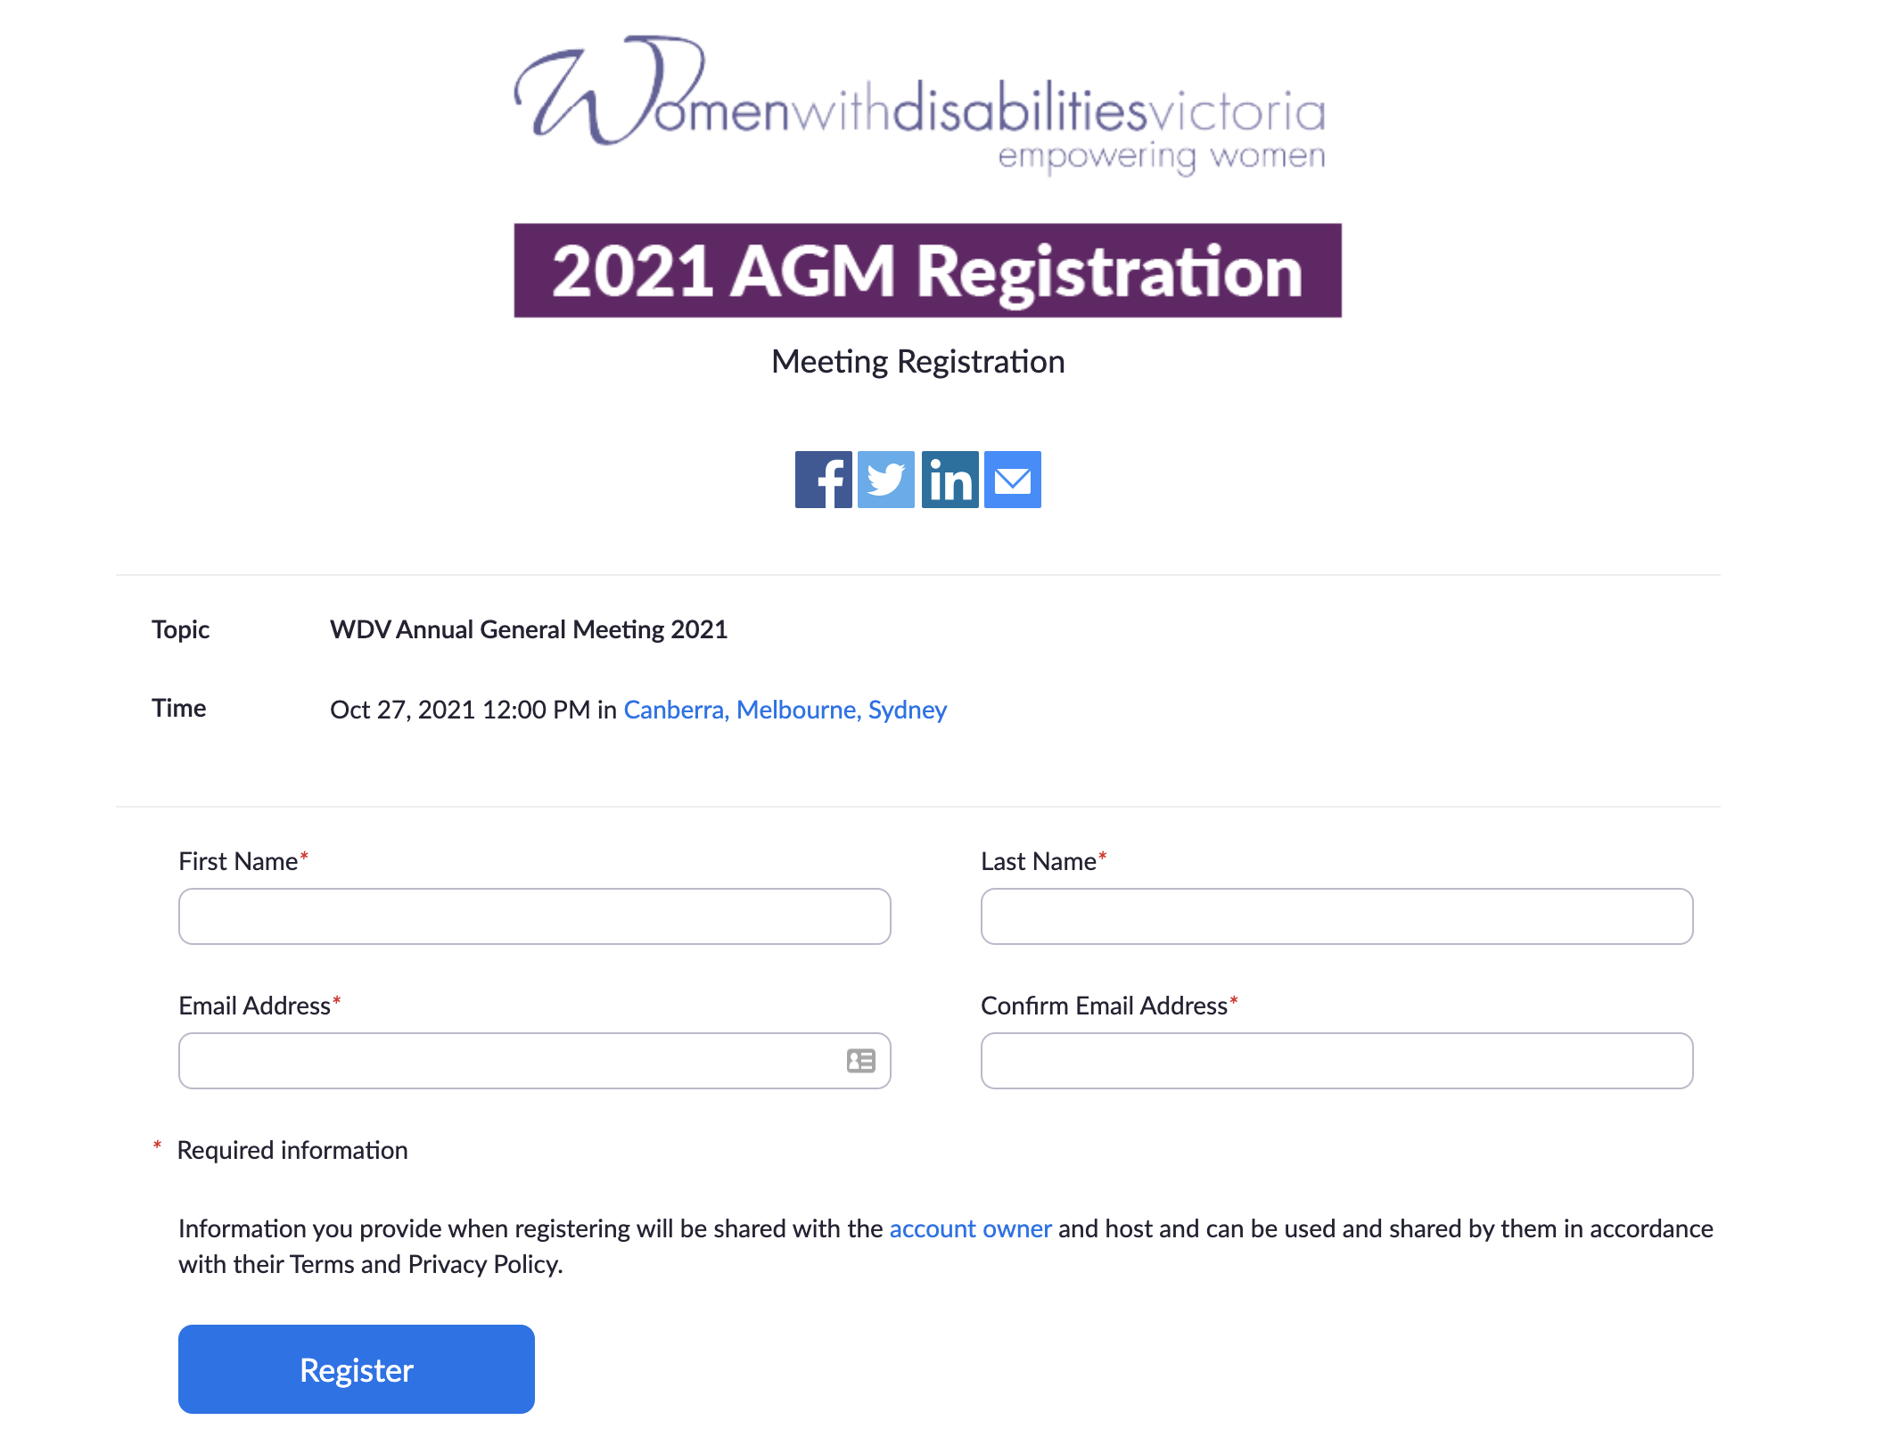
Caption: The AGM Registration Page

Step 3
You will be taken to a Meeting Registration Approval page. From there you will be shown the meeting link. You will be sent an email with all of these details as well.
If you did not receive your confirmation email, please check your Junk and Spam folders. If it is not there, please contact us.
You will only be able to join the meeting from 1 hour before the start time of the meeting (11am on Wednesday 27 October).

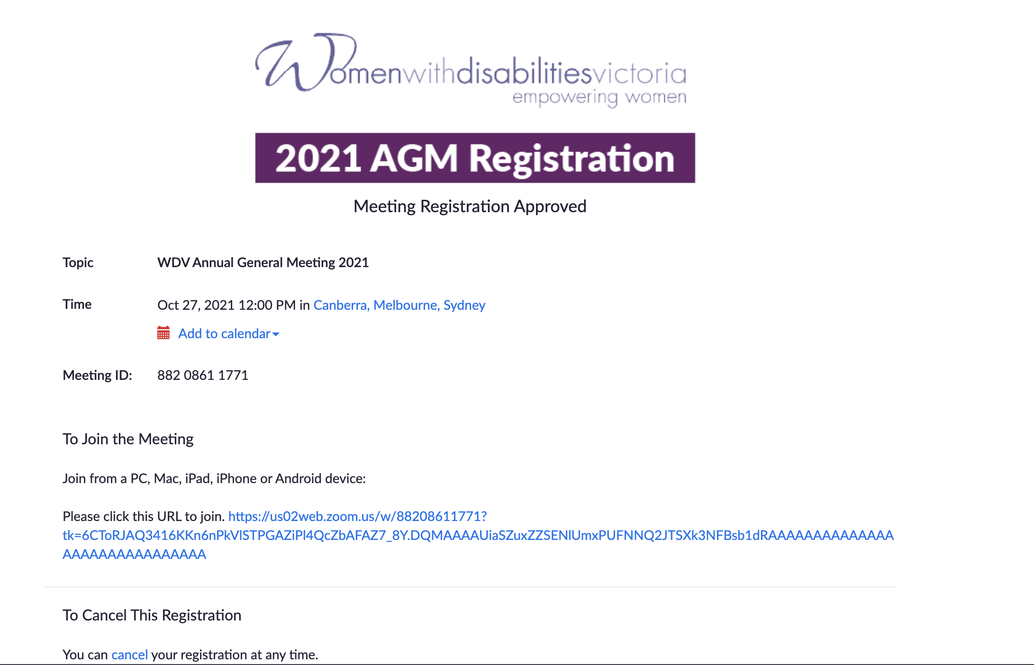
Caption: The Meeting Registration Approval page with the instructions on joining the meeting

agm@wdv.org.au
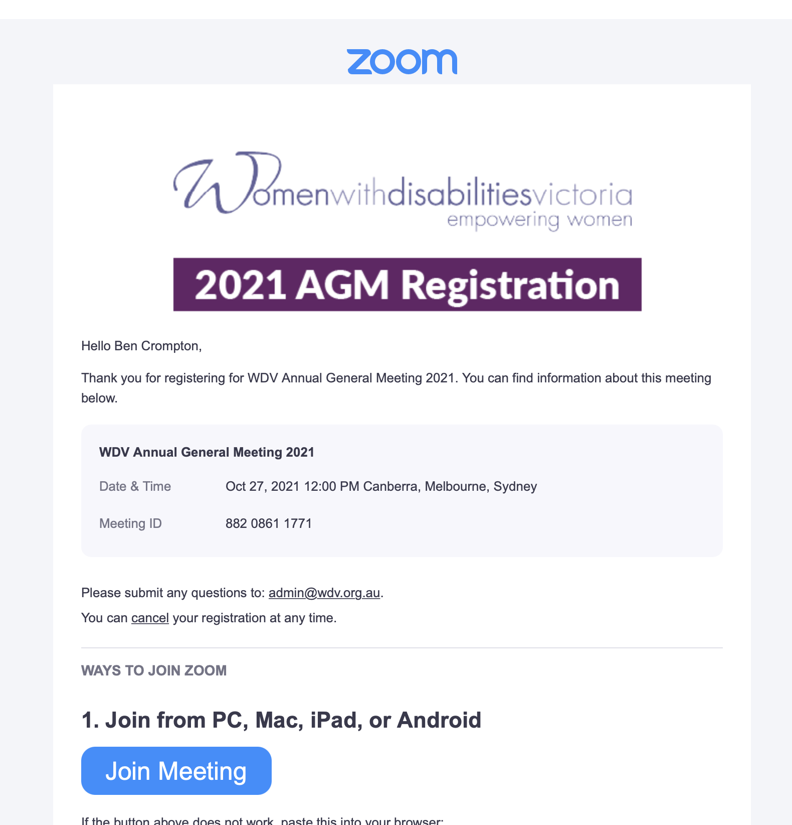
Caption: Registration confirmation email containing all of the details to enter the meeting

Part 2 – Joining the Meeting

Step 1
Download Zoom if you have not already done so. You can download it here. Choose either “Zoom Client for Meetings”, or if you want to use it on a mobile, “Zoom Mobile Apps”.

Step 2
Click on the ‘Join Meeting’ button inside your confirmation email. Or you can copy and paste the link into your browser.
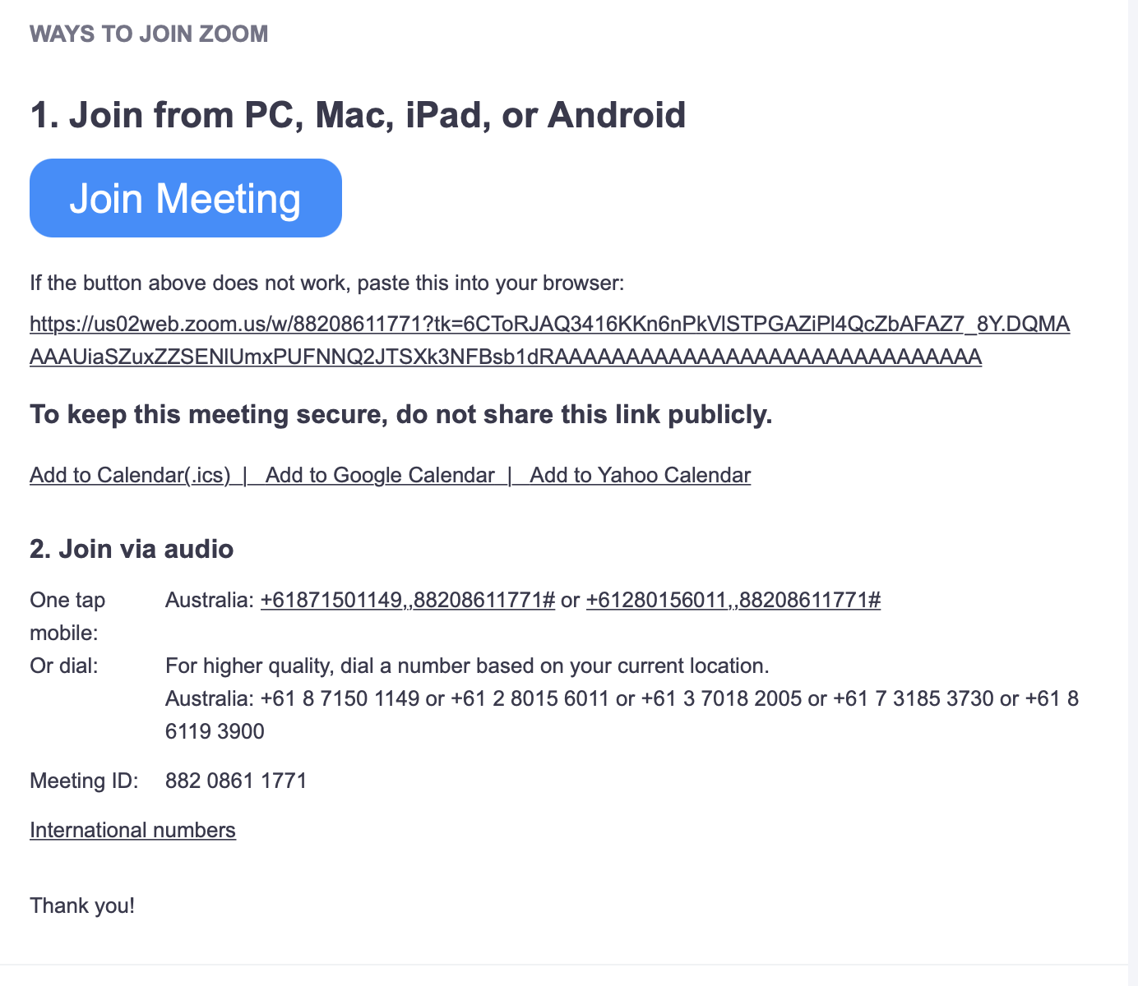
Caption: Registration confirmation email containing all of the details to enter the meeting

Step 3
You will then be taken to a new page. The Zoom application should then open and take you to the meeting waiting room.
Important: You may be given a warning box that asks you to ‘Open Zoom.us?’. Select ‘Open’ or ‘Allow’. If you do not allow access the meeting will not open for you.
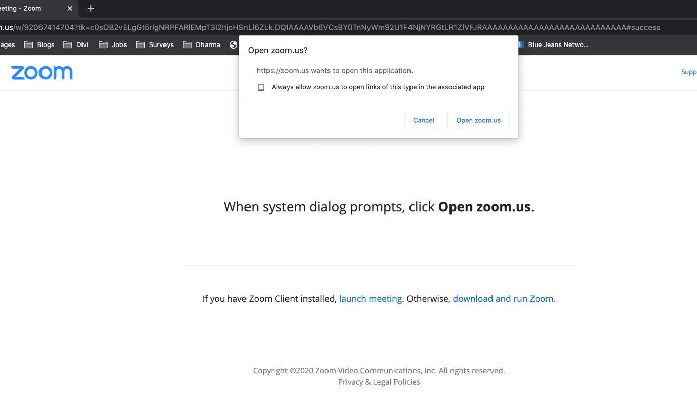
Caption: New page opened showing the ‘Open zoom.us’ box

Step 4
You will then see a message saying “Please Wait, the meeting host will let you in soon” – this is the meeting’s waiting room. Please remain there. We will then check-in each member.
If we need any further information from you, you may be taken to a breakout room for us to confirm any details.

Step 5
Once you are checked in to the meeting, Zoom will then open, asking you to select an audio option.
Select “Join with Computer Audio”.
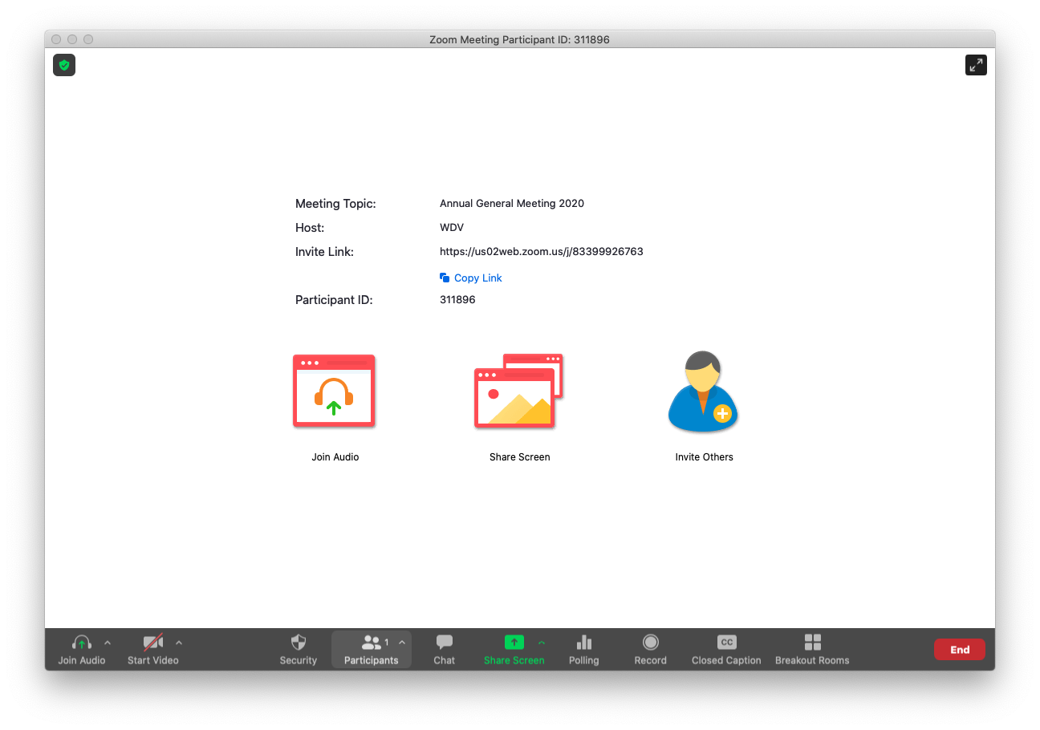
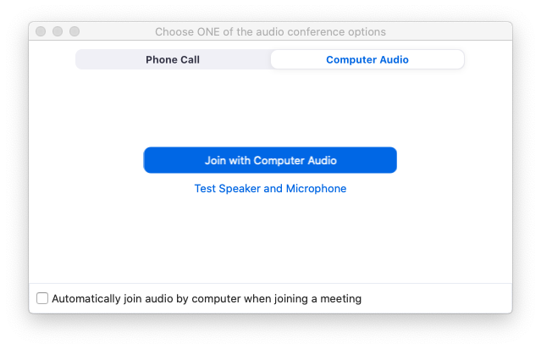
Caption: Zoom Meeting showing the audio selection options.

Step 6
You have now joined the meeting – Welcome!

Part 3 – Inside the Meeting
Once you are in the meeting there will be a series of slides with both written and spoken information on how the meeting will run and instructions on how to participate in the meeting.
As a default, everyone’s microphone will be muted. If you are due to speak, or if you raise your hand to ask a question, you will be asked to unmute your microphone.
When the meeting starts, you will see and hear the Chair of the meeting on the screen and any other speakers.

Turning off your video (if you don’t want to be seen)
If you want to ensure that you are not photographed/filmed in the meeting recording, you should make sure that your video is turned off.
During the meeting, click or tap on the ‘Stop Video’ icon.

Raising Your Hand
You may need to raise your hand during the meeting if you want to move or second a motion, or ask a question about the business of the meeting.
How you raise your hand may differ depending on whether you are using a computer, tablet, phone or other device. To do this:
On Computer
During the meeting, click on the icon labelled "Participants" at the bottom centre or top of your screen. In the window that opens on the right side of the screen, click the button down the bottom labelled "Raise Hand." Your virtual hand is now raised.
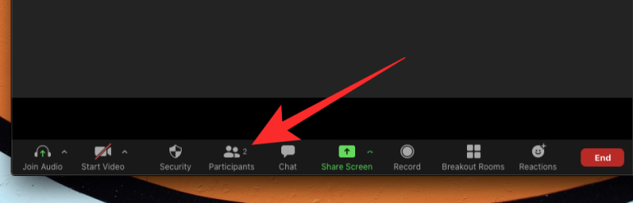
Caption: The Participants button on the bottom or top of your computer screen

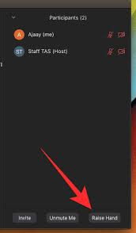
Caption: The Raise Hand button will appear when you select ‘Participants’
On Mobile (if using the app)
- In the Zoom toolbar, select Show Participants
- Select ‘More’
- Then select ‘Raise Hand’
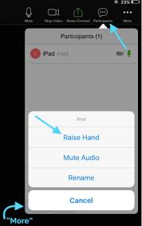
Caption: The Raise Hand button will appear when you select ‘Participants’ on your mobile
By phone
While on the call, press *9 – your virtual hand will then be raised.

Moving and Seconding a Motion
During the meeting, members will be asked if they would like to move or second the motions put to the AGM. If you wish to move or second a motion you will need to raise your “virtual hand”.

Voting in the Board Elections
When it comes time to voting in the Board elections, a polling window will appear for you to select your option and cast your vote.
Simply select the one candidate who is your preferred candidate.
Caption: Part of the polling window as seen on a computer
(Note: these are candidates for 2020 meeting)

If Members Are Watching on the Same Device
Each member signed into the meeting will be able to vote once. If there are multiple members together, each will need to be signed into the meeting on a separate computer or device so they can vote using the polling function.
If this is not possible, and two or more Members are participating in the meeting on the same device and all want to be able to vote, the Member who is signed into the meeting will need to vote by using the polling function (as detailed above), and the other/s will need to appoint a Proxy to vote on their behalf.

Members Appointed as a Proxy
If you have been appointed as a Proxy to vote on behalf of other Member/s you will cast your own vote via the polling function (as detailed above).
For any proxy votes you hold, the process will be slightly different. Please follow the following steps:
- Select the Chat function
- Choose ‘Proxy Votes’ in the drop down next to ‘To’
- In the message please say who the member is you are the proxy for, and the name of the Nominee they are voting for. For example “Proxy vote for Leah Smith, voting for Nominee number 15” (or the Nominee’s name).

Speaking during the meeting
If you are scheduled to speak in the meeting or are called on in the meeting then you will need to have your audio and/or video turned on. If this happens you will receive a request inside Zoom, and you will need to select ‘Unmute’.
Caption: The request that shows on the screen if you are prompted to unmute your audio

Asking a question during the meeting
If you have a question during the meeting about the business of the meeting (not technical support – for this, see below), you can ask this in two ways:
- Typing your question into the Chat box
  - Select ‘Chat’ and in the drop down box next to ‘To’, select ‘Meeting Questions’ and send a message with your question.
- Raising your hand and asking the question verbally
  - The speaker will respond to you and you will be able to ask your question. Note that you will be asked to unmute your microphone.

Requesting technical support during the meeting
WDV staff aim to provide some technical support during the meeting – but note that we will be limited in how many requests we can answer. You can contact us the following ways:
- If you are already in the Zoom meeting: Select ‘Chat’ and in the drop down box next to ‘To’, select ‘WDV Support’ and send a message.
- Email: AGM@wdv.org.au
- Phone: (03) 9286 7800.

Accessibility Guide
This section provides more information about the accessibility features inside of Zoom. If you are using these features, we recommend you read this section.
We are using the Zoom meeting platform which is compliant with WCAG 2.1, and as such has in-built support for keyboard navigation, screen readers and other technology.
We will have an Auslan Interpreter and Live Captioning provided. We will also be providing audio description for any video or slides on the screen.

Auslan Interpreter
The Auslan interpreter will be on the screen during the entire meeting.

Closed Captions
We also have live captions available. To access the closed captions, select the ‘Closed Caption’ button at the bottom or top of the screen.
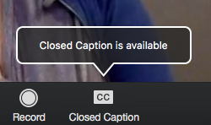
Caption: The Closed Caption button to turn on captions in the meeting

Audio Description
At times there may be slides or visuals providing information during the meeting. If so, we will be providing audio description to convey the information. The description will be the main audio coming through the meeting, so you will not have to enable it, just ensure your speakers are not muted.

Keyboard Navigation
Zoom supports Keyboard Shortcuts for easy navigation of its platform.
You can view the Zoom article on Hot Keys and Keyboard Shortcuts, for a full list.

Screen Reader Support
Zoom follows the latest accessibility standards to ensure that the product is fully accessible to the latest screen readers.
Full details are available in these guides from the University of Melbourne:
- Using Zoom with JAWS
- Using Zoom with NVDA
- Using Zoom with Voiceover on MacOS

Key functions to note if using Keyboard Shortcuts or a Screen Reader
The main functions you might want to note for the meeting are how to:
- Raise your hand (to move/second a motion, or ask a question about the business of the meeting)
  - Alt+Y (Windows)
  - Option-Y (Mac)
- Use Chat (to lodge a proxy vote, ask for technical support or ask a question) - the following commands show and hide the chat panel
  - Alt+H (Windows)
  - Cmd+Shift+H (Mac)

- Turn off your video (if you don’t want to be seen) - the following commands turn the video on and off:
  - Alt+V (Windows)
  - Cmd+Shift+V (On Mac)

- Unmute your microphone (if asked to speak) - the following commands mute and unmute your audio:
  - Alt+A (Windows)
  - Cmd+Shift+A (Mac)
To vote in a Zoom poll, your screenreader should be able to read down the list of names in the polling window. Use your keyboard to make your selection from the radio buttons.

Additional Accessibility Information
Zoom has created a set of FAQs about accessibility features including:
- Important accessibility keyboard commands for keyboard users
- High contrast support
- Larger font settings.
If you have any accessibility requirements that are not covered in the guides above, please contact us prior to the meeting.

Accessing the Meeting – FAQs

I can’t access the meeting from my browser – how do I get in?
This meeting requires the Zoom application to be downloaded and cannot be accessed from your browser. Please download the Zoom application to your computer or mobile device.
If you discover you haven’t done this and the meeting has already started, you might be better off just trying to join the meeting by phone.

How do I join by phone?
To join by phone, please contact us to register you. You will then be able to access the meeting with the details below:
- Dial: +61 3 7018 2005
- Meeting ID: 882 0861 1771
You will be asked to enter the Meeting ID, followed by the hash key. You don’t need a participant number, so if asked for this, simply press the hash key again.
Please note that if you join by phone you will not be able to use the poll function, so it is recommended you appoint a proxy prior to the meeting.

Can I share my audio or video during the meeting?
Everyone but the host of the meeting and the active speakers will have their audio muted. Your video may also be turned off.
If you are called on to speak, please see Speaking during the meeting.

I am having issues with Zoom or I can’t access the meeting
Please see Requesting technical support during the meeting.

How do I appoint a Proxy to vote on my behalf?
If you realise you will need to appoint a Proxy to vote on your behalf, and you haven’t done so already when the AGM Notice pack was sent out, please contact us ASAP and we will explain how to do so.

