Experts in Our Health

A Training Session for Health Workforces
Women with disabilities experience multiple barriers to accessing the health services they need. The Experts in Our Health training supports health professionals and staff to improve the accessibility of services.
Training participants will learn about barriers, and engage in facilitated discussion about practices that uphold rights and support access.
The presenters will showcase the Experts in Our Health Guide, Factsheets and Poster. The resources have been designed by a team of Health Experts with lived experience of disability, and will be made available in accessible formats.

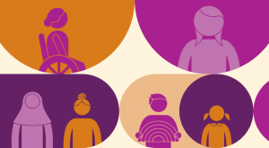

Details
Length: Approximately 60 minutes
Location: In-person or online via Zoom
Cost: Free, funded by Department of Social Services
For more information: contact
Rosie Granland on 0412 283 587 or rosie.granland@wdv.org.au or
Dee Henry on 92 86 7801 or
dee.henry@wdv.org.au

