Women with Disabilities Victoria (WDV)

Sharing information via

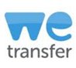
WeTransfer and Dropbox
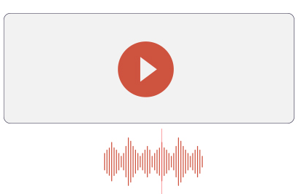
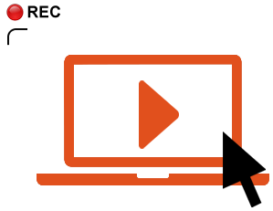
To apply as a participant in a program, or as an employee with WDV, you may like to apply with a video or voice (audio) recording.

Because audio and video files can’t always be emailed, you may like to upload them to the cloud, using WeTransfer or Dropbox

The below instructions show how to share files via WeTransfer and Dropbox.
Both programs are free.

Depending on what you are applying for, you may need to send different bits of information.
For example:
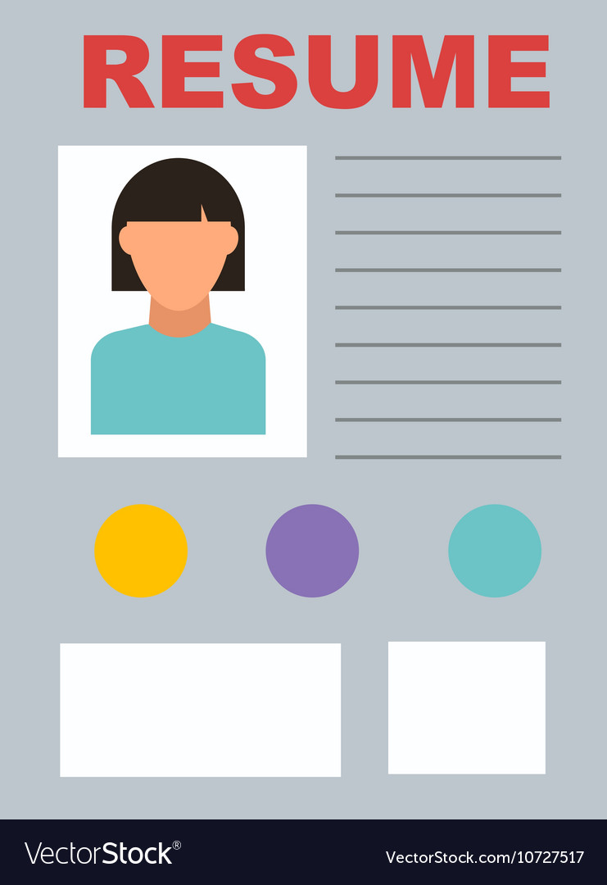
- Completed application form for a program
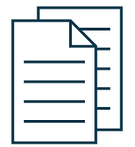
- Cover letter for a job
- Resume / CV for a job
- Response to the Key selection criteria for a job

If you choose to send files via WeTransfer, Dropbox, or another cloud storage site, you will need to let WDV know you have done this.
The document talking about what you are applying for, will have information about who to contact.

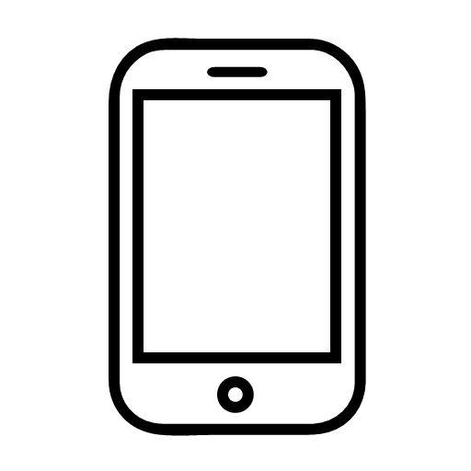
These instructions were created for users using a web browser. You may like to use the phone or computer apps. The below instructions will be similar but not the same if you choose to use an app.
Instructions were up to date as of December 2020. Sometimes sites change their layouts, have different advertisements as backgrounds, or are a bit different depending on the type of computer / phone you are using.

Unless stated otherwise, each image is solely a screenshot displaying the same key information given in text form. Therefore no alternative Text is provided.

If you are having issues uploading and sending files across, you may like to ask someone that you know to assist you.

You can also contact WDV
Phone: 03 9286 7800
Email: Check other document information for who to email

WeTransfer – Computer

- 1. Go to https://wetransfer.com
- 2. Create an account or login  - Choose either Sign up or Login (both found in the top right corner), depending on whether you already have an account  - WeTransfer does not require people to have an account to send files, but we recommend setting up a free account | 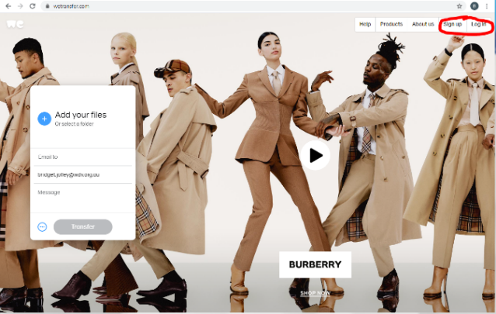
3a. Sign up  (Or go to 3b. to login)  - Scroll down to the bottom of the page, and click on Sign up for free  - Complete the required information, including the Terms of Service and Privacy and Cookie Statement  - You can choose to opt in or not to opt in, to ‘receive WeTransfer news and product options’  - Click on Let’s go  - You will be asked to verify your email address  - Go to your email, and open the email from WeTransfer and click on Verify email  - You will be redirected back to WeTransfer with a message saying ‘Your account has been verified’  - Click on Send Files  - Go to Step 4 | 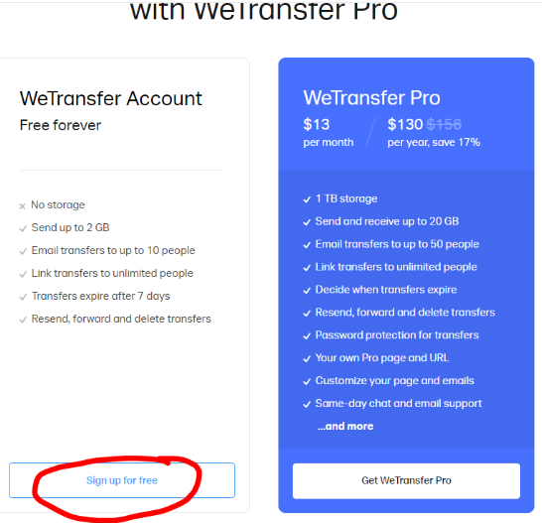  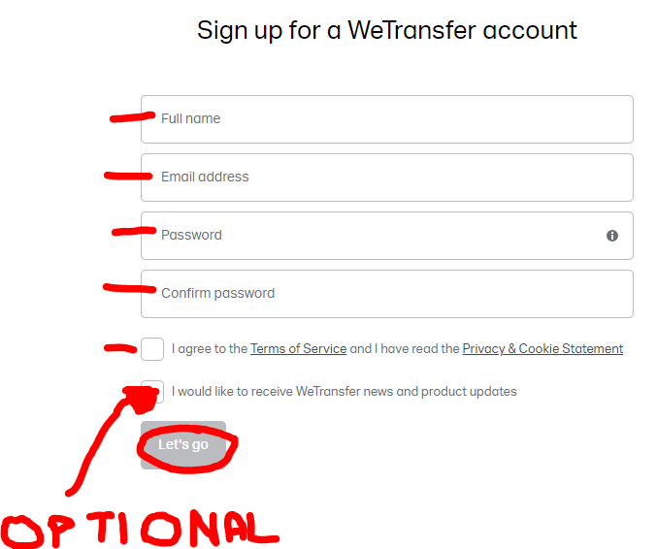  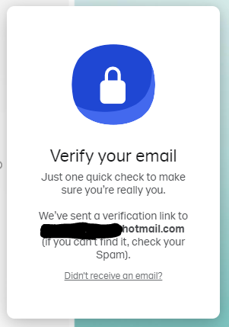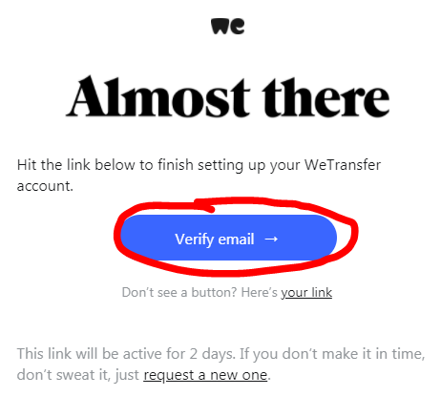  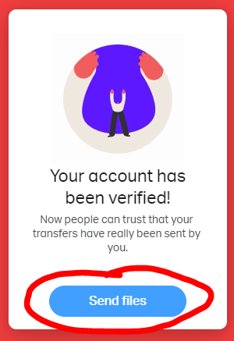
3b. Login  - Enter your email address and password, then click on Submit  - Go to Step 4 | 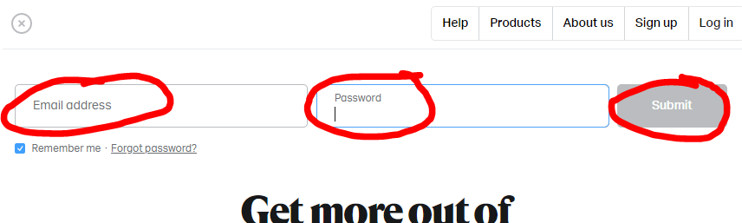
4. Add files  - Click on Add your files or select a folder  - From your library, choose the files or folder you would like to upload. You can choose multiple files at a time  - Please note, there is a 2GB maximum per transfer  - Click on Open  - Your chosen files have been added to the transfer  - If you would like to add further things, click on ‘Add more files’ and choose either ‘files’ or ‘folders’  - Repeat the previous step | 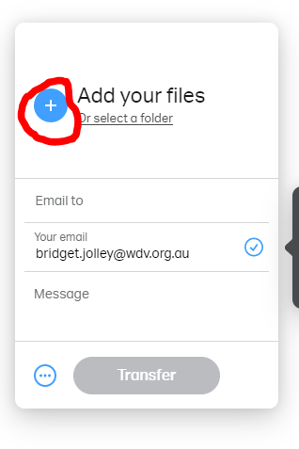  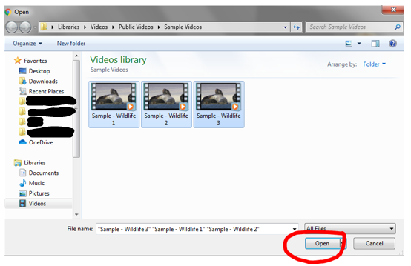  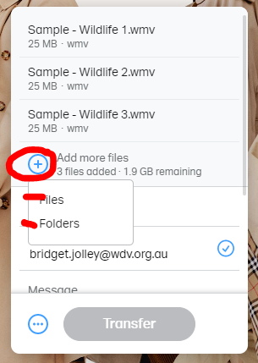
5. Complete message details  - For ‘email to’ field, enter the appropriate email address as found in the documentation relating to what you’re applying for.  - Check ‘your email’ is correct  - Enter your message, please include:  - What you are applying for  - What files you are transferring, e.g. an application form, response to the key selection criteria only, or response to the key selection criteria, your resume, and a cover letter, etc.  - How you will be advising WDV that you’ve shared files (e.g. by phone or email)  - Your full name, particularly if it is not in your email address | 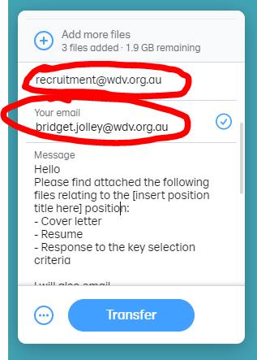  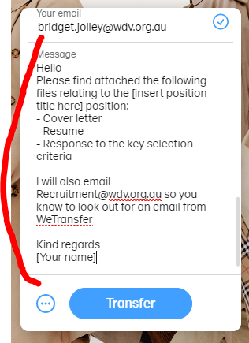
6. Check details and Transfer  - Check that all your required files/folders are ready to be transferred  - Check email addresses are correct  - Check your message has all key information  - Click on Transfer  - Do not leave the page until you get a message saying ‘You’re done’ | 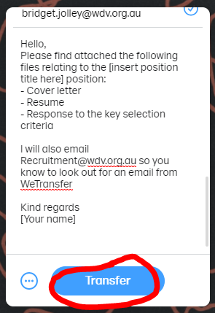  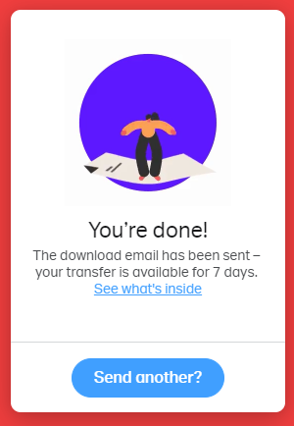
7. Advise WDV that you’ve sent files via WeTransfer
- Contact WDV by phone or email, and advise which files you’ve sent via WeTransfer, and what they relate to
  - Phone: 03 9286 7800
  - Email: The appropriate email address will have been provided in other documentation.

WeTransfer – Phone
- 1. On your phone’s web browser, go to https://wetransfer.com
- 2. Create an account or login  - Click on Login in the top right hand corner, whether or not you already have an account  - WeTransfer does not require people to have an account to send files, but we recommend setting up a free account | 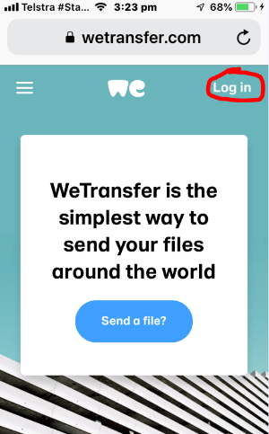
3a. Sign Up  (Or go to 3b. to login)  - Scroll down the login page until you get to ‘WeTransfer Account’  - Click on Sign up for free  - Complete the required information, including the Terms of Service and Privacy and Cookie Statement  - You can choose to opt in or not, to ‘receive WeTransfer news and product options.  - Click on Let’s go  - At this point, you need to verify your email address  - Go to your email account and open the email from WeTransfer asking you to verify your email address.  - Click on Verify email  - You may need to re-enter your login details  - You will see a message saying ‘Your account has been verified’  Go to Step 4 | 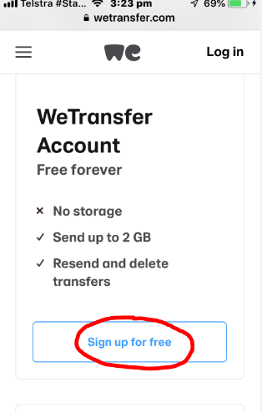  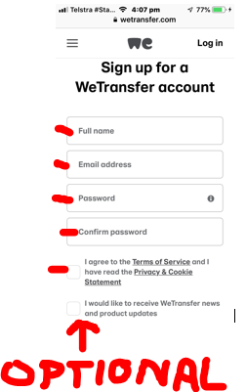  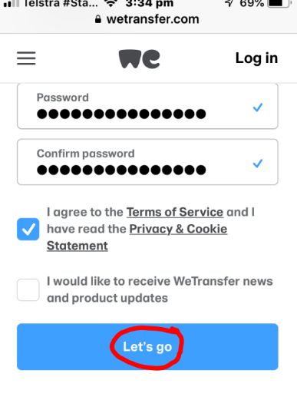
3b. Login  - Enter your email address and password, then click on ‘Submit’  - Go to the menu in the top left, and then click on Home  - Go to Step 4 | 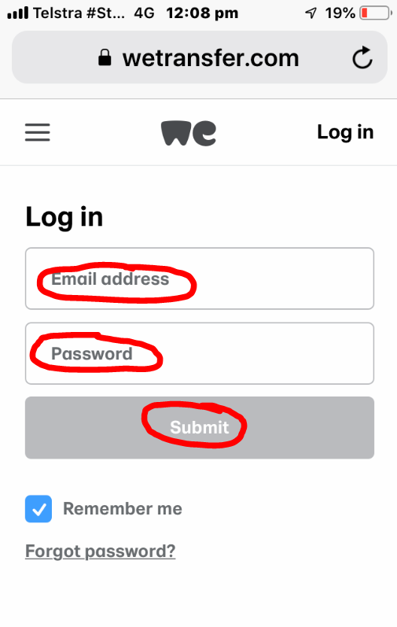  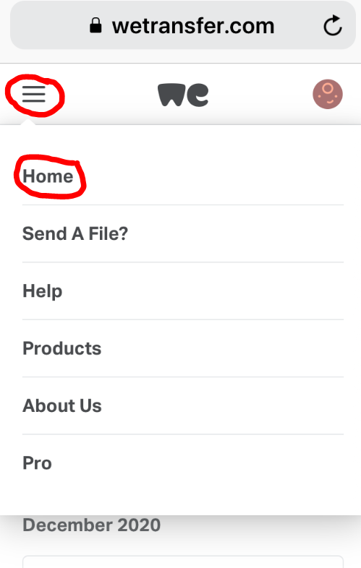
4. Add files  - Click on Send a file  - Click on Add your files  - Add the required files stored on your phone.  - Please note, there is a 2GB maximum per transfer  - If you would like to add further things, click on ‘Add more files’  - Add further files stored on your phone | 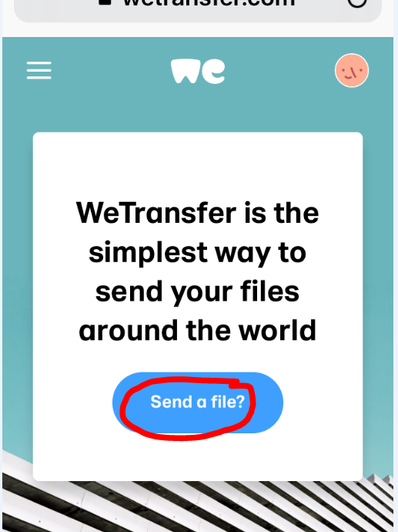  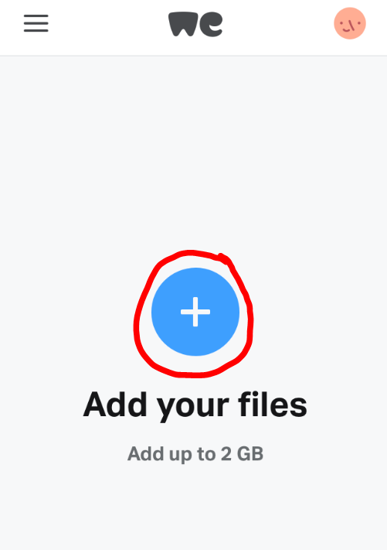  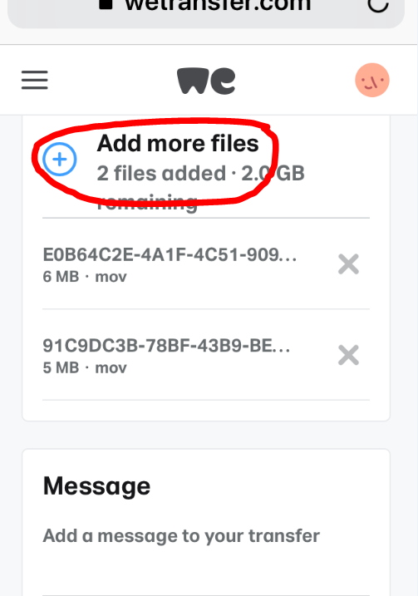
5. Complete message details  - Enter your message, please include:  - What you are applying for  - What files you are transferring, e.g. an application form, response to the key selection criteria only, or response to the key selection criteria, your resume, and a cover letter, etc.  - How you will be advising WDV that you’ve shared files (e.g. by phone or email)  - Your full name, particularly if it is not in your email address | 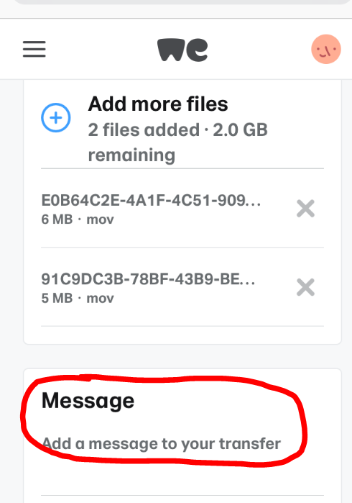  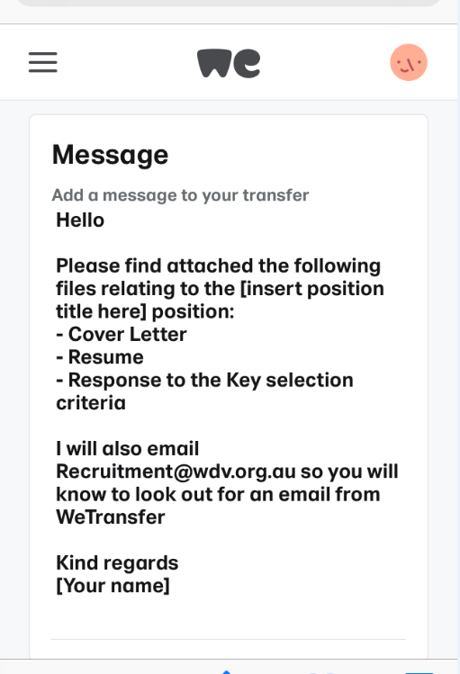
6. Check details  - Check the right files are attached  - Check you’ve included everything in your message  - Click on Next | 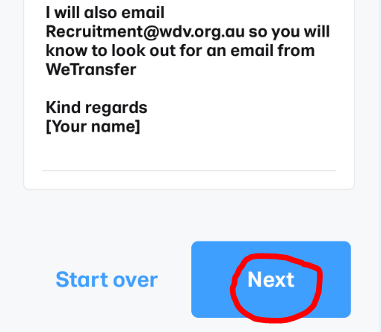
6. Choose between ‘Send an email’ or ‘Get a link’  - Click on either Send an email (recommended), or Get a link  - Click on Next | 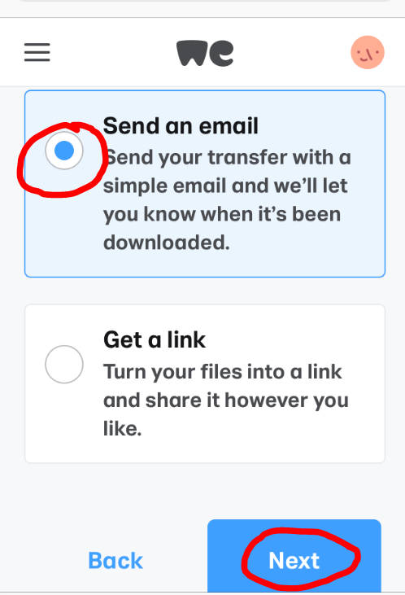
7. Enter email details  - For ‘email to’ field, enter the appropriate email address as found in the documentation relating to what you’re applying for.  - Click on Transfer | 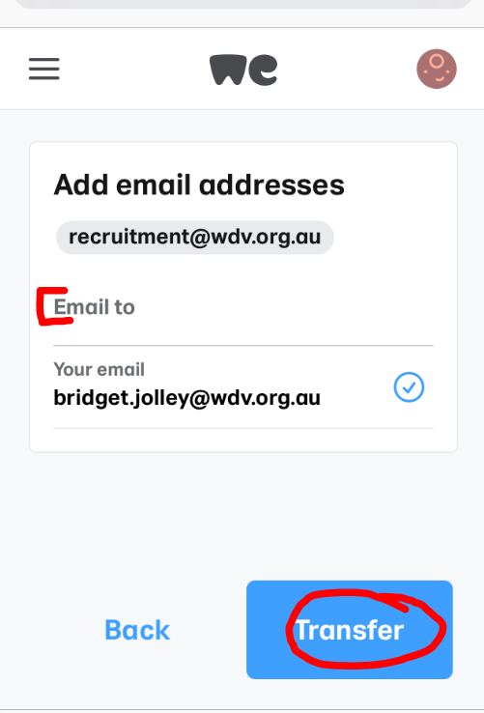
8. Wait for files to be transferred  - A display will show as your files are being transferred  - A message will say ‘You’re done’ when your files have successfully been transferred | 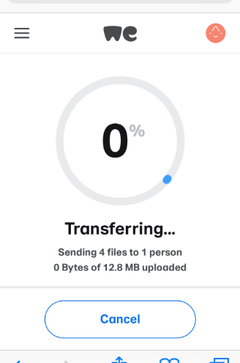  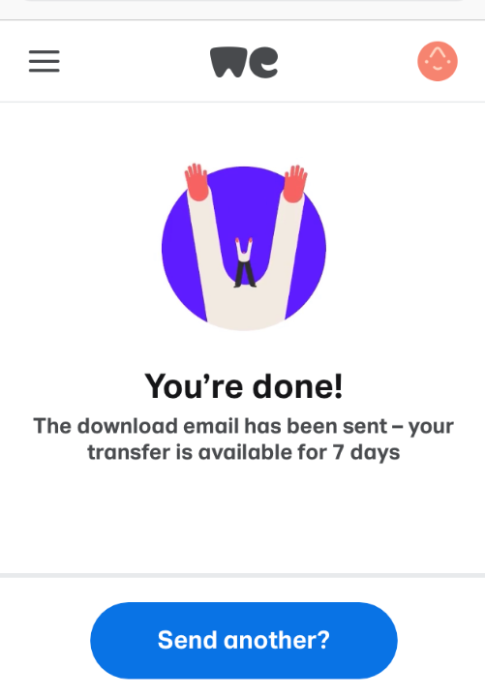
9. Advise WDV that you’ve sent files via WeTransfer
- Contact WDV by phone or email, and advise which files you’ve sent via WeTransfer, and what they relate to
  - Phone: 03 9286 7800
  - Email: The appropriate email address will have been provided in other documentation.

Dropbox – Computer

1. Go to https://www.dropbox.com/
2. Create an account or login  - In the top right corner, choose Sign in or Sign up | 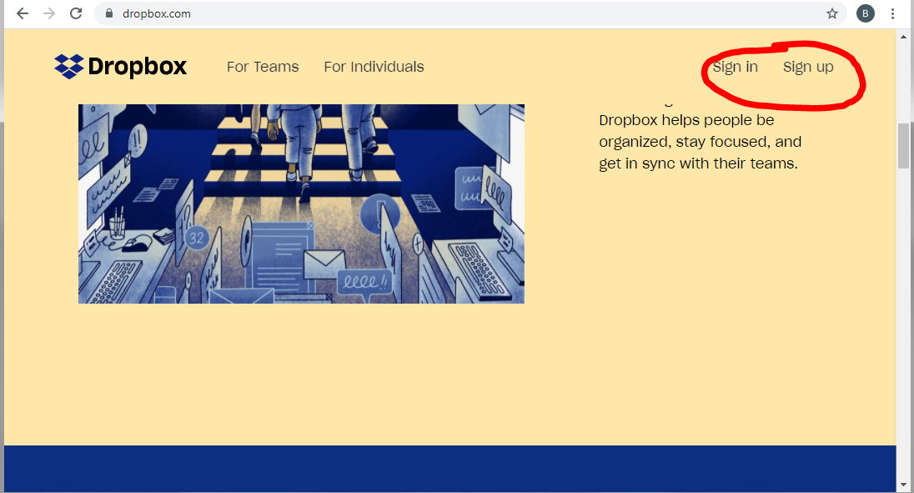
3a. Sign in  - Enter Sign in details, including your email and password  - Click on Sign In  - Go to Step 4 | 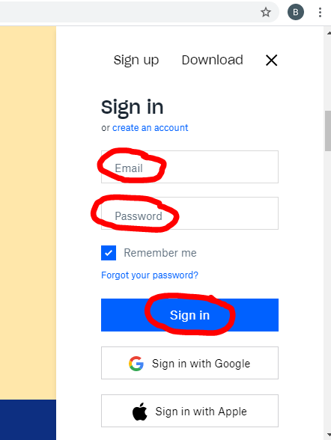
3b. Sign Up  (Or go to 3b. to login)  - Create account details, including your first name, last name, email, and password.  - Check and tick I agree to the Dropbox terms  - Click on Sign up  - Choose the free account by clicking on Or continue with 2 GB Dropbox Basic plan  - At this point, you need to verify your email address  - Go to your email account and open the email from Dropbox asking you to verify your email address.  - Click on Verify your email  - You might be asked to download the app. You can download and use the app, or don’t and navigate to the home page by clicking on the Dropbox icon on the left  - Go to Step 4 | 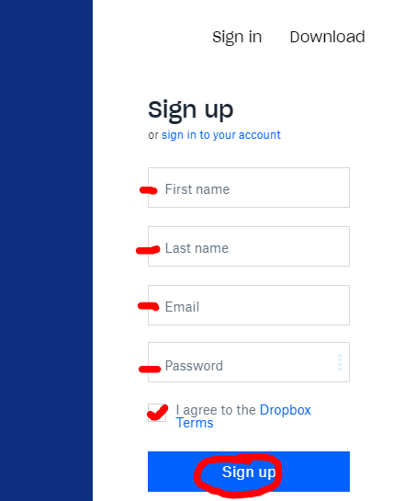  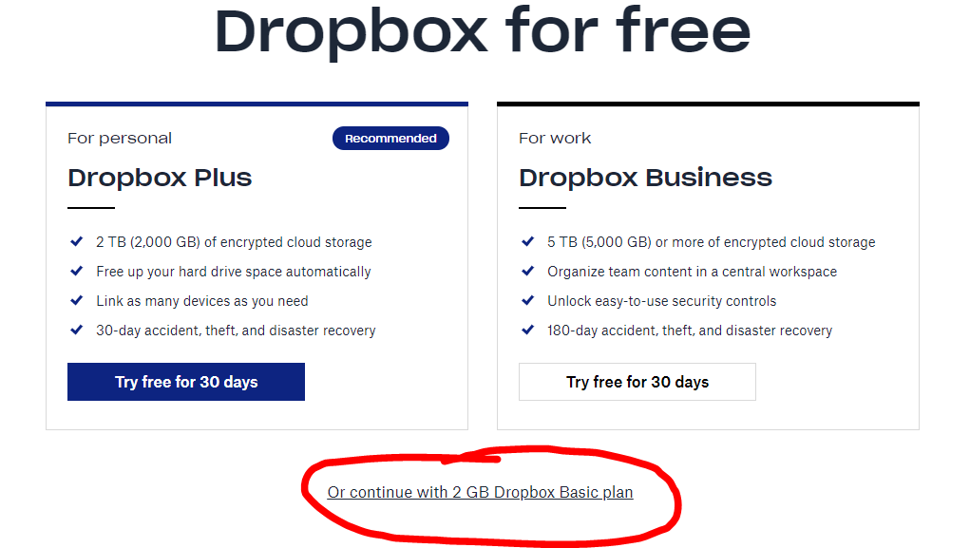  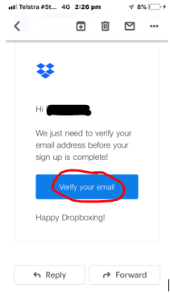
4. Upload files / folder  - Click on either upload files or upload folder  - Choose the files or folder you would like to upload  - Choose the required folder or files you would like to upload  - If uploading files, you will be asked to select a folder, or ‘create new folder’  - Click on Upload  - Please note Dropbox has a 2GB storage limit  - Confirm you would like to upload files/folder by clicking on Upload  - A status bar will appear to say how long is left to upload the files/folder  - The status bar will change to say ‘Uploaded…’ once complete | 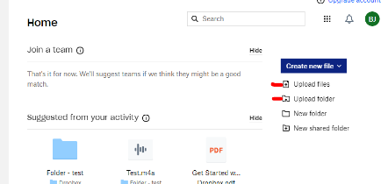  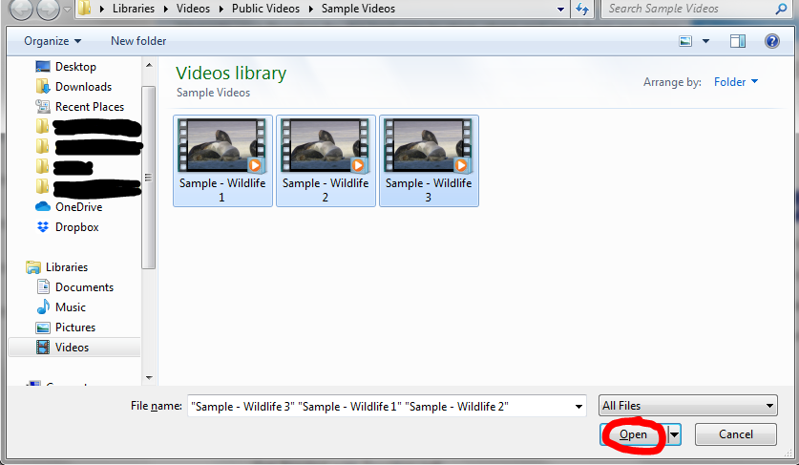  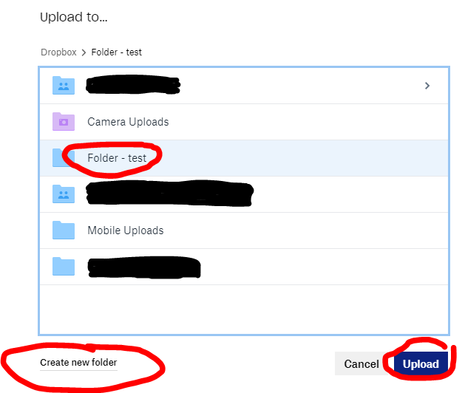  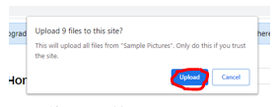  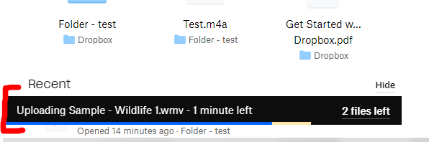
5. Share file/s or folder with WDV  - For folders  - Click on the folder you would like to share  - In the column on the right, click on Share. (Do not click on the drop down arrow to the immediate right of share)  - For files  - Navigate to the file/s you want to share. You can choose multiple files  - Click on ‘Share’. (Do not click on the drop down arrow to the immediate right of share)  - Where it says ‘Add an email or name’, enter the appropriate email address. This can be found on the documentation relating to what you are applying for.  - Hit the ‘enter’ key.  - You can then include a note/message  - Enter your message, please include:  - What you are applying for  - What files you are transferring, e.g. an application form, response to the key selection criteria only, or response to the key selection criteria, your resume, and a cover letter, etc.  - How you will be advising WDV that you’ve shared files (e.g. by phone or email)  - Your full name, particularly if it is not in your email address  - An example message:  Hello  Please find attached the following files relating to the [insert position title here] poition:  - Cover letter  - Resume  - Response to the Key selection criteria  I will also email WDV so you will know to look out for an email from Dropbox  Kind regards  [Your name]  - Check the email address and message that’s been entered  - Click on Share file  - Your files/folder have now been shared | 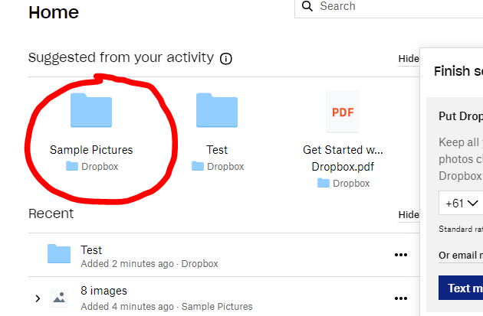  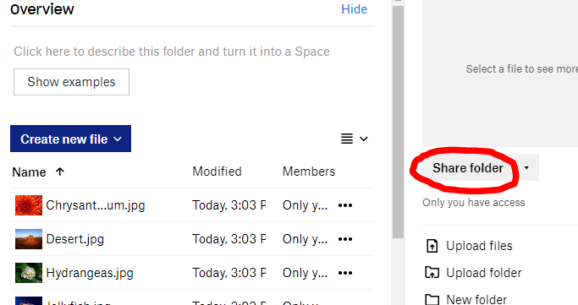  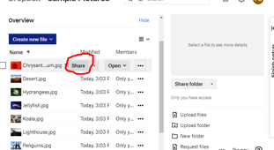  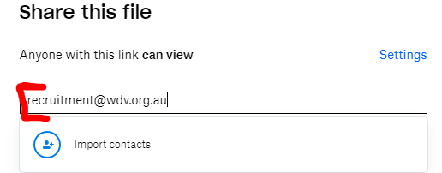  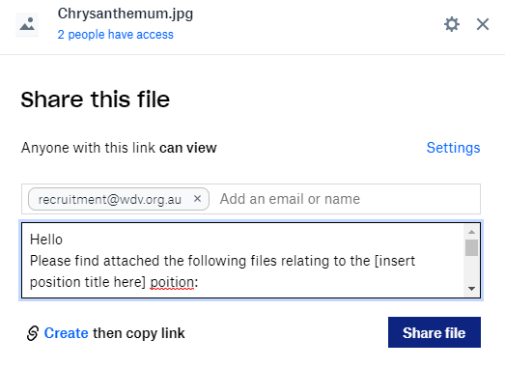  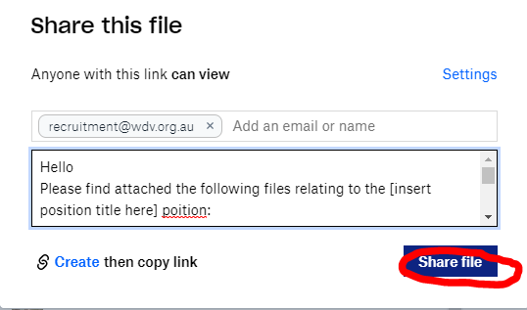
6. Advise WDV that you’ve sent files via Dropbox
- Contact WDV by phone or email, and advise which files/folders you’ve sent via Dropbox, and they relate to
  - Phone: 03 9286 7800
  - Email: the appropriate email address can be found in the documentation relating to what you’re applying for

Dropbox – Phone

1. Go to https://www.dropbox.com/
2. Create an account or login  - In the top right corner, choose Sign in or scroll down the home page to find Sign up for free | 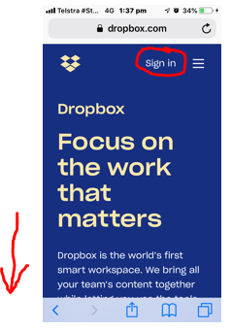  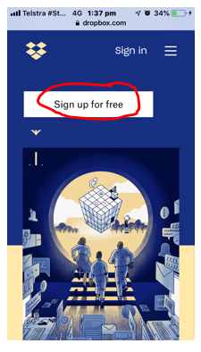
3a. Sign in  - Enter Sign in details, including your email and password  - Click on Sign In  - Go to Step 4 | 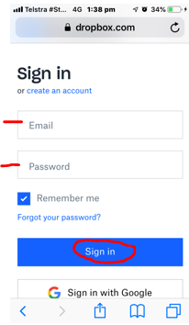
3b. Sign Up  (Or go to 3b. to login)  - Create account details, including your first name, last name, email, and password.  - Check and tick I agree to the Dropbox terms  - Click on Sign up  - Scroll down the page. Find and click on Or continue with 2 GB Dropbox Basic plan  - At this point, you need to verify your email address  - Go to your email account and open the email from Dropbox asking you to verify your email address.  - Click on Verify your email  - You might be asked to download the app at this point. You can download and use the app. If you don’t, navigate to the home page by clicking on the Dropbox icon on the left  - Go to Step 4 | 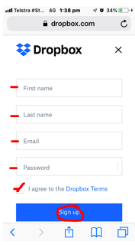  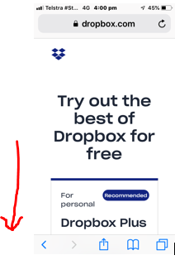  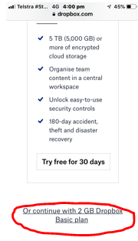
4. Upload files / folder  - Click on the uploads/folders menu  - Click on either upload files or upload folder  - Choose the files or folder you would like to upload from your phone  - Please note Dropbox’s 2GB storage limit  - If uploading files, choose or create a ‘new folder’ for the files to sit under  - Click on Upload  - A status bar will appear to say how long is left to upload the files/folder  - The status bar will change to say ‘Uploaded…’ once complete | 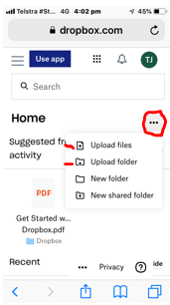  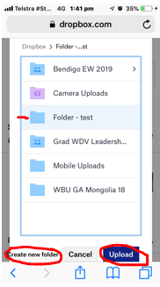  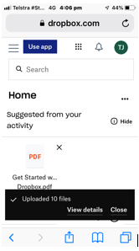
5. Share file/s or folder with WDV  - Under ‘Recent’, select the folder, and then/or, files you would like to transfer  - Use the menu on the right to find and click on Send with Transfer  - Check files are correct and click on Create Transfer  - A status bar will appear to say ‘Creating new transfer’  - Click on Send by email  - In the ‘To’ field, enter in the appropriate email address  - Click on ‘Send’  - A status page will appear to say ‘Creating your transfer’  - Once complete, a message will say ‘Your transfer is on its way’ | 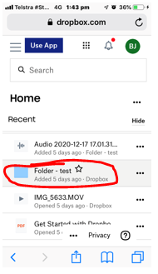  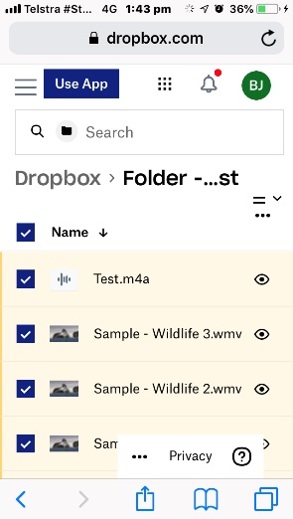  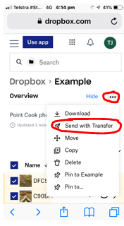  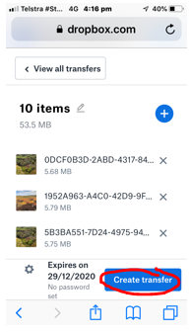  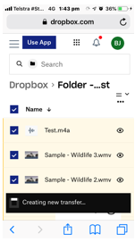  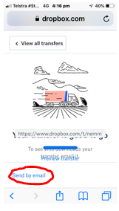  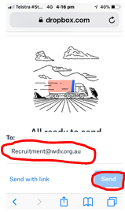  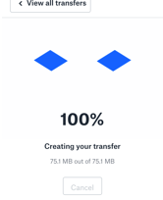
6. Advise WDV that you’ve sent files via Dropbox
- Contact WDV, and advise you’ve sent file/folders via Dropbox and what they relate to
  - Phone: 03 9286 7800
  - Email: The appropriate email address will have been provided in other documentation.
- Make sure you include
  - What the files relate to
  - What files you are transferring, e.g. an application form, response to the key selection criteria only, or a cover letter, response to the key selection criteria and your resume, etc.

End of Document

