Experts in Our Health

A Training Session for Health and Community Services Workforces
Women with disabilities experience multiple barriers to accessing health services. The Experts in Our Health training supports organisations to improve accessibility and implement inclusive co-design of services and programs.
Training participants will learn about barriers, and engage in facilitated discussion about practices that uphold rights and support access.
The presenters will showcase the Experts in Our Health Resources. These have been designed by a team of Health Experts with lived experience of disability, and will be made available in accessible formats.
Please contact the project staff to discuss the needs of your team.

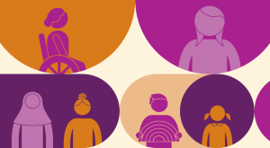

Details
Length: Approximately 60 minutes
Location: In-person or online via Zoom
Cost: Free, funded by Department of Social Services
For more information: contact
Rosie Granland on 03 92 86 7816 or rosie.granland@wdv.org.au or
Dee Henry on 03 92 86 7801 or
dee.henry@wdv.org.au

