Understanding Disability Guide

Gender and Disability Workforce Development Program

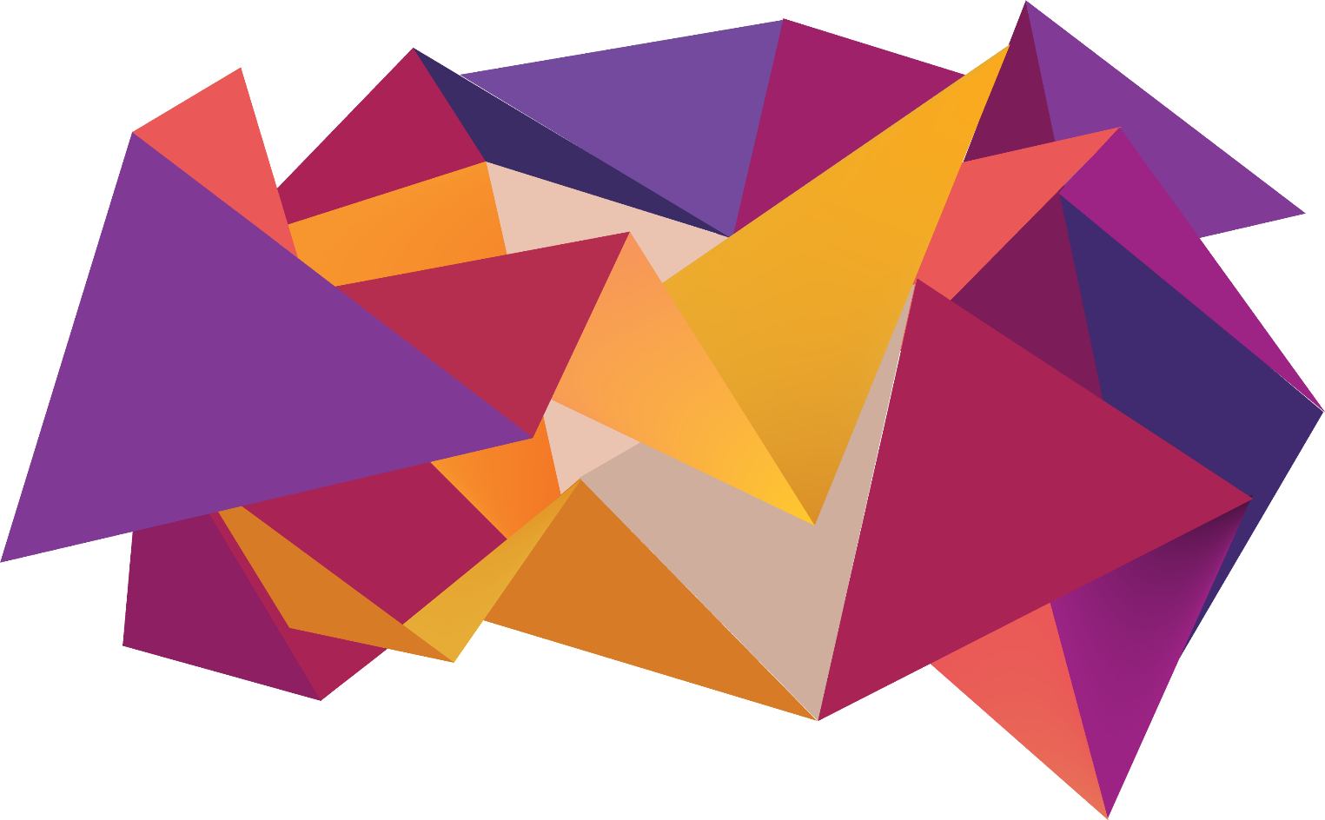

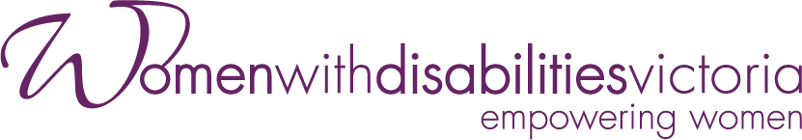

The development of this resource was supported by the Office for Prevention of Family Violence and Coordination.
Our particular thanks to Women with Disabilities Victoria’s twelve Gender and Disability Experts by Experience Advocates, who contributed their expertise to this resource as part of our co-design process.
This resource was prepared by Women with Disabilities Victoria.
Published by Women with Disabilities Victoria: Level 9/255 Bourke Street, Melbourne, Victoria 3000.
© Women with Disabilities Victoria 2022

Note: The word “woman” used throughout this guide refers to anyone who identifies as a woman.

Contents
Purpose 3
Disability and Violence: Australian Statistics and Facts 4
Changes to Disability 5
What is Ableism? 5
The Right to Live Free from Violence and Abuse 5
Models of Disability 5
WDV’s Perspective 6
The 6 Keystones 7
The Social Model of Disability 7
The Human Rights Model of Disability 8
The Gender Equality Approach 9
Intersectional Understanding 10
Centring of Lived Experience 11
Disability Pride 12
Combining the 6 Keystones 13
Change is Possible 14
References 15

Purpose
The purpose of this guide is to provide information to workforces in disability, social services and violence prevention on how Women with Disabilities Victoria (WDV) understands disability, and how we want key stakeholders, policy makers, planners and other organisations to think about disability.
This guide is based on the Understanding Disability video. It explores 6 keystones, co-designed by women with disabilities, to provide understanding of respectful engagement and planning with women with disabilities.
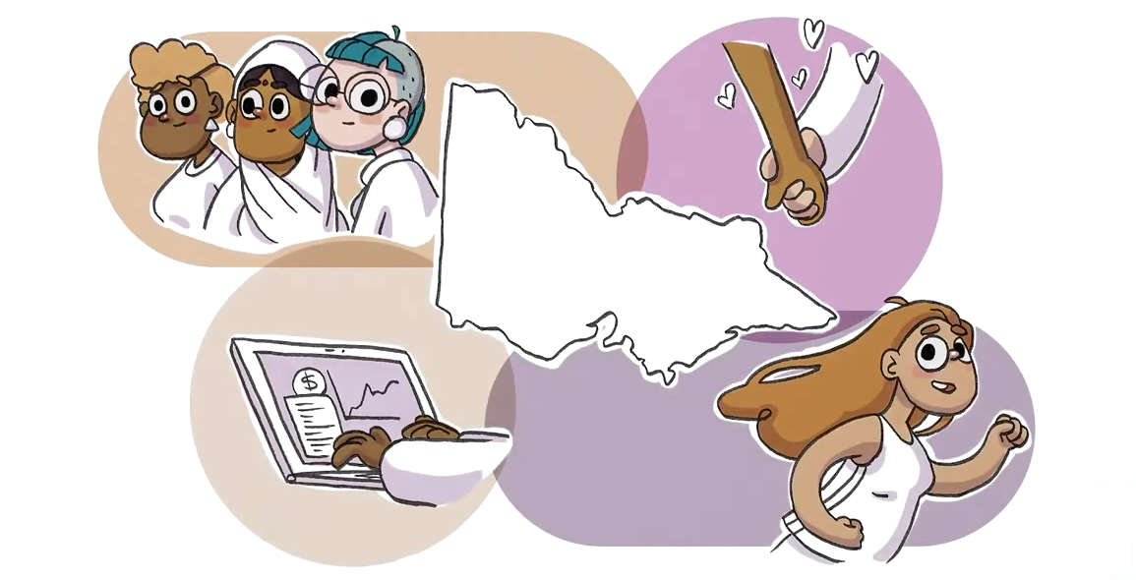
The co-design process included consultations with experts in disability inclusion and violence prevention within the WDV’s Gender and Disability Experts by Experience Advocates, a group made up of twelve women with disabilities, project staff and other key stakeholders.
This resource is important because it tells us how to address gender and disability inequality in a tangible way. With this resource you can do your part to restructure policies, systems and practices, making them accessible and inclusive.

Disability and Violence: Australian Statistics and Facts

Nearly one in five women and girls have a disability.
Women with disabilities are more likely to experience violence.
Gender-based discrimination and disability-based discrimination combine and increase the risk of violence for women with disabilities.
Women with disabilities face additional inequalities compared to men with disabilities. For example, they are more likely to be unemployed, have primary caring responsibilities and be affected by poverty.
Other groups, such as Aboriginal and Torres Strait Islanders, culturally and linguistically diverse communities, LGBTQIA+ communities and older Australians, may experience violence in different ways, including additional barriers to accessing support.
51% of Aboriginal and Torres Strait Islander women and girls have a disability (significantly higher than in the general population).
The rate of disability for Victoria’s culturally and linguistically diverse people is 22% (slightly higher than in the general population).
The proportion of Victorians with a disability is higher in rural and regional Victoria than it is in cities (22% compared to 17%).
Violence and discrimination are preventable.

Changes to Disability
In this guide we talk about different models of disability. Definitions and understandings of disability have changed over time. Understanding the different models of disability helps us to understand the everyday impact disability has on our lives and how our experiences are shaped by disability and inequality.

What is Ableism?
“Ableism” refers to discrimination and social prejudice against people with disabilities, or people who are perceived to have disabilities. Ableism defines people by their disabilities and assumes that people with disabilities are inferior compared to able-bodied people, who are presented as the norm. Ableism is reinforced by wider structural systems and attitudes that justify treating people with disabilities as less. These negative structural systems and attitudes still exist today and are designed to silence, exclude, disrespect and trivialise the violence people with disabilities experience within rigid systems, structures and practices.

The Right to Live Free from Violence and Abuse
Living free from violence and abuse is a human right and human rights are women’s rights. Violence can be institutional or systemic. Violence is not always intentional, but it’s important to realise that intentional or not, it’s still violence, and violence is always a choice.
An example of institutional violence is disability service providers not providing women with disabilities choice or control over the support worker they want or the shift time.
Another example is a woman with a disability having her disability support pension ceased because her partner earns too much. This systemically disempowers her by taking away her financial independence.
For a long time, women with disabilities have been treated as different and less. People believed our disabilities needed to be fixed or cured. We have been discriminated against, treated without respect, targeted for violence and excluded from leadership positions. Progress has been made. However, we are still treated poorly by society, community, family and carers.
We can change this by thinking positively about disability, focusing on our strengths and abilities, and taking steps to address current structural inequalities.

Models of Disability
Some models of disability have not empowered women with disabilities. These include the eugenic, medical and charity models of disability.
These models made people think negatively about disability, like we needed to be silenced, hidden away, pitied, fixed or removed from society completely. These models have resulted in discrimination against us.
While some these models may be considered a relic of their time, they still influence the ways people think, feel and behave around disability today.
Positive models of disability like the social model and the human rights model have empowered us. These models are about giving us the same opportunities and rights as everyone else, and telling society to change instead of people with disabilities.
People with disabilities created these models for ourselves to show that equality and inclusion are important to us.

WDV’s Perspective
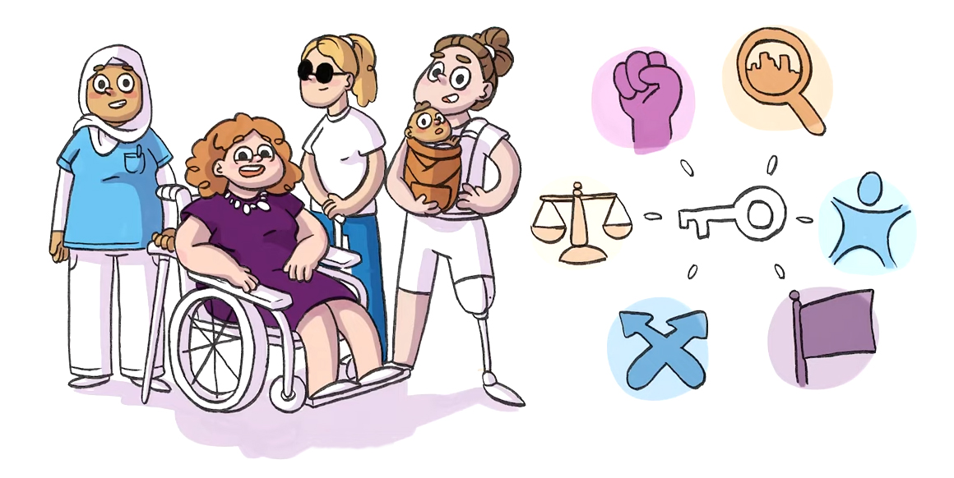
WDV uses the social model and the human rights model. We add to these models four other important perspectives:
gender equality;
intersectionality;
centring of lived experience;
and disability pride.

Together, these models and perspectives make up WDV’s 6 Keystones for understanding disability.

The 6 Keystones

The Social Model of Disability
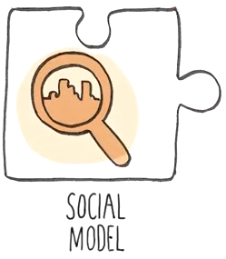
The Social Model of Disability tells us that the problem is not our disabilities, but a society and a system that leaves out people with disabilities. It tells us that disability is not a personal tragedy. There is nothing wrong with us. We just experience the world differently. It's not up to us to get better or change, it’s up to society to change.
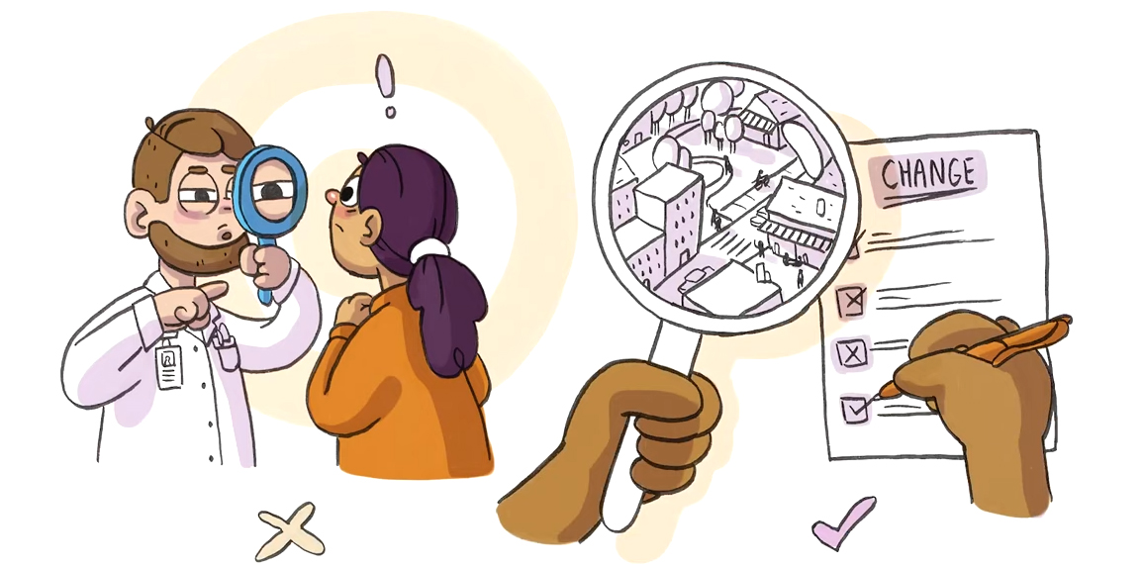
It’s about putting the focus on ableism and negative attitudes towards disability rather than disability itself as the problem.
The social model aims to make society more accessible by removing stigma and discrimination.

The Human Rights Model of Disability
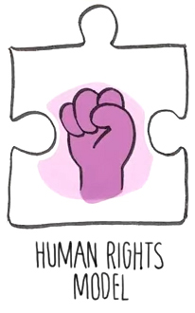
The Human Rights Model of Disability extends from the social model and tells us that disability cannot be used as an excuse to discriminate or deny access and opportunity.
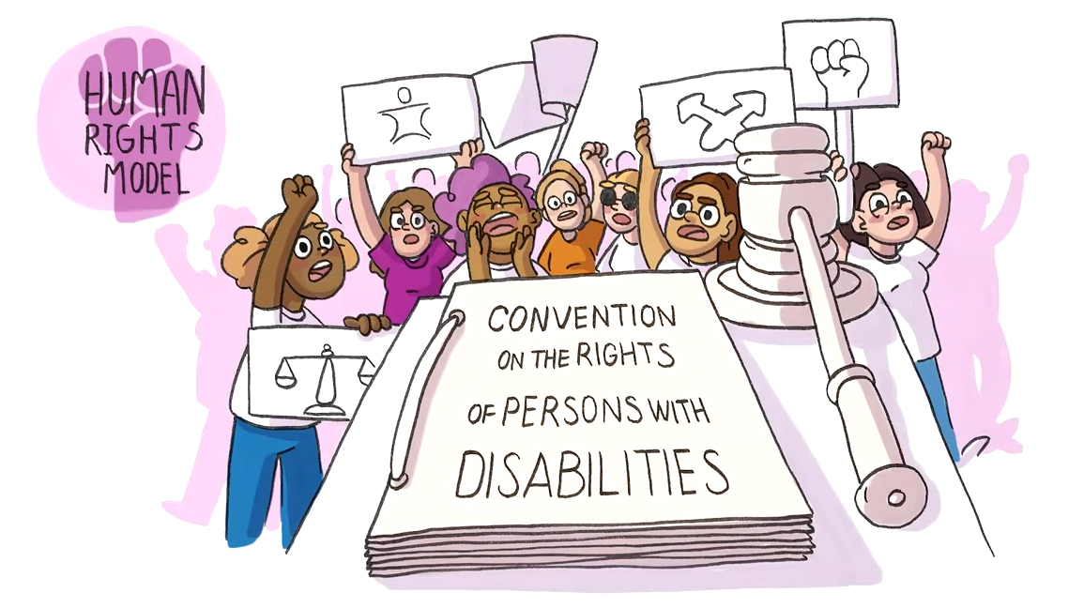

Equality does not mean treating everyone the same, and governments have a responsibility to support people with disabilities.

The Gender Equality Approach
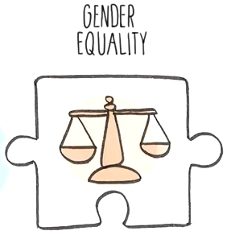
The gender equality approach means understanding that people are treated differently based on both their gender and disability.
A man with a disability will have different experiences to women and non-binary people with disabilities, and a trans person with a disability will have different experiences to cisgender people.
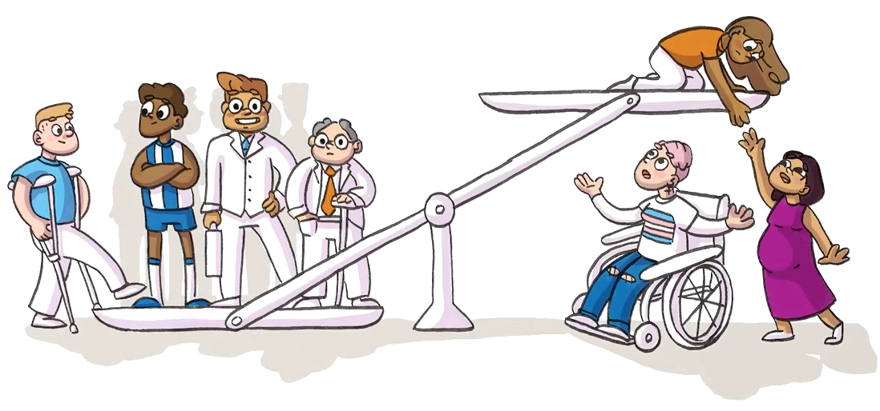
We live in an unequal society which treats women and gender diverse people as having less value and being less worthy of opportunities.

Intersectional Understanding
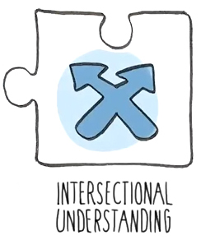
We all have multiple identities. Intersectionality is when two or more of our identities come together within systems and structures that harm and discriminate against people based on these identities.
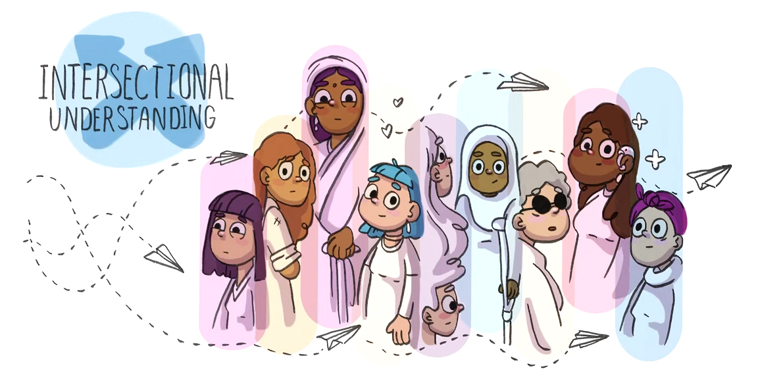
For example, women with disabilities experience sexism and ableism at the same time. This means that women with disabilities experience a double disadvantage compared to women without disabilities and men with disabilities, as being a woman and having a disability overlap.

Centring of Lived Experience
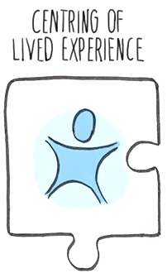
As women with disabilities, we are the experts in our own lives, not our families, carers, doctors or other professionals who support us. We know our needs better than anyone else because we actually live with our disabilities every day.
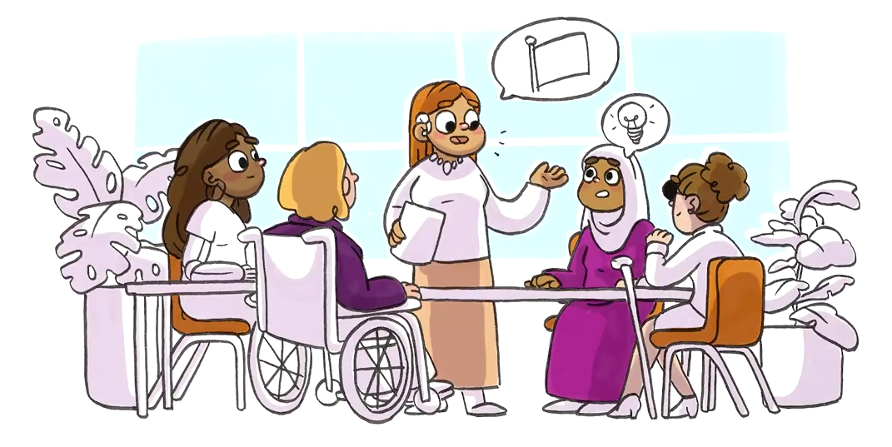
Disability rights advocates say,
“nothing about us without us”.

This means that researchers and professionals need to include women with disabilities when designing policies or programs about disability. They need to value our lived experience and acknowledge our worth by paying for our expertise.

Disability Pride
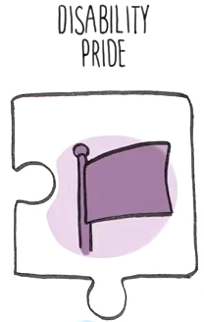
An idea taken from the queer pride movement, disability pride recognises that people with disabilities are worthy and should lead dignified lives.
Disability pride tells us not to be ashamed of having a disability. Disability pride reminds us that women with disabilities belong to society and celebrates our achievements.
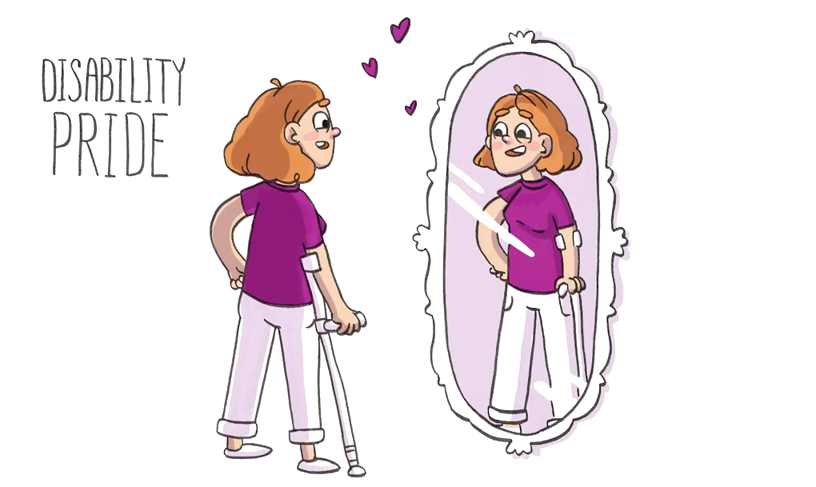
Disability is a part of who we are, but it does not define us. We are made up of many different identities and this impacts our life experiences.
Most importantly, disability pride teaches us to love ourselves and our disabled bodies, while allowing us to be part of a proud disabled community.

Combining the 6 Keystones

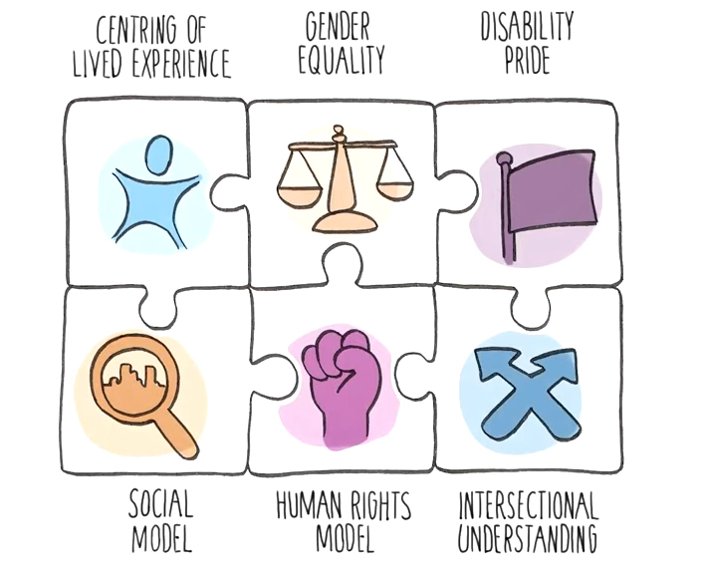
None of the above models should be viewed in isolation. We must acknowledge all of them for a more equitable and inclusive society. Just like a person’s identity is intersectional, so are our keystones.
“Disability doesn’t make you exceptional, but questioning what you think about it does.”
– Stella Young.

Change is Possible
We can create change by actively addressing gender and disability inequality by what we do, what we say and how we behave and interact with others.
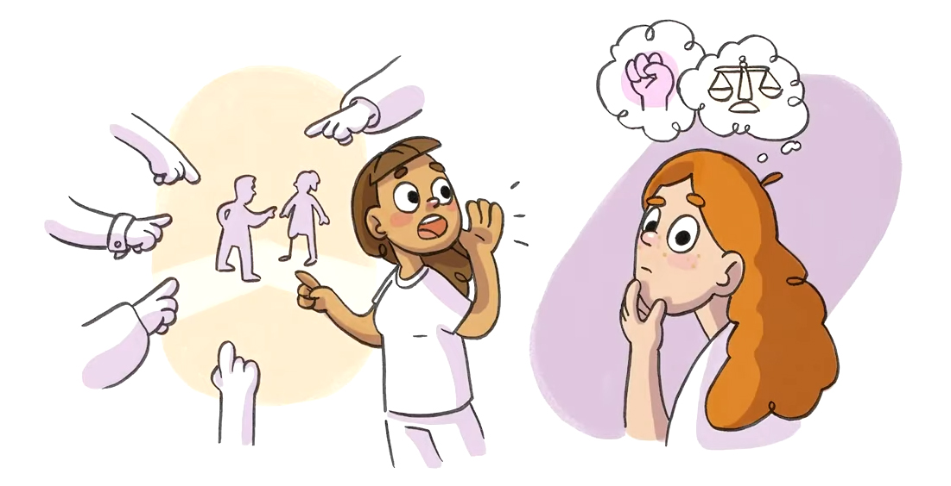
We can all make an effort to challenge our unconscious biases, and take action.
If you come across ableist behaviour, you can call it out.
You can design structures, programs and practices that are accessible and approachable.
Promote respect, choice, autonomy and equal opportunity.
Education, awareness raising and challenging unconscious bias is key.
Ask women with disabilities about our lives and experiences, as we are the experts. Remember, it’s our choice to answer or not answer certain inappropriate questions, especially if we don’t know or trust you yet. Women with disabilities have boundaries, just like everyone else, and these boundaries need to be respected.
Structures, policies, practices and research about disability should be disability led and co-designed with women with disabilities.
For more information about actions you can take to prevent violence against women with disabilities, please visit our resources on family violence on our website at https://www.wdv.org.au/family-violence-resources/

References
Brenes Reyes J. R. 2013, Review of Disability Politics &amp; Theory by A.J. Withers, Canadian Journal of Disability Studies, 2 (3), 135–138.
Disability Advocacy Resource Unit (DARU) 2021, Human Rights Model of Disability, viewed September 8 2021, https://www.daru.org.au/course/human-rights-model-of-disability
Independence Australia 2021, A Story of Disability Pride, viewed 9 September 2021, https://www.independenceaustralia.com.au/tips-and-advice/a-story-of-disability-pride/
Our Watch 2021, Quick Facts, Department of Prevention Victorian Government, viewed 7 September 2021, https://www.ourwatch.org.au/quick-facts
People with Disabilities Australia 2021, History Of Disability Rights in Australia, United Nations, viewed 7 September 2021, https://pwd.org.au/about-us/our-history/
Settlement Services International, Still Outside the Tent: Cultural Diversity and Disability in a Time of Reform – a Rapid Review of Evidence, Occasional Paper 2, October 2018.
Women with Disabilities Victoria (WDV) 2018, WDV Facts Sheets and Statements, viewed September 8 2021, https://www.wdv.org.au/publications-resources/wdv-fact-sheets/

Wurundjeri Country
Postal: GPO Box 1160, Melbourne VIC 3001
Phone: 03 9286 7800
Email: wdv@wdv.org.au

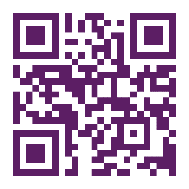
For more information visit: https://www.wdv.org.au/

