Experts in Our Health

A Workshop for Women with Disabilities
Women with disabilities experience many barriers to accessing the healthcare they need. The Experts in Our Health Workshop is for women, trans, gender diverse and non-binary folk with disabilities. The workshop is about health rights, speaking up, finding what we need and sharing our ideas for making services accessible.
The workshop will feature the Experts in Our Health Guide, Factsheets and Posters. The resources have been designed by a team of Health Experts with lived experience of disability, and will be available in accessible formats.
Please note this workshop is for people over 18 only.
Please contact project staff to discuss access and support requirements.
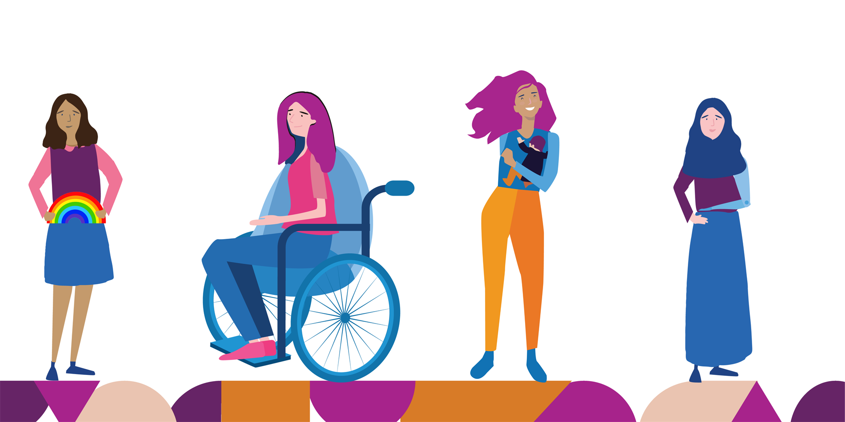

Details
Length: Approximately 90 minutes
Location: In person or online via Zoom
Cost: Free, funded by Department of Social Services
For more information: contact
Rosie Granland on 0412 283 587 or rosie.granland@wdv.org.au or
Dee Henry on 92 86 7801 or
dee.henry@wdv.org.au

