FACT SHEET 01

Creating Accessible and Safe Healthcare Settings for Women with Disabilities (WWD)

This fact sheet is designed for everyone working in the healthcare sector. This set of resources is created to inform all healthcare staff, including administrative staff, clinical and allied health professionals. Accessibility and inclusion are everyone’s business.
They are designed to increase your awareness of challenges faced by WWD receiving healthcare and support your understanding of your roles and responsibilities in creating an accessible, safe, and welcoming healthcare environment for all.

Your role in upholding the rights of Women with Disabilities
By understanding the rights of WWD in healthcare, you can play an important part in defending and promoting those rights.
As a person who works in the healthcare sector, you have an obligation to ensure WWD are treated with respect and dignity. You are responsible for ensuring that women with disabilities have access to inclusive and welcoming services and facilities, as stated in the Australian Charter of Healthcare Rights.
You can do this by listening, using inclusive language, asking broad and open questions and working collaboratively with WWD as equal partners. It is important to remember that WWD are the experts in their own bodies and health; and to work towards the health outcomes that each individual person seeks.

Take an active approach to understanding gender, health, and disability
Recognise and understand the various, complex and interrelated factors influencing the health of WWD. These may include social factors such as living arrangements, socio-economic status, cultural background, immigration or visa status, Aboriginal and/or Torres Strait Islander, LGBTIQA+ communities and more.
Understanding the combined impacts of gender, disability and other identities will allow you to provide safe, equitable and appropriate support for WWD. This includes working from a trauma-informed model and ensuring the voices of WWD are heard.
Your roles and responsibilities in providing an accessible and inclusive service
All health service employees have a legal, ethical and professional responsibility to provide accessible and inclusive services to WWD. It is recommended to have an understanding of the relevant legislative requirements in the areas of physical access and disability action planning.
Accessibility is everyone’s responsibility and should not be confined to one particular role, organisation or service.
Organisations need to be proactive in providing independent access to healthcare and reflect on inclusivity and ensure the views of WWD are heard and considered.

Women with disabilities working in healthcare settings
Women with disabilities are paid employees due to the skills they bring to their roles. Disclosure of their disability may not be necessary however, if a woman does decide to disclose their disability they must be provided with a safe space. If this is the case for you, you can view our resources for WWD working in healthcare.
Some of my bigger issues, constant nagging issues, are things like signage, access outside like footpaths, crossings, those sorts of really big issues are a problem for me being vision impaired. But inside the building there’s a lot of assumptions made. Covid is a classic example that everybody knows where the QR code is and can find it.
– Melanie

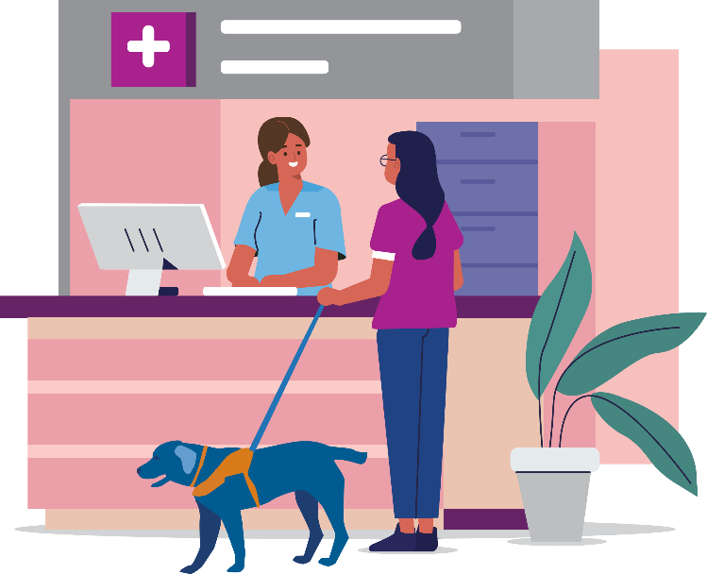
For information about the rights for women with disabilities in healthcare please go to:
https://www.safetyandquality.gov.au/consumers/working-your-healthcare-provider/australian-charter-healthcare-rights/supportive-resources-second-edition-australian-charter-healthcare-rights

The development of this resource was supported by the Australian Government Department of Social Services. Go to www.dss.gov.au for more information.
The Australian Government Department of Social Services funding is gratefully acknowledged.
Women with Disabilities Victoria would also like to acknowledge the ongoing support from our partner organisations – Multicultural Centre for Women’s Health, Women’s Health Loddon Mallee and Women’s Health in the North as well as members of the Project Advisory Group.
Our particular thanks to Women with Disabilities Victoria’s twelve Health Experts, who contributed their expertise to this resource as part of our co-design process.
This resource was prepared by Women with Disabilities Victoria.
Published by Women with Disabilities Victoria:
Level 9/255 Bourke Street, Melbourne, Victoria 3000
© Women with Disabilities Victoria 2022
For more information visit: https://www.wdv.org.au/

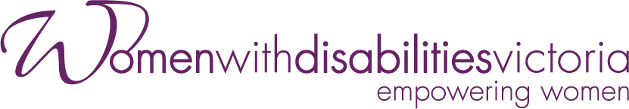
Wurundjeri Country
Postal: GPO Box 1160, Melbourne VIC 3001
Phone: 03 9286 7800
Email: wdv@wdv.org.au

