FACT SHEET 01

Creating accessible and safe healthcare settings for Women with Disabilities (WWD)

This fact sheet is for healthcare staff. Healthcare staff include administrative staff, clinical and allied health professionals.

Accessibility and inclusion are everyone’s business
It is important that all healthcare staff:
Are aware of the challenges WWD face when receiving healthcare.
Know your role in creating accessible, safe, and welcoming healthcare environments.
- Provide accessible and inclusive healthcare services.
All healthcare staff should know about:
Legal requirements for physical access.
Ways to support independent access to buildings and services.
- Your workplace disability action plan.
Healthcare organisations should make sure all staff:
Promote accessibility and inclusion.
- Collaborate with WWD.

Your role in upholding the rights of Women with Disabilities
Under the Australian Charter of Healthcare Rights, WWD have the right to inclusive and accessible healthcare services.
It is your responsibility as healthcare staff to:
Treat WWD with respect and dignity.
- Promote the rights of WWD.
To promote the rights of WWD you can:
Work with WWD, remembering that they are the experts in their own bodies and health.
Listen to WWD to work towards their individual healthcare outcomes.
Use inclusive language.
- Ask broad and open questions.

Take an active approach to understanding gender, health, and disability
Recognise and understand the various, complex and interrelated factors influencing the health of WWD such as:
Aboriginal or Torres Strait Islander identity.
LGBTIQA+ identity.
Cultural background.
Immigration or visa status.
Living arrangements.
- Socio-economic status.
To provide safe, equitable, and appropriate healthcare and support for WWD it's important that you:
Recognise and understand the factors influencing WWD's health.
Work from a trauma-informed model.
- Collaborate with WWD.

Women with disabilities working in healthcare settings
WWD are paid employees for the skills they bring to their roles.
WWD do not have to tell staff about their disability. However, there must be a safe space provided if they wish to do so.

Some of my bigger issues, are constant nagging issues, things like signage, access outside like footpaths, crossings, those sorts of really big issues are a problem for me being vision impaired. Inside the building there’s a lot of assumptions made, Covid is a classic example that everybody knows where the QR code is and can find it.
– Melanie

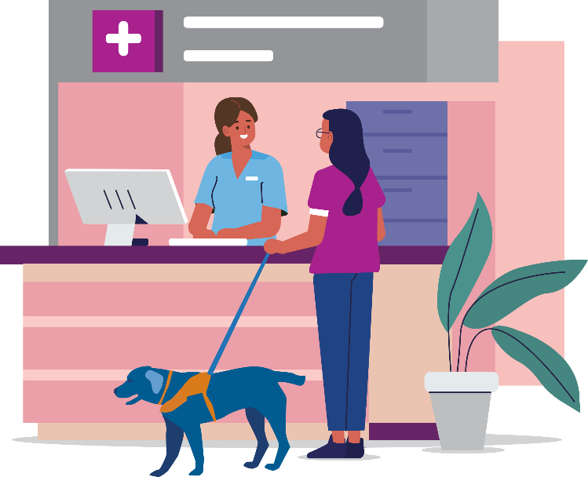

More information
For information about the rights for women with disabilities in healthcare please go to:
www.safetyandquality.gov.au/consumers/working-your-healthcare-provider/australian-charter-healthcare-rights/supportive-resources-second-edition-australian-charter-healthcare-rights
You can learn more at: www.wdv.org.au

The development of this resource was supported by the Australian Government Department of Social Services. Go to www.dss.gov.au for more information.
The Australian Government Department of Social Services funding is gratefully acknowledged.
Women with Disabilities Victoria would also like to acknowledge the ongoing support from our partner organisations – Multicultural Centre for Women’s Health, Women’s Health Loddon Mallee and Women’s Health in the North as well as members of the Project Advisory Group.
Our particular thanks to Women with Disabilities Victoria’s twelve Health Experts, who contributed their expertise to this resource as part of our co-design process.
This resource was prepared by Women with Disabilities Victoria.
Published by Women with Disabilities Victoria: PO Box 18314, Collins Street East. VIC 8003
© Women with Disabilities Victoria 2022

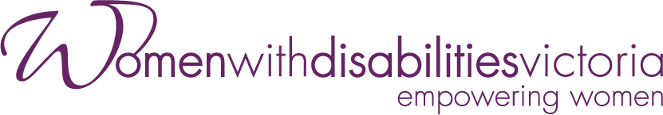
Wurundjeri Country
Postal: PO Box 18314, Collins Street East.
VIC 8003
Phone: 03 9286 7800
Email: wdv@wdv.org.au

