FACT SHEET 02

Your role in upholding the rights of women with disabilities (WWD)

This fact sheet is for healthcare staff. Healthcare staff include administrative and management staff, clinical and allied health professionals.

Ensuring the human rights of WWD is everyone’s responsibility
It is your responsibility as healthcare staff to:
- Treat WWD with respect and dignity.
- Defend and promote the rights of WWD.
- Provide accessible and inclusive healthcare services.

How you can uphold the rights of WWD
Work together
Healthcare staff must remember that WWD are the experts in their own bodies and health.
To achieve the best healthcare outcomes for WWD, healthcare staff should:
Collaborate with WWD (including both clients and colleagues).
Regularly check that services and supports are effective for WWD.
Have an open mind about the health needs, strategies, and goals of WWD.
Respect the health outcomes each WWD is seeking.
- Avoid coercive practices by knowing what healthcare outcomes each WWD is seeking.
Healthcare staff should work from a trauma-informed model by:
Supporting WWD to have continuity of care.
Avoiding the need for WWD to repeat trauma related details or stories.
- Preparing before you interact with WWD.
Listen
It's important to respect and listen to WWD to understand how different factors influence their health and healthcare needs.
You should make sure to provide a safe place and enough time for WWD to discuss their healthcare needs with you.
To create a safe environment you can:
Fully support and accept each WWD, including their healthcare goals, disability, gender, and identity.
Avoid assumptions about disability and gender.
Ask questions that are broad and open ended.
- Use body language to show that you are engaged in the conversation.
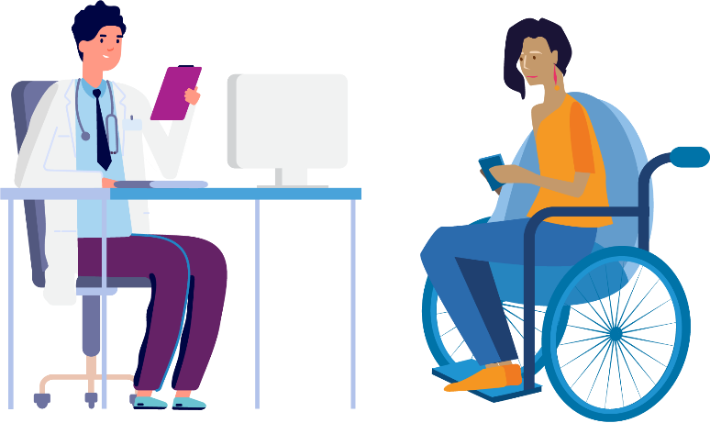

It is important to ask about disability, even if you don’t know how to immediately offer support to WWD. Asking about disability can help WWD share their experiences and information about how you can further support them.
Focus on the individual
It is important to focus on the unique healthcare needs and goals each WWD has.
Not all healthcare needs and goals are related to an individual's disability. Healthcare staff must respect WWD by exploring all healthcare concerns and goals, irrespective of the relationship to an individual's disability.
It is not always relevant for WWD to disclose and discuss their disability. You should respect their choices in situations where this may happen.
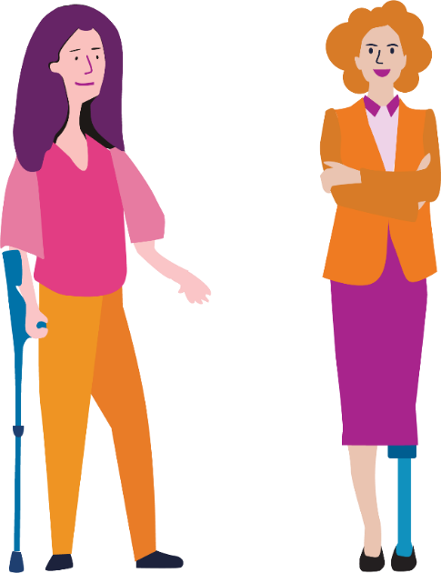
I think the biggest one for me is that they [women with disabilities] are entitled to the same level of healthcare that everybody else has, and that can be a bit more complicated and it often requires more appointments and more doctors and specialists and more time but you should be able to receive the same support.
– Rebecca

More information
For information about the rights for women with disabilities in healthcare please go to:
www.safetyandquality.gov.au/consumers/working-your-healthcare-provider/australian-charter-healthcare-rights/supportive-resources-second-edition-australian-charter-healthcare-rights
You can learn more at: www.wdv.org.au
The development of this resource was supported by the Australian Government Department of Social Services. Go to www.dss.gov.au for more information.
The Australian Government Department of Social Services funding is gratefully acknowledged.
Women with Disabilities Victoria would also like to acknowledge the ongoing support from our partner organisations – Multicultural Centre for Women’s Health, Women’s Health Loddon Mallee and Women’s Health in the North as well as members of the Project Advisory Group.
Our particular thanks to Women with Disabilities Victoria’s twelve Health Experts, who contributed their expertise to this resource as part of our co-design process.
This resource was prepared by Women with Disabilities Victoria.
Published by Women with Disabilities Victoria: PO Box 18314, Collins Street East. VIC 8003
© Women with Disabilities Victoria 2022

Wurundjeri Country
Postal: PO Box 18314, Collins Street East.
VIC 8003
Phone: 03 9286 7800
Email: wdv@wdv.org.au

