FACT SHEET 02

Your Role in Upholding the Rights of Women with Disabilities (WWD)

This fact sheet is for everyone working in the healthcare sector. Ensuring the human rights of WWD is everyone’s responsibility. This resource is designed to encourage healthcare staff, including administrative staff, managers, clinical and allied health professionals to learn about the rights of WWD in healthcare. It identifies the important role healthcare staff play in protecting and promoting these rights.
As a person who works in the healthcare sector, you have both the power and obligation to ensure WWD are treated with respect and dignity. You are responsible for providing accessible, inclusive and welcoming services and facilities.
Here are our recommendations for ensuring that the rights of WWD are upheld:
1. Work together – treat WWD as equals and experts in their own health. Ensure you ask about how to best support their health by maintaining an open mind about health needs, strategies and goals.
- WWD are the experts in their own health and body. Remember, diagnostic modelling is not final. Ensure that you engage with WWD in an ongoing manner and continuously check on the effectiveness of services and supports.
- Respect the outcomes each WWD is seeking. By being curious about the desired outcome of each WWD, coercive practices can be avoided.
- Practice in a way that recognises the effects of possible trauma.
- Always prepare prior to interactions with WWD. Support WWD to have continuity of care, and avoid asking them to repeat details, stories or traumas.
2. Listen – provide time and space to discuss the health of WWD. Listen respectfully and allow time to understand complexity. Create a safe environment to speak, by:
- Providing unconditional positive regard to WWD. This includes suspending judgement and questioning assumptions about disability and gender.
- (For example, have you asked about sexual, reproductive and mental health? If not, why is that?).
- Asking broad and open-ended questions about health needs.
- Asking about disability even if you don’t know how to immediately offer support.
- Practicing using open body language to demonstrate active listening.

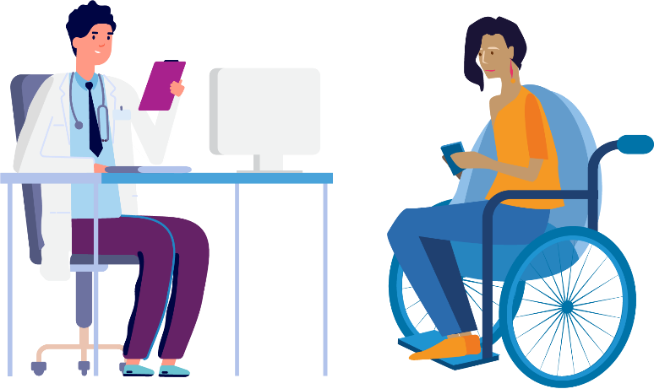

3. Focus on the individual instead of the process – the needs and goals of each person are unique.
- Not everything is related to disability – respect the health of WWD as a whole and ensure non-disability related concerns are explored.
- Always respect the choices WWD make about disclosing and discussing their disability.

I think the biggest one for me is that they [women with disabilities] are entitled to the same level of healthcare that everybody else has, and that can be a bit more complicated and it often requires more appointments and more doctors and specialists and more time but you should be able to receive the same support.
– Rebecca

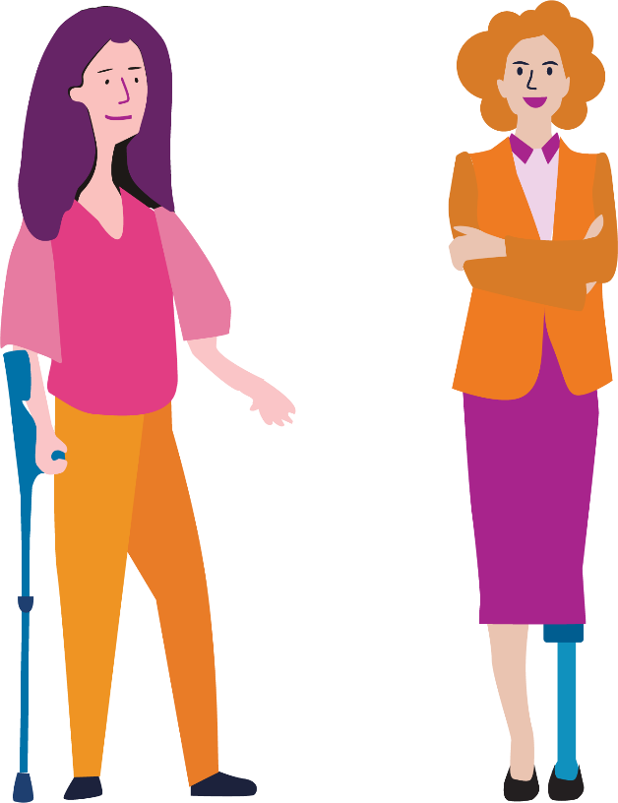
The development of this resource was supported by the Australian Government Department of Social Services. Go to www.dss.gov.au for more information.
The Australian Government Department of Social Services funding is gratefully acknowledged.
Women with Disabilities Victoria would also like to acknowledge the ongoing support from our partner organisations – Multicultural Centre for Women’s Health, Women’s Health Loddon Mallee and Women’s Health in the North as well as members of the Project Advisory Group.
Our particular thanks to Women with Disabilities Victoria’s twelve Health Experts, who contributed their expertise to this resource as part of our co-design process.
This resource was prepared by Women with Disabilities Victoria.
Published by Women with Disabilities Victoria:
Level 9/255 Bourke Street, Melbourne, Victoria 3000
© Women with Disabilities Victoria 2022
For more information visit: https://www.wdv.org.au/

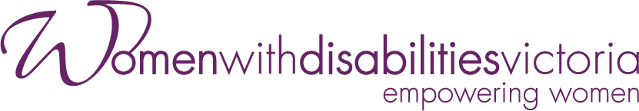
Wurundjeri Country
Postal: GPO Box 1160, Melbourne VIC 3001
Phone: 03 9286 7800
Email: wdv@wdv.org.au

