FACT SHEET 03

Take an Active Approach to Understanding Gender, Health and Disability

This fact sheet is designed for everyone working in the healthcare sector. Understanding the intersection of gender, health and disability is important in achieving a positive patient experience. This resource has been created for all healthcare staff, including administrative staff, managers, clinical and allied health professionals.
It encourages a holistic, person-centered approach to healthcare provision by understanding the various complex and interrelated factors influencing the health of Women with Disabilities (WWD). Here’s how you can take an active approach to understanding gender, health and disability:
1. Learn about the social model of disability – understand how systems contribute to your clients’ barriers to healthcare and social participation.
- WWD frequently encounter barriers and exclusion which can be exhausting and stressful. Ask what you can do to dismantle specific barriers that your clients are facing.
- Aim to eliminate physical, attitudinal and other barriers to effective healthcare. By doing this you are acting as a supporter and ally of WWD.
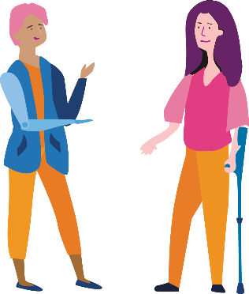
- Offer services, facilities and information that is accessible and inclusive of each client’s needs.
- Use inclusive, respectful language and avoid ableist language and slurs. Ableist language and slurs are words or phrases that may be hurtful, upsetting, retraumatising or offensive to many disabled people. Follow each person’s lead on which language to use. For example, if a client uses the term ‘disabled’, use it also.
2. Consider multiple layers of disadvantage – including race, gender, social, cultural and economic background, Aboriginal and/or Torres Strait Islander, sexuality or age.
- Regularly consider the implications of various social systems on your clients’ health and access needs.
- Engage in education and awareness about safe and holistic healthcare for WWD, recognising that WWD are more likely to experience family violence. Access training to identify potential violence and/or coercive control from support people and respond to disclosures of violence and abuse.
- Recognise that WWD who are members of other marginalised groups experience unique barriers to healthcare. For example, immigrant women may not have access to Medicare, and First Nations women may experience intergenerational trauma and may not have access to culturally safe and appropriate health services.

3. Use a holistic approach based on the social determinants of health:
- Provide wrap around support – stay actively involved in finding and engaging with appropriate and broad supports such as housing, emotional support, disability support, employment, transport, finances etc.
- Learn about services that WWD might be eligible for and proactively inform them. Understand your role as potential ‘gatekeeper’ of services and provide continuous support to increase clients’ access.
- Ask about disability and how you or other service providers can be of assistance.
- Ask about both physical and mental health, as these are interrelated.
4. Promote and provide accessible information proactively:
- Find out about clients’ health literacy levels and tailor information so it can be easily understood. Support WWD to develop their health literacy to maximise their healthcare participation.
- Promote and provide all information in accessible formats and language based on individual needs.
- Proactively research and provide information about available supports.
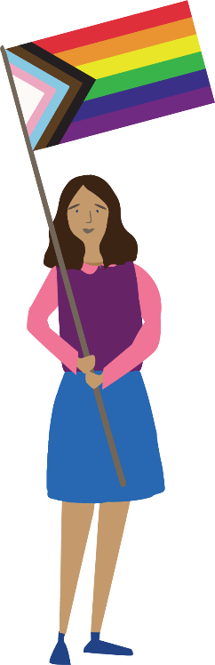
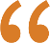 Health is not just about your physical health... you have the right to have your own opinion and control over what procedures or treatment path you go down, and you also have the right to social and mental health as well and that’s a really important part of the process and certainly not to be neglected.
– Kylie
The development of this resource was supported by the Australian Government Department of Social Services. Go to www.dss.gov.au for more information.
The Australian Government Department of Social Services funding is gratefully acknowledged.
Women with Disabilities Victoria would also like to acknowledge the ongoing support from our partner organisations – Multicultural Centre for Women’s Health, Women’s Health Loddon Mallee and Women’s Health in the North as well as members of the Project Advisory Group.
Our particular thanks to Women with Disabilities Victoria’s twelve Health Experts, who contributed their expertise to this resource as part of our co-design process.
This resource was prepared by Women with Disabilities Victoria.
Published by Women with Disabilities Victoria:
Level 9/255 Bourke Street, Melbourne, Victoria 3000
© Women with Disabilities Victoria 2022
For more information visit: https://www.wdv.org.au/

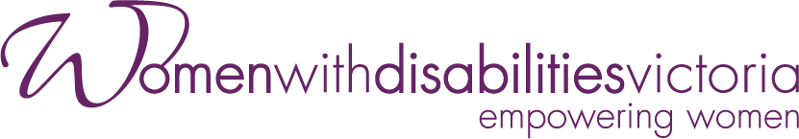
Wurundjeri Country
Postal: GPO Box 1160, Melbourne VIC 3001
Phone: 03 9286 7800
Email: wdv@wdv.org.au

