FACT SHEET 05

Women with disabilities (WWD) working in healthcare settings

This fact sheet is for healthcare organisations and Women with Disabilities (WWD) working as healthcare staff. Healthcare staff includes administration, management, governance, and volunteers.

Benefits of employing WWD
Employing WWD in healthcare settings will:
Increase diversity of workforces.
Increase organisational knowledge and disability expertise.
Make sure workforces represent clients that they serve.
- Add to inclusive workplace culture and increased empathy.

How employers can be more inclusive
Employers can increase skills and knowledge across their organisations by prioritising the lived experience of WWD.
To do this employers should recruit WWD across all organisational roles, including:
Service delivery
Administration
Management
- Governance.
Employers should:
Involve organisational leaders in planning, implementing and reviewing inclusion activities.
Incorporate disability inclusion into strategic plans with indicators of progress and accountability.
Make sure that COVID-19 processes are inclusive of all employees, with accessible adjustments available.
- Provide training on disability inclusive practices for all staff and volunteers.
When working with WWD employers should:
Know how to ask about accessibility needs discreetly and upfront.
Ensure the WWD's confidentiality is upheld.
- Consider the organisational environment and follow up with WWD as accessibility needs may change.
It is important for workplaces to consider reasonable adjustments including:
Negotiation of flexible hours and rosters.
Accommodation and recognition of invisible aspects of disability such as fatigue or chronic pain.
- Physical access.

Barriers WWD may face in the workplace
WWD may face barriers in the workplace because:
Healthcare systems and organisations are often guided by the medical model of disability.
- Disclosure of disability and access needs is a personal decision, it is up to the individual when and if it takes place.
Barriers to accessibility can cause:
WWD to feel socially isolated at work.
WWD to take on an advocacy role for them self or someone else, possibly leading to decreased:
- Confidence
- Motivation
- Engagement at work.
Often WWD take on responsibility as the only person who can create change. This can result in higher stress levels.
Every WWD will have a different preference for telling other people about their disability and support needs. It is up to each WWD to decide:
If they want to disclose their personal information.
When they may disclose the information.
Who they disclose the information to.
- How much information they want to provide.

How WWD can navigate healthcare systems as employees
As a WWD your wellbeing may be supported by:
Connecting with other women you work with.
Finding allies of WWD in your workplace.
- Creating a support network.
Work out where you can go for support by connecting with:
Disability support services.
Community groups.
- Work groups.
Remember:
That you can talk about your expertise as a person with a disability alongside your other attributes.
That your lived experience is valuable and should always be recognised and appreciated.
You can ask and expect to be paid for your time, effort and expertise at all times.
You can promote and advocate for voices of WWD to be heard throughout the organisation, at every level.
- You can challenge decision-making where WWD have not been consulted.
Consider joining committees or being a part of leadership in your workplace or organisation.
You have the legal right to ask for and receive your accessibility needs at work. You can contact Job Access for information, support, assessments and potential funding for modifications.
It is helpful to tell your employer what you need right away from your employer. You may need more than just the ‘obvious’ things such as ramps etc and you are entitled to this.

More information
You can learn more at: www.wdv.org.au/
The development of this resource was supported by the Australian Government Department of Social Services. Go to www.dss.gov.au for more information.
The Australian Government Department of Social Services funding is gratefully acknowledged.
Women with Disabilities Victoria would also like to acknowledge the ongoing support from our partner organisations – Multicultural Centre for Women’s Health, Women’s Health Loddon Mallee and Women’s Health in the North as well as members of the Project Advisory Group.
Our particular thanks to Women with Disabilities Victoria’s twelve Health Experts, who contributed their expertise to this resource as part of our co-design process.
This resource was prepared by Women with Disabilities Victoria.
Published by Women with Disabilities Victoria: PO Box 18314, Collins Street East. VIC 8003
© Women with Disabilities Victoria 2022

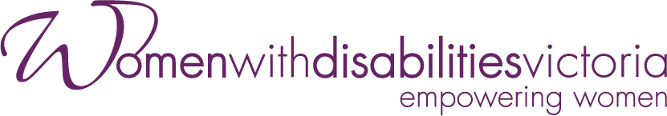
Wurundjeri Country
Postal: PO Box 18314, Collins Street East.
VIC 8003
Phone: 03 9286 7800
Email: wdv@wdv.org.au

