Experts in
our Health

A guide developed by and for
women with disabilities to support
our informed health choices.

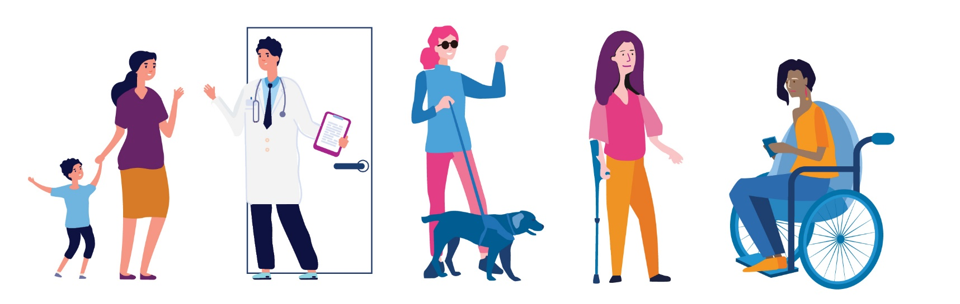

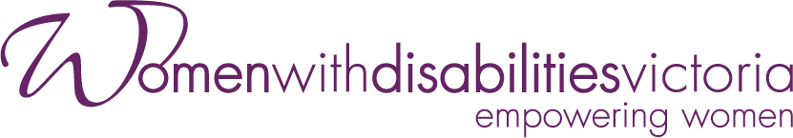

The development of this resource was supported by the Australian Government Department of Social Services. Go to www.dss.gov.au for more information.
The Australian Government Department of Social Services funding is gratefully acknowledged.
Women with Disabilities Victoria would also like to acknowledge the ongoing support from our partner organisations – Multicultural Centre for Women’s Health, Women’s Health Loddon Mallee and Women’s Health in the North as well as members of the Project Advisory Group.
Our particular thanks to Women with Disabilities Victoria’s twelve Health Experts,
who contributed their expertise to this resource as part of our co-design process.
This resource was prepared by Women with Disabilities Victoria.
Published by Women with Disabilities Victoria:
Level 9/255 Bourke Street, Melbourne, Victoria 3000
© Women with Disabilities Victoria 2022

Contents

Foreword 4
Acknowledgements 5
Women with Disabilities and Health 6
Who are women with disabilities? 6
Purpose of the Experts in Our Health Guide 6
Access to Health Services for Women with Disabilities 6
Statistics About Women with Disabilities and Health 8
Barriers to Access 8
Some important things to think about 9
Some questions to help us think about accessible and inclusive healthcare 9
Our Right to Health 10
Right to Equal and Timely Care 10
Right to Safety and Respect 10
Right to Accessible Information 10
Right to Be Heard 10
Right to Make Choices 10
Right to Access and Support 11
Right to Complain 11
Advocating for our Health 12
Advocating for Ourselves 12
Advocating for Change 12
Finding our way around Health Systems 14
Experiences of Navigating Health Systems 14
Types of Health Services 14
Public and Private Healthcare 14
Cost of Healthcare 15
Health Services and the NDIS 16
Interpreter Services in Health Settings 17
Places to Get Help 18
Glossary – Words and Meanings 21
Sources 22

Foreword

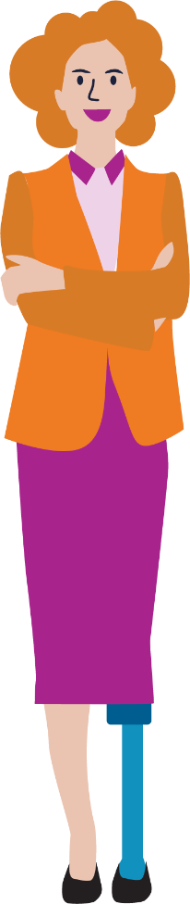

The Experts in Our Health Guide and accompanying resources are a result of the strength and insight of women with disabilities. They describe how women have faced barriers to health and have spoken up for their right to equal and accessible health services.
The Guide shows women with disabilities how they can navigate health systems and advocate for themselves and others in achieving optimal health. It is empowering to find ways to speak up and be heard.
It is important to know about our rights. As women with disabilities, we break down barriers that prevent us accessing healthcare on an equal basis with others. We are experts in our health and wellbeing, and we can make change.

DISCLAIMER: This guide has been designed to be accessible and useable for all women with disabilities. The information presented in this resource is current as of November 2021, we have provided links to resources which will give specific information.

Acknowledgements

Many thanks to those who gave their valuable time to participate in consultations that shaped the content and design of this resource.
We thank our partner organisations in informing this resource through consultation and support – Multicultural Centre for Women’s Health, Women’s Health Loddon Mallee and Women’s Health in the North.
Our particular thanks to Women with Disabilities Victoria’s twelve Health Experts, who contributed expertise that formed the basis of the Experts in Our Health Guide and accompanying resources. The co-design process highlighted the positive value of hearing directly from women with disabilities – and learning from their experience, wisdom and strength. WDV acknowledges the invaluable contribution of the women whose stories and opinions are featured in the Experts in Our Health Resources.
A cross-sector Project Advisory Group provided significant expertise and guidance in the development of the resource.
Membership comprised:
- Carmela Carey, WDV Health Expert
- Sandra Fueggle, WDV Outer East Hub Liaison Officer
- Regina Torres-Quiazon, Multicultural Centre for Women’s Health
- Cherise Smith, Royal Women’s Hospital
- Lynn Holt, Health Issues Centre
- Tricia Currie, Women’s Health Loddon Mallee
- Rosie Brennan, Women’s Health in the North
- Danielle McCaffrey, Star Health

Members’ enthusiasm, commitment, and valuable insights throughout all stages of the development of the resource is much appreciated. Thanks to WDV staff for their ongoing support of the Experts in Our Health Project.

Women with Disabilities and Health

Who are women with disabilities?
Women with disabilities are people who identify as women, transgender people, gender diverse people and/or non-binary folk who come from many backgrounds and have many different life experiences:
- We come from different cultures and speak and sign many languages.
- We live in cities, regional towns and rural areas.
- We may be attracted to people of any gender.
- We may be Aboriginal and/or Torres Strait Islander.
- We are young people and older people.
- These may impact on our lives at any time.
Women with disabilities are a diverse group of people who are resilient and strong. As individuals, we have unique voices and strengths. As a community, we empower each other to make change.

Purpose of the Experts in Our Health Guide
The guide is designed to assist women with disabilities:
- Understand what accessible healthcare is and learn about our health rights.
- Find our way around health services and systems.
- Learn about how to advocate for ourselves in a health setting, as well as
- Advocate for accessible health services for all women with disabilities.

Access to Health Services for Women with Disabilities
Women with Disabilities Victoria (WDV) hear about the barriers our members face when accessing the health services they need. Some of the experiences women with disabilities have described include:
- Not being able to physically access healthcare settings and services.
- Not feeling respected by healthcare staff.
- Not being involved in decisions that affect their healthcare and treatment.
- Not having their communication needs and preferences met.
- Having healthcare staff focus on their disability rather than their health concerns.

It is your right to access the services you need to maintain or improve your physical health and mental wellbeing.

It is your right to be provided with the appropriate services for you, at the time that you need them.
It is your right to go to a few different community or health practitioners or service providers to get the help and information you need, in the way you need it.

It is your right to be supported, safe, respected and to receive quality care in every health setting, every time you access care and support.

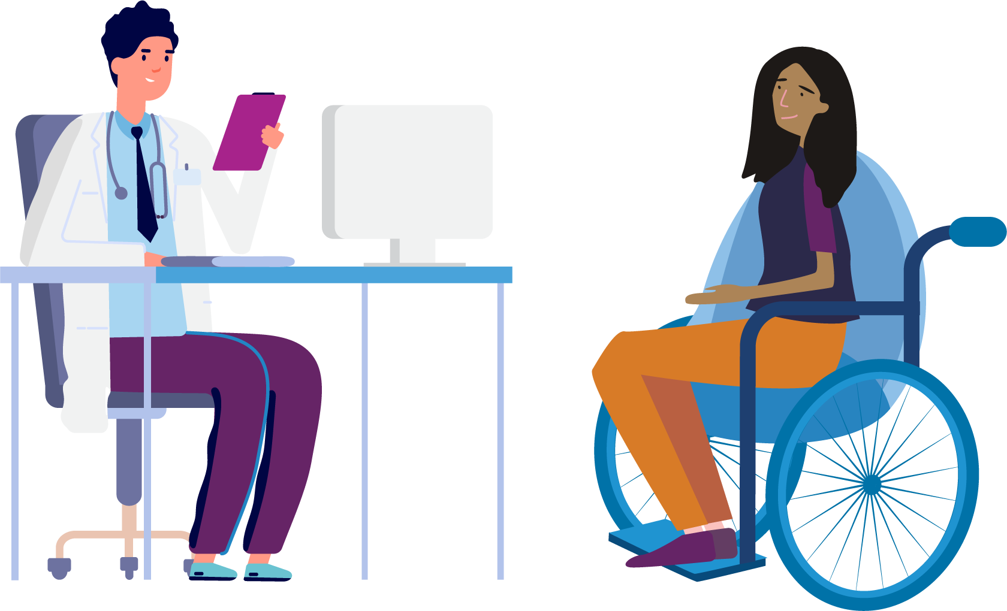

Statistics About Women with Disabilities and Health

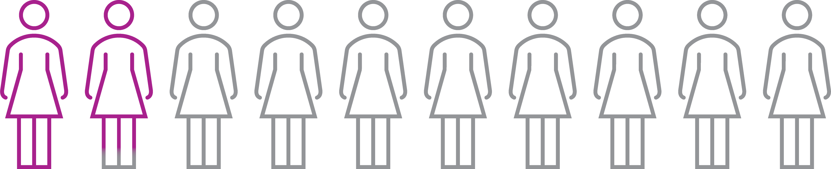

17.8% of women in Australia identify as having a disability.

Based on self-reported data, women with disability are more likely to have poorer health than women who do not identify as having disabilities.
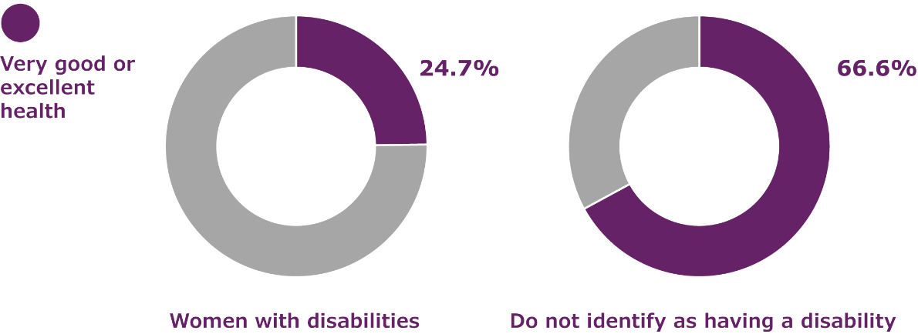
According to the Australian Institute of Health and Welfare, only 24.7% of women with disabilities experience very good or excellent health, compared with 66.6% of women who do not identify as having disabilities.

Barriers to Access
There are many different reasons why women with disabilities may find health services inaccessible, and as a result experience poorer health outcomes, than other members of the community. These barriers include:
- Health information not being provided in a way that is accessible.
- Services being located in buildings without accessible features such as ramps and accessible toilet facilities.
- Health care providers lacking knowledge about disability, and the skills and resources they need to make care accessible and inclusive.
- Misconceptions and stereotypes about women with disabilities and sex, which mean that women with disabilities may not easily access sexual and reproductive health services and information.
- Women with disabilities experiencing additional challenges to their social and emotional wellbeing, which can be made worse by lack of access to mental health support.
- Information about, and physical access to screening programs such as breast screening not being provided in ways that are inclusive of women with disabilities.
- Women with disabilities experience more barriers to employment and stable housing than other Australians, making some health services unaffordable.

Some important things to think about
- There are many things that contribute to the health and wellbeing of each of us. Where we live, the schools we attend, experience of family violence and how much money we have are examples of things that affect our health. These things are beyond our control. However, access to healthcare is a fundamental human right.
- We have the same right to healthcare as every other person, and we have the right to make our own health choices.
- It is the responsibility of health services to learn about what each of us needs, and to make their service accessible and inclusive.
- We may be members of different communities, such as Aboriginal and/or Torres Strait Islander, LGBTIQA+, faith-based or migrant and refugee communities. These factors may add to the barriers we experience.
- We can advocate for accessible and inclusive health services by joining groups such as disability advisory committees and taking on consumer advisory roles.
- We can empower each other when we join together to advocate for change.

Some questions to help us think about accessible and inclusive healthcare

Did you know that it is a human right for us to have good health?

What does accessible and inclusive healthcare feel, look and sound like?
How might other life factors, for example living in a rural area, affect our access to health services?

For me, having a physical disability, one of the main barriers is the built environment. If I go down the street and I need to go into the health service, but there’s two or three steps, or they’ve got the doorbell that I can’t reach. Those basic things would stop me from taking the first step.
– Jill

Our Right to Health

The United Nations Convention on the Rights of Persons with Disabilities describes the right of all people with disabilities to equal access to healthcare. It is the responsibility of those who design and deliver health services to make them accessible and inclusive. Whether you are in a hospital setting, community health centre or clinician’s office, you have the right to accessible healthcare.
In Australia, our right to health care is supported by the Australian Charter of Health Care Rights. The Charter describes the rights that consumers, or someone they care for, can expect when receiving health care. These rights apply to all people in all places where health care is provided in Australia. This includes public and private hospitals, day procedure services, general practice and other community health services.

Right to Equal and Timely Care
You have the right to the same quality healthcare as any other person.
You have the right to access treatment at the time you need it.

Right to Safety and Respect
You have the right to be safe from violence and abuse in all healthcare settings.
You have the right to be treated with respect.
You have the right to say no if something doesn’t feel right.

Right to Accessible Information
You have the right to information about your healthcare in formats that are accessible for you.
You have the right to ask for an interpreter or communication support that meets your needs and preferences.
You have the right to know about every aspect of your healthcare.
You have the right to consider options and make choices.

Right to Be Heard
You have the right to ask questions. Even if it is the same question, you have the right to ask it more than once.
You are the expert on your own experience. You have the right to tell health providers about your body and mind and have your opinion respected.
You have the right to be given enough time to talk about your concerns and ask questions of your health provider.

Right to Make Choices
You have the right to make your own health choices.
You have the right to seek as many opinions as you need to make informed choices about your healthcare.

Right to Access and Support
You have the right to access health services independently if you choose to.
You have the right to be supported by another person in a health setting if you choose to.

Right to Complain
You have the right to have your accessibility needs met, and to tell the people who manage health services if they are not meeting them.
You have the right to choose to speak up about lack of care or poor service provision. You also may choose not to.
You have the right to contact a complaints body such as the Health Complaints Commissioner or Human Rights Commission if you have not received acceptable care.

...the key is don’t give up. Believe in yourself, believe that you have the same rights, that you are equal to everybody else. And be kind to you, because it’s hard, it’s hard work and you’re not the problem, it’s the world around you, and that’s a big pill to swallow sometimes. It’s hard to believe that could be the case, but it’s really true. You are not the problem, the world is just not accommodating you.
– Yvonne

Advocating for our Health

Advocacy means to speak up for what we need. We can be advocates for ourselves or we can be advocates for our community. Women with disabilities can advocate for themselves when they are in a health setting by telling providers about their individual needs and preferences. We can also advocate for change in the health sector with and on behalf of our community.

Advocating for Ourselves

What can I do to advocate for myself when accessing a health service?

You could:
- Learn about your health rights before you attend an appointment with a health provider. See ‘Places to Get Help’ section below.
- Bring a trusted support person with you when you attend a health service, even if your support person just gives you confidence.
- Seek out people who can answer your questions clearly and thoroughly, giving you the information you need to make decisions.
- Request information to be given to you in accessible formats if you need it.
- Be persistent and keep at it. It sometimes takes time to find the information and treatment you need. Keep going until you find a health provider who can help you.
- Find ways to connect with other women with disabilities who may share your experiences. The support of our peers helps us develop courage and confidence to speak up for ourselves.

Advocating for Change

What can I do to advocate for more accessible and inclusive health services?

You can:
- Speak to your health providers about your experience as a woman with disability and tell them what accessible healthcare means for you.
- Seek opportunities to provide input into health services through becoming a member of their Board, disability advisory committees or consumer advisory roles.
- Connect with self-advocacy groups and join campaigns for accessible and inclusive communities. Combining our voices can help us be heard.

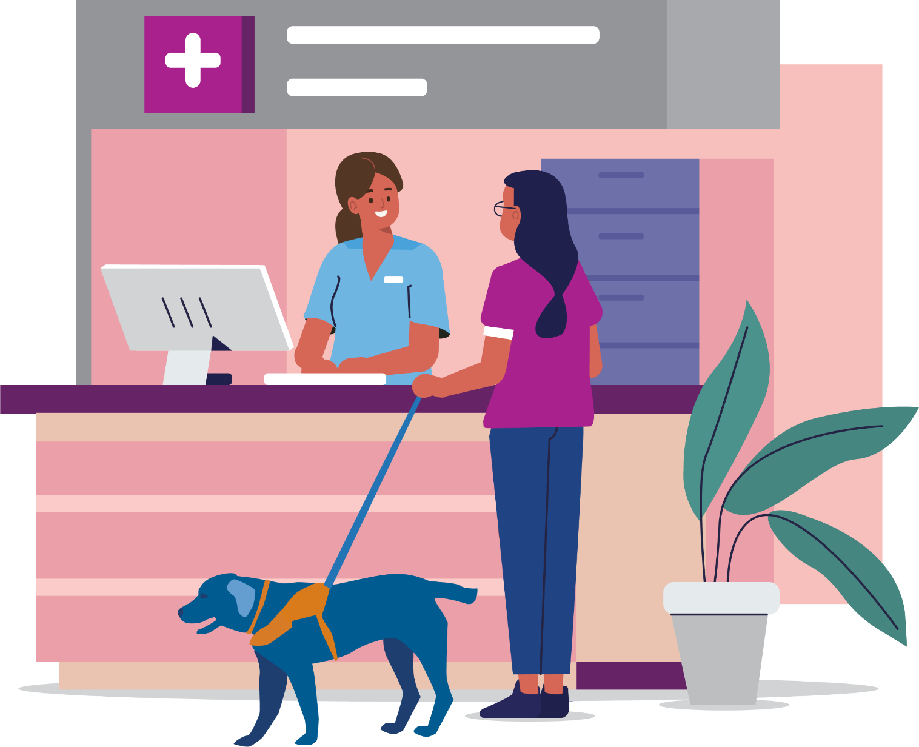

...knowing I’ve had support people has been, I think, instrumental in building my own confidence. And in terms of advocating, now if I’m not happy with an outcome or I don’t feel like I have a plan to manage my health for the next foreseeable time, instead of going through that period uncertain and maybe really struggling to keep up with work or any other aspects of my life, I will make that known.
– Angela

Finding our way around Health Systems

Experiences of Navigating Health Systems
Finding our way around the many different health services available can be challenging for all women, and particularly for women with disabilities. We may need to find out about or get referrals for and book appointments with many different services.
Women with disabilities regularly report feeling exhausted from facing barriers in many areas of our lives. We may have experience of trauma, often within medical systems and some of us have long histories of medical treatments and interventions.
Trying to manage or treat a health condition is challenging, and for women with disabilities in particular this can have a big impact on our wellbeing.

Types of Health Services
There are many different types of health services that look after different aspects of our health. Here are some examples of health services:
- General Practitioners
- Specialists
- Hospitals
- Community Health Centres
- Allied Health Practitioners, such as dentists and pharmacists
- Radiography, Screening and Pathology Services.

Public and Private Healthcare
Public hospitals provide services at no cost to people with access to Medicare. They are funded by the government but can also be funded by health insurance when patients choose to use their private cover in a public hospital.

When you are treated in a public hospital:
- The public health system will cover the cost of your treatment.
- As a public patient, you cannot choose your hospital, doctor or specialist.
Private health funds help cover some of the cost of your health care. If you join a private health fund, you can claim some money towards the cost of your treatment. For example, hospital cover helps cover costs when you go to hospital as a private patient.

When you are treated as a private patient in hospital:
- Your health insurer covers some or all of the hospital costs (such as accommodation).
- Medicare covers some of the doctors’ costs.
- Your health insurer covers some or all of the remaining doctors’ costs.
- As a private patient, you can choose your hospital, doctor and specialist.
There are often out-of-pocket costs when you access private healthcare, so finding out about these before having treatment is important.
The Department of Health website has more information about public and private healthcare: https://www.health.gov.au/health-topics/private-health-insurance
Please note, some women with disabilities do not have access to Medicare including those on temporary visas or even those who hold permanent resident visas and have not enrolled in Medicare.

Cost of Healthcare
Health services can cost money, even if they are partially funded by the government. This can change so it is always good to find out about the costs of services before you make a decision. There are often costs for private health services, even if they are covered by insurance.
When you receive medical care, whether it is under private or public health, you will likely come across these different terms, it is good to know what they mean.
Gaps or Out-of-Pocket Cost: are the difference between what you are charged and what Medicare and/or your private health insurer (if you have one) will pay for your medical treatment. Another way to think of it is ‘the amount you pay’.
Medicare rebate: is an amount paid back to you for a service. The Medicare rebate is the amount that has been set as an appropriate charge for that service, on a list called the Medicare Benefit Schedule (MBS). For example, Medicare covers 75% of the Medicare Benefits Schedule (MBS) (Item Number). If you are under Private Health Insurance, your insurer will cover the remaining 25% of the MBS (Item Number).
Medicare covers some or all of the costs of services such as:
- visits to a GP
- visits to specialists in their rooms
- diagnostic imaging
- diagnostic tests
- dental care for some children
- eye checks by optometrists
- allied health services.

Item Number: A Medicare item number is the number on a list by which Medicare identifies your treatment. You can use that number to check with Medicare, and/or your private health insurer what they will pay for your treatment.
General Practitioners and other health professionals sometimes bulk bill, which means Medicare pays the whole cost of the appointment. If they don’t bulk bill, the patient pays some of the cost of the session. You can make a claim for a refund if you pay the full cost of your appointment with a GP and many other health service providers. If you receive the Disability Support Pension or have a Health Care Card it is good to let your General Practitioner know as sometimes they will choose to bulk bill.
Through your General Practitioner, you can have access to a Chronic Disease Management Plan which allows you to have five visits per calendar year to a physiotherapist, podiatrist, dietitian or psychologist at no cost.
Mental Health Professionals, including psychologists, psychiatrists, counsellors, social workers and occupational therapists, can be seen with a treatment plan completed by a General Practitioner. Medicare may cover some or all of the cost of the sessions.
The National Disability Insurance Scheme (NDIS) may fund some mental health supports for people living with disabilities. For information about how to apply to join the NDIS, you can go to: https://www.ndis.gov.au/applying-access-ndis/how-apply
Pharmaceutical Benefits Scheme (PBS) partially covers the cost of most medicines. Once a person spends a certain amount on medicines in one year, they reach the PBS Safety Net threshold. With a PBS Safety Net Card, the price of medicines is lower for the rest of the year, for Concession Card holders it can be free. Tip, if you take a lot of prescription medication, think about purchasing all prescriptions from the same chemist as they will be able to tell you when you reach the PBS Safety Net.
Informed Financial Consent is that:
- You’ve been informed about the costs you can expect, and what benefits you’re getting for that cost. Your doctor and hospital have a responsibility to give you all the information before you have your treatment
- You consent to them, knowing what you’re getting, and what you’ll need to pay.
Find out more about Informed Financial Consent.
Your doctor could also use the Australian Medical Association’s (AMA) Template to give you Informed Financial Consent.

Health Services and the NDIS
The National Disability Insurance Scheme (NDIS) funds some health supports directly related to a person’s disability, and state health systems fund services related to health. More information can be found at: https://ourguidelines.ndis.gov.au/how-ndis-supports-work-menu/mainstream-and-community-supports/who-responsible-supports-you-need/health

Interpreter Services in Health Settings
Communication is a key entitlement under the Charter of Australian Health Care Rights. Women with disabilities must have access to appropriate communication support when they need to know their rights, give consent, participate in decision-making and be informed of information relating to their health and wellbeing.
Interpretation services in state-funded health settings including public hospitals are funded by the state and booked through each service’s booking system.
Interpreter services available are:
The National Auslan Interpreter Booking and Payment Service (NABS) https://www.nabs.org.au/ a Commonwealth Government service which can provide Auslan interpretation for health appointments.
For people over 65 who do not have an NDIS plan, NABS is free for health care appointments with your GP, Specialist or specified health consultations.
For people with an NDIS plan that includes interpreting hours, you can book an interpreter with NABS for your health care and other appointments (work, hobbies, financial, etc).
For anyone under 65 without NDIS, or anyone not eligible for NDIS, NABS is not free. Interpreting can be provided at a cost.
Spoken languages other than English. Most healthcare settings either have National Accreditation Authority for Translators and Interpreters (NAATI) on staff or can access an interpreter for you for on-site interpreting or over the phone via the government Translating and Interpreting Service (TIS) http://www.tisnational.gov.au/ This is a free service. But it is best to let the service know if you need an on-site interpreter as it will need to be booked beforehand.

...there are really good doctors and supports out there and health professionals and physios and all of that, and sometimes it’s just a matter of keeping on going until you find the people who can understand you and where you’re coming from, and who understand that if you’ve walked into the room it’s because it’s not all well, that there is something happening...so it’s waiting to find the right team for you.”
– Kelly

Places to Get Help

If you need help to find an accessible health service or to advocate for your rights in a health setting, the following places may be able to help you.

Australian Charter of Health Care Rights
The charter can be found at www.safetyandquality.gov.au/consumers/working-your-healthcare-provider/australian-charter-healthcare-rights/supportive-resources-second-edition-australian-charter-healthcare-rights

Blind Citizens Australia
Call 1800 033 660, text 0436 446 780 or go to the website www.bca.org.au
Offers advocacy information, advice and resources on a range of issues including healthcare.

Centre Against Sexual Assault (CASA House)
Call 1800 806 292 or go to
www.casahouse.com.au
CASA can provide counselling and crisis support if you have been sexually assaulted recently or in the past. For information about violence, abuse and sexual assault in Easy English visit https://www.secasa.org.au/programs-and-services/making-rights-reality/

Communication Rights Australia
Call 1300 666 604 or go to
www.communicationrights.org.au
Provides information and advocates for people with disabilities whose human rights have been abused. It gives priority to people with little or no speech.

Deaf Victoria
Deaf Victoria is a non-profit organisation led and managed by deaf and hard of hearing people and provides individual advocacy support. If you need assistance with advocacy or have a question, you can contact them via email at:
info@deafvictoria.org.au

Disability Advocacy Resource Unit – Find an Advocate
Go to https://www.daru.org.au/find-an-advocate
On the Disability Advocacy Resource Unit (DARU) website you can find advocates such as ones for individual advocacy, ones for systemic advocacy, referral and information services, who you can contact to make a complaint about a service you are receiving and self-advocacy and campaign groups you can join.

Sexual Health Victoria
Call 1800 013 952 or go to
https://shvic.org.au/
Sexual Health Victoria promotes reproductive and sexual health for all Victorians through their clinics, education and advocacy. To find a clinic near you please go to https://shvic.org.au/our-reproductive-and-sexual-health-clinics

Health Complaints Commissioner (HCC)
Call 1300 582 113 or go to
www.hcc.vic.gov.au
HCC can investigate health service providers who pose a serious risk to the health, safety or welfare of the public and help resolve complaints about health services.

Independent Mental Health Advocacy (IMHA)
Call 1300 947 820 or email
contact@imha.vic.gov.au
IMHA provide advocacy support across Victoria and have a range of advocacy and health rights resources available on their website https://www.imha.vic.gov.au/

Jean Hailes
provides information about many different topics related to women’s health: https://www.jeanhailes.org.au

Medical Treatment Planning and Decisions ACT 2016
Information on medical decision making in Victoria can be found here:
https://www.health.vic.gov.au/patient-care/medical-treatment-planning-and-decisions-act-2016

Mental Health Complaints Commissioner Victoria (MHCC)
Call 1800 246 054 or
https://www.mhcc.vic.gov.au/

If you would like to make a complaint about a mental health service or treatment and care, the MHCC would like to hear from you.

Multi-cultural Centre for Women’s Health
provides free multilingual women’s health information. Call 1800 656 421 or go to www.mcwh.com.au

National Auslan Interpreter Booking and Payment Service (NABS)
https://www.nabs.org.au/ is a Commonwealth Government service which can provide Auslan interpretation for health appointments.

National Disability Insurance Scheme (NDIS)
Call 1800 800 110 or go to
https://www.ndis.gov.au/
The National Disability Insurance Services can provide all people with disability with information and connections to services in their communities such as doctors, sporting clubs, support groups, libraries and schools, as well as information about what support is provided by each state and territory government.

Office of the Public Advocate
Call 1300 309 337 or go to
www.publicadvocate.vic.gov.au
The Office of the Public Advocate provide guardianship and advocacy services for people with disabilities. They provide advice and support.

Office for the Public Advocate, HealthCARE Conversations video
https://www.publicadvocate.vic.gov.au/14-news-media-item/371-new-video-gives-patients-with-disability-a-voice
This video is aimed at improving communication between health practitioners and people with disability.

Royal Women’s Hospital Women with Individual Needs Clinic
Call 03 8345 2159 or 0435 962 657 or go to https://www.thewomens.org.au/health-professionals/maternity/women-with-individual-needs#a_information
The Women with Individual Needs Clinic is an antenatal care clinic for women who are pregnant and have a disability. The clinic is open on Mondays, Tuesdays and Fridays, if you do phone and there is no one to take your call, calls will be returned within a day or two. Phone calls to this service are strictly confidential.

Safe Steps
Call 1800 015 188 or go to
https://www.safesteps.org.au/
Safe Steps provides specialist support services for anyone in Victoria who is experiencing or afraid of family violence. They are available 24 hours, 7 days a week.

Services Australia, Health and Disability
https://www.servicesaustralia.gov.au/living-with-disability
This website has information on accessing Medicare and some health services at low or no cost.
Help for people with disability or for if you are caring for someone. What to do when a loved one dies.

Translating and Interpreting Service (TIS)
provide onsite language interpreting or over the phone https://www.tisnational.gov.au/

United Nations Convention on the Rights of Persons with Disabilities
The convention can be found at
https://www.un.org/development/desa/disabilities/convention-on-the-rights-of-persons-with-disabilities.html

WIRE
Call 1300 134 130 or email
support@wire.org.au or go to
www.wire.org.au
Wire offers a free information and referral service for all Victorian women. They are open Monday - Friday 9.00am-5.00pm (except public holidays). You can also visit WIRE at the Women’s Information Centre Monday-Friday 9.30am-4.30pm

Women’s Health Victoria
Call 03 9664 6300 or go to
www.whv.org.au/about/our-sector
Women’s Health Victoria have information and links to Women’s Health Services in different regions across Victoria.

Glossary – Words and Meanings

Ableism – Discrimination toward and prejudice against people with disabilities.
Advocacy – Can mean speaking up for yourself or joining with others to speak up for change to structures and systems.
Empowering – Enhances the self-determination and active participation of women with disabilities by offering useful and accessible information, removing barriers to engagement and promoting and celebrating women’s capacities and inner strengths.
Disability – A “physical, sensory, psychiatric or cognitive impairment (including an intellectual disability), acquired brain injury or dementia that, in interactions with various barriers may hinder a person’s full and effective participation in society on an equal basis with others” (Australian Institute of Health and Welfare, 2020).
Discrimination – The prejudice and unjust treatment experienced by a person or group because of a particular trait or identity.
Gender – Gender relates to social expectations around the ways women and men behave, and the different roles and responsibilities they are expected to take. Gender encompasses a range of identities that do not necessarily correspond to traditional ideas of male and female.
General Practitioner – A medical professional who is the first or primary contact when a person has concerns about their health.

Health – may mean having or not having or a disease or risk factor as an individual. However, health can be described as being physically, mentally and socially well (WHO 1946). Health reflects the interactions between a person’s genetics, lifestyle and environment.
Health Service – A health service helps an individual or group assess, maintain, improve or manage their physical or psychological health.
Human Rights – The rights everyone is entitled to no matter who they are or where they live. The rights all people have simply because they are alive.
Intersectionality – is an approach that analyses social inequality and the ways a person’s race, gender, sexuality, age or disability intersect and can contribute to discrimination and oppression. Intersectionality asks us to see that sexism and ableism always intersect and interact with other forms of oppression.
NDIS – The National Disability Insurance Scheme is a scheme of the Australian Government that funds costs associated with disability.
Resource – An information source that is designed to help women with disability recognise violence and abuse, understand their rights and seek support. They may take a variety of forms including documents, apps, websites, videos and training sessions.
Social Model of Disability – The social model of disability proposes that what makes a person disabled is not their condition or impairment, but the attitudes and structures of the society they live in.

Sources

Australian Commission on Safety and Quality in Healthcare. (2019). Australian Charter of Healthcare Rights. https://www.safetyandquality.gov.au/consumers/understanding-your-rights
Australian Government Department of Health. (2021, August 18). About Private Health Insurance. https://www.health.gov.au/health-topics/private-health-insurance/about-private-health-insurance
Australian Government Department of Health. (2021, August 18). Medicare. https://www.health.gov.au/health-topics/private-health-insurance/about-private-health-insurance
Australian Government Department of Home Affairs. (2020, September 1) Translating and Interpreting Services. TIS National Website. https://www.tisnational.gov.au/
Australian Institute of Health and Welfare. (2020). Health of People with Disability. AIHW Snapshot Website. https://www.aihw.gov.au/reports/australias-health/health-of-people-with-disability
Australian Medical Association. (2020, September 1). Informed Financial Consent. AMA Website. https://www.ama.com.au/articles/informed-financial-consent
Lowrie, M. (2014). An inquiry into access to Auslan Interpreters in Victorian Hospitals. Deaf Victoria Website. https://www.deafvictoria.org.au/wp-content/uploads/2020/09/Deaf-Victoria-Auslan-interpreter-report-2014-D3-3-1.pdf
National Auslan Interpreter Booking Service. (2021, September 1) Deaf Community. NABS Website. https://www.nabs.org.au/about-nabs---deaf-community.html
National Disability Insurance Agency. (2021, September 1). Health. NDIS Website. https://www.ndis.gov.au/understanding/ndis-and-other-government-services/health
People with Disabilities Australia and Youth Action. (2019). Speaking Up for Yourself. PWDA Website. https://pwd.org.au/wp-content/uploads/2019/09/CreatingAccess_Factsheet_SpeakingUpForYourself_WEB.pdf
United Nations. (2006). Convention on the Rights of People with Disabilities. UN Department of Economic and Social Affairs Website. https://www.un.org/development/desa/disabilities/convention-on-the-rights-of-persons-with-disabilities.html
Women with Disabilities Victoria. (2010). Access to Health Services for Women with Disabilities. WDV Website. https://www.wdv.org.au/documents/Access%20to%20health%20services%20-%20the%20issues%20for%20women%20with%20disabilities.pdf

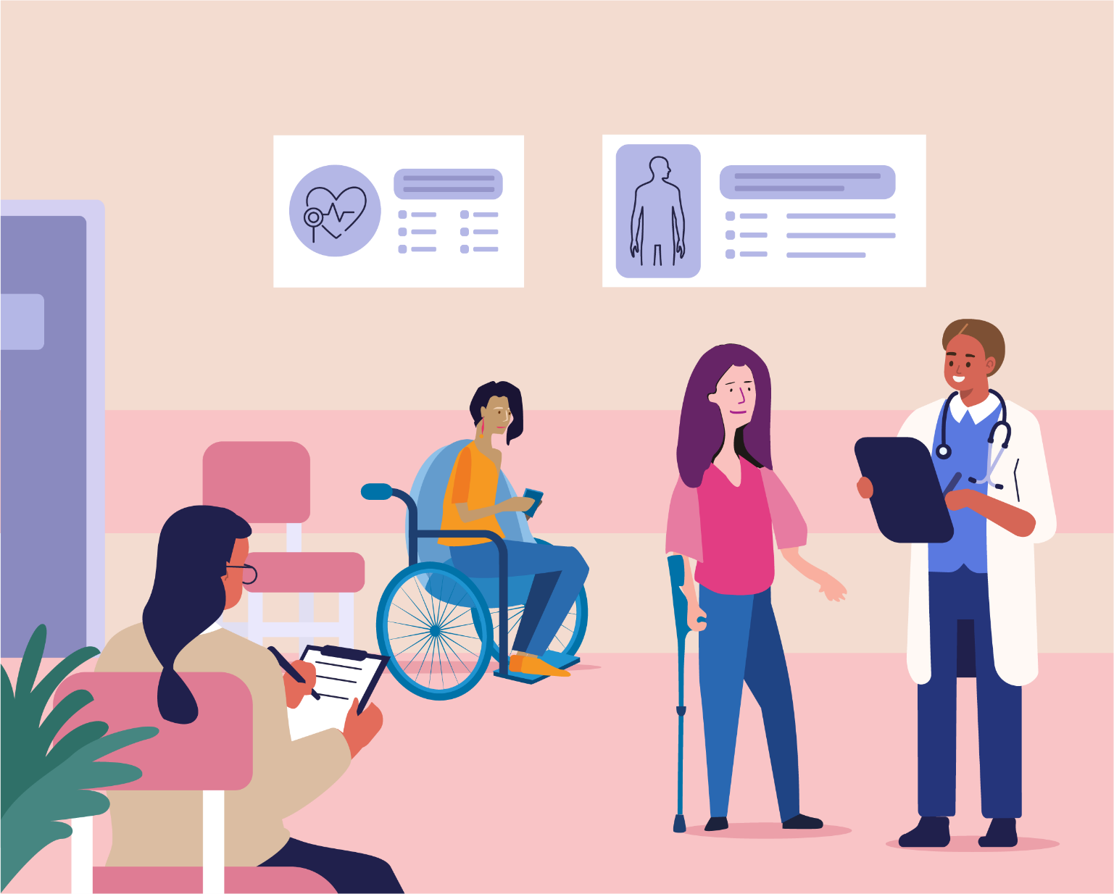

Wurundjeri Country
Postal: GPO Box 1160, Melbourne VIC 3001
Phone: 03 9286 7800
Email: wdv@wdv.org.au

For more information visit
https://www.wdv.org.au/

