Experts in
Our Health

A guide developed by and for
women with disabilities to support
our informed health choices.

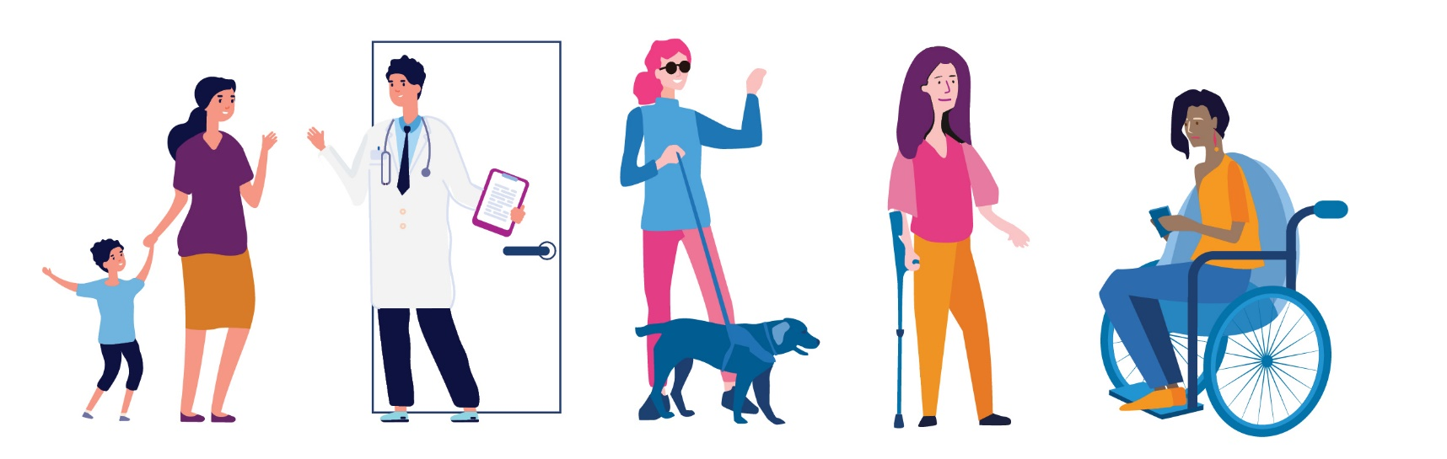

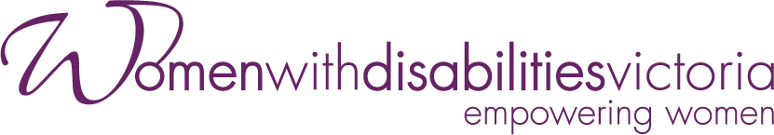

The development of this resource was supported by the Australian Government Department of Social Services. Go to www.dss.gov.au for more information.
The Australian Government Department of Social Services funding is gratefully acknowledged.
This guide was prepared by Women with Disabilities Victoria.
Published by Women with Disabilities Victoria: PO Box 18314, Collins Street East. VIC 8003
© Women with Disabilities Victoria 2022

Contents

Foreword 4
Acknowledgements 5
Women with disabilities and health 6
Who are women with disabilities? 6
Purpose of the experts in our health guide 6
Access to Health Services for Women with Disabilities 6
Statistics About Women with Disabilities and Health 8
Barriers to Access 8
Some important things to think about 9
Some questions to help us think about accessible and inclusive healthcare 9
Our right to health 10
Right to equal and timely care 10
Right to safety and respect 10
Right to accessible information 10
Right to be heard 10
Right to make choices 11
Right to access and support 11
Right to complain 11
Advocating for our health 12
Advocating for ourselves 12
Advocating for change 12
Finding our way around health systems 14
Experiences of navigating health systems 14
Types of Health Services 14
Public and private healthcare 14
Cost of healthcare 15
Health services and the NDIS 16
Interpreter services in health settings 17
Places to get help 18
Glossary – Words and Meanings 21
Sources 22

Foreword

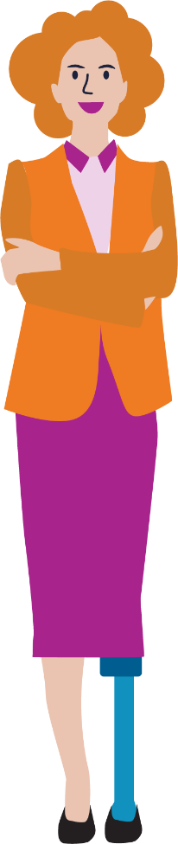
The Experts in Our Health Guide and accompanying resources are a result of the strength and insight of women with disabilities. They describe how women have faced barriers to health and have spoken up for their right to equal and accessible health services.
The Guide shows women with disabilities how they can:
- navigate health systems.
- advocate for themselves and others in achieving optimal health.
It is empowering to find ways to speak up and be heard.
It is important to know about our rights. As women with disabilities, we break down barriers that prevent us accessing healthcare on an equal basis with others. We are experts in our health and wellbeing, and we can make change.

DISCLAIMER: This guide has been designed to be accessible and useable for all women with disabilities. The information presented in this resource is current as of November 2021. We have provided links to resources which will give more information.

Acknowledgements

Thank you to everyone who took part in consultations to help shape the content and design of this resource, including our partner organisations:
Multicultural Centre for Women’s Health.
Women’s Health Loddon Mallee.
- Women’s Health in the North.
Our particular thanks to our twelve Health Experts. Your expertise formed the basis of the Experts in Our Health Guide and accompanying resources. The co-design process highlighted the positive value of hearing directly from women with disabilities. The process allowed us to learn from their experiences, wisdom and strength.
We acknowledge the invaluable contribution of the women whose stories and opinions are featured in the Experts in Our Health Resources.
A cross-sector Project Advisory Group provided significant expertise and guidance in the development of the resource.
The members of the Project Advisory Group were:
Carmela Carey, WDV Health Expert.
Sandra Fueggle, WDV Outer East Hub Liaison Officer.
Regina Torres-Quiazon (Multicultural Centre for Women’s Health).
Cherise Smith (Royal Women’s Hospital).
Lynn Holt (Health Issues Centre).
Tricia Currie (Women’s Health Loddon Mallee).
Rosie Brennan, (Women’s Health in the North).
- Danielle McCaffrey (Star Health).
Members’ enthusiasm, commitment, and valuable insights throughout all stages of the development of the resource is much appreciated. Thanks to WDV staff for their ongoing support of the Experts in Our Health Project.

Women with disabilities and health

Who are women with disabilities?
Women with disabilities are people who identify as women, transgender people, gender diverse people and/or non-binary folk. We come from many backgrounds and have many different life experiences. We:
Come from different cultures and speak and sign many languages.
Live in cities, regional towns and rural areas.
May be attracted to people of any gender.
May be Aboriginal and/or Torres Strait Islander.
- Are young people and older people.
These factors and experiences may impact on our lives at any time.
Women with disabilities are a diverse group of people who are resilient and strong. As individuals, we have unique voices and strengths. As a community, we empower each other to make change.

Purpose of the experts in our health guide
The guide is designed to assist women with disabilities:
Understand what accessible healthcare is and learn about our health rights.
Find our way around health services and systems.
Learn about how to advocate for ourselves in a health setting.
- Advocate for accessible health services for all women with disabilities.

Access to Health Services for Women with Disabilities
Women with Disabilities Victoria (WDV) often hear about the barriers our members face when accessing the health services they need. Some of the experiences women with disabilities have described include:
Not being able to physically access healthcare settings and services.
Not feeling respected by healthcare staff.
Not being involved in decisions that affect their healthcare and treatment.
Not having their communication needs and preferences met.
- Having healthcare staff focus on their disability rather than their health concerns.

It is your right to access the services you need to maintain or improve your physical health and mental wellbeing.

It is your right to be provided with the appropriate services for you, at the time that you need them.
It is your right to go to different community or health practitioners or service providers to get the help and information you need, in the way you need it.

It is your right receive quality care in every health setting, every time you access care and support.

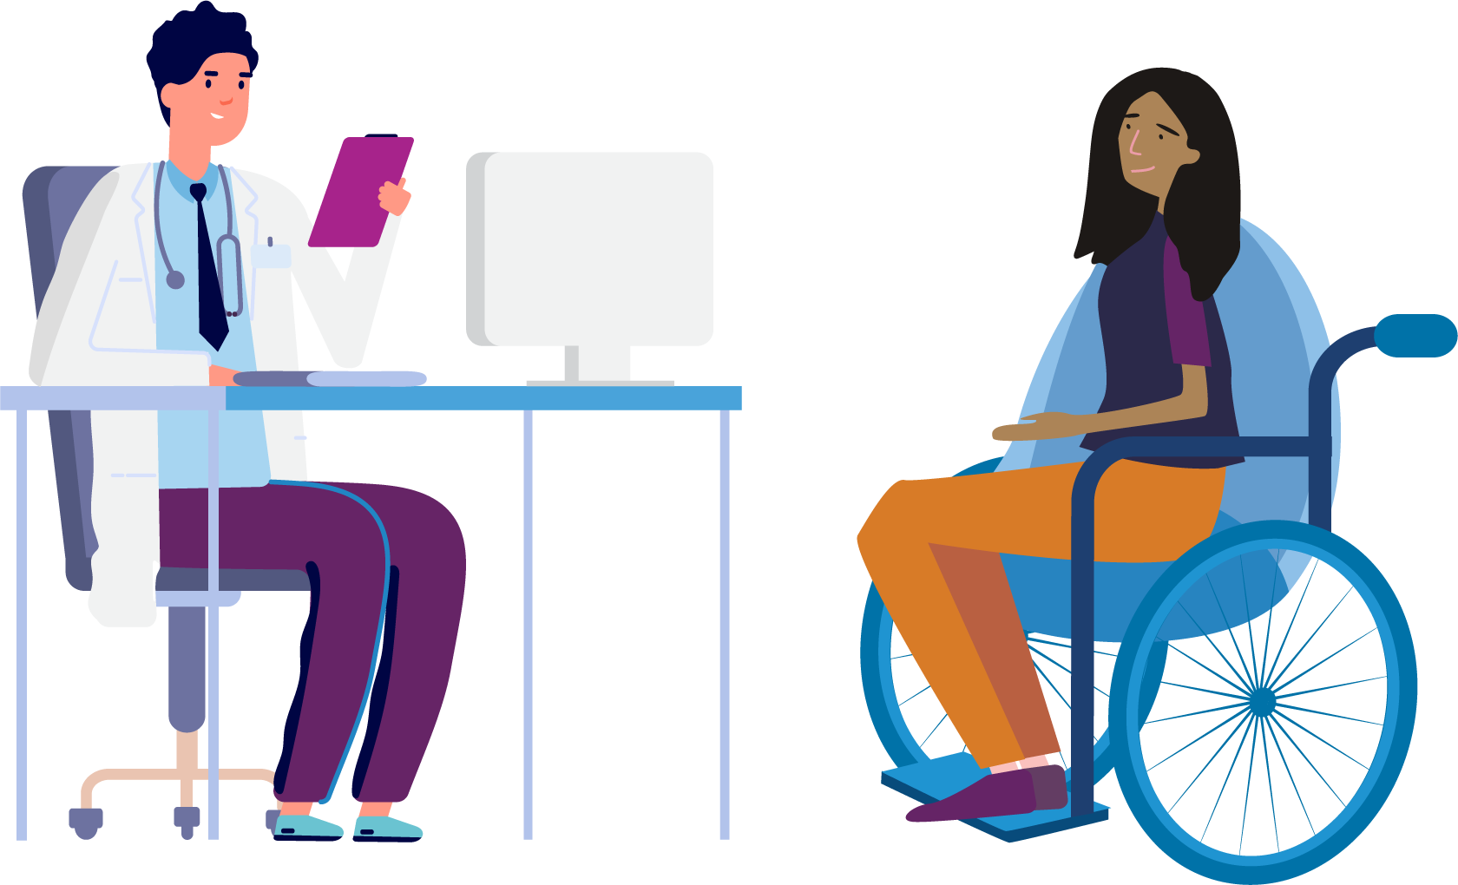

Statistics About Women with Disabilities and Health

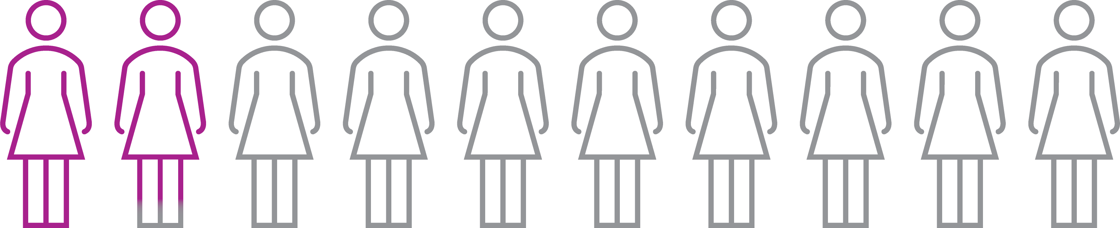

17.8% of women in Australia identify as having a disability.

Based on self-reported data, women with disability are more likely to have poorer health than women who do not identify as having disabilities.
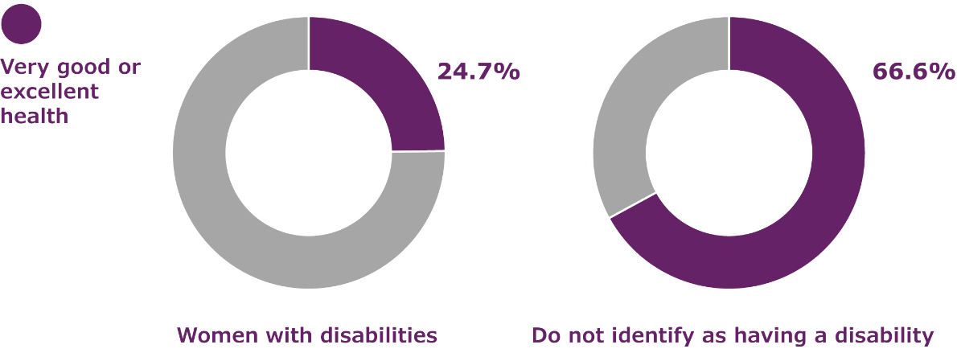
According to the Australian Institute of Health and Welfare, only 24.7% of women with disabilities experience very good or excellent health, compared with 66.6% of women who do not identify as having disabilities.

Barriers to Access
There are many different reasons why women with disabilities may find health services inaccessible. These barriers can mean that women with disabilities experience poorer health outcomes, than other members of the community. These barriers include:
Health information not being provided in a way that is accessible.
Services being located in buildings without appropriate physical access features.
Health care providers lacking knowledge, skills, and resources about disability to make care accessible and inclusive.
Health care providers lacking knowledge about women with disabilities and sex. This lack of knowledge can make it hard for women with disabilities to access sexual and reproductive health services.
Women with disabilities experiencing additional challenges to their social and emotional wellbeing, which can be made worse by lack of access to mental health support.
Information about, and physical access to screening programs such as breast screening not being provided in ways that are inclusive of women with disabilities.
- Some health services being unaffordable because women with disabilities experience more barriers to employment and stable housing than other Australians.

Some important things to think about
There are many things that contribute to the health and wellbeing of each of us, including:
Where we live.
The schools we attend.
Experience of family violence.
- How much money we have.
We may be members of different communities, such as Aboriginal and/or Torres Strait Islander, LGBTIQA+, faith-based or migrant and refugee communities. These factors may add to the barriers we experience. Many of these things are beyond our control. However, access to healthcare is a fundamental human right. We have the same right to healthcare as every other person, and we have the right to make our own health choices.
It is the responsibility of health services to learn about what each of us needs, and to make their service accessible and inclusive.
We can empower each other when we join together to advocate for change. We can advocate for accessible and inclusive health services by joining groups such as disability advisory committees and taking on consumer advisory roles.

Some questions to help us think about accessible and inclusive healthcare

Did you know that it is a human right for us to have good health?

What does accessible and inclusive healthcare feel, look and sound like?
How might other life factors, for example living in a rural area, affect our access to health services?

For me, having a physical disability, one of the main barriers is the built environment. If I go down the street and I need to go into the health service, but there’s two or three steps, or they’ve got the doorbell that I can’t reach. Those basic things would stop me from taking the first step.
– Jill

Our right to health

All people with disabilities have the right to equal access to healthcare under the United Nations Convention on the Rights of Persons with Disabilities. It is the responsibility of those who design and deliver health services to make them accessible and inclusive. You have the right to accessible healthcare no matter what setting you are in.
In Australia, our right to health care is supported by the Australian Charter of Health Care Rights. The Charter describes the rights that everyone can expect when receiving health care. These rights apply to all people in all places where health care is provided in Australia. This includes public and private hospitals, day procedure services, general practice and other community health services. .

Right to equal and timely care
You have the right to:
the same quality healthcare as any other person.
access treatment at the time you need it.

Right to safety and respect
You have the right to:
be safe from violence and abuse in all healthcare settings.
be treated with respect.
say no if something doesn’t feel right.

Right to accessible information
You have the right to:
information about your healthcare in formats that are accessible for you.
ask for an interpreter or communication support that meets your needs and preferences.
know about every aspect of your healthcare.
consider options and make choices.

Right to be heard
You have the right to:
ask questions. Even if it is the same question, you have the right to ask it more than once.
Tell health providers about your body and mind and have your opinion respected, because you are the expert on your own experience.
Have enough time to talk about your concerns and have your health provider listen to you.

Right to make choices
You have the right to:
make your own health choices.
seek as many opinions as you need to make informed choices about your healthcare.

Right to access and support
You have the right to
access health services on your own if you choose to.
be supported by another person in a health setting if you choose to.

Right to complain
You have the right to:
have your accessibility needs met.
tell the people who manage health services if your accessibility needs are not being met.
choose if you want to speak up about lack of care or poor service provision.
contact a complaints body such as the Health Complaints Commissioner or Human Rights Commission if you have not received acceptable care.
...the key is don’t give up. Believe in yourself, believe that you have the same rights, that you are equal to everybody else. And be kind to you, because it’s hard, it’s hard work and you’re not the problem, it’s the world around you, and that’s a big pill to swallow sometimes. It’s hard to believe that could be the case, but it’s really true. You are not the problem, the world is just not accommodating you.
– Yvonne

Advocating for our health

Advocacy means to speak up for what we need. We can be advocates for ourselves or we can be advocates for our community. Women with disabilities can advocate for themselves when they are in a health setting by telling providers about their individual needs and preferences. We can also advocate for change in the health sector with and on behalf of our community.

Advocating for ourselves

What can I do to advocate for myself when accessing a health service?

You could:
Learn about your health rights before you attend an appointment with a health provider. See the ‘Places to Get Help’ section below.
Bring a trusted support person with you when you attend a health service, even if your support person just gives you confidence.
Seek out people who can answer your questions clearly and thoroughly, so you can get the information you need to make decisions.
Ask for information to be given to you in accessible formats that work for you.
Be persistent and keep at it. Sometimes it takes time to find the information and treatment you need. Keep going until you find a health provider who can help you.
Find ways to connect with other women with disabilities who may share your experiences. The support of our peers helps us develop courage and confidence to speak up for ourselves.

Advocating for change

What can I do to advocate for more accessible and inclusive health services?

You can:
Speak to your health providers about your experience as a woman with disability and
Tell your healthcare providers what accessible healthcare means for you.
Seek opportunities to provide input into health services. Consider becoming a member of their Board, disability advisory committees or consumer advisory roles.
Connect with self-advocacy groups and join campaigns for accessible and inclusive communities. Combining our voices can help us be heard.

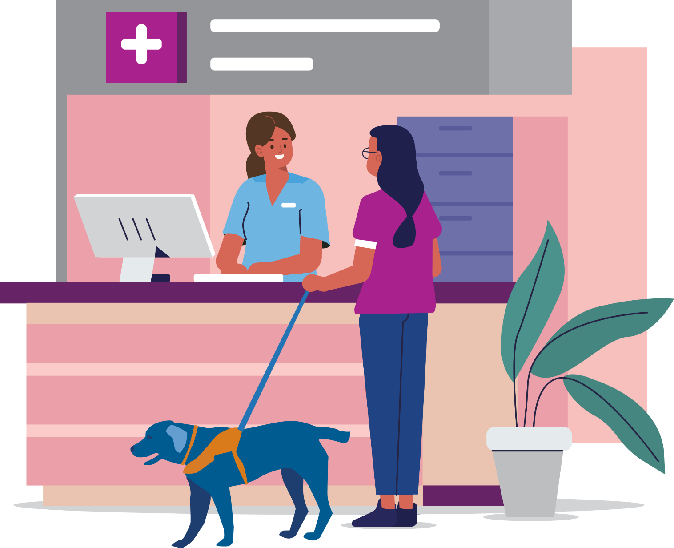

...knowing I’ve had support people has been, I think, instrumental in building my own confidence. And in terms of advocating, now if I’m not happy with an outcome or I don’t feel like I have a plan to manage my health for the next foreseeable time, instead of going through that period uncertain and maybe really struggling to keep up with work or any other aspects of my life, I will make that known.
– Angela

Finding our way around health systems

Experiences of navigating health systems
For women with disabilities it can be challenging finding our way around the many different health services available. We may need to access many different services, learn more about or get referrals, and book appointments.
Women with disabilities regularly report feeling exhausted from facing barriers in many areas of our lives. We may have experience of trauma, often within medical systems, and some of us have long histories of medical treatments and interventions.
Trying to manage or treat a health condition is challenging, and this can have a big impact on our wellbeing.

Types of Health Services
There are many different types of health services that look after different aspects of our health. Here are some examples of health services:
General Practitioners
Specialists
Hospitals
Community Health Centres
Allied Health Practitioners, such as dentists and pharmacists
Radiography, Screening and Pathology Services.

Public and private healthcare
If you have access to Medicare public hospitals provide services for free. They are funded by the government but can also be funded by health insurance when patients choose to use their private cover in a public hospital.

When you are treated in a public hospital:
- The public health system will cover the cost of your treatment so you not have to pay anything.
- You cannot choose your hospital, doctor or specialist as a public patient.
Private health insurance can help cover some of the cost of your health care. If you join a private health fund, you can claim some money towards the cost of your treatment. For example, hospital cover helps cover costs when you go to hospital as a private patient.

When you are treated as a private patient in hospital:
- Your health insurer covers some or all of the hospital costs (such as accommodation).
- Medicare covers some of the doctors’ costs.
- Your health insurer covers some or all of the remaining doctors’ costs.
- You can choose your hospital, doctor and specialist.
There are often out-of-pocket costs when you access private healthcare, so finding out about these before having treatment is important.
The Department of Health website has more information about public and private healthcare: https://www.health.gov.au/health-topics/private-health-insurance
Please note, some women with disabilities do not have access to Medicare. For example, women on temporary visas or even those who hold permanent resident visas and have not enrolled in Medicare.

Cost of healthcare
Health services can cost money, even if the government pay for parts of them. This can change so it is always good to find out about the costs of services before you make a decision. There are often costs for private health services, even if they are covered by insurance.
When you receive medical care, whether it is under private or public health, you will likely come across these different terms. Here is what they mean.
Gaps or Out-of-Pocket Cost: are the difference between what Medicare and/or your private health insurer (if you have one) will pay for your medical treatment and what you are charged. Another way to think of it is ‘the amount you pay’.
Medicare rebate: is an amount paid back to you after you use a service. The Medicare rebate is the amount that has been set as the right cost for that service, on a list called the Medicare Benefit Schedule (MBS). For example, Medicare covers 75% of the cost for services on the Medicare Benefits Schedule (MBS). If you are under Private Health Insurance, your insurer will cover the remaining 25% of the MBS.
Medicare covers some or all of the costs of services such as:
visits to a GP.
visits to specialists in their rooms.
diagnostic imaging.
diagnostic tests.
dental care for some children.
eye checks by optometrists.
- allied health services.
Item Number: A Medicare item number is the number on a list by which Medicare identifies your treatment. You can use that number to check with Medicare, and/or your private health insurer what they will pay for your treatment.
General Practitioners and other health professionals sometimes bulk bill, which means Medicare pays the whole cost of the appointment. If they don’t bulk bill, the patient pays some of the cost for the appointment. You can make a claim to Medicare for a refund if you pay the full cost of your appointment with a GP and many other health service providers.
If you receive the Disability Support Pension or have a Health Care Card it is good to let your General Practitioner know as sometimes they will choose to bulk bill.
Through your General Practitioner, you can have access to a Chronic Disease Management Plan which allows you to have five visits per calendar year to a physiotherapist, podiatrist, dietitian or psychologist for free.
Mental Health Professionals, including psychologists, psychiatrists, counsellors, social workers and occupational therapists, can be seen with a treatment plan completed by a General Practitioner. Medicare may cover some or all of the cost of the sessions.
The National Disability Insurance Scheme (NDIS) may fund some mental health supports for people living with disabilities. For information about how to apply to join the NDIS, you can go to: www.ndis.gov.au/applying-access-ndis/how-apply
The Pharmaceutical Benefits Scheme (PBS) partially covers the cost of most medicines. Once a person spends a certain amount on medicines in one year, they reach the PBS Safety Net threshold. With a PBS Safety Net Card, the price of medicines is lower for the rest of the year and for Concession Card holders it can be free.
Tip: if you take a lot of prescription medication, think about buying all prescriptions from the same chemist so they can tell you when you reach the PBS Safety Net.
Informed Financial Consent is when:
You’ve been told about the costs you can expect, and what benefits you’re getting for that cost. Your doctor and hospital must give you all the information before you have your treatment.
- You consent to them, knowing what you’re getting, and what you will need to pay.
Find out more about Informed Financial Consent: www.ama.com.au/article/ama-informed-financial-consent
Your doctor could also use the Australian Medical Association’s (AMA) Template to give you Informed Financial Consent.

Health services and the NDIS
The National Disability Insurance Scheme (NDIS) funds some health supports directly related to a person’s disability, while state health systems fund services related to health. More information can be found at: www.ourguidelines.ndis.gov.au/how-ndis-supports-work-menu/mainstream-and-community-supports/who-responsible-supports-you-need/health

Interpreter services in health settings
Communication is a key entitlement under the Charter of Australian Health Care Rights. Women with disabilities must have access to appropriate communication support when discussing their health and wellbeing so they can:
Know their rights.
Give informed consent.
Participate in decision-making.
- Know information about their individual health and wellbeing.
Interpretation services in state-funded health settings including public hospitals are funded by the state and booked through each service’s booking system.
Interpreter services available are:
The National Auslan Interpreter Booking and Payment Service (NABS) www.nabs.org.au/ can provide Auslan interpretation for health appointments. NABS is free for health care appointments with your GP, Specialist or specified health consultations if you are over 65 and do not have an NDIS plan. If you do have an NDIS plan that includes interpreting hours, you can book an interpreter with NABS for your health care and other appointments (work, hobbies, financial, etc). NABS is not free for anyone under 65 without NDIS, or anyone not eligible for NDIS. Interpreting can be provided at a cost.
Spoken languages other than English. Most healthcare settings either have access to an interpreter for on-site interpreting or over the phone interpreting via the Translating and Interpreting Service (TIS) www.tisnational.gov.au/ This is a free service and it is best to let the service know if you need an on-site interpreter so it can be booked beforehand. The healthcare service may also have access to staff from the National Accreditation Authority for Translators and Interpreters (NAATI).

...there are really good doctors and supports out there and health professionals and physios and all of that, and sometimes it’s just a matter of keeping on going until you find the people who can understand you and where you’re coming from, and who understand that if you’ve walked into the room it’s because it’s not all well, that there is something happening...so it’s waiting to find the right team for you.”
– Kelly

Places to get help

If you need help to find an accessible health service or to advocate for your rights in a health setting, the following places may be able to help you.

Australian Charter of Health Care Rights
The charter can be found at www.safetyandquality.gov.au/consumers/working-your-healthcare-provider/australian-charter-healthcare-rights/supportive-resources-second-edition-australian-charter-healthcare-rights

Blind Citizens Australia
offers advocacy information, advice and resources on a range of issues including healthcare.
Call 1800 033 660
Text 0436 446 780
Website www.bca.org.au

Centre Against Sexual Assault (CASA House)
can provide counselling and crisis support if you have been sexually assaulted recently or in the past.
Call 1800 806 292
Website www.casahouse.com.au
For information about violence, abuse and sexual assault in Easy English visit www.secasa.org.au/programs-and-services/making-rights-reality/

Communication Rights Australia
provides information and advocates for people with disabilities whose human rights have been abused. It gives priority to people with little or no speech.
Call 1300 666 604
Website www.caus.org.au

Deaf Victoria
is a non-profit organisation led and managed by deaf and hard of hearing people and provides individual advocacy support. If you need assistance with advocacy or have a question, you can email them.
Email info@deafvictoria.org.au

Disability Advocacy Resource Unit – Find an Advocate
Can help you find advocates such as ones for individual advocacy, ones for systemic advocacy, referral and information services, who you can contact to make a complaint about a service you are receiving and self-advocacy and campaign groups you can join.
Website www.daru.org.au/find-an-advocate

Health Complaints Commissioner (HCC)
can investigate health service providers who pose a serious risk to the health, safety or welfare of the public and help resolve complaints about health services.
Call 1300 582 113
Website www.hcc.vic.gov.au

Independent Mental Health Advocacy (IMHA)
provide advocacy support across Victoria and have a range of advocacy and health rights resources available on their website.
Call 1300 947 820
Email contact@imha.vic.gov.au
Website www.imha.vic.gov.au

Jean Hailes
provides information about many different topics related to women’s health.
Website www.jeanhailes.org.au

Medical Treatment Planning and Decisions ACT 2016
Information on medical decision making in Victoria can be found at this website:
www.health.vic.gov.au/patient-care/medical-treatment-planning-and-decisions-act-2016

Mental Health Complaints Commissioner Victoria (MHCC)
to make a complaint about a mental health service or treatment and care.
Call 1800 246 054
Website www.mhcc.vic.gov.au

Multi-cultural Centre for Women’s Health
provides free multilingual women’s health information.
Call 1800 656 421
Website www.mcwh.com.au

National Auslan Interpreter Booking and Payment Service (NABS)
is a Commonwealth Government service which can provide Auslan interpretation for health appointments.
Website www.nabs.org.au/

National Disability Insurance Scheme (NDIS)
can provide all people with disability with information and connections to services in their communities such as doctors, sporting clubs, support groups, libraries and schools, as well as information about what support is provided by each state and territory government.
Call 1800 800 110
Website www.ndis.gov.au

Office of the Public Advocate
provides guardianship and advocacy services for people with disabilities as well as advice and support.
Call 1300 309 337
Website www.publicadvocate.vic.gov.au

Office for the Public Advocate, HealthCARE Conversations video
is aimed at improving communication between health practitioners and people with disability. You can watch it here:
www.publicadvocate.vic.gov.au/14-news-media-item/371-new-video-gives-patients-with-disability-a-voice

Royal Women’s Hospital Women with Individual Needs Clinic
is an antenatal care clinic for women who are pregnant and have a disability. The clinic is open on Mondays, Tuesdays and Fridays. If you call and there is no one to take your call, calls will be returned within a day or two. Phone calls to this service are strictly confidential.
Call 8345 2159 or 0435 962 657
Website www.thewomens.org.au/health-professionals/maternity/women-with-individual-needs#a_information

Safe Steps
provides specialist support services for anyone in Victoria who is experiencing or afraid of family violence. They are available 24 hours, 7 days a week.
Call 1800 015 188
Website www.safesteps.org.au

Services Australia, Health and Disability
website has information on accessing Medicare and some health services at low or no cost. Help for people with disability or for if you are caring for someone. What to do when a loved one dies.
Website www.servicesaustralia.gov.au/living-with-disability

Sexual Health Victoria
promotes reproductive and sexual health for all Victorians through their clinics, education and advocacy. To find a clinic near you please go to www.shvic.org.au/our-reproductive-and-sexual-health-clinics
Call 1800 013 952
Website https://shvic.org.au/

Translating and Interpreting Service (TIS)
provide onsite language interpreting or over the phone.
Website www.tisnational.gov.au

United Nations Convention on the Rights of Persons with Disabilities
The convention can be found at this website
www.un.org/development/desa/disabilities/convention-on-the-rights-of-persons-with-disabilities.html

WIRE
offers a free information and referral service for all Victorian women. They are open Monday–Friday, 9.00am-5.00pm (except public holidays). You can also visit WIRE at the Women’s Information Centre Monday–Friday, 9.30am-4.30pm.
Call 1300 134 130
Email support@wire.org.au
Website www.wire.org.au

Women’s Health Victoria
have information and links to Women’s Health Services in different regions across Victoria.
Call 03 9664 6300
Website www.whv.org.au/about/our-sector

Glossary – Words and Meanings

Ableism – Discrimination toward and prejudice against people with disabilities.
Advocacy – Can mean speaking up for yourself or joining with others to speak up for change to structures and systems.
Empowering – Enhancing the self-determination and active participation of women with disabilities by offering useful and accessible information, removing barriers to engagement and promoting and celebrating women’s capacities and inner strengths.
Disability – A “physical, sensory, psychiatric or cognitive impairment (including an intellectual disability), acquired brain injury or dementia that, in interactions with various barriers may hinder a person’s full and effective participation in society on an equal basis with others” (Australian Institute of Health and Welfare, 2020).
Discrimination – The prejudice and unjust treatment experienced by a person or group because of a particular trait or identity.
Gender – Gender relates to social expectations around the ways women and men behave, and the different roles and responsibilities they are expected to take. Gender encompasses a range of identities that do not necessarily correspond to traditional ideas of male and female.
General Practitioner – A medical professional who is the first or primary contact when a person has concerns about their health.

Health – may mean having or not having a disease or risk factor as an individual. However, health can be described as being physically, mentally and socially well (WHO 1946). Health reflects the interactions between a person’s genetics, lifestyle and environment.
Health Service – A health service helps an individual or group assess, maintain, improve or manage their physical or psychological health.
Human Rights – The rights everyone is entitled to no matter who they are or where they live. The rights all people have simply because they are alive.
Intersectionality – is an approach that analyses social inequality and the ways a person’s race, gender, sexuality, age or disability intersect and can contribute to discrimination and oppression. Intersectionality asks us to see that sexism and ableism always intersect and interact with other forms of oppression.
NDIS – The National Disability Insurance Scheme is a scheme of the Australian Government that funds costs associated with disability.
Resource – An information source that is designed to help women with disability learn new information, understand their rights and seek support. They may take a variety of forms including documents, apps, websites, videos and training sessions.
Social Model of Disability – The social model of disability proposes that what makes a person disabled is not their condition or impairment, but the attitudes and structures of the society they live in.

Sources

Australian Commission on Safety and Quality in Healthcare. (2019). Australian Charter of Healthcare Rights. https://www.safetyandquality.gov.au/consumers/understanding-your-rights
Australian Government Department of Health. (2021, August 18). About Private Health Insurance. https://www.health.gov.au/health-topics/private-health-insurance/about-private-health-insurance
Australian Government Department of Health. (2021, August 18). Medicare. https://www.health.gov.au/health-topics/private-health-insurance/about-private-health-insurance
Australian Government Department of Home Affairs. (2020, September 1) Translating and Interpreting Services. TIS National Website. https://www.tisnational.gov.au/
Australian Institute of Health and Welfare. (2020). Health of People with Disability. AIHW Snapshot Website. https://www.aihw.gov.au/reports/australias-health/health-of-people-with-disability
Australian Medical Association. (2020, September 1). Informed Financial Consent. AMA Website. https://www.ama.com.au/articles/informed-financial-consent
Lowrie, M. (2014). An inquiry into access to Auslan Interpreters in Victorian Hospitals. Deaf Victoria Website. https://www.deafvictoria.org.au/wp-content/uploads/2020/09/Deaf-Victoria-Auslan-interpreter-report-2014-D3-3-1.pdf
National Auslan Interpreter Booking Service. (2021, September 1) Deaf Community. NABS Website. https://www.nabs.org.au/about-nabs---deaf-community.html
National Disability Insurance Agency. (2021, September 1). Health. NDIS Website. https://www.ndis.gov.au/understanding/ndis-and-other-government-services/health
People with Disabilities Australia and Youth Action. (2019). Speaking Up for Yourself. PWDA Website. https://pwd.org.au/wp-content/uploads/2019/09/CreatingAccess_Factsheet_SpeakingUpForYourself_WEB.pdf
United Nations. (2006). Convention on the Rights of People with Disabilities. UN Department of Economic and Social Affairs Website. https://www.un.org/development/desa/disabilities/convention-on-the-rights-of-persons-with-disabilities.html
Women with Disabilities Victoria. (2010). Access to Health Services for Women with Disabilities. WDV Website. https://www.wdv.org.au/documents/Access%20to%20health%20services%20-%20the%20issues%20for%20women%20with%20disabilities.pdf

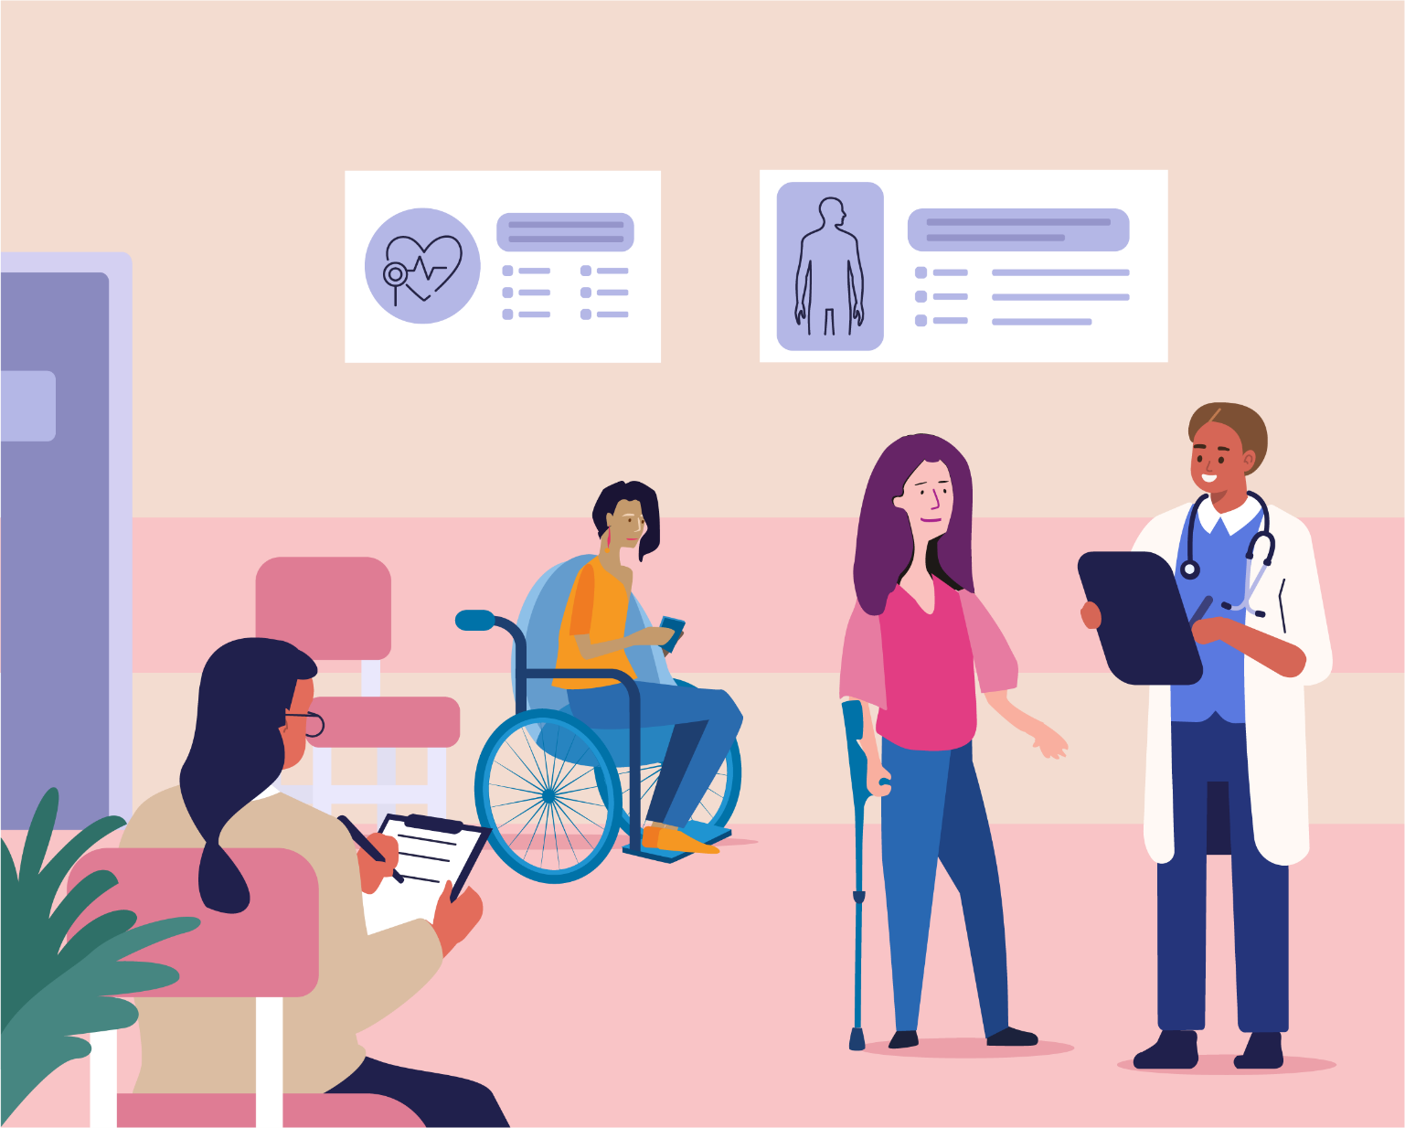

Wurundjeri Country
Postal: PO Box 18314, Collins Street East.
VIC 8003
Phone: 03 9286 7800
Email: wdv@wdv.org.au

Website www.wdv.org.au

