Inclusive Co-Design in Practice
Seven ways Women with Disabilities Victoria supports accessible and inclusive co-design of resources, services and programs

1. Creating safe and accessible co-design spaces
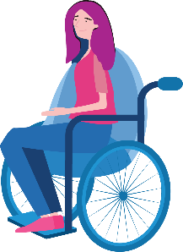
As women with lived experience of disability, we know we can communicate our ideas in ways that are comfortable and accessible for us.
Information we need is produced before each co-design session, and communicated in ways that meet the needs of everyone.
Co-design groups come up with ways to interact which are respectful and safe for everyone, and we review these regularly.

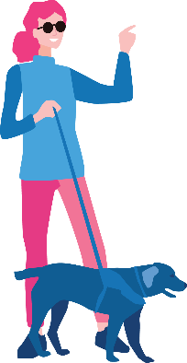
2. Empowering each other in co-design teams
As experts by experience, we are involved in the co-design process from beginning to end, and our input is included in the final resources.
It is ok for any person to speak up and say what they think during our
co-design sessions.
Meeting in co-design teams is an empowering experience, because our members and facilitators share with and support each other.

3. Supporting participation through valuing diversity
Our group facilitators, whether they have lived expertise or not, know women with disabilities are experts in their own access requirements.
Each member of a co-design group is valued for their unique knowledge, skills and strengths.
Women with Disabilities Victoria show that they value lived expertise by paying all group members fairly for their time and contribution.

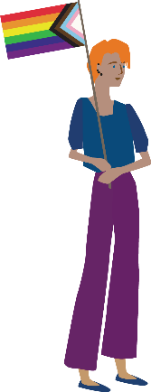
4. Developing relationships based on authenticity, empathy and trust
Women with Disabilities Victoria genuinely want our input, and co-design groups take time to explore lived experiences, perspectives and values.
Group members who share hard experiences and different points of view are respected and valued for their contribution.
Group facilitators know that valuing diverse life experiences and identities is important.

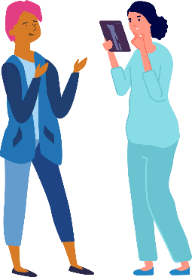
5. Building capacity through continuous learning
Co-design groups undertake learning together so that we have knowledge, understanding and language that is shared.
We all learn from each other, and each co-design group member has expertise that is different but equal.
We plan learning experiences throughout our co-design journeys, based on what group members want and need.

6. Improving through continuous feedback
Our group members are able to give feedback at any time during a co-design process.
Co-design group facilitators ask for feedback about accessibility, and group members can communicate about access in different ways.
Women with Disabilities Victoria prioritises access, and empowers co-design facilitators to address barriers as soon as they are identified.

7. Ongoing monitoring and evaluation
Evaluation reports have the voices of women with disabilities at their centre.
All co-designers participate in evaluation in ways that are accessible.
An inclusive and accessible co-design experience is an important measure of the success of the work of Women with Disabilities Victoria.

The development of this resource was supported by the Australian Government Department of Social Services. Go to www.dss.gov.au for more information. The Australian Government Department of Social Services funding is gratefully acknowledged.
Women with Disabilities Victoria would also like to acknowledge the ongoing support from our partner organisations – Multicultural Centre for Women’s Health, Women’s Health Loddon Mallee and Women’s Health in the North as well as members of the Project Advisory Group.
Our particular thanks to Women with Disabilities Victoria’s twelve Health Experts, who contributed their expertise to this resource as part of our co-design process.
This resource was prepared by Women with Disabilities Victoria. Published by Women with Disabilities Victoria: PO Box 18314, Collins St East. VIC 8003. © Women with Disabilities Victoria 2022
For more information visit: https://www.wdv.org.au/
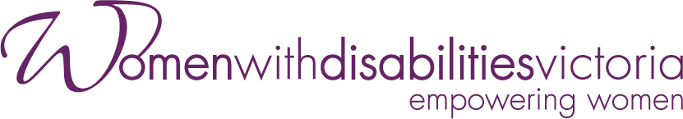
Wurundjeri Country
Postal: PO Box 18314, Collins St East. VIC 8003
Phone: 03 9286 7800
Email: wdv@wdv.org.au

