We are Experts in Our Health

Listen to women with disabilities
Take the time to ask women about their health. Ask us how to make life more accessible for us.

Women with Disabilities are individuals
Consider the many factors that impact the health of women with disabilities.

Accessibility is Everyone’s Business
Work to remove physical, communication and attitudinal barriers.

Create partnerships with women with disabilities
Allow women with disabilities to make decisions in collaboration with their health team.

Value the voices of women with disabilities
Ensure that women with disabilities have input at all levels across the organisation.

For more information visit: https://www.wdv.org.au/
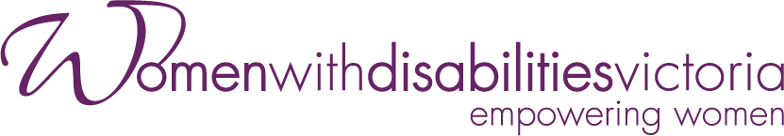
The development of this resource was supported by the Australian Government Department of Social Services. Go to www.dss.gov.au for more information. The Australian Government Department of Social Services funding is gratefully acknowledged.
Women with Disabilities Victoria would also like to acknowledge the ongoing support from our partner organisations – Multicultural Centre for Women’s Health, Women’s Health Loddon Mallee and Women’s Health in the North as well as members of the Project Advisory Group.
Our particular thanks to Women with Disabilities Victoria’s twelve Health Experts, who contributed their expertise to this resource as part of our co-design process.
This resource was prepared by Women with Disabilities Victoria. Published by Women with Disabilities Victoria: PO Box 18314, Collins St East. VIC 8003. © Women with Disabilities Victoria 2022

