Our Voice - Our Future

Women with Disabilities Co-Design Symposium

Women with Disabilities Victoria are hosting a free symposium on co-design to promote women with disabilities representation, belonging and inclusion
Nothing about us – Without us!
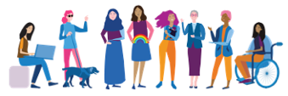

The Co-Design Symposium will highlight resources, expert knowledge, skills, and examples of inclusive practice, increasing the confidence of services to enhance lived experience representation in their work.

The event is open to anyone working in health, government, prevention of violence against women (PVAW), disability and social service sectors.

The symposium will include:
- Co-design and health
- Co-design and prevention of violence against women with disabilities
- Launch of co-design resources
- Co-design discussions
- Co-design: examples, how to’s and troubleshooting sessions
- A panel on co-design featuring lived experience experts versed in co-design practice.

This event will be accessible, free and focus on increasing inclusion, lived experience representation and co-design and development.

Register now!
Attend the entire event or selected sessions. Registrants will have access to the recorded session content for one month after the event.

Date: Thursday 6th October 2022 from 10:00am to 2:00pm.
Location: online via Zoom
Cost: free
Register: by 4th October 2022 at
https://wwdv.wildapricot.org/event-4953231
For more information: contact Carly Myers on carly.myers@wdv.org.au or phone 9286-7815

