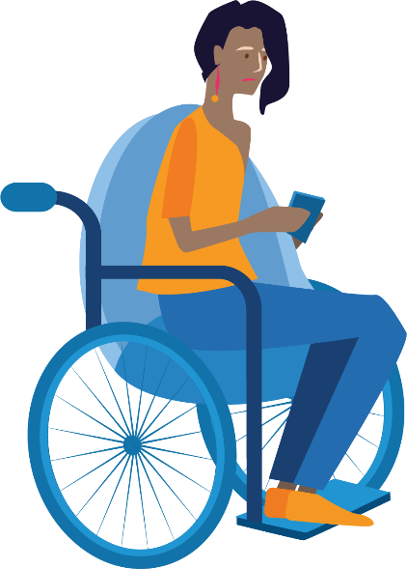

2022-2023
WDV Board

Nomination Guidelines

- All Full Members of Women with Disabilities Victoria are eligible to nominate themselves or another Full Member for a position as Director on the Board.
- Nominations for the position of Director must:
  - be made by submitting the completed Nomination form.
  - include the responses to the eight (8) questions listed in the Nomination form. Responses will be compiled and presented as the Nominee’s nomination statement.
  - include the written consent of the Nominee (This can be an electronic or handwritten signature where marked).
- Nominees are encouraged to submit a photograph to be used accompanying their nomination statements.
- Nominations close at 5pm on Tuesday 25 October 2022. Late nominations will not be accepted.
- Nominations must be received by the Board Governance Officer by either:
  - Email: agm@wdv.org.au
  - Web page: https://www.wdv.org.au/agm2022/
  - Post: in the Reply Paid Envelope attached
    - If you misplace the envelope, please send the form to Board Governance Officer, PO Box 18314, Collins Street East, VIC 8003.
    - Note: if sending by post, please allow sufficient time for delivery (at least 4 business days) by the date above.
- Nominations will be acknowledged via email within 7 days of the closing date.
- The written statements provided by the Nominees will be sent in advance to all WDV Members, posted on the WDV website, and be presented by the Nominees at the hybrid AGM on Tuesday 8 November 2022.
- Nominees will be required to present their statement to Members at the AGM (or, if unable to attend in person, appoint someone to do so).
- If the number of nominations received is equal to the number of vacancies, the members nominated shall be deemed to be elected without a poll, otherwise an election will be conducted at the AGM.
- Women with Disabilities Victoria values diversity and particularly encourages young women, Indigenous & First Nations women, women from culturally and linguistically diverse backgrounds and people who are LBTQIA+ who are Full Members to apply.
- If you have any questions regarding your eligibility for membership with Women with Disabilities Victoria or for your nomination to the WDV Board please contact us by:
  - Email: agm@wdv.org.au
  - Phone: 0497 186 467
- For further information regarding the role and responsibilities of the WDV Board please refer to the Board Position Description document.

